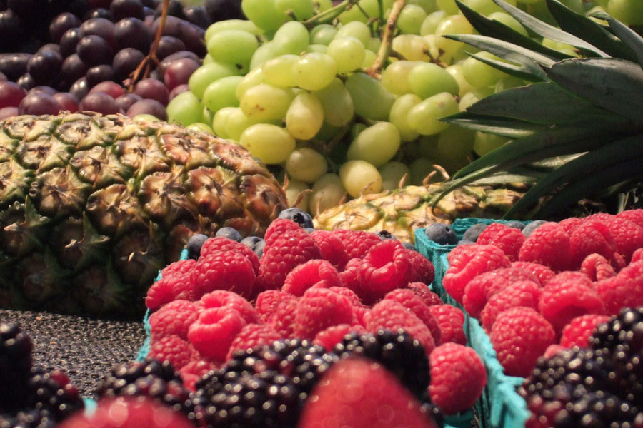

Doesn't this make you drool?

Did last night’s dinner make you drool with anticipation? Did lunch have you licking your chops? According to research by teams from Thailand and Sweden, enjoying your food increases the nourishment your body receives from it.

**The Experiment**

Imagine a bowl of Thai vegetables and rice in coconut milk, seasoned with hot chili paste. Sound scrumptious? Or too spicy for your palate? The researchers served this dish to Thai women accustomed to such fare, then measured how much iron they absorbed.

Next, the researchers served the same meal to Swedish women accustomed to [less spice](http://indianapublicmedia.org/amomentofscience/spicy-source-of-pain-relief/). Guess what happened? The Swedish women absorbed significantly less iron than their Thai counterparts.

Going further, the researchers served the Thai women the same ingredients, processed into an unappetizing, goopy puree. This time, the Thai women absorbed 70% less iron than they had before.

**How Can This Be?**

The researchers believe the answer’s in the brain. Before you eat a bite, there’s a brain phase of digestive secretion. Seeing, smelling, or just anticipating a good meal prompts the brain to send messages to glands along the digestive tract. “Hey you guys!

Yummy morsels coming!” These happy thoughts prompt secretion of saliva, gastric juices and enzymes for digestion. In particular, acidic gastric juices are key to iron absorption. Without the acid, the body absorbs little iron.

When you’re relaxed and enjoying your food, your brain primes your gut to absorb the most nutrients. So there’s scientific evidence for something we’ve suspected all along-an appealing, leisurely meal is a lot more nutritious than unappetizing grub!

昨晚的晚餐会让你流口水吗？午餐让你舔你的排骨？根据泰国和瑞典团队的研究，享受食物可以增加身体从中获得的营养。

### 本实验

想象一下泰国蔬菜和椰奶中的米饭，用辣椒酱调味。听起来很美味？还是太辣了你的味觉？研究人员将这道菜送给习惯于这种食物的泰国女性，然后测量他们吸收了多少铁。

接下来，研究人员向习惯于[减少香料的](http://indianapublicmedia.org/amomentofscience/spicy-source-of-pain-relief/)瑞典女性提供同样的一餐。猜猜发生了什么？瑞典女性吸收的铁比泰国女性少得多。

更进一步，研究人员为泰国妇女提供了相同的成分，加工成一种令人不快的莽糊泥。这一次，泰国女性吸收的铁比以前减少了70％。

### 怎么会这样？

研究人员相信大脑中的答案。在你吃一口之前，有消化分泌的大脑阶段。看到，闻到或只是期待一顿美餐会促使大脑向消化道的腺体发送信息。“嘿，伙计们！

美味的食物来了！“这些快乐的想法促使唾液，胃液和酶的分泌促进消化。特别是，酸性胃液是铁吸收的关键。没有酸，身体吸收少量铁。

当你放松并享受食物时，你的大脑会使你的肠道吸收最多的营养。因此有科学证据表明我们一直怀疑的东西 - 一种吸引人的，悠闲的膳食比不令人厌恶的食物更有营养！