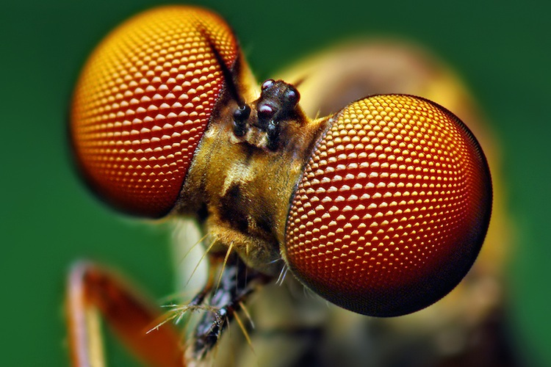

Insect eyes are very different from ours. Our eyes are similar to a camera. There is a pupil at the front that admits light, and the cornea and lens bend light to form an image. The image falls on the retina, a sheet of light-sensing cells at the back of the eye.

**Very, Very Different**

The insect eye, on the other hand, is a compound eye, consisting of thousands of tiny hexagonal tubes called ommatidia. Each has its own lens at the front and its own cluster of light sensing cells at the back. The tubes form an interlocking carpet that wraps around the insect’s head. The image formed is a mosaic, and each tube contributes one piece.

Insect eyes are different from ours because, about 600 million years ago, the ancestors of insects and crustaceans evolved vision separately from the ancestors of humans and other animals with backbones. Each found a different, but successful solution to the problem of how to form an image, and passed on that solution to its descendants.

**Are There Advantages?**

The image they form is not as clear and detailed as a camera eye, but compound eyes do have a much wider field of view, which is useful in flight. Wrap around vision helps aerial hunters like dragonflies spot their prey.

Many insects can see ultraviolet light, which we can’t. Flowers have ultraviolet markings, that are visible to pollinating insects, but not to us. Every kind of eye serves the needs of its user.

昆虫的眼睛与我们的眼睛截然不同。我们的眼睛类似于相机。前面有一个瞳孔允许光线，角膜和镜头弯曲光线形成图像。图像落在视网膜上，一组位于眼睛后部的光敏细胞。

### 非常非常不同

另一方面，昆虫的眼睛是复眼，由数千个称为小眼睛的微小六角形管组成。每个镜头前部都有自己的镜头，后部有自己的光感应单元。这些管形成一个互锁的地毯，包裹着昆虫的头部。形成的图像是马赛克，每个管贡献一个。

昆虫的眼睛与我们的不同，因为大约6亿年前，昆虫和甲壳类动物的祖先与人类的祖先和其他具有骨干的动物分开进化。每个人都找到了一个不同但成功的解决方案来解决如何形成图像的问题，并将该解决方案传递给它的后代。

### 有优势吗？

它们形成的图像不如摄像机眼睛那么清晰和细致，但是复眼可以有更宽的视野，这在飞行中很有用。环绕视觉有助于像蜻蜓这样的空中猎人发现它们的猎物。

许多昆虫可以看到紫外线，我们不能。花有紫外线标记，授粉昆虫可见，但不是我们。每种眼睛都能满足用户的需求。