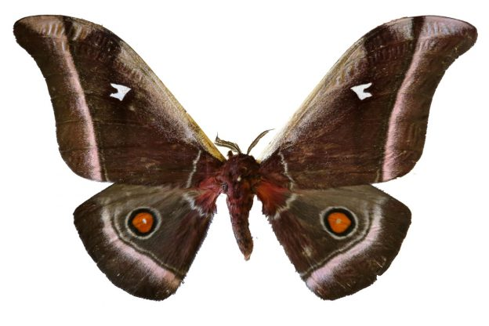

From the perspective of moths, bats are the terror of the night sky. Bats hunt at night, when most moth species are active. The Bats use sonar echolocation to detect and intercept flying insect prey. This makes it very dangerous to be a moth.

Luckily, moths have evolved numerous ways to protect themselves.

Many moth species have ears that can hear the bat’s sonar pulses and take evasive action. But many are deaf. In 2018 a team of British scientists reported a new way that these moths protect themselves—acoustic camouflage.

In the same way that visual camouflage makes things hard to see, acoustic camouflage makes the moth hard to detect with sonar.

Moths and butterflies have similar wings, but most butterflies are active during the day and don’t face the threat of bat predation. When the researchers compared the sound-reflecting properties of moths and day-flying butterflies, they found that nocturnal moths have special adaptations to reduce the amount of sound they reflect at the ultrasonic frequencies of bat sonar. They can absorb up to 85% of incoming ultrasound, compared to only 20% for butterflies.

Moths have scales on their bodies and around their wing joints that are thicker and denser than those on butterflies. The scales are like fur, and absorb sound. Removing it increased a moth’s chances of being eaten by a bat by 38%. The researchers found that the scales of moths are structured on the microscopic level, so that they vibrate at just the right frequencies to cancel out the ultrasound frequencies of bat sonar.

从飞蛾的角度来看，蝙蝠是夜空的恐怖。当大多数蛾类活跃时，蝙蝠在夜间捕猎。蝙蝠使用声纳回声定位来探测和拦截飞行昆虫的猎物。这使得成为一只飞蛾非常危险。

幸运的是，飞蛾已经发展出许多保护自己的方法。

许多蛾类都有耳朵可以听到蝙蝠的声纳脉冲并采取规避行动。但是很多人都是聋子。2018年，一队英国科学家报告了这种飞蛾保护自身的新方法 - 声学伪装。

就像视觉伪装让人难以看清一样，声学伪装使得声纳很难用声纳探测到。

飞蛾和蝴蝶有相似的翅膀，但大多数蝴蝶在白天活跃，不会面临蝙蝠捕食的威胁。当研究人员比较飞蛾和白昼蝴蝶的声反射特性时，他们发现夜间飞蛾有特殊的适应性，以减少它们在蝙蝠声纳超声频率下反射的声音量。它们可以吸收高达85％的进入超声波，而蝴蝶只有20％。

飞蛾的身体和翅膀关节周围都有鳞片，比蝴蝶上的鳞片更厚更密。鳞片就像毛皮，吸收声音。去除它会使飞蛾被蝙蝠吃掉的几率提高38％。研究人员发现，飞蛾的鳞片是在微观层面上构建的，因此它们以恰当的频率振动，以抵消蝙蝠声纳的超声频率。