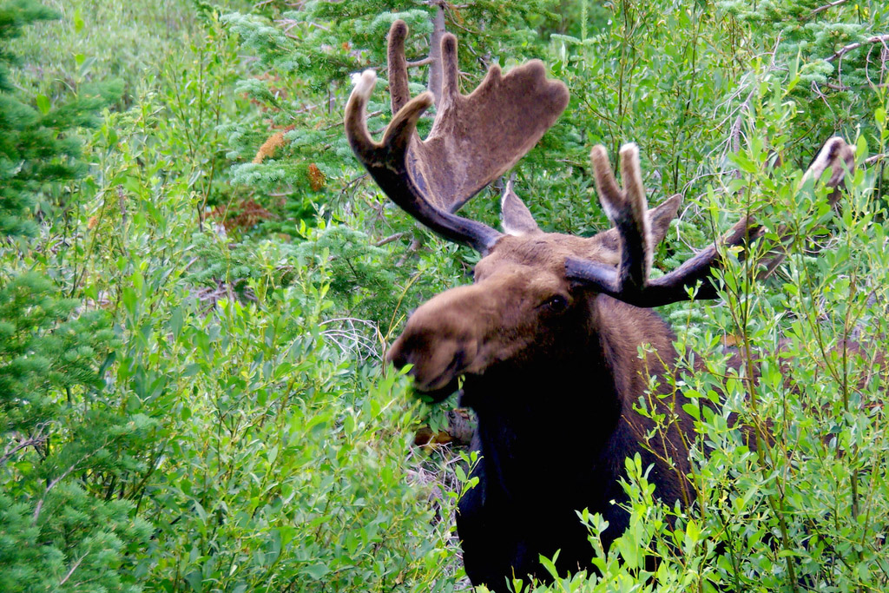

Ever since plant eating animals evolved long, long ago, plants and animals have waged an arms race of sorts.

**Munch Ammunition**

Some plants evolve defense mechanisms to try to prevent being eaten, and herbivores evolve strategies for overcoming the plants’ defenses. Take, for example, reindeer and moose:

European reindeer and moose are partial to a plant called red fescue. To keep from being munched on, the plant partners with a fungus that produces a toxin. When a reindeer or moose begins chewing on red fescue, the fungus releases the toxin, which restricts blood flow to the animals’ legs, which can lead to the loss of limbs. The idea, at least, is that the reindeer or moose will stop eating rather than lose their limbs.

**Spit Take**

But the plants’ toxic defense system has a fatal flaw. Before eating red fescue, reindeer and moose drool on the plant. And not just because they’re hungry. The saliva, it turns out, contains chemicals that neutralize the fungal toxin.

Scientists don’t yet know exactly how this works. They think the drool might mess with chemical signals red fescue uses to alert the fungus that it’s time to make the toxin.

In any case, it’s a cool example of the ongoing struggle between plants and the animals that eat them. And who knows? As the millennia pass, red fescue might evolve better ways to ward off predators, forcing moose and reindeer back to the evolutionary drawing board.

自从植物长期以来进食动物以来，植物和动物就开始了种族的军备竞赛。

### 蒙克弹药

一些植物进化防御机制以防止被吃掉，食草动物发展出克服植物防御的策略。以驯鹿和驼鹿为例：

欧洲的驯鹿和驼鹿偏向于一种叫做红羊茅的植物。为了避免被碾压，植物与产生毒素的真菌合作。当驯鹿或驼鹿开始咀嚼红色羊茅时，真菌会释放出毒素，这会限制血液流向动物的腿部，从而导致四肢丧失。至少，这个想法是驯鹿或驼鹿会停止进食而不是失去四肢。

### 吐痰

但植物的有毒防御系统存在致命的缺陷。在吃红色羊茅之前，驯鹿和驼鹿在植物上流口水。而且不只是因为他们饿了。事实证明，唾液含有中和真菌毒素的化学物质。

科学家还不确切知道它是如何工作的。他们认为流口水可能会混淆红色羊茅使用的化学信号来警告真菌是时候制造毒素了。

无论如何，这是植物和吃它们的动物之间持续斗争的一个很好的例子。谁知道呢？随着几千年的过去，红羊茅可能会发展出更好的方法来抵御掠食者，迫使驼鹿和驯鹿回到进化的绘图板上。