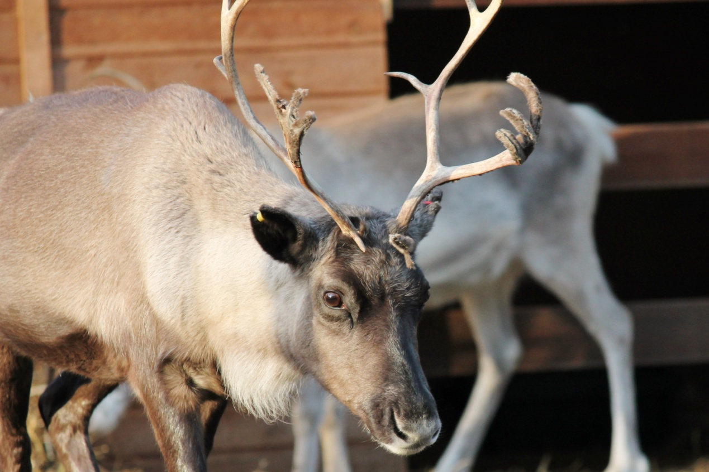

**Fact vs. Fiction**

For many children, reindeer are the antlered, red-nosed creatures that launch Santa’s sleigh into the wintry sky each Christmas. Contrary to the belief of children worldwide, reindeer noses do not glow red but rather tend towards a furry grey. And unless they jump off a cliff, reindeer are strictly land-based animals lacking the power of flight. So much for the hype. Reindeer are also called caribou, and are large members of the deer family that live in tundra regions of North America, Eurasia, Greenland, and northern islands. Both sexes have large antlers that can grow up to four feet in width. In the winter, wild caribou exist on lichens known as “reindeer moss.” Their coats are specially designed with hollow hairs to insulate their bodies and keep them warm even during arctic winters.

**Arctic Mainstay**

People have domesticated reindeer for over 5,000 years, and they are herded by arctic-dwellers such as the Saami of Northern Europe and the Tungus of Siberia. Much as Native Americans depended on bison, reindeer herders depend on the animals for everything from meat to milk to clothing. And yes, in some regions reindeer are used to pull sleighs. Unlike American bison, caribou and reindeer are not endangered. In fact they thrive in various habitats around the world. During the spring herds numbering in the thousands migrate to calving grounds where they give birth to new generations.

### 事实与虚构

对于许多孩子来说，驯鹿是每年圣诞节都会将圣诞老人的雪橇推入寒冷的天空中的角质红鼻子生物。与全世界儿童的信仰相反，驯鹿的鼻子不会发红，而是倾向于毛茸茸的灰色。除非他们从悬崖上跳下来，否则驯鹿是严格的陆地动物，缺乏飞行的力量。炒作太多了。驯鹿也被称为北美驯鹿，是生活在北美洲，欧亚大陆，格陵兰岛和北部岛屿的苔原地区的鹿科的大型成员。两性都有大型鹿角，长度可达4英尺。在冬季，野生驯鹿已知地衣存在“驯鹿苔。”他们的外套是专门空心毛绝缘自己的身体，甚至在北极的冬天御寒的设计。

### 北极主流

人们驯养驯鹿已有5000多年的历史，他们被北欧的萨米人和西伯利亚的通古斯等北极居民所吸引。就像美洲原住民依靠野牛一样，驯鹿牧民依靠动物来处理从肉到牛奶到衣服的各种事物。是的，在某些地区，驯鹿被用来拉雪橇。与美洲野牛不同，驯鹿和驯鹿并不濒临灭绝。事实上，它们在世界各地的各种栖息地中茁壮成长。在春季，成千上万的牛群迁移到产犊地，在那里生下新一代。