Russian history

Prison withouta

roof

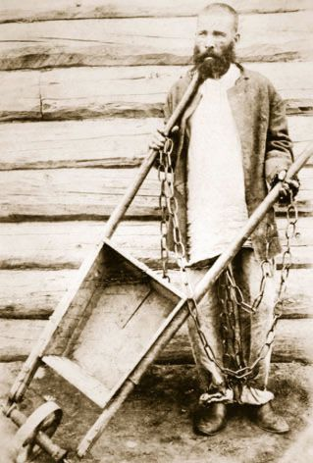

The House of the Dead: Siberian Exile

Under the Tsars. By Daniel Beer. Allen Lane;

487 pages; £30. To be published in America

by Knopf in January

“H

ERE was a world all its own, unlike

anything else,” wrote Fyodor Dos-

toevsky. Like hundreds of thousands of

Russiansbefore him, and manymore after,

Dostoevsky had been in Siberian exile,

banished in 1850 to the “vast prison with-

out a roof” that stretched out beyond the

Ural mountains for thousands of miles to

the Pacific Ocean. The experience marked

him for ever. Siberia, he wrote later, is a

“house ofthe livingdead”.

It was no metaphor. In 19th-century

Russia, to be sentenced to penal labour in

the prisons, factories and mines ofSiberia

was a “pronouncement of absolute anni-

hilation”, writesDaniel Beerin hismaster-

ly new history of the tsarist exile system,

“The House ofthe Dead”. For lesser crimi-

nals, beingcastinto one ofSiberia’slonely

village settlements was its own kind of

death sentence. On a post of plastered

bricksin a forestmarkingthe boundary be-

tween Siberia and European Russia, exiles

trudging by would carve inscriptions.

“Farewell life!” read one. Some, like Dos-

toevsky, might eventually return to Euro-

pean Russia. Mostdid not.

Successive tsars sought to purge the

Russian state ofunwanted elements. Later,

as Enlightenment ideas of penal reform

gained prominence, rehabilitation jostled

with retribution forprimacy. Butthe penal

bureaucracy could not cope. The number

of exiles exploded over the course of the

19th century, as an ever greater number of

activities were criminalised. A century of

rebellions, from the Decembristuprising in

1825 to the revolution of1905, ensured that

asteadysupplyofpolitical dissidents were

carted across the Urals by a progressively

more paranoid state. The ideals ofenlight-

ened despotism—always somewhat illu-

sory—were swept away. Exiles re-

emerged—if they ever did—sickly, brutal-

ised and often violentlycriminal.

In the Russian imagination, the land be-

yond the Urals was not just a site of dam-

nation, but a terra nullius for cultivation

and annexation to the needsofthe imperi-

al state. Siberia, Mr Beer writes, was both

“Russia’s heart ofdarkness and a world of

opportunity and prosperity”. Exile was

from the outseta colonial asmuch as a pe-

nal project. Women—idealised as “frontier

domesticators”—were coerced into follow-

ing their husbands into exile to establish a

stable population of penal colonists.

Mines, factories, and latergrand infrastruc-

ture projectssuch asthe trans-Siberian rail-

way were to be manned by productive,

hardylabourers, harvestingSiberia’snatu-

ral richeswhile rehabilitatingthemselves.

Butin this, too, the system failed utterly.

Unlike Britain’s comparable system of pe-

nal colonisation in Australia, the tsars nev-

er brought prosperity to Siberia. Fugitives

and vagabonds ravaged the countryside,

visiting terror on the free peasantry, Sibe-

ria’sreal colonists. Acontinental prison be-

came Russia’s“Wild East”.

In the end, the open-air prison of the

tsarist autocracy collapsed under the

weight of its own contradictions. The ex-

iled and indigenous populations were en-

gaged in low-level civil war, with resentful

Siberian townsfolk up in arms protesting

the presence of exiles thrust on them by

the state. Aland intended aspolitical quar-

antine became a crucible of revolution.

And modernisation—above all the arrival

of the railway—ultimately turned the

whole concept of banishment into an ab-

surd anachronism. With revolution in 1917,

the system simplyimploded.

But it never really disappeared. The

tsars’ successors, the Soviets, proclaimed

lofty ideals but in governing such a vast

land they, too, became consumed bythe ty-

rannic paranoia that plagued their fore-

bears. Out of the ashes of the old system

rose a new one, the gulag, even more fear-

some than whatitreplaced. MrBeer’sbook

makes a compelling case for placing Sibe-

ria right at the centre of 19th-century Rus-

sian—and, indeed, European—history. But

forstudentsofSovietand even post-Soviet

Russia it holds lessons, too. Many of the

country’s modern pathologies can be

traced back to this grand tsarist experi-

ment—to its tensions, its traumas and its

abjectfailures.