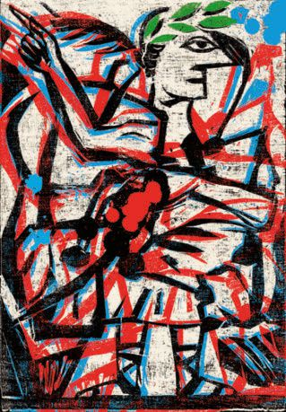

The Holy Roman Empire

Neitherholynora

failure

The Holy Roman Empire: A Thousand Years

of Europe’s History

O

N A map, the Holy Roman Empire re-

semblessomethingcloserto a Jackson

Pollock painting than an empire. Splat-

tered acrossthe landsofcentral Europe are

countless territories overseen by an em-

peror who shared power with a hierarchy

spanning princes, bishops and dukes,

down to abbots, knightsand citycouncils.

Territory sizes ranged from the vast king-

dom of Prussia to the tiny Free Imperial

City ofZell am Harmersbach, halfthe size

of San Marino. By its maturity the empire

had evolved into a “mixed monarchy” that

wasneitherfeudal nordemocratic, federal

nor unitary. Instead it was a combination

ofall ofthem.

To the modern reader, this may seem

chaotic to the point ofinefficiency. But Pe-

ter Wilson of Oxford University argues

that we have been conditioned to see the

empire this way. From the 19th century,

nationalist historians rewrote European

state history as a progression towards cen-

tralised, ethnicnation-states. Thusthe idea

of the Holy Roman Empire as a failed na-

tion-state (asopposed to a successful multi-

ethnic empire) has prevailed since—even

Hitler condemned this era of his beloved

Germany.

In his masterly retelling, Mr Wilson

paints a more nuanced picture of the em-

pire asa stable and unique entitythat pro-

tected the weak. An empire with rulers

such as Conrad II—who stopped to hear

pleas from a serf, a widow and an orphan

despite being late for his coronation in

1027—could onlybe an empire dedicated to

“peace through consensus” between rul-

ers(verymuch plural) and ruled.

Consensus, achieved by distributing

power, made the empire’s decentralised

structure an advantage ratherthan a weak-

ness. The resultwasmultiple strands ofgo-

verning hierarchies rooted in the feudal

system, each level able to make itsown de-

cisions while being subservient to those

higher up. Local bodies such as peasant

communes could make decisions about

their land while obeying an imperial

prince, who in turn obeyed imperial insti-

tutionsthatacted asa check.

Supreme imperial power was initially

vested in the emperor himself, but by the

15th century had evolved into structures

neverbefore seen in European history. The

imperial parliament (“Reichstag”) sat per-

manently beginning in 1663 (Britain’s

“MotherofParliaments” waspermanently

in session only decades later). The Reich-

stagdecided questionsaffectingthe whole

empire, and itscollege ofelectorschose the

emperor. The highest court of appeal dis-

played remarkable similarities to modern

judiciaries, with justices chosen by the

court itself, giving independent rulings

that could favour the humblest plaintiff

againstthe mostregal defendant.

Mr Wilson argues that inhabitants of

the empire were loyal to thissystem—it em-

phasised local identities and freedoms,

with citizenship based on political alle-

giance rather than culture or creed. Quite

astoundingparadoxescould result—Coun-

ter-Reformation bishopswho enjoyed “ab-

solute” rule could only fume quietly over

theirJewish orProtestantpopulations, free

to practise their religion under imperial

protection.

However, political systems that work

on paper do not always work in practice.

Serfdom and the rise of princely absolut-

ism are rehabilitated byMrWilson as tools

for consensus, without discussion oftheir

frequent abuse. Take the prince of Hild-

burghausen, who wasknown to keep two

pistols and a hunting-knife on his table

while listening to advisers. They knew he

was within his absolutist rights to use

them iftheydared “advise” too freely.

Brieflylookingto the future, Mr Wilson

notes new, post-modern distortions. Euro-

pean Union politicians have celebrated

Charlemagne’s empire as an early form of

transnational co-operation, despite the fact

Charlemagne had no “nations” to make

co-operate. Any comparisons with the EU

must allow for the fact that the empire

treated its subjects and member-states hi-

erarchically, in contrast to EU’s principles

of democratic equality. Mr Wilson rightly

believesthatthe empire should be seen as

a unique entity, ratherthan a blueprint for

modern Europe.