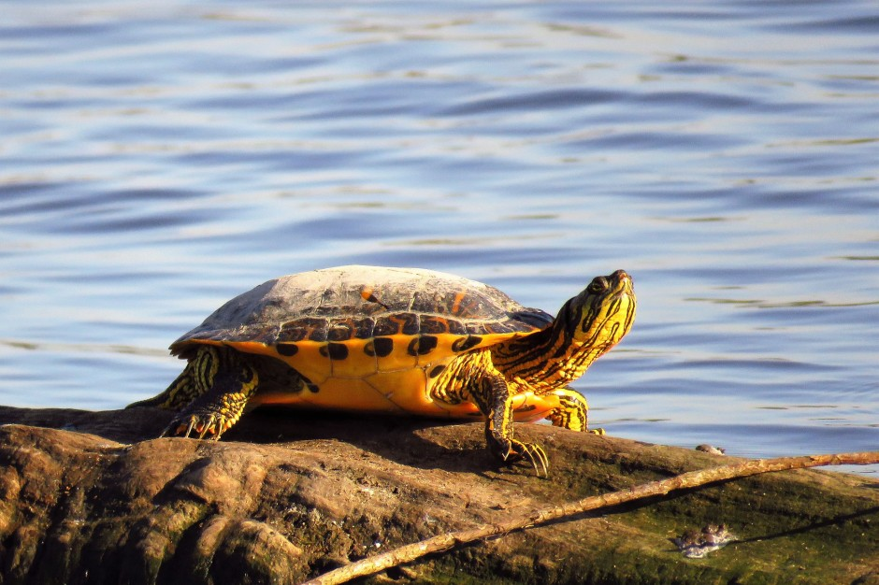

What’s the difference between a turtle and a tortoise?

Let’s start with the similarities, first. They’re both reptiles and part of the order called Testudines.

But the distinctions among Testudines (Tes-TU-di-neez) typically depends on which habitat the animals are adapted to. The terminology also differs by country.

**Australia Says Tortoise, America Says Turtle**

In Australia, all species of Testudines that are aquatic are called tortoises, with the exception of sea turtles.

In America, the name “turtle” is given to most aquatic Testudines. Though, the Eastern box turtle for example has many traits we assign to tortoises. So, how do we distinguish between these types?

There aren’t many hard or fast distinctions between different Testudines, but most turtles live in water except when venturing to find a nest for their eggs on land. Their sleek shells and webbed or flipper feet make turtles streamlined for swimming. ([And if you’re interested in how turtles in colder climates can survive living in the water during winter, click here.](https://indianapublicmedia.org/amomentofscience/surviving-winter-underwater/))

However, many species also leave the water frequently to spend time on land, or on logs basking in the sun.

*Testudines are one of the most ancient groups of animals. Scientists estimate the oldest member of this group was on Earth 220 million years ago.*

**On Land**

Tortoises are essentially land-dwelling Testudines. They are equipped with broad front legs with strong claws and stubby, club-shaped rear feet like elephants. Those powerful front feet are great for burrowing but ill-adapted to swimming.

Tortoises’ dome-shaped shells are not streamlined for aquatic maneuvering either. They maintain a vegetarian diet, whereas many aquatic turtles are carnivorous or omnivorous.

**Terrapins**

And then there are the terrapins. These small Testudines are technically a species of turtle, and they live around brackish, swampy waters.

With a shell that is somewhere between the turtle’s sleek design and the tortoise’s dome shape, they are at home in both water and on land, displaying the diversity of the amazing Testudines.

And if you couldn’t figure out if the photograph is a turtle, tortoise, or terrapin, here’s the answer: it’s a terrapin!

Want to learn about a famously altruistic kind of tortoise?

乌龟和乌龟有什么区别？

首先让我们从相似之处开始。它们都是爬行动物，也是命令Testudines的一部分。

但是，Testudines（Tes-TU-di-neez）之间的区别通常取决于动物适应的栖息地。术语也因国家而异。

### 澳大利亚说龟，美国说乌龟

在澳大利亚，所有水生的Testudines都被称为陆龟，但海龟除外。

在美国，大多数水生的Testudines都会使用“乌龟”这个名字。虽然，例如东方箱龟有许多我们分配给龟的特性。那么，我们如何区分这些类型？

不同的Testudines之间没有太多的硬性或快速区别，但大多数海龟生活在水中，除非冒险在陆地上找到它们的蛋巢。它们光滑的贝壳和网状或鳍状足部使海龟流线型游泳。（[如果您对寒冷气候中的海龟如何在冬季生活在水中生存感兴趣，请点击此处。](https://indianapublicmedia.org/amomentofscience/surviving-winter-underwater/)）

然而，许多物种也常常将水留在陆地上，或在晒太阳的原木上。

*Testudines是最古老的动物群之一。科学家估计这个群体中最年长的成员是在2.2亿年前的地球上。*

### 着陆

陆龟基本上是陆地上的土鳖。它们配备宽阔的前腿，有强壮的爪子和粗短的，像大象一样的球杆状后脚。那些强大的前脚非常适合挖洞，但不适合游泳。

陆龟的圆顶形壳体也不适合水上机动。他们保持素食，而许多水龟是肉食性或杂食性的。

### 水龟

还有水龟。这些小型的Testudines在技术上是一种乌龟，它们生活在咸水，沼泽水域。

它的外壳介于龟的圆滑设计和乌龟的圆顶形状之间，它们在水中和陆地上都处于家中，展现了惊人的Testudines的多样性。

如果你无法弄清楚这张照片是乌龟，乌龟还是鳖，这就是答案：这是一只鳖！

想了解一种着名的利他主义的乌龟？