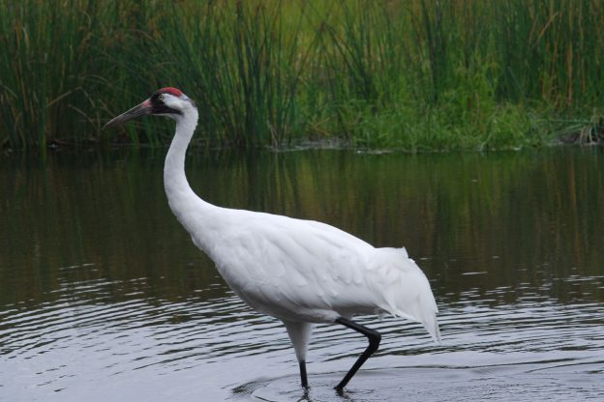

We all know that outside the world of Sesame Street, big birds can’t talk. However, our own big bird, the five-foot tall Whooping Crane, can communicate in a variety of other ways.

Their inability to talk doesn’t mean that the tall white birds are silent. Thanks to specialized looped windpipes, their calls can be heard for miles in their wetland homes. Often, a mated pair will call simultaneously, a behavior known as unison calling. These calls allow the male and female to strengthen their pair bond and tell rival cranes and other potential threats they need to give the pair some space.

If an intruder gets close, the cranes may turn to more visual displays. Whooping Cranes’ heads are crowned with a patch of bare red skin. Cranes warn encroaching individuals that they are too close by tilting their heads down to display this patch. They can also direct more blood flow to it, making the red brighter and the patch larger. More visible red means an angrier crane.

But not all crane communication is aggressive. Whooping Crane pairs, which mate for life, participate in a spectacular dancing display. They bow to one another, spread their wings, toss bits of grass or sticks above their heads, and jump high into the air.

We believe this dance reaffirms their pair bond, which must be strong for the couple to defend a territory and successfully raise chicks. Dancing and playing also may serve as a way for cranes to blow off steam, and reduce stress levels. They also may dance because it’s just plain fun.

我们都知道，在芝麻街的世界之外，大鸟不能说话。然而，我们自己的大鸟，五英尺高的鸣鹤，可以通过各种其他方式进行交流。

他们无法说话并不意味着高大的白鸟是沉默的。由于专门的环形气管，他们的呼叫可以在湿地家中听到数英里。通常，配对将同时呼叫，这种行为称为协调呼叫。这些呼叫允许男性和女性加强他们的配对关系，并告诉敌对起重机和他们需要的其他潜在威胁，以给对方一些空间。

如果入侵者靠近，起重机可能会转向更直观的显示。百日鹤的脑袋上点缀着一片赤裸的红色皮肤。起重机警告说，他们太靠近了他们，因为他们向下倾斜以显示这个补丁。它们还可以引导更多的血液流入，使红色更亮，贴片更大。更明显的红色意味着愤怒的起重机。

但并非所有起重机通信都具有侵略性 与生活交配的鸣鹤配对，参加壮观的舞蹈表演。他们互相鞠躬，展开翅膀，在头顶上扔一些草或棍棒，然后高高跃起。

我们相信这种舞蹈重申了他们的配对，这对夫妻捍卫领土并成功养小鸡必须是强大的。跳舞和玩耍也可以作为起重机吹掉蒸汽，减少压力的一种方式。他们也可以跳舞，因为它很有趣。