使用maven给spring项目打可直接运行的jar包（配置文件内置外置的打法）
https://www.cnblogs.com/hdwang/p/5418747.html
从网上看过许多打jar包的例子，大多是将配置文件打进jar包的。经过本人一番研究，终于搞清楚了怎样将jar包的配置文件外置。
废话不说，直接上spring的pom.xml的配置文件。
<project xmlns="http://maven.apache.org/POM/4.0.0" xmlns:xsi="http://www.w3.org/2001/XMLSchema-instance"
xsi:schemaLocation="http://maven.apache.org/POM/4.0.0 http://maven.apache.org/xsd/maven-4.0.0.xsd">
<modelVersion>4.0.0</modelVersion>
<groupId>com.hdwang</groupId>
<artifactId>test</artifactId>
<version>0.0.1-SNAPSHOT</version>
<properties>
<spring.version>4.0.9.RELEASE</spring.version>
</properties>

<dependencies>
<!-- 通用包 -->
<dependency>
<groupId>org.apache.commons</groupId>
<artifactId>commons-lang3</artifactId>
<version>3.4</version>
</dependency>
<dependency>
<groupId>commons-io</groupId>
<artifactId>commons-io</artifactId>
<version>2.4</version>
</dependency>

<!-- poi类库 -->
<dependency>
<groupId>org.apache.poi</groupId>
<artifactId>poi</artifactId>
<version>3.13</version>
</dependency>
<dependency>
<groupId>org.apache.poi</groupId>
<artifactId>poi-ooxml</artifactId>
<version>3.13</version>
</dependency>

<!-- mysql驱动包 -->
<dependency>
<groupId>mysql</groupId>
<artifactId>mysql-connector-java</artifactId>
<version>5.1.18</version>
</dependency>

<!-- spring包 -->
<dependency>
<groupId>org.springframework</groupId>
<artifactId>spring-aop</artifactId>
<version>${spring.version}</version>
</dependency>
<dependency>
<groupId>org.springframework</groupId>
<artifactId>spring-beans</artifactId>
<version>${spring.version}</version>
</dependency>
<dependency>
<groupId>org.springframework</groupId>
<artifactId>spring-context</artifactId>
<version>${spring.version}</version>
</dependency>
<dependency>
<groupId>org.springframework</groupId>
<artifactId>spring-context-support</artifactId>
<version>${spring.version}</version>
</dependency>
<dependency>
<groupId>org.springframework</groupId>
<artifactId>spring-core</artifactId>
<version>${spring.version}</version>
</dependency>
<dependency>
<groupId>org.springframework</groupId>
<artifactId>spring-expression</artifactId>
<version>${spring.version}</version>
</dependency>
<dependency>
<groupId>org.springframework</groupId>
<artifactId>spring-jdbc</artifactId>
<version>${spring.version}</version>
</dependency>
<dependency>
<groupId>org.springframework</groupId>
<artifactId>spring-orm</artifactId>
<version>${spring.version}</version>
</dependency>
<dependency>
<groupId>org.springframework</groupId>
<artifactId>spring-test</artifactId>
<version>${spring.version}</version>
</dependency>
<dependency>
<groupId>org.springframework</groupId>
<artifactId>spring-tx</artifactId>
<version>${spring.version}</version>
</dependency>

<!-- mybatis包 -->
<dependency>
<groupId>org.mybatis</groupId>
<artifactId>mybatis</artifactId>
<version>3.3.0</version>
</dependency>
<dependency>
<groupId>org.mybatis</groupId>
<artifactId>mybatis-spring</artifactId>
<version>1.2.3</version>
</dependency>
<!-- dbcp →
<dependency>
<groupId>commons-dbcp</groupId>
<artifactId>commons-dbcp</artifactId>
<version>1.2.2</version>
</dependency>
<dependency>
<groupId>commons-pool</groupId>
<artifactId>commons-pool</artifactId>
<version>1.6</version>
</dependency>

<!-- 拼音 -->
<dependency>
<groupId>com.belerweb</groupId>
<artifactId>pinyin4j</artifactId>
<version>2.5.0</version>
</dependency>

</dependencies>

<build>
<finalName>generateImportCarSql</finalName>
<sourceDirectory>src/main/java</sourceDirectory>
<resources>
<!-- 控制资源文件的拷贝 -->
<resource>
<directory>src/main/resources</directory>
<includes>
<include>**/*.properties</include>
<include>**/*.xml</include>
<include>**/*.tld</include>
</includes>
<!--<filtering>false</filtering>-->
<!-- 配置文件外置（在打包时取消注释）
资源文件拷贝到编译输出路径target的子文件夹config目录下，最终结构如下:
target
...config
...spring
...mapper
...env
...lib
...generateImportCarSql.jar
-->
<!--<targetPath>${project.build.directory}/config</targetPath>-->
</resource>
</resources>

<plugins>
<!-- 设置编译版本 -->
<plugin>
<groupId>org.apache.maven.plugins</groupId>
<artifactId>maven-compiler-plugin</artifactId>
<version>3.1</version>
<configuration>
<source>1.7</source>
<target>1.7</target>
<encoding>UTF-8</encoding>
</configuration>
</plugin>

<!-- 打包jar文件时，配置manifest文件，加入lib包的jar依赖 -->
<plugin>
<groupId>org.apache.maven.plugins</groupId>
<artifactId>maven-jar-plugin</artifactId>
<configuration>
<archive>
<!-- 清单文件 -->
<manifest>
<mainClass>com.hdwang.Application</mainClass>
<addClasspath>true</addClasspath>
<classpathPrefix>lib/</classpathPrefix>
</manifest>
<!-- 给清单文件添加键值对(配置文件外置) -->
<manifestEntries>
<Class-Path>config/</Class-Path>
</manifestEntries>
</archive>
<classesDirectory>
</classesDirectory>
</configuration>
</plugin>
<!-- 拷贝依赖的jar包到lib目录 -->
<plugin>
<groupId>org.apache.maven.plugins</groupId>
<artifactId>maven-dependency-plugin</artifactId>
<executions>
<execution>
<id>copy</id>
<phase>package</phase>
<goals>
<goal>copy-dependencies</goal>
</goals>
<configuration>
<outputDirectory>
${project.build.directory}/lib
</outputDirectory>
</configuration>
</execution>
</executions>
</plugin>
<!-- 解决资源文件的编码问题 -->
<plugin>
<groupId>org.apache.maven.plugins</groupId>
<artifactId>maven-resources-plugin</artifactId>
<version>2.5</version>
<configuration>
<encoding>UTF-8</encoding>
</configuration>
</plugin>
<!-- 打包source文件为jar文件 -->
<plugin>
<artifactId>maven-source-plugin</artifactId>
<version>2.1</version>
<configuration>
<attach>true</attach>
<encoding>UTF-8</encoding>
</configuration>
<executions>
<execution>
<phase>compile</phase>
<goals>
<goal>jar</goal>
</goals>
</execution>
</executions>
</plugin>
</plugins>
</build>
</project>

使用配置文件外置打包时，注意取消targetPath配置节的注释（使用IDE开发时，运行项目报错需要注释掉，注意配置文件输出目录不能是classes，否则会将配置文件打进jar包），最终生成的目录结构如下（运行所需文件及文件夹）:
maven打包命令:mvn package
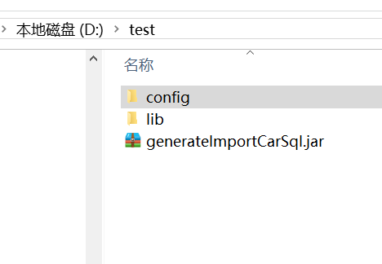
运行命令: java -jar generateImportCarSql.jar
注意：本项目是spring普通项目，非spring web项目，配置文件由spring加载，spring配置文件路径采用classpath写法，下面展示各种spring路径配置实例：
1.java代码启动spring项目路径写法
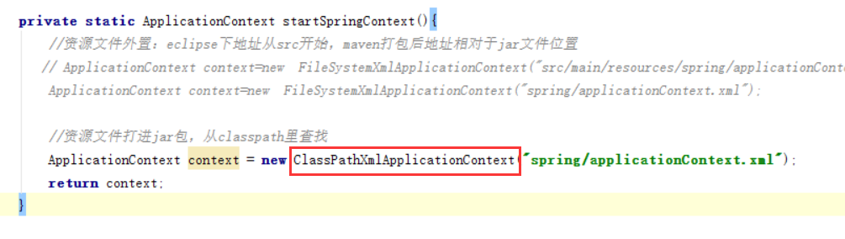
2.spring配置文件引用另一个spring配置文件
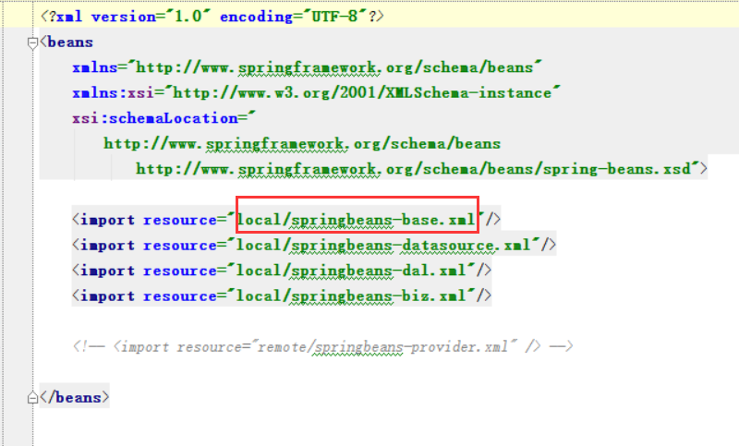
3.spring配置文件中placeHolder路径填写
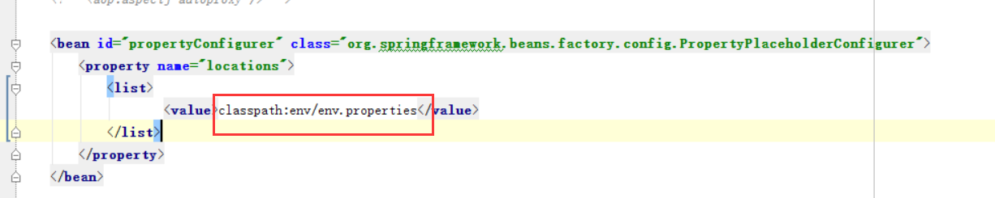
4.spring集成mybatis时mybatis配置文件路径填写
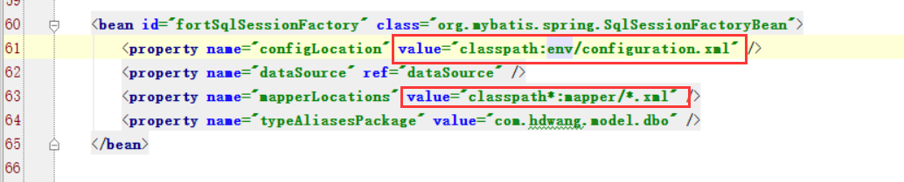
由于以上各种路径的配置均采用相对于classpath路径的写法。故在项目打包后和项目运行时均可以运行，关键在于classpath路径的设定。
附上jar包清单文件的内容，注意class-path的路径可以配置多个文件夹，多个jar包，之间用空格隔开，注意文件夹一定要在结尾加上/,例如：classpath为当前目录写 ./ 为当前目前下级config文件夹则为 ./config/ 或者config/
