1. **装MYSQL**

1).安装

[peter@localhost runEv]$ **rpm -ivh MySQL-client-community-5.1.58-1.rhel5.i386.rpm MySQL-server-community-5.1.58-1.rhel5.i386.rpm**

安装完毕后

2). [peter@localhost runEv]$ **ls /etc/rc.d/init.d/my\***

/etc/rc.d/init.d/mysql

3). [peter@localhost BpmServer]$ **netstat -anlp|grep mysql**

(Not all processes could be identified, non-owned process info

will not be shown, you would have to be root to see it all.)

unix 2 [ ACC ] STREAM LISTENING 80680 - /var/lib/mysql/mysql.sock

4).根据下面命令进入MYSQL管理台，并允许其它IP访问MYSQL

[peter@localhost BpmServer]$ **mysql -S /var/lib/mysql/mysql.sock -uroot -pwjj**

Welcome to the MySQL monitor. Commands end with ; or \g.

Your MySQL connection id is 218

Server version: 5.1.58-community-log MySQL Community Server (GPL)

Copyright (c) 2000, 2010, Oracle and/or its affiliates. All rights reserved.

This software comes with ABSOLUTELY NO WARRANTY. This is free software,

and you are welcome to modify and redistribute it under the GPL v2 license

Type 'help;' or '\h' for help. Type '\c' to clear the current input statement.

mysql>**grant all privileges on *.* to root@'%' identified by ‘wjj’;**

**mysql> flush privileges;**

3).修改mysql字符集，默认的是latin,将其修改为utf8

先将**[peter@localhost mysql]$ cp -a /usr/share/mysql/my-large.cnf /etc/my.cnf**

**并在my.cnf里面增加下面三行数据**

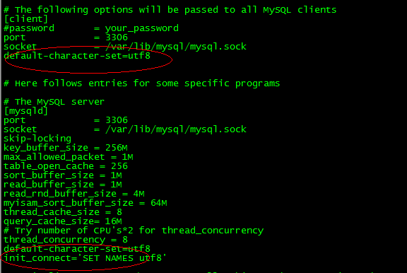

4).执行下面命令

#**service mysql restart**

**2.安装jdk**

1). [peter@localhost runEv]$ **sudo chmod u+x jdk-6u25-linux-i586.bin**

2). [peter@localhost runEv]$ **./ jdk-6u25-linux-i586.bin**

3).设置环境变量[peter@localhost ~]$ **vim .bash_profile**

JAVA_HOME=/home/peter/runEv/jdk1.6.0_25

CLASSPATH=$JAVA_HOME/lib/dt.jar:$JAVA_HOME/lib/tools.jar

PATH=$PATH:$JAVA_HOME/bin

export JAVA_HOME CLASSPATH

export PATH

1. **安装tomcat**

将tomcat6 copy进目录，可以修改其端口号

/home/peter/runEv/tomcat-6.0.33/conf/ server.xml 中修改

1. **进bpmserver拖进服务器，并写一个run.sh脚本**

[peter@localhost BpmServer]$ **cat run.sh**

#!/bin/bash

BPM_HOME=/home/peter/runEv/BpmServer

classpath=$BPM_HOME/humantasksServer-1.0-SNAPSHOT.jar

#java com.beyondsoft.humantask.server.StartHumanTaskServer

$JAVA_HOME/bin/java -jar $classpath

启动的时候[peter@localhost runEv]$ nohup sh run.sh *