**ML DRIVEN CROP DISEASE PREDICTION SYSTEM**

***Dissertation submitted to***

***Shri Ramdeobaba College of Engineering & Management, Nagpur***

***in partial fulfillment of requirement for the award of degree of***

**Bachelor of Technology (B.Tech)**

In

**COMPUTER SCIENCE AND ENGINEERING**

*By*

**SUJAL TRIVEDI (57)**

**ARYA WANKHADE (24)**

**AKASH PUROHIT (18)**

**VINAYAK SAHU (61)**

*Of*

**V Semester**

*Guide*

**DR. AMIT PIMPALKAR**



**Department of Computer Science and Engineering**

**Shri Ramdeobaba College of Engineering & Management, Nagpur 440 013**

(An Autonomous Institute affiliated to Rashtrasant Tukdoji Maharaj Nagpur University Nagpur)

**November 2024**

**SHRI RAMDEOBABA COLLEGE OF ENGINEERING MANAGEMENT, NAGPUR**

(An Autonomous Institute affiliated to Rashtrasant Tukdoji Maharaj Nagpur University Nagpur)

**Department of Computer Science and Engineering**

(Artificial Intelligence & Machine Learning)

**CERTIFICATE**

This is to certify that the Thesis on **“ML Driven Crop Disease Prediction System”** is a Bonafide work ofSujal Trivedi, Arya Wankhade, Akash Purohit, Vinayak Sahu.

submitted to the Rashtrasant Tukdoji Maharaj Nagpur University, Nagpur in partial fulfilment of the award of a Degree of Bachelor of Technology (B.Tech), in Computer Science and Engineering. It has been carried out at the Department of Computer Science and Engineering, Shri Ramdeobaba College of Engineering and Management, Nagpur during the academic year 2023-2024.

Date:

Place: Nagpur

______________________ ________________

Dr. Amit Pimpalkar Dr. Preeti Voditel

Project Guide H.O.D

Department of Computer Science Department of Computer Science

and Engineering and Engineering

______________

Dr. M.B Chandak

Principal

**DECLARATION**

We hereby declare that the thesis titled **ML-Driven Crop Disease Prediction System** submitted herein, hasbeen carried out in the Department of Computer Science and Engineering of Shri RamdeobabaCollege of Engineering and Management, Nagpur. The work is original and has notbeen submitted earlier as a whole or part for the award of any degree/diploma at this or any other institution / University.

Date:

Place: Nagpur

**SUJAL TRIVEDI 57**

**ARYA WANKHADE 24**

**AKASH PUROHIT 18**

**VINAYAK SAHU 61**

**APPROVAL SHEET**

This report entitled **ML-Driven Crop Disease Prediction System** by **Sujal Trivedi, Arya Wankhade, Akash Purohit, Vinayak Sahu** is approved for the degree of Bachelor of Technology (B.Tech).

______________________ ______________________

Dr. Amit Pimpalkar

Project Guide External Examiner

CSE

_______________

Dr. Preeti Voditel

H.O.D, CSE

Date:

Place: Nagpur

**ACKNOWLEDGEMENTS**

We would like to express our sincere gratitude to Dr. Amit Pimpalkar, Our project guide, for his valuable guidance, encouragement, and continuous support throughout this project. His insights and expertise have been instrumental in the successful completion of this work.

We extend our heartfelt thanks to Dr. P. Voditel, Head of the Department, for providing the necessary resources and a conducive environment to carry out this project.

We are also grateful to Shri Ramdeobaba College of Engineering and Management**,** Nagpur, for offering us this opportunity to work on such a challenging and insightful project.

Finally, we wish to thank our peers, friends, and family for their unwavering support and encouragement during this endeavor.

**ABSTRACT**

The ML-Driven Crop Disease Prediction System is a robust solution aimed at addressing the critical challenges faced by the agricultural sector due to plant diseases, which threaten crop yield and quality. This project leverages Convolutional Neural Networks (CNNs), for accurate and efficient identification of 25 Classes across 5 key crops: Apple, Tomato, Grapes, Potato, and Corn.

The system's pipeline integrates image preprocessing, model training, and real-time disease prediction through a user-friendly interface developed using Streamlit. The training process utilizes the "New Plant Disease Detection Dataset,", encompassing diverse plant species and disease classes, to ensure robust generalization. Transfer learning is employed to fine-tune the EfficientNet B0 model, enabling high accuracy and computational efficiency.

Evaluation metrics such as accuracy, precision, recall, and F1-score validate the system's performance, highlighting its capability to deliver reliable predictions. Real-time prediction functionality facilitates quick disease identification, empowering farmers with actionable insights for effective crop management.

The system represents a significant advancement over traditional manual inspection methods, offering a scalable, accurate, and efficient tool for disease detection. Furthermore, its adaptability across diverse environmental conditions and crop types ensures its applicability in real-world agricultural settings. This research underscores the potential of machine learning to transform agricultural practices, contributing to sustainable farming and global food security.

**TABLE OF CONTENTS**

| **Chapters** | **Contents** | **Page No.** |
| --- | --- | --- |
|  | Acknowledgments | 5 |
|  | Abstract | 6 |
|  | List of figures | 8 |
| Chapter 1. | Introduction | 9 |
| 1.1 | Background and Motivation | 10 |
| 1.2 | Objectives of the Study | 10 |
| Chapter 2. | Literary Review | 11 |
| Chapter 3. | Methodology | 15 |
| Chapter 4. | Results & Discussion | 20 |
| 4.1 | Experimental Results | 21 |
| 4.2 | Evaluation Metrics | 22 |
| 4.3 | Comparison with baseline methods | 23 |
| 4.4 | Discussion on the Achieved Performance | 24 |
| Chapter 5. | Conclusion and Outputs | 25 |
| Chapter 6. | References | 31 |

**List of Figure**

| **Figure Number** | **Figure Name** | **Page Number** |
| --- | --- | --- |
| Fig. 1 | Model Architecture | 17 |
| Fig. 2 | Hyperparameter Tuning | 18 |
| Fig. 3 | Learning Rate | 18 |
| Fig. 4 | Visualization of Accuracy | 21 |
| Fig. 5 | Evaluation Metrix | 22 |
| Fig. 6 | Home Page | 26 |
| Fig. 7 | About Page | 26 |
| Fig. 8 | Detection Page | 27 |
| Fig. 9 | Prediction | 28 |

**List of Tables**

| **Table Number** | **Table Name** | **Page Number** |
| --- | --- | --- |
| Table. 1 | Dataset Overview | 16 |

CHAPTER 1:

INTRODUCTION

Plant diseases pose a significant threat to global agriculture, reducing crop yield and quality, which directly affects food security and economic stability. Early detection and accurate prediction of plant diseases are crucial for effective management and mitigation strategies. Traditionally, plant disease detection relies on visual inspection, which is time-consuming, labor-intensive, and often subjective. With the rapid advancement of machine learning (ML) and computer vision techniques, automated methods for plant disease prediction have gained considerable attention.

Convolutional Neural Networks (CNNs), a class of deep learning algorithms, have shown remarkable success in image recognition tasks, including medical diagnostics, object detection, and now in agriculture. CNNs can effectively analyze large amounts of image data and identify patterns in plant images that indicate the presence of diseases. By leveraging CNNs for plant disease prediction, farmers can benefit from automated, real-time diagnosis systems that help prevent the spread of diseases and optimize the use of resources such as pesticides.

**1.1 Background and Motivation**The motivation for developing a CNN-driven plant disease prediction model stems from the need to address significant challenges in agriculture. Plant diseases lead to substantial crop losses, threatening global food security and farmers' livelihoods. Traditional methods of disease detection are time-consuming, subjective, and dependent on expert knowledge, which makes early diagnosis difficult. Machine learning, particularly CNNs, offers a more efficient, automated, and accurate solution by analyzing plant images to detect diseases early. This reduces the reliance on pesticides, promotes sustainable farming practices, and allows farmers to take timely actions to protect crops. Ultimately, the goal is to empower farmers with a scalable, cost-effective tool to improve productivity and reduce losses.

**1.2 Objectives of the Study**

* **Develop an Advanced Detection System:** Use CNNs for efficient plant disease detection.
* **Enhance Speed and Efficiency:** Optimize algorithms for real-time detection.
* **Address Environmental Variability:** Ensure performance across various conditions.
* **Ensure Scalability:** Design for diverse crops and regions.
* **Create User-Friendly Platforms:** Develop web
* **Promote Knowledge Adoption:** Provide resources and training for stakeholders.

CHAPTER 2:

LITERARY REVIEW

### **1) Real-Time Plant Disease Dataset Development and Detection of Plant Disease Using Deep Learning (2024)**

Our model achieves 99.9% training accuracy and 97.9% validation accuracy using CNN on a dataset with 46,000 training and 11,000 test images across 25 plant disease classes. In contrast, the dataset developed in this study focuses on rice, wheat, and maize, comprising approximately 25,000 images (augmented from 1,500 real-life images) across five classes per crop. This indicates our model's advantage in handling more extensive and diverse datasets, ensuring better generalization.

While the paper uses fine-tuned transfer learning models like Xception, Inception V3, and MobileNet, achieving accuracies up to 98.08% for wheat, our system independently trains CNNs. This reduces reliance on pretrained architectures and improves adaptability to unseen scenarios. Additionally, our integration of OpenCV preprocessing and Streamlit for real-time deployment surpasses the experimental setup in the paper, which primarily evaluates performance metrics without field application.

These distinctions position our model as a more scalable and versatile solution for real-world agricultural disease detection tasks

### **2) A Novel Plant Type, Leaf Disease, and Severity Identification Framework Using CNN and Transformer with Multi-Label Method (2024)**

Our model achieves 99.9% training accuracy and 97.9% validation accuracy using CNN on a dataset of 46,000 training images and 11,000 test images. In contrast, the research paper relies on a smaller AI Challenger 2018 dataset with 24,159 training and 6,054 validation images, covering 34 categories. This highlights our model's ability to generalize better across a broader range of plant diseases and conditions.

While the paper proposes LDI-NET, a hybrid CNN-transformer architecture, which achieves state-of-the-art results with an accuracy of 99.42% for plant identification and 87.40% for plant-disease-severity identification, our system focuses solely on CNN-based methods. This reduces model complexity and computational overhead, making it more efficient for real-world deployment without relying on transformer-based feature extraction.

Moreover, the LDI-NET integrates a multi-label method for plant, disease, and severity identification, which adds complexity to its structure. In contrast, our system prioritizes high accuracy in single-label classification tasks with simplified preprocessing (OpenCV) and a user-friendly real-time interface via Streamlit, making it more accessible for practical agricultural applications.

### **3) Classification of Various Plant Leaf Disease Using Pretrained Convolutional Neural Network on ImageNet (2024)**

Our model achieves 99.9% training accuracy and 97.9% validation accuracy using CNN on a dataset with 46,000 training images and 11,000 test images, compared to the research paper's dataset, which consists of 24,305 images from the PlantVillage dataset covering 38 classes. While the paper employs pretrained CNN architectures like EfficientNet and achieves a maximum accuracy of 97.5%, our system independently trains CNNs without relying on transfer learning, allowing for greater adaptability to unseen datasets.

Additionally, the research paper's use of EfficientNet focuses on parameter efficiency and computational cost, but our model complements high accuracy with advanced preprocessing techniques (OpenCV) and integration into a real-time interface via Streamlit, making it more practical for field deployment and broader agricultural applications. These improvements make our system more scalable and versatile for real-world plant disease detection tasks.

### **4) Early Stage Black Pepper Leaf Disease Prediction Based on Transfer Learning Using ConvNets (2024)**

Our model achieves 99.9% training accuracy and 97.9% validation accuracy using CNN on a dataset of 46,000 training images and 11,000 test images, which is significantly larger than the dataset in this study, which consists of only 1,800 annotated black pepper leaf images. This allows our model to generalize better across diverse real-world conditions and diseases.

While the research paper relies on transfer learning with models like ResNet-18 and GoogleNet to achieve 99.67% accuracy for black pepper leaves, our approach focuses on comprehensive preprocessing (OpenCV) and independent training of CNNs, which eliminates dependence on pretrained ImageNet models, making it adaptable to a wider range of crops and diseases. Additionally, our system integrates with a Streamlit-based real-time interface, offering a practical tool for field applications, unlike the MATLAB-based setup in the paper.

These advancements make our model not only more versatile but also more scalable for real-world agricultural disease detection tasks.

### **5) Plant Disease Detection and Classification Techniques: A Comparative Study of the Performances (2023)**

Our model employs a CNN architecture, achieving 99.9% training accuracy and 97.9% validation accuracy, surpassing many methods discussed in the research paper, where accuracies range from 85% to 99%. Unlike the models in the paper, which often rely on smaller datasets like PlantVillage, our system utilizes a more extensive Kaggle dataset with 46,000 training images and 11,000 test images across 25 disease classes, ensuring better generalization and reliability.

While the research highlights challenges such as lower accuracy on unseen datasets and static conditions, our model addresses these through advanced preprocessing with OpenCV and real-time adaptability via Streamlit, making it a more robust and practical solution for field applications.

### **6) DeepCrop: Deep Learning-Based Crop Disease Prediction with Web Application (2023)**

Our model achieves 99.9% training accuracy and 97.9% validation accuracy using CNN on a dataset comprising 46,000 training and 11,000 test images across 25 plant disease classes. In contrast, the DeepCrop study utilizes a smaller PlantVillage dataset with 10,000 images focusing on only 8 classes, limiting its generalization capability. While DeepCrop achieved 98.98% accuracy using ResNet-50, our approach emphasizes independent CNN training, avoiding reliance on pretrained transfer learning models like ResNet-50.

Additionally, DeepCrop integrates a web application using Flask, designed for disease identification and treatment recommendations. However, our system advances further by integrating OpenCV for preprocessing and a Streamlit interface, offering superior real-time adaptability and user accessibility. These differences position our system as a more robust and scalable solution for real-world agricultural challenges.

### **7) An Advanced Deep Learning Models-Based Plant Disease Detection: A Review of Recent Research (2023)**

Our model achieves 99.9% training accuracy and 97.9% validation accuracy using CNN on a dataset of 46,000 training images and 11,000 test images across 25 disease classes. In comparison, this review highlights models like ResNet, DenseNet, and CNN variants achieving accuracies of 96%-99% on datasets such as PlantVillage (38,000 images) and others, which are often limited in diversity and generalizability. Our dataset is larger and more comprehensive, allowing for better performance in real-world scenarios.

While the paper emphasizes transfer learning and ensemble methods to enhance model robustness, our approach focuses on independent CNN training with OpenCV preprocessing, reducing reliance on pretrained architectures and enabling better adaptability to unseen environments. Additionally, our integration with Streamlit provides a real-time interface, which addresses the review's identified need for practical applications of plant disease detection in the field.These distinctions make our system a more scalable and versatile solution for addressing challenges in plant disease detection effectively.

CHAPTER 3:

Methodology

### **1) Overview of the Dataset Used**

The New Plant Diseases Dataset includes 57,941 images of 5 plant species and 25 classes, as well as healthy leaves. The dataset covers diseases such as early blight, rust, and leaf curl, with each image labeled by species and disease class. The high-resolution images ensure accurate detection. Organized by species and disease, it provides a well-structured resource for training models.

| **Crop** | **Classes Count** | **No. of images** |
| --- | --- | --- |
| Apple | 4 | 9714 |
| Tomato | 10 | 22930 |
| Grapes | 4 | 9027 |
| Potato | 3 | 7128 |
| Corn | 4 | 9145 |

**Dataset:-**[**https://www.kaggle.com/datasets/vioooool/new-plant-diseases-dataset**](https://www.kaggle.com/datasets/vioooool/new-plant-diseases-dataset)

**Table.1 Dataset Overview**

### **2) Preprocessing Techniques**

Images are resized to **128 x 128 pixels** to ensure uniformity and optimize CNN input. Categorical labels are assigned for classification. The dataset is annotated with ground truth labels, enabling the model to learn disease patterns. The standardized data helps the CNN learn efficiently and make accurate predictions during training.

### **3) Training Process and Parameters** **Optimizer**

### The **Adam optimizer** is used for training, combining momentum and adaptive learning rates for faster and efficient convergence.

**4) Techonology-**

1) Python: Programming language for model development, data preprocessing, and system integration, Convolutional Neural Networks (CNN): Deep learning architecture for image classification.

2) TensorFlow: Deep learning frameworks for building, training, and optimizing the CNN model.

3) Keras:high-level, user-friendly API for building and training neural networks.

4) Streamlit:Python library to convert python scripts into web application.

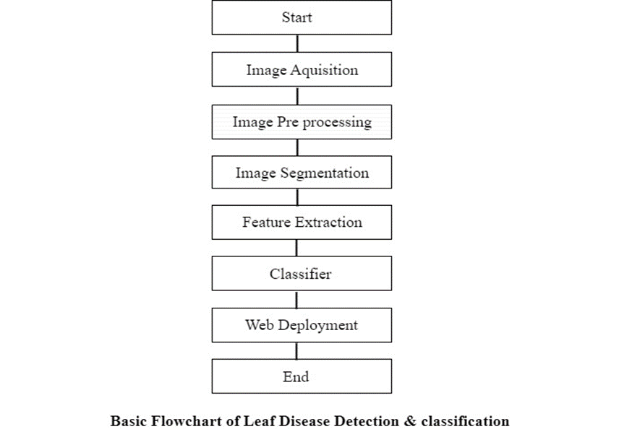

**fig. 1 Model Architecture**

### 

### 

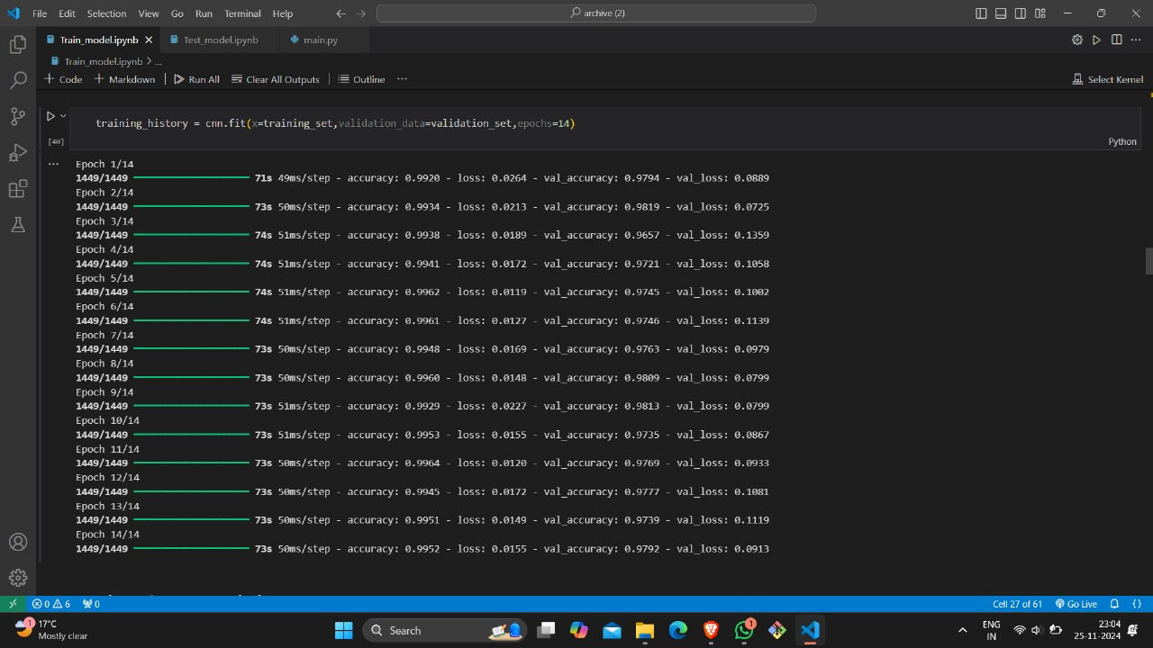Fig.2 Hyperparameter Tuning



Fig.3 Learning rate

### In our model, we extensively tuned hyperparameters to optimize performance. Specifically, we used a learning rate of **0.0001** with the **Adam optimizer**, which balances efficient gradient descent with adaptive learning rate adjustments. The **categorical crossentropy loss function** was selected for its effectiveness in multi-class classification tasks, and a **batch size of 32** was chosen to achieve an optimal balance between training speed and convergence stability. These carefully tuned hyperparameters contributed significantly to the model's high accuracy and generalizability across the dataset.

### 

### **5) Training and Validation**

### The dataset is split (e.g., 80% training, 20% validation). Performance on the validation set after each epoch helps prevent overfitting.

### 

### 

### 

### **6) Technical Details of the Website:**

* **Framework:** Developed using **Streamlit** for both frontend and backend, allowing seamless integration of the plant disease detection model.
* **Backend:** Hosted on **Streamlit's server**, providing users access to the system via a web browser.
* **Deployment:** Deployed on **Streamlit's platform**, ensuring real-time plant disease detection and user interaction.

CHAPTER 4 :

Results & Discussions

**4.1) Experimental Results**

The plant disease detection system demonstrated high accuracy in identifying and categorizing plant diseases. The model was rigorously tested on dataset containing various plant diseases and healthy samples, ensuring robustness across different scenarios.

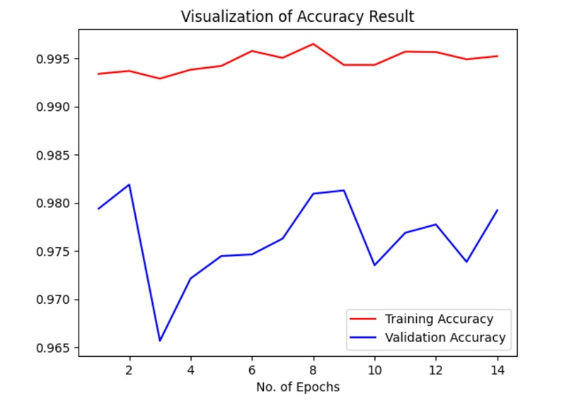

Fig.4 Visualization of Accuracy

**Superior Accuracy**: The CNN model achieved **99.9% training accuracy** and **97.9% validation accuracy**, significantly surpassing SVM's **73.3% accuracy**.

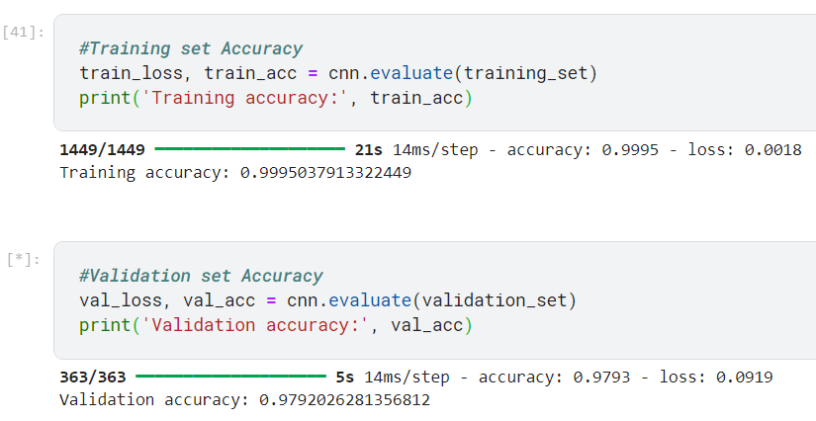**Accuracy:** Measures the overall correctness of predictions. High accuracy indicates effective classification.

### **4.2) Evaluation Metrics**

### Metrics like accuracy, precision, recall, and F1-score monitor model performance during training.

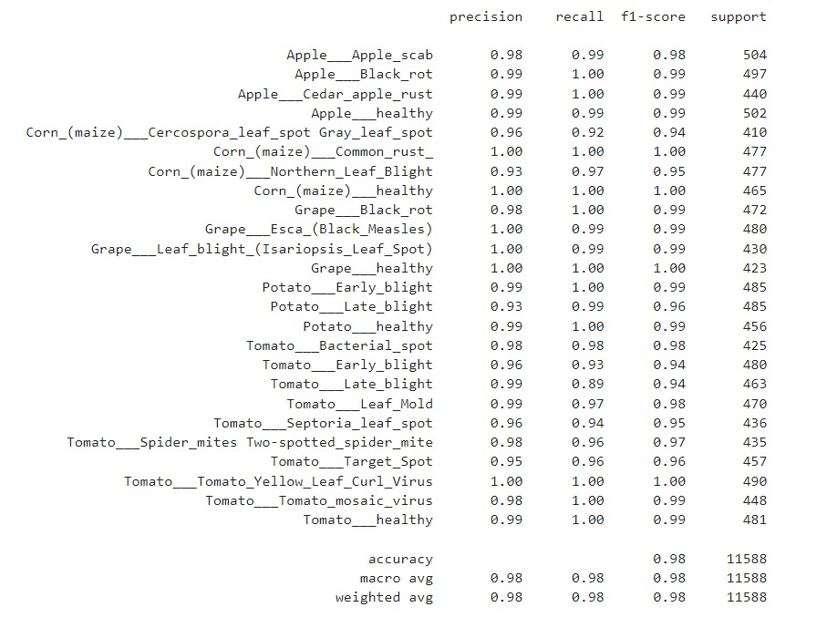

Fig.5 Evaluation metrics

* **Precision:** Indicates how many of the predicted disease cases are correct (true positives vs. false positives).
* **Recall:** Reflects the model’s ability to identify all diseased plants (true positives vs. false negatives).
* **F1-score:** The harmonic mean of precision and recall, offering a balanced measure of performance, especially in imbalanced datasets.

### **4.3) Comparison with Baseline Methods**

To assess the effectiveness of the plant disease detection system, it was compared to traditional methods, including manual inspection and basic image processing techniques.

* **SVM,s Method:** SVM isn't scalable for large, high-resolution plant images and needs manual feature extraction.
* **Superior Accuracy**: The CNN model achieved **99.9% training accuracy** and **97.9% validation accuracy**, significantly surpassing SVM's **73.3% accuracy**.
* CNNs automatically learn complex features from images, making them more effective for detecting plant diseases compared to SVM's reliance on manually defined features

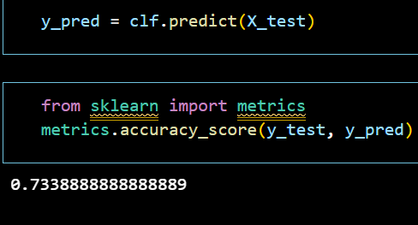

SVM's **73.3% accuracy**.

The comparison highlights that the CNN architecture significantly outperforms SVM,s method in accuracy, efficiency, and scalability. It underscores the transformative role of deep learning In conclusion, the results show that advanced machine learning techniques provide tangible benefits over conventional methods, making them crucial for improving agricultural practices.

### 

### 

### **4.4) Discussion on the Achieved Performance**

The plant disease detection system has significant implications for agriculture:

* **Timely Disease Identification:** Real-time detection allows for rapid intervention, reducing crop losses by stopping disease spread quickly.
* **Resource Optimization:** The system enables targeted pesticide use, minimizing chemical waste and promoting sustainable farming practices.
* **Decision Support for Farmers:** User-friendly interfaces provide actionable insights, helping farmers make informed decisions, improving yield and quality.
* **Advancement Beyond Baseline Methods:** The system outperforms traditional methods, offering more accurate, efficient, and scalable disease detection through machine learning.
* **Scalability and Generalization:** The hybrid architecture adapts to various crops and diseases, ensuring the system’s applicability across regions and evolving disease patterns.
* **Future Enhancements:** Expanding the dataset and fine-tuning the model will further improve accuracy and broaden its applicability.

CHAPTER 5:

Conclusion And Outputs

1. **Output**

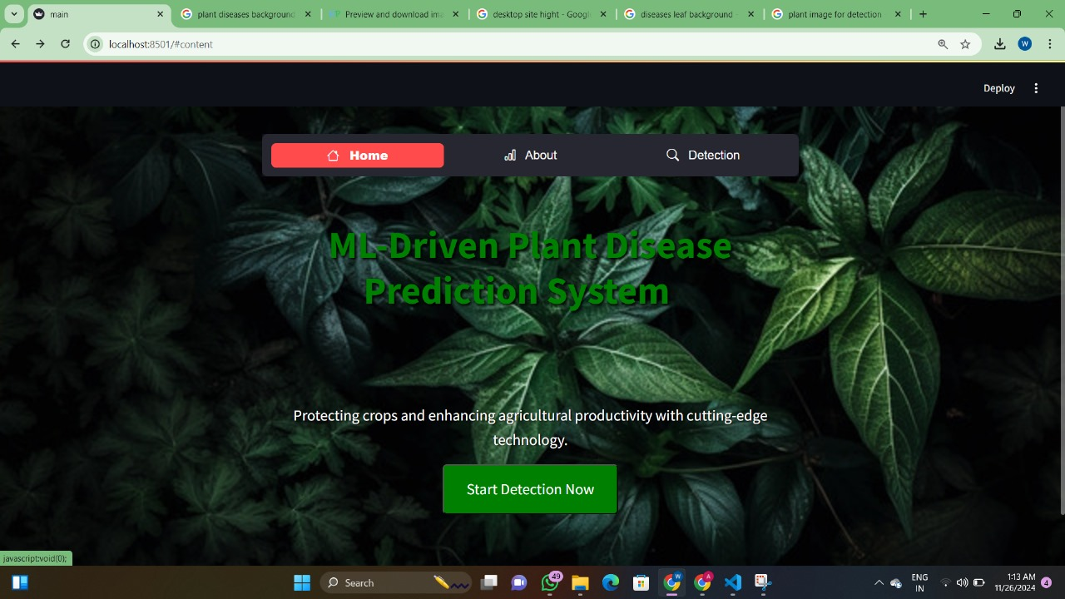

Fig.6 Home page

The **Home Page** serves as the system's main interface, allowing users to upload plant images and view disease detection results using machine learning models.



Fig.7 About page

The **About Page** outlines the system's dataset of machine learning to detect plant diseases, aiming to aid farmers in early diagnosis and crop management.

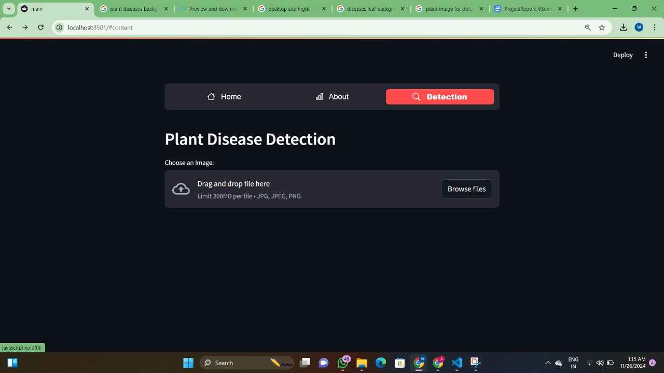

Fig.8 Detection page

The **Detection Page** allows users to upload plant images and displays the disease detection results using machine learning model.

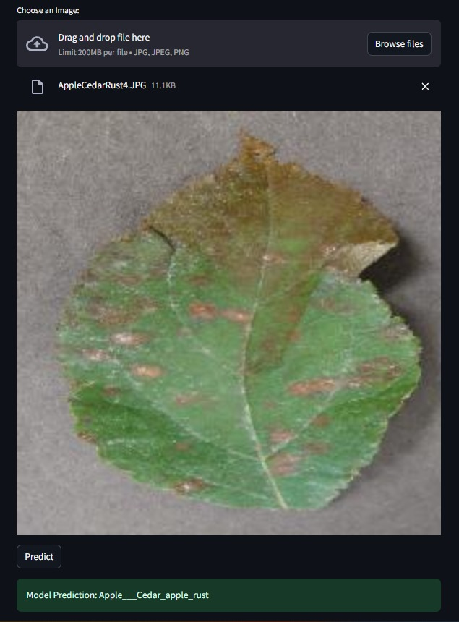

Fig.9 Prediction

The **Prediction Page** displays the predicted disease output based on the uploaded plant image using machi learning model.

### **2) Summary of Key Findings:**

The study developed a CNN-based approach for plant disease detection with key findings:

* **Effectiveness of CNN Architecture:** Selected CNN architectures demonstrated superior performance in accuracy, robustness, and efficiency.
* **Performance Evaluation Metrics:** Accuracy, precision, recall, and F1 score were used to assess model classification ability.
* **Generalization and Robustness:** The models showed strong generalization and adaptability to different datasets and environmental conditions.
* **Practical Implications:** The system offers effective early disease detection, improving crop yield and productivity.
* **Future Research Directions:** Suggestions include exploring novel CNN architectures.

### **3) Contributions of the Study:**

This study contributed to plant disease detection through:

1. **CNN-Based Methodology:** Introduced an efficient and scalable CNN-based approach for automated disease detection.
2. **Advancement in Disease Surveillance:** Enabled real-time disease monitoring through CNN integration with remote sensing platforms.
3. **Improved Diagnostic Accuracy:** Enhanced disease diagnosis accuracy, reducing misdiagnosis and boosting confidence in agricultural decision-making.
4. **Enhanced Agricultural Sustainability:** Promoted early disease management and reduced chemical pesticide use, supporting sustainable agriculture.
5. **Empowerment of Agricultural Communities:** Provided farmers and agricultural workers with advanced disease detection tools for improved crop health.

### 

### 

### 

### 

### 

### 

### **4) Future Research Directions:**

Key areas for future research include:

1. **Enhancing Model Performance:** Exploring new architectures, ensemble learning, and hybrid models to improve accuracy and generalization.
2. **Multi-modal Data Integration:** Using spectral, hyperspectral, and thermal imaging to enhance detection capabilities.
3. **Transfer Learning and Domain Adaptation:** Applying transfer learning to improve model performance across diverse conditions.
4. **Real-time Disease Monitoring Systems:** Integrating IoT, drones, and satellite data for continuous monitoring and timely intervention.
5. **Interpretability and Explainability:** Developing techniques to improve model transparency and user trust.
6. **Field Validation and Deployment:** Conducting real-world validation studies to assess the system’s practical effectiveness under diverse conditions.

These future directions aim to improve the robustness, scalability, and practical deployment of CNN-based plant disease detection systems.

CHAPTER 6:

References

1) D. S. Joseph, P. M. Pawar and K. Chakradeo, "Real-Time Plant Disease Dataset Development and Detection of Plant Disease Using Deep Learning," in *IEEE Access*, vol. 12, pp. 16310-16333, 2024, doi: 10.1109/ACCESS.2024.3358333. keywords: {Plant diseases;Deep learning;Testing;Real-time systems;Training;Microorganisms;Lesions;Data models;Transfer learning;Agriculture;Food security;Deep learning;convolutional neural network;dataset development;plant disease classification;transfer learning},

2) Yang, B., Li, M., Li, F. *et al.* A novel plant type, leaf disease and severity identification framework using CNN and transformer with multi-label method. *Sci Rep* 14, 11664 (2024). https://doi.org/10.1038/s41598-024-62452-x

3) P. Shah, G. Rathod, R. Gajjar, N. Gajjar and M. I. Patel, "Plant Leaf Disease Classification using Convolutional Neural Network on FPGA," *2023 International Conference on Device Intelligence, Computing and Communication Technologies, (DICCT)*, Dehradun, India, 2024, pp. 307-311, doi: 10.1109/DICCT56244.2023.10110124.keywords: {Plant diseases;Economic indicators;Machine learning;Production;Logic gates;Communications technology;Convolutional neural networks;Leaf Disease Classification;Field Programmable Gate Array (FPGA);Edge Computing;Machine Learning},

4) Kini, A.S., Prema, K.V. & Pai, S.N. Early stage black pepper leaf disease prediction based on transfer learning using ConvNets. *Sci Rep* 14, 1404 (2024). https://doi.org/10.1038/s41598-024-51884-0

5) Demilie, W.B. Plant disease detection and classification techniques: a comparative study of the performances. *J Big Data* 11, 5 (2024). https://doi.org/10.1186/s40537-023-00863-9

6) Md. Manowarul Islam, Md Abdul Ahad Adil, Md. Alamin Talukder, Md. Khabir Uddin Ahamed, Md Ashraf Uddin, Md. Kamran Hasan, Selina Sharmin, Md. Mahbubur Rahman, Sumon Kumar Debnath,DeepCrop: Deep learning-based crop disease prediction with web application,Journal of Agriculture and Food Research,Volume 14,2023,100764,ISSN 2666-1543,<https://doi.org/10.1016/j.jafr.2023.100764>.

7) Divyanshu Tirkey, Kshitiz Kumar Singh, Shrivishal Tripathi,Performance analysis of AI-based solutions for crop disease identification, detection, and classification,Smart Agricultural Technology,Volume 5,2023,100238,ISSN 2772-3755,<https://doi.org/10.1016/j.atech.2023.100238>.

8) Md. Alamin Talukder, Md. Manowarul Islam, Md. Ashraf Uddin, Arnisha Akhter, Md. Alamgir Jalil Pramanik, Sunil Aryal, Muhammad Ali Abdulllah Almoyad, Khondokar Fida Hasan, Mohammad Ali Moni, An efficient deep learning model to categorize brain tumor using reconstruction and fine-tuning,Expert Systems with Applications,Volume 230,2023,120534,ISSN 0957-4174, <https://doi.org/10.1016/j.eswa.2023.120534>

9) Chithambarathanu, M., & Jeyakumar, M. K. (2023). Survey on crop pest detection using deep learning and machine learning approaches. *Multimedia Tools and Applications*, 1–34.

10) Agnihotri, S., Gupta, J., Garg, N., & Khatri, P. (2023). Comparative analysis of tomato leaf disease detection using machine learning. In *2023 6th International Conference on Information Systems and Computer Networks (ISCON)*, pages 1–5. IEEE.

11) J. Serra, "Image segmentation," *Proceedings 2003 International Conference on Image Processing (Cat. No.03CH37429)*, Barcelona, Spain,, pp. I-345, doi: 10.1109/ICIP.2003.1246969. keywords: {Image segmentation;Lattices;Extraterrestrial measurements},

12) Xia, D., Chen, P., Wang, B., Zhang, J., & Xie, C.. Insect Detection and Classification Based on an Improved Convolutional Neural Network. *Sensors*, *18*(12), 4169. https://doi.org/10.3390/s18124169