Vision Statement of the Department.
To be a preferred hub for nurturing computer engineering aspirants through innovative, ethical, value-based technical education, impactful research, and industry collaboration, to become successful professionals contributing for the betterment of society.
Mission Statement of the Department.
To nurture computer engineering professionals by offering Dynamic learning environment that encourages problem-solving using emerging technology, National Education Policy aligned evidence-based technical education, fostering ,innovation, research, and industry–institute collaboration & Holistic, ethical and sustainable development for lifelong success.

Session 2026-2027
Vision:Dream of where you want. | Mission: Means to achieve Vision
Program Educational Objectives of the program (PEO): (broad statements that describe the professional and career accomplishments)
PEO1 | Preparation | P: Preparation | Pep-CL abbreviation pronounce as Pep-si-lL easy to recall
PEO2 | Core Competence | E: Environment  (Learning Environment) | Pep-CL abbreviation pronounce as Pep-si-lL easy to recall
PEO3 | Breadth | P: Professionalism | Pep-CL abbreviation pronounce as Pep-si-lL easy to recall
PEO4 | Professionalism | C: Core Competence | Pep-CL abbreviation pronounce as Pep-si-lL easy to recall
PEO5 | Learning  Environment | L: Breadth (Learning in diverse areas) | Pep-CL abbreviation pronounce as Pep-si-lL easy to recall
Program Outcomes (PO): (statements that describe what a student should be able to do and know by the end of a program)
Keywords of POs:
Engineering knowledge,Problem analysis, Design/development of solutions,Conduct Investigations of Complex Problems, Engineering Tool Usage, The Engineer and The World,Ethics, Individual and Collaborative Team work,Communication, Project Management and Finance, Life-Long Learning
PSO Keywords: Cutting edge technologies, Research
“I am an engineer, and I know how to apply engineering knowledge to investigate, analyse and design solutions to complex problems using tools for entire world following all ethics in a collaborative way with proper management skills throughout my life.” to contribute to the development of cutting-edge technologies and Research.
Integrity: I will adhere to the Laboratory Code of Conduct and ethics in its entirety.

Name and Signature of Student and Date
(Signature and Date in Handwritten)
Vision Statement of the Department.
To be a preferred hub for nurturing computer engineering aspirants through innovative, ethical, value-based technical education, impactful research, and industry collaboration, to become successful professionals contributing for the betterment of society.
Mission Statement of the Department.
To nurture computer engineering professionals by offering Dynamic learning environment that encourages problem-solving using emerging technology, National Education Policy aligned evidence-based technical education, fostering ,innovation, research, and industry–institute collaboration & Holistic, ethical and sustainable development for lifelong success.
Session | 2024-25 (ODD) |  | Course Name | Web Technology Lab
Semester | 3 |  | Course Code | 23CT1301
Roll No | 41 |  | Name of Student | Akshad wankhede
Practical Number |  | 4A
Course Outcome |  | - Understand various internet technologies.  - Design the web pages using HTML and CSS.  - Implement the XML technology to store the data.  - Develop the interactive web pages using JavaScript.
Aim |  | To design an interactive user registration form using HTML and CSS, and implement client-side form validation using JavaScript conditional statements, loops, and regular expressions.
Problem Definition |  | Develop a client-side web interface containing input fields for Name, Email, Phone Number, and Password. Write a JavaScript script to intercept the submit event, evaluate each field against specified constraints (non-empty strings, character limits, standard email patterns, and a 10-digit mobile number format), display real-time inline error messages for invalid fields, and process inputs iteratively via loops upon successful validation.
Theory  (100 words) |  | JavaScript enables dynamic Document Object Model (DOM) manipulation and client-side validation, reducing unnecessary server requests and latency. Conditional statements (if, else if, else) form the core decision-making logic, testing constraints such as null inputs, string lengths, and syntax compliance.  Regular expressions (Regex) match input patterns against predefined character rules, such as verifying standard email syntax (/^[^\s@]+@[^\s@]+\.[^\s@]+$/) and exact 10-digit numeric mobile strings. Iteration constructs like for...of or forEach loops traverse collections of DOM nodes and input arrays efficiently, automating tasks like batch data extraction, error clearing, and state resets without redundant code.
Procedure and Execution  (100 Words) |  | Step for Implementation:  DOM Structure: Build semantic form elements in HTML with distinct id attributes and contextual <small class="error-msg"> elements beneath each field.  Styling Rules: Configure CSS styling for default inputs, error states (.error input with red outlines), and success feedback classes.  Event Interception: Use document.getElementById() to select form elements and attach an addEventListener("submit", ...) handler calling e.preventDefault().  Conditional Checking: Execute stepwise validation rules on trimmed values using if-else blocks and Regex methods (test()), assigning error text dynamically.  Iteration & State Update: If all checks pass, run a for...of loop over inputs to log clean values, display a success banner, and reset styles.
Code:HTML: <!DOCTYPE html>
<html lang="en">
<head>
<meta charset="UTF-8">
<meta name="viewport" content="width=device-width, initial-scale=1.0">
<title>User Ragistration Form</title>
<!-- link css file -->
<link rel="stylesheet" href="style.css">
</head>
<body>

<div class="container">
<h2>Create Account</h2>

<!-- success notifcation text -->
<div id="successMsg" class="sucess-alert"></div>

<form id="registrationForm">

<div class="form-group">
<label for="fullName">Full Name</label>
<input type="text" id="fullName" placeholder="Enter full name">
<small class="error-msg"></small>
</div>

<div class="form-group">
<label for="email">Email Address</label>
<input type="text" id="email" placeholder="example@mail.com">
<small class="error-msg"></small>
</div>

<div class="form-group">
<label for="phone">Phone Number</label>
<input type="text" id="phone" maxlength="10" placeholder="10 digit number">
<small class="error-msg"></small>
</div>

<div class="form-group">
<label for="password">Password</label>
<input type="password" id="password" placeholder="Min 6 characters">
<small class="error-msg"></small>
</div>

<button type="submit" id="subBtn">Submit</button>
<button type="reset" id="rstBtn">Reset</button>

</form>
</div>

<!-- javascript file linked at last -->
<script src="script.js"></script>
</body>
</html>
CSS: * {
box-sizing: border-box;
font-family: Arial, Helvetica, sans-serif;
}

body {
background-color: #eef2f5;
padding: 30px;
margin: 0;
}

/* center card */
.container {
background: #ffffff;
max-width: 380px;
margin: 0 auto;
padding: 22px;
border-radius: 8px;
border: 1px solid #d4d4d4;
box-shadow: 2px 4px 10px rgba(0,0,0,0.1);
}

h2 {
text-align: center;
margin-top: 0;
color: #222;
}

.form-group {
margin-bottom: 14px;
position: relative;
}

.form-group label {
font-size: 13px;
font-weight: bold;
display: block;
margin-bottom: 4px;
color: #444;
}

.form-group input {
width: 100%;
padding: 8px 10px;
border: 1px solid #bbb;
border-radius: 4px;
outline: none;
font-size: 14px;
}

/* error and sucess classes toggled by js */
.form-group.error input {
border-color: #e74c3c !important;
}

.form-group.success input {
border-color: #2ecc71 !important;
}

.form-group .error-msg {
color: #e74c3c;
font-size: 11px;
display: block;
margin-top: 3px;
min-height: 14px;
}

/* submit and reset button styling */
#subBtn {
background-color: #007bff;
color: white;
border: none;
padding: 9px 16px;
border-radius: 4px;
cursor: pointer;
font-weight: bold;
}

#subBtn:hover {
background-color: #0056b3;
}

#rstBtn {
background: #ccc;
border: none;
padding: 9px 12px;
border-radius: 4px;
cursor: pointer;
}

.sucess-alert {
display: none;
background-color: #d4edda;
color: #155724;
border: 1px solid #c3e6cb;
padding: 8px;
margin-bottom: 12px;
border-radius: 4px;
text-align: center;
font-size: 13px;
}
JAVASCRIPT: // getting all inputs and elements
const form = document.getElementById("registrationForm");
const fullName = document.getElementById("fullName");
const email = document.getElementById("email");
const phone = document.getElementById("phone");
const password = document.getElementById("password");
const successMsg = document.getElementById("successMsg");

// Helper function: Error dikhane ke liye
function setError(inputElement, message) {
const formGroup = inputElement.parentElement;
formGroup.className = "form-group error"; // adding error class
const errorElement = formGroup.querySelector(".error-msg");
errorElement.innerText = message;
}

// Helper function: Success mark karne ke liye
function setSuccess(inputElement) {
const formGroup = inputElement.parentElement;
formGroup.className = "form-group success"; // changing to success
const errorElement = formGroup.querySelector(".error-msg");
errorElement.innerText = "";
}

// form submit event
form.addEventListener("submit", function (e) {
e.preventDefault(); // submit reload rokne ke liye

var isValid = true; // flag variable

// 1. Name Validation (conditional statements + regex check)
const nameValue = fullName.value.trim();
const nameLetterRegex = /^[a-zA-Z\s]+$/;

if (nameValue === "" || nameValue == null) {
setError(fullName, "Full Name is required.");
isValid = false;
} else if (nameValue.length < 3) {
setError(fullName, "Name must be at least 3 characters long.");
isValid = false;
} else if (nameLetterRegex.test(nameValue) == false) {
setError(fullName, "Name can only contain alphabet letters.");
isValid = false;
} else {
setSuccess(fullName);
}

// 2. Email Validation using regular expression
const emailValue = email.value.trim();
const emailPattern = /^[^\s@]+@[^\s@]+\.[^\s@]+$/;

if (emailValue === "") {
setError(email, "Email address is required.");
isValid = false;
} else if (!emailPattern.test(emailValue)) {
setError(email, "Please enter a valid email address.");
isValid = false;
} else {
setSuccess(email);
}

// 3. Phone Validation (Regex check + Loop verification)
const phoneValue = phone.value.trim();
const phonePattern = /^[0-9]{10}$/;

if (phoneValue === "") {
setError(phone, "Phone number is required.");
isValid = false;
} else if (!phonePattern.test(phoneValue)) {
setError(phone, "Please enter a valid 10-digit mobile number.");
isValid = false;
} else {
// manual loop to double check every character is a digit
var onlyNums = true;
for (var i = 0; i < phoneValue.length; i++) {
var ch = phoneValue.charAt(i);
if (ch < '0' || ch > '9') {
onlyNums = false;
break;
}
}

if (onlyNums == false) {
setError(phone, "Phone must contain numbers only.");
isValid = false;
} else {
setSuccess(phone);
}
}

// 4. Password Validation (length check + uppercase search loop)
const passwordValue = password.value.trim();

if (passwordValue === "") {
setError(password, "Password is required.");
isValid = false;
} else if (passwordValue.length < 6) {
setError(password, "Password must be at least 6 characters.");
isValid = false;
} else {
// loop to verify at least one capital letter exists
var hasCapital = false;
for (var j = 0; j < passwordValue.length; j++) {
if (passwordValue[j] >= 'A' && passwordValue[j] <= 'Z') {
hasCapital = true;
break;
}
}

if (!hasCapital) {
setError(password, "Include at least one uppercase letter (A-Z).");
isValid = false;
} else {
setSuccess(password);
}
}

// 5. Final check and Loop demonstration
if (isValid == true) {
successMsg.innerText = "Registration successful!";
successMsg.style.display = "block";

// array loop to log entered values
const allInputs = [fullName, email, phone, password];
console.log("--- Form Data Submitted ---");
for (let k = 0; k < allInputs.length; k++) {
console.log(allInputs[k].id + ": " + allInputs[k].value);
}

// timeout reset
setTimeout(function () {
form.reset();

// loop to reset styles
for (const input of allInputs) {
input.parentElement.className = "form-group";
}
successMsg.style.display = "none";
}, 2500);

} else {
successMsg.style.display = "none";
}
});

Vision Statement of the Department.
To be a preferred hub for nurturing computer engineering aspirants through innovative, ethical, value-based technical education, impactful research, and industry collaboration, to become successful professionals contributing for the betterment of society.
Mission Statement of the Department.
To nurture computer engineering professionals by offering Dynamic learning environment that encourages problem-solving using emerging technology, National Education Policy aligned evidence-based technical education, fostering ,innovation, research, and industry–institute collaboration & Holistic, ethical and sustainable development for lifelong success.
 | Output: 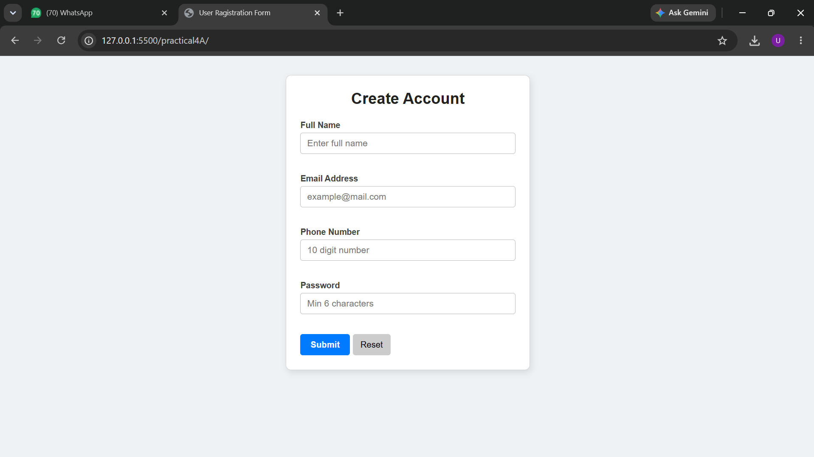
Output Analysis | Empty Submission: Submitting blank fields immediately highlights all input borders in red and renders corresponding messages (e.g., "Full Name is required."), preventing submission.  Malformed Input:  - Entering an email without an @ or domain yields "Please enter a valid email address."  - Supplying alphabets or fewer/more than 10 digits in the phone field triggers "Please enter a valid 10-digit mobile number."  - A password shorter than 6 characters renders "Password must be at least 6 characters."  Valid Submission: When all conditions evaluate to true, error banners vanish, border highlights turn green, a "Registration successful!" alert appears, and form values are parsed iteratively via a loop in the browser console before resetting.
Link of student Github profile where lab assignment has been uploaded | https://github.com/wankhedeakshad89-create/Web-Technology.git
Conclusion | Client-side form validation was successfully implemented using JavaScript. The experiment demonstrates how conditional logic effectively traps invalid user data before submission, how inline DOM manipulation provides clear visual feedback, and how loops simplify batch processing of input collections for cleaner, maintainable front-end code.
Plag Report (Similarity index < 12%)
Date | 21-09-2026

