Software Requirement Specification (SRS)

Project Name: Diagnosis of Cardiovascular Disease in Patients using Deep Learning

SRS is organized as follows:
- Project title
- Introduction
- Overall description(New project)
- External interface requirements
- System features
- Non functional requirements
- Acceptance criteria
- Deliverables

Revision History

Version | Date of Release | Pages Affected | Reasons for Change | Signature
1.0 |  | All | Initial release of project | SWAPNIL
  2023-06-15
1.1 |  | Appendix N  Page 21 and 22 | Added detailed system architecture | BHANU TEJA MANDLA
  2023-06-18
2.0 |  | All | Changes are made in data preprocessing steps for improving accuracy. | BHANU TEJA ,ANUP,SWAPNIL
  2023-06-24
2.1 |  | Page 6 | Version release with complete feature set | BHANU TEJA,SWAPNIL,ANUP
  2023-07-04

Table of Contents

1.0 Project Code 6
2.0 Title of the project 6
3.0 Introduction 6
3.1 Purpose 6
3.2 Document Conventions 6
3.3 Intended Audience and Reading Suggestions 6
3.4 Project/Product Scope 6
3.5 References 6
4.0 Overall Description 6
4.1 Project/Product Perspective 6
4.2 Project/Product Functions 7
4.3 User Classes and Characteristics 7
4.4 Operating Environment 7
4.4.1 Server 7
4.4.2 Client: 7
Browser based clients either in Microsoft Windows or Linux Environment. 7
Android based mobile client. 7
4.5 Design and Implementation Constraints 7
4.6 User Documentation 7
4.7 Assumptions and Dependencies 8
5.0 External Interface Requirements 8
5.1 User Interfaces 8
6.0 System Features 9
7.0 Other Nonfunctional Requirements 20
• Performance Requirements 20
• Safety Requirements 20
• Security Requirements 21
• Software Quality Attributes 21
7.1 Other Requirements 21
7.2 Applicable Standards 21
8.0 Acceptance criteria 22
9.0 Deliverables 22

- Title of the project
Diagnosis of Cardiovascular Disease in Patients using Deep Learning

- Introduction
  - Purpose
Recent advancements in healthcare, driven by the integration of technology, particularly in disease prediction and diagnosis, have revolutionized patient care. Cardiovascular diseases (CVDs) stand as a prominent cause of global morbidity and mortality. Early and precise detection of CVDs can markedly improve patient outcomes and mitigate healthcare expenditures. This project employs convolutional neural networks (CNNs) for analyzing electrocardiogram (ECG) images to predict the probability of cardiovascular diseases in patients. The goal is to facilitate proactive healthcare interventions and preventive strategies.
  - Document Conventions
- Structure: Numbered sections and subsections for clarity (e.g., 1.0 Title of the Project, 2.0 Introduction,etc).
- Formatting: Main headings in bold with numbered sections, subheadings in bold with decimals.
- Instructions: Step-by-step format for tasks, bullet points for related information.
- Visual Aids: Screenshots for visual guidance, diagrams for processes.
- Cross-References: Hyperlinks for navigation within the document, URLs for external resources.
- Terminology: Acronyms defined upon first use, technical terms explained in context.
- Contact: Support contact details provided for assistance.

  - Intended Audience and Reading Suggestions(BD team,BD head,ED, HoDs)
Business Development (BD) Team:
- Audience Description: The BD team includes members proficient in identifying healthcare technology opportunities.
- Reading Suggestions: Highlight the project's potential to enhance disease prediction accuracy, reduce healthcare costs, and expand market reach through advanced AI-driven diagnostic solutions.
Business Development (BD) Head:
- Audience Description: The BD head oversees strategic business growth initiatives within the healthcare sector.
- Reading Suggestions: Emphasize the project's strategic alignment with healthcare innovation goals, potential for market differentiation, and implications for establishing industry partnerships.
Executive Director (ED):
- Audience Description: The ED guides organizational strategy and operational excellence.
- Reading Suggestions: Focus on the project's potential to improve patient outcomes, reduce healthcare expenditures, and align with long-term organizational objectives in healthcare technology innovation.
Heads of Departments (HoDs):
- Audience Description: HoDs are responsible for departmental operations and resource allocation.
- Reading Suggestions: Detail technical feasibility, resource requirements for CNN implementation, integration with existing healthcare systems, and department-specific benefits in enhancing cardiovascular disease management and patient care.

  - Project/Product Scope(about the internal use ,deployment)

• Internal Use: Developed a deep learning system using CNNs and ECG data to predict cardiovascular disease likelihood for internal deployment within healthcare settings.
• Deployment: Successfully deployed the system, integrating it with existing healthcare environments to enhance clinical decision support and patient management capabilities.

  - References
    - François Chollet. "Deep Learning with Python." Manning Publications, 2018
    - Litjens, G., Kooi, T., Bejnordi, B. E., Setio, A. A. A., Ciompi, F., Ghafoorian, M., ... & Sánchez, C. I. (2017). A survey on deep learning in medical image analysis. Medical Image Analysis, 42, 60-88.
    - Weng, S. F., Reps, J., Kai, J., & Garibaldi, J. M. (2017). Can machine-learning improve cardiovascular risk prediction using routine clinical data? PLoS ONE, 12(4), e0174944.

- Overall Description
  - Project/Product Perspective
This project aims to utilize deep learning techniques to predict cardiovascular diseases (CVDs) to improve early detection, enhance patient outcomes, and reduce healthcare costs. The document serves as a detailed blueprint for developing this CVD prediction system, covering architecture, component design, data design, user interface design, and implementation guidelines to ensure it meets all specified requirements.

  - Product Functions
Functionalities of the project:

The cardiovascular disease prediction system includes:
1. Data Ingestion and Preprocessing: Collects and cleans patient data, integrates with EHR systems, handles missing values, normalizes data, and extracts features.
2. Predictive Model: Trains a deep learning model on patient data, continuously updates it, and provides real-time and batch predictions of disease risk.
3. User Interface: Offers dashboards for healthcare professionals for risk assessment and trend analysis, and a mobile app for patients with personalized risk scores, health recommendations, and notifications.
4. Data Management: Stores data securely, backs up regularly, controls access with RBAC, and maintains an audit trail.
5. System Administration: Manages user roles, monitors performance, logs errors, and ensures system reliability.
6. Reporting and Analytics: Generates performance reports, tracks usage analytics, and ensures regulatory compliance.

This system aims to improve patient outcomes and enhance preventive care through accurate and actionable insights.

  - Operating Environment
    - Server
Server OS: Linux (e.g., Ubuntu Server) or Windows Server
Language: Python (for deep learning frameworks such as TensorFlow or PyTorch)
Database: PostgreSQL or MySQL
Application Server: Flask or Django (for Python-based web applications)
Tool: Docker for containerization and deployment
    - Client: Client OS Typically Windows, macOS, or Linux distributions:

  - Design and Implementation Constraints
Operating Environment Constraints: Ensure compatibility with the selected server OS (e.g., Linux or Windows Server) and associated software dependencies (Python, TensorFlow/PyTorch, PostgreSQL/MySQL, Flask/Django).

Development Environment Constraints: Availability of skilled Python developers proficient in deep learning frameworks, database management, and web development.

Performance Requirements: Efficient utilization of computational resources for real-time or near-real-time prediction of cardiovascular disease likelihood based on ECG images.

Scalability: Design considerations for scaling the application to handle increasing user loads and data volumes, particularly in healthcare settings where demand for predictive analytics may vary.

  - User Documentation
User manual and on-line help document will be delivered along with the software. Installation instructions will be available in the Installation manual.

- External Interface Requirements

  - User Interfaces
The targeted browser Mozilla FireFox 12.0, Google chrome, MS Edge

  - Hardware Interfaces
The Proposed system configuration is as follows:

Sl. No. | ITEM | Server 1 | Server 2
01 | Processor | Quad core Processor (64 bit) | Quad core Processor (64 bit)
03 | No., of processor | One | One
04 | Memory | 8 GB expandable to 24 GB | 8 GB expandable to 24 GB
10 | HDD capacity | 1TB | 1TB
12 | Network | 2 Gigabit RJ45 | 2 Gigabit RJ45 connectors
13 | USB ports | Four | Four
17 | OS | Linux | Linux

  - Communications Interfaces:
4.3.1 Internal Communication
- Protocol: TCP/IP
- Description: Ensures consistent and reliable data transmission within the server infrastructure.
- Purpose: Supports optimal performance for CNN model training and inference.
4.3.2 External Communication
- Protocol: RESTful APIs
- Description: Facilitates interoperability with external systems such as electronic health records (EHR) and healthcare analytics platforms.
- Purpose: Enables seamless integration of cardiovascular disease predictions into clinical workflows.
4.3.3 Data Exchange Formats
- Format: JSON (JavaScript Object Notation)
- Description: Lightweight and structured format for efficient data interchange and processing.
- Purpose: Enhances compatibility across software components involved in the project.
4.3.4 Security Protocols
- Protocol: HTTPS (HTTP Secure)
- Description: Encrypts data transmitted over the network to ensure confidentiality and integrity.
- Purpose: Ensures compliance with healthcare data privacy regulations and protects sensitive patient information.

- System Features
5.1 Features: The key features implemented in our project are:-
• ECG Data Preprocessing
- Description: Preprocess raw ECG data to extract relevant features.
- Flow Diagram: Illustrates the sequence of steps involved in preprocessing, including signal filtering, normalization, and feature extraction.
• CNN Model Training
- Description: Train convolutional neural network models using preprocessed ECG data.
- Flow Diagram: Shows the process flow for selecting model architecture, data augmentation techniques, and the training process itself.
• Predictive Analysis
- Description: Utilize trained CNN models to predict the likelihood of cardiovascular diseases.
- Use Case Diagram: Displays interactions between system components, illustrating how input ECG data leads to prediction outputs.
• Integration with Healthcare Systems
- Description: Integrate prediction results with electronic health records (EHR) and healthcare analytics platforms.
- Use Case Diagram: Visualizes data flow and integration points between the prediction system and external healthcare systems.
• User Interface for Healthcare Professionals
- Description: Develop a user-friendly interface for healthcare professionals to interact with prediction results.
- UI Design Mockups: Provides mockups of user interface screens for viewing predictions, patient histories, and diagnostic insights.
• Data Privacy and Security Measures
- Description: Implement measures to secure patient data during transmission and storage.
- Security Architecture Diagram: Illustrates encryption protocols (e.g., HTTPS), access control mechanisms, and data privacy safeguards.
• Performance Optimization
- Description: Optimize system performance for efficient real-time prediction and scalability.
- Performance Metrics: Defines benchmarks and metrics for assessing system responsiveness, throughput, and resource utilization.
• Documentation and Reporting
- Description: Prepare comprehensive documentation and reporting functionalities for system administrators and healthcare stakeholders.
- Report Templates: Includes templates for generating prediction reports, system performance analysis, and user feedback.
5.2 Flow Diagram :-
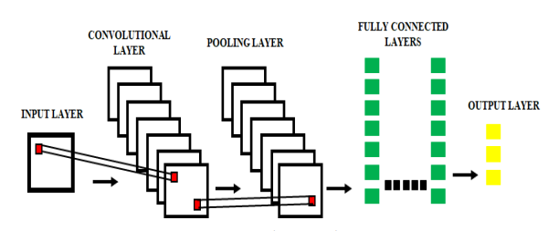

5.3 Use Case Diagram:-

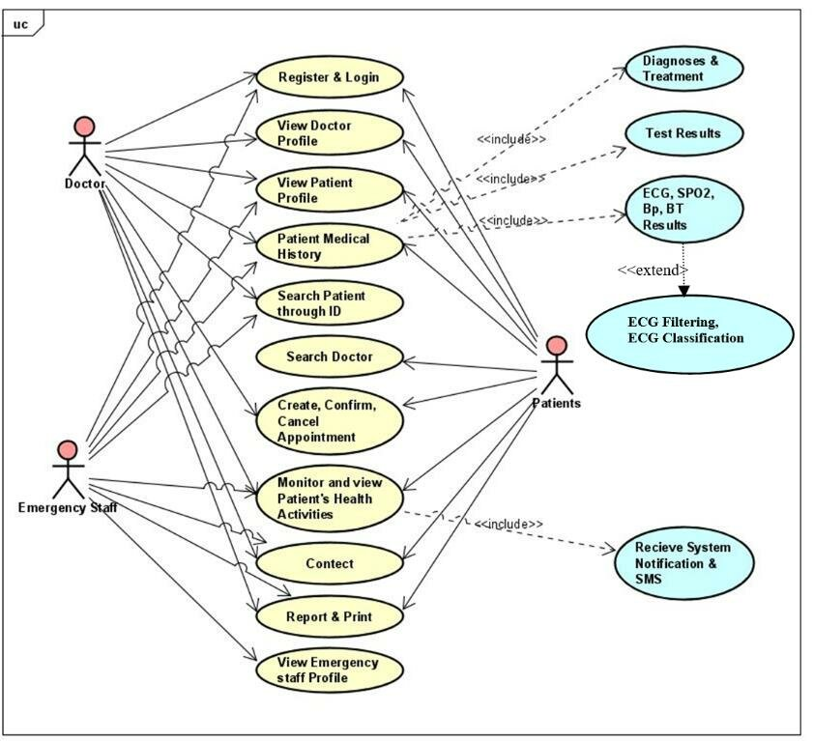

- Deliverables

6.1 Detailed functional specifications document outlining system features, interactions, and requirements.
6.2 Fully trained CNN models capable of predicting CVD likelihood from ECG data.
6.3 Developed user interface for healthcare professionals to visualize and interpret prediction results.
6.4 Integration of prediction system with existing healthcare information systems (e.g., EHR, analytics platforms).
6.5 Comprehensive documentation including technical manuals, user guides, and system architecture diagrams.
6.6 Performance evaluation reports highlighting system responsiveness, accuracy, and scalability metrics.

