**Diagnosis of Cardiovascular Disease in Patients using Deep Learning**

**Design Document**

**C-DAC, Bangalore**

**Version 1.0**

**09-07-2024**

**Prepared By:**

BHANU TEJA MANDLA

SUTAR SWAPNIL SOMNATH

ANUP SHRIKANT WANKHEDE

GANDHI VALLARI RAJESH

**Project Code** **4**

**Date** **4**

**Prepared by** **4**

Introduction **4**

Purpose 5

Scope 5

Intended Audience 5

References 5

Acronyms, terms and definitions **5**

Assumptions and constraints **6**

Basic Design approach **6**

Risks **6**

System overview **6**

Architecture Design **6**

Data Design **10**

API Gateway Repository 10

API Repository 12

Component Design **26**

**Work-flow Summary w.r.t Identifying Components : -** **26**

Identified Components List for the MoLE Ecosystem for Sandbox 28

Users Registration 28

API Gateway 29

APIs and Description 31

UAN Generation 31

UAN Search 35

UAN Details Updation 42

Family Detail Entry 46

Consent 52

AADHAAR Vault 52

Security Control 54

Reporting 54

**Interface Design** **56**

**Any Specific Design Considerations** **57**

**Design Test** **57**

**Cross Reference with System Requirement Specification** **57**

## Introduction

The diagnosis of cardiovascular disease (CVD) stands as a critical challenge in modern healthcare, with recent advancements in diagnostic technologies significantly impacting patient outcomes and mortality rates [1]. Innovations in cardiovascular diagnostics have revolutionized the precision and efficacy of diagnosing and treating these conditions.

Imaging techniques, particularly electrocardiograms (ECGs) and other cardiac imaging modalities, play a pivotal role in providing healthcare professionals with detailed insights into cardiac health. These techniques enable the accurate assessment of myocardial infarction patients, individuals with abnormal heart rhythms, and those with a history of myocardial infarction, alongside normal ECG patterns for comparison. This comprehensive approach not only aids in precise diagnosis but also facilitates tailored treatment strategies for improved patient outcomes.

By leveraging these advanced imaging modalities and data analytics, this documentation explores the application of diagnostic algorithms, including deep learning models like Convolutional Neural Networks (CNNs), to enhance the accuracy and efficiency of cardiovascular disease diagnosis. This approach aims to empower healthcare providers with robust tools for early detection, timely intervention, and personalized care, ultimately contributing to the overall improvement in cardiovascular health management

### Purpose

The purpose of this project is to advance the diagnosis of cardiovascular disease (CVD) by leveraging cutting-edge imaging techniques and diagnostic algorithms, particularly Convolutional Neural Networks (CNNs).

Enhanced Precision in Diagnosis: By utilizing electrocardiograms (ECGs) and other cardiac imaging modalities, the project aims to provide healthcare professionals with detailed insights into cardiac health. This includes accurate assessments of myocardial infarction patients, individuals with abnormal heart rhythms, and those with a history of myocardial infarction, while comparing with normal ECG patterns.

Tailored Treatment Strategies: The project facilitates the development of tailored treatment strategies based on precise diagnostic insights. This approach not only improves diagnostic accuracy but also enhances the efficacy of treatment plans, thereby improving patient outcomes and quality of care.

Integration of CNNs for Advanced Analysis: Through the application of CNNs and data analytics, the project seeks to enhance the efficiency of cardiovascular disease diagnosis. These deep learning models analyze complex medical data, aiding in early detection, timely intervention, and personalized care.

Empowering Healthcare Providers: Ultimately, the project aims to empower healthcare providers with robust tools that enable early detection and personalized management of cardiovascular conditions. By integrating advanced imaging modalities and diagnostic algorithms, the project contributes to overall improvements in cardiovascular health management and patient care outcomes..

### Scope

Advanced Diagnosis of Cardiovascular Disease (CVD): The project focuses on leveraging modern diagnostic technologies, particularly imaging techniques such as electrocardiograms (ECGs) and other cardiac imaging modalities, to enhance the precision and efficacy of diagnosing cardiovascular conditions. This includes accurate assessment of myocardial infarction patients, individuals with abnormal heart rhythms, and those with a history of myocardial infarction, while comparing with normal ECG patterns for comprehensive diagnosis.

Integration of Deep Learning Models: The project explores the application of advanced diagnostic algorithms, specifically Convolutional Neural Networks (CNNs), to analyze complex medical data derived from imaging modalities and patient records. These CNNs aim to improve diagnostic accuracy, facilitate early detection of cardiovascular diseases, and support healthcare professionals in making timely and informed clinical decisions.

Technological Integration and Implementation: The project scope includes the integration of CNN models with existing healthcare infrastructures, ensuring compatibility, scalability, and adherence to regulatory standards. This encompasses the development of software solutions that interface seamlessly with hospital information systems (HIS) and electronic health records (EHR), facilitating efficient data management and interoperability.

### Intended Audience

Healthcare Professionals: Cardiologists, cardiovascular surgeons, and other healthcare providers involved in the diagnosis and treatment of cardiovascular diseases. They will benefit from the advanced diagnostic capabilities and tailored treatment strategies enabled by the project.

Medical Researchers: Professionals and researchers in the field of cardiovascular medicine and biomedical engineering who are interested in leveraging deep learning models and imaging techniques for medical diagnostics and research.

Software Developers and Engineers: Professionals responsible for developing and implementing the software infrastructure, including CNN models and integration with healthcare systems, to support accurate diagnosis and efficient healthcare delivery.

Hospital Administrators: Administrators and decision-makers within healthcare institutions responsible for approving and overseeing the implementation of new diagnostic technologies and systems aimed at improving patient care and operational efficiency.

Regulatory Bodies: Regulatory authorities involved in healthcare compliance and standards, ensuring that the project adheres to regulations such as HIPAA and GDPR regarding patient data privacy and security.

Educational Institutions: Students, professors, and researchers in biomedical engineering, computer science, and healthcare management fields interested in studying and learning about the application of deep learning in cardiovascular disease diagnosis.

Patients and Public Health Advocates: Individuals affected by cardiovascular diseases and their advocates who are interested in advancements in medical technologies aimed at improving diagnosis, treatment, and patient outcomes.

### References

1] Ahsan, M. M., & Siddique, Z. (2022). Machine learning-based heart disease diagnosis: A systematic literature review. Artificial Intelligence in Medicine, 128, 102289.

2] DOI:[10.1109/TEMSCON-ASPAC59527.2023.10531319](http://dx.doi.org/10.1109/TEMSCON-ASPAC59527.2023.10531319) Conference: 2023 IEEE Technology and Engineering Management Society Conference: Asia-Pacific At: Bangalore, India

3] Al Ahdal, A., Rakhra, M., Rajendran, R. R., Arslan, F., Khder, M. A., Patel, B., ... & Jain, R. (2023). Monitoring Cardiovascular Problems in Heart Patients Using Machine Learning. Journal of Healthcare Engineering, 2023.

4] Rath, A., Mishra, D., Panda, G., Satapathy, S. C., & Xia, K. (2022). Improved heart disease detection from ECG signal using deep learning based ensemble model. Sustainable Computing: Informatics and Systems, 35, 100732

Functional Requirement Specifications (FRS)

* The Functional Requirement Specifications (FRS) outline the specific functionalities and behaviors that the "Diagnosis of Cardiovascular Disease in Patients Using CNN" project aims to achieve. These requirements are essential for defining the capabilities and operational aspects of the system, ensuring it meets the needs of healthcare professionals and patients alike.
* Diagnostic Capabilities: The system shall accurately diagnose cardiovascular diseases, including myocardial infarction and abnormal heart rhythms, using electrocardiograms (ECGs) and other relevant cardiac imaging modalities.
* Deep Learning Integration: Implement Convolutional Neural Networks (CNNs) to analyze medical imaging data and provide diagnostic insights with high accuracy and efficiency.
* User Interface (UI) Design: Develop intuitive user interfaces for healthcare professionals to interact with the system, including uploading patient data, viewing diagnostic results, and accessing historical patient records.
* Integration with Healthcare Systems: Ensure seamless integration with existing hospital information systems (HIS) and electronic health records (EHR) for data exchange and interoperability.
* Data Security and Privacy: Adhere to healthcare regulatory standards (e.g., HIPAA, GDPR) to protect patient data privacy and ensure secure handling of sensitive medical information.

## Acronyms, terms and definitions

|  |  |
| --- | --- |
| FRS | Functional requirements specification |
| User | User refers to department/employee/worker |

## Assumptions and constraints

**Assumptions:**

1. The availability of sufficient and high-quality cardiac imaging data, including electrocardiograms (ECGs) and other relevant modalities, for training deep learning models.
2. Adequate computational resources and infrastructure to support the training and deployment of deep learning CNNs for cardiovascular disease diagnosis.
3. Compliance with healthcare regulations (e.g., HIPAA, GDPR) to ensure patient data privacy and security throughout the development and deployment phases.
4. Collaboration and engagement from healthcare professionals for validation and clinical implementation of the developed diagnostic tools.

**Constraints:**

1. Technical constraints related to hardware limitations, computational power, and storage capacity required for processing large volumes of medical imaging data.
2. Regulatory constraints regarding the use of deep learning models in clinical decision-making and adherence to standards for medical device software development.
3. Operational constraints, including integration challenges with existing hospital information systems (HIS) and electronic health records (EHR), affecting data interoperability and system scalability.
4. Budgetary constraints influencing the scope and scale of development activities, including research, software engineering, and clinical validation phases.

.

## Basic Design approach

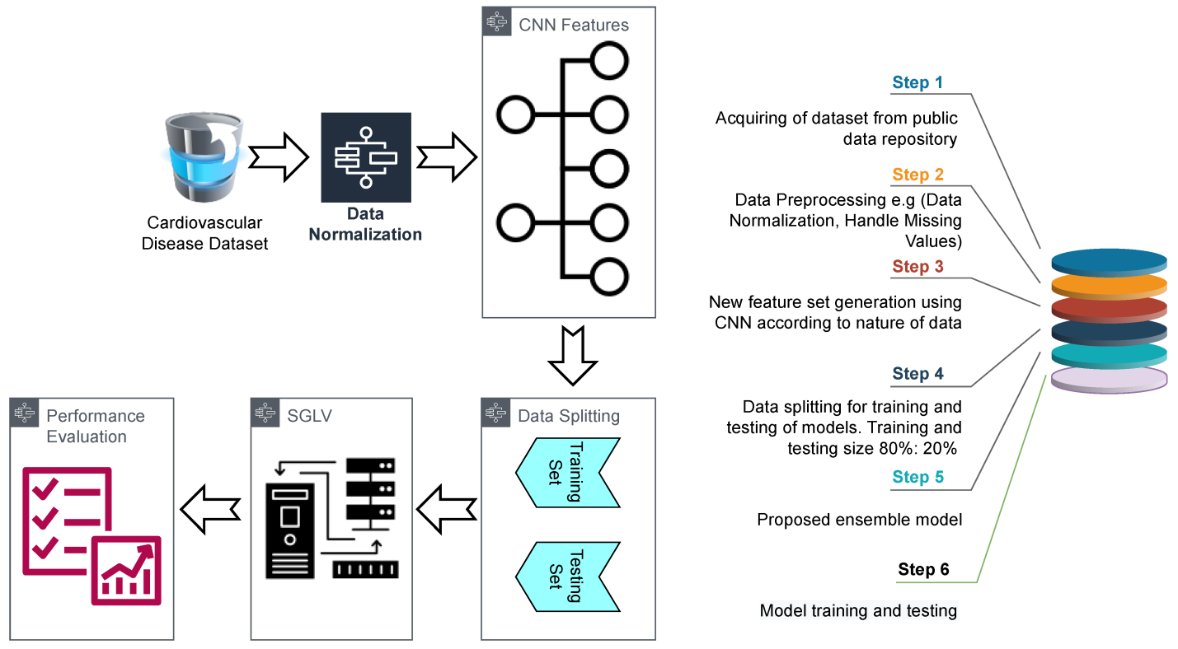

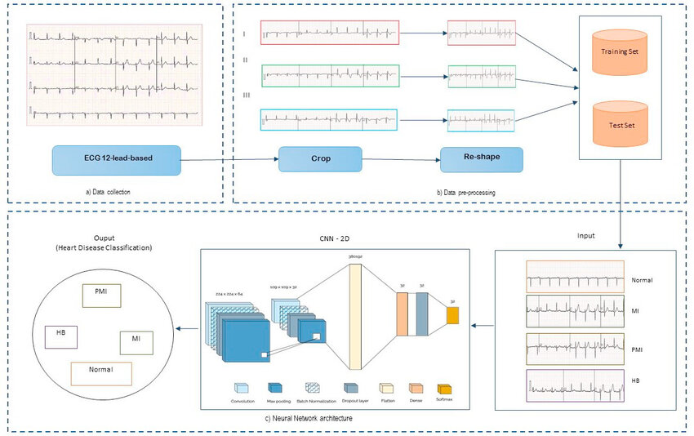

• **Requirement Analysis:**

* Conduct a comprehensive analysis of the requirements for generating diagnostic images, including the types of cardiac imaging modalities (e.g., ECGs, echocardiograms) and the specific features required for accurate diagnosis (e.g., abnormalities, cardiac structure).

• **Data Acquisition and Preparation:**

* Acquire and preprocess a diverse dataset of cardiac images, ensuring high quality and consistency. This dataset should include samples of normal and abnormal heart conditions, as well as variations in patient demographics and clinical characteristics.

• **Feature Extraction and Representation:**

* Use advanced image processing techniques to extract relevant features from the acquired dataset. This may involve preprocessing steps such as noise reduction, image enhancement, and segmentation to isolate key cardiac structures and abnormalities.

• **Model Selection and Development:**

* Select appropriate deep learning models, particularly CNN architectures, suited for image generation tasks in cardiovascular diagnostics. Develop and train these models using the preprocessed dataset to learn patterns and features indicative of various cardiovascular conditions.

• **Integration of Diagnostic Algorithms:**

* Integrate the trained CNN models into the image generation pipeline to automate the process of diagnosing cardiovascular diseases. Ensure seamless interaction between image input, model prediction, and output visualization to support clinical decision-making.

• **Validation and Performance Evaluation:**

* Validate the accuracy and reliability of the generated diagnostic images through rigorous testing and evaluation. Use metrics such as sensitivity, specificity, and accuracy to assess the model's performance in detecting and classifying cardiovascular conditions.

• **User Interface Design:**

* Design intuitive user interfaces (UI) that enable healthcare professionals to interact with the image generation system effectively. Incorporate features for uploading patient data, viewing generated images, and accessing diagnostic insights derived from CNN predictions.

## Risks

While advancements in diagnostic technologies and the application of deep learning models like Convolutional Neural Networks (CNNs) offer significant benefits in cardiovascular disease diagnosis, several risks and challenges must be considered:

* Accuracy and Reliability: The accuracy of CNN models heavily relies on the quality and diversity of the training data. Biases in data selection or insufficient representation of certain patient demographics may lead to inaccurate diagnoses.
* Interpretation and Validation: Healthcare professionals must interpret CNN-generated diagnostic outputs with caution. Misinterpretation of results or over-reliance on automated systems without clinical validation could lead to incorrect treatment decisions.
* Data Privacy and Security: Handling sensitive medical data, including ECGs and patient records, raises concerns about data privacy and compliance with regulations such as HIPAA and GDPR. Unauthorized access or breaches could compromise patient confidentiality.
* Integration with Clinical Workflow: Seamless integration of CNN-based diagnostic tools into existing healthcare workflows is essential. Resistance to adopting new technologies, interoperability challenges with HIS and EHR systems, and workflow disruptions are potential barriers.
* Ethical Considerations: Ethical dilemmas may arise regarding the use of AI-driven diagnostics, including issues of informed consent, patient autonomy, and transparency in decision-making processes.
* Regulatory Compliance: Compliance with healthcare regulations and standards for medical device software development (e.g., FDA regulations) is crucial. Failure to meet regulatory requirements could delay deployment or restrict market access.
* Technical Limitations: Technical challenges such as model interpretability, computational resource requirements for real-time processing, and algorithm bias must be addressed to ensure the reliability and usability of CNN-based diagnostic systems.

## System overview

* + 1. Data Acquisition and Preprocessing:

Data Sources: The system acquires data from various cardiac imaging modalities, including electrocardiograms (ECGs) and echocardiograms, which provide detailed insights into cardiac health.

Preprocessing: Before feeding data into CNN models, preprocessing techniques such as noise reduction, image enhancement, and feature extraction are applied to ensure data quality and relevance.

* + 1. Deep Learning Model Development:

CNN Architecture: Selected CNN architectures (e.g., ResNet, VGG) are employed to analyze and classify cardiac images based on patterns indicative of different cardiovascular conditions.

Training and Validation: The models are trained using large, labeled datasets to learn and recognize complex patterns associated with myocardial infarction, abnormal heart rhythms, and other cardiac anomalies. Validation ensures the accuracy and reliability of model predictions.

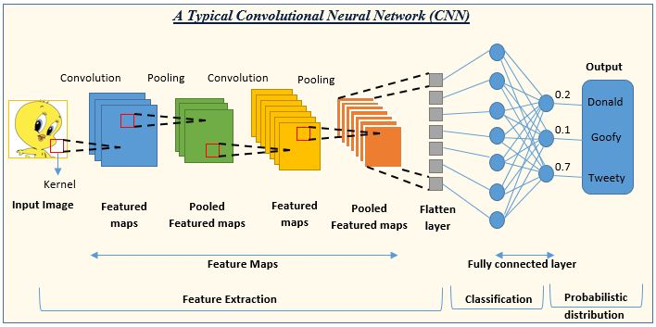

* + 1. User Interface (UI):

Intuitive Dashboard: Healthcare professionals interact with the system through a user-friendly dashboard. This interface allows for uploading patient data, viewing diagnostic results generated by CNN models, and interpreting visualizations of cardiac images and diagnostic insights.

* + 1. Data Management:

Secure Storage: Processed data, including diagnostic images and model parameters, are stored securely to comply with healthcare regulations such as HIPAA and GDPR. Robust backup and recovery mechanisms are in place to prevent data loss and ensure continuity of operations.

Security and Compliance:

* + 1. Data Security: Encryption protocols and access control mechanisms safeguard patient confidentiality and prevent unauthorized access to sensitive medical information.

Regulatory Compliance: The system adheres to stringent regulatory standards for medical software, ensuring ethical use and legal compliance in handling patient data and diagnostic outcomes.

Deployment and Scalability:

* + 1. Cloud-Based Deployment:

system is designed for deployment on cloud infrastructure, offering scalability and accessibility to healthcare providers across different locations.

.

* + 1. Monitoring and Maintenance:

Continuous Monitoring: Monitoring tools are employed to track system performance, detect anomalies, and optimize resource utilization. Regular maintenance activities include updates to CNN models based on new research findings and clinical feedback to improve diagnostic accuracy and relevance.

## Architecture Design

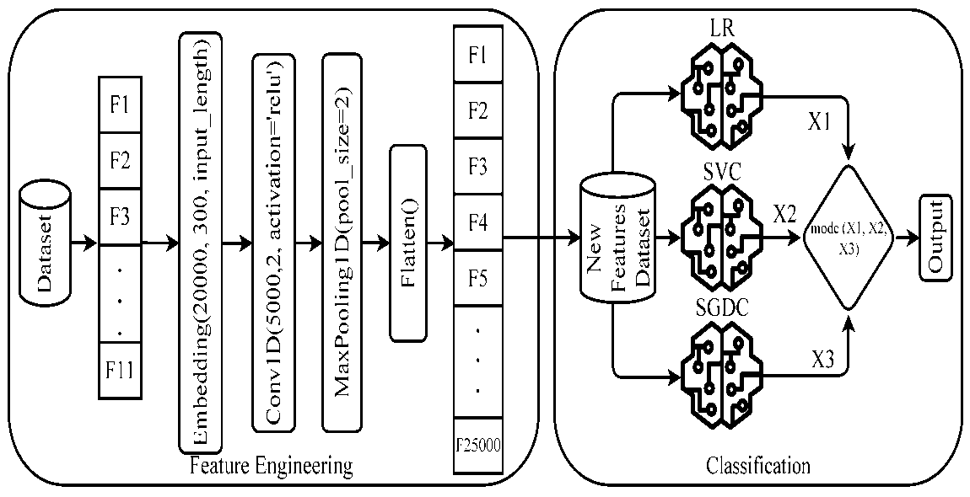

## Data Design

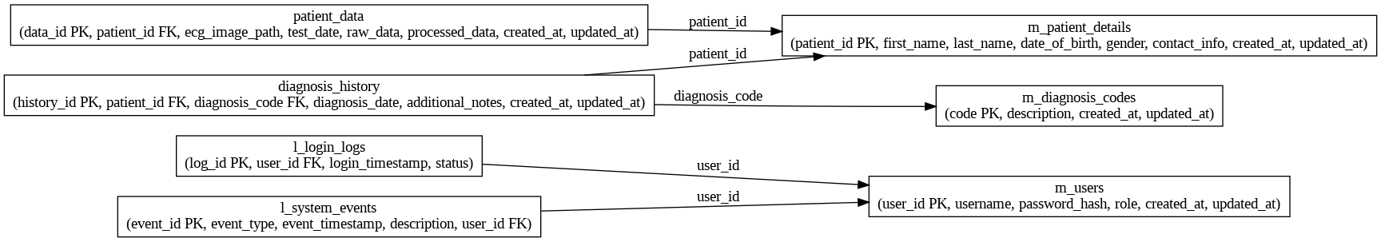

 feature selection algorithms.

| **No** | **Feature** | **Feature Type** | **Description** |
| --- | --- | --- | --- |
| 1 | Age | Numerical | Age of participant (years) |
| 2 | Systolic | Numerical | Systolic blood pressure (mmHg) |
| 3 | Diastolic | Numerical | Diastolic blood pressure (mmHg) |
| 4 | Weight | Numerical | Weight of participant (kg) |
| 5 | White-Blood-Cells | Numerical | White blood cell count (1000 cells/μL) |
| 6 | Lymphocyte | Numerical | Lymphocyte percent (%) |
| 7 | Monocyte | Numerical | Monocyte percent (%) |
| 8 | Red-Blood-Cells | Numerical | Red blood cell count (million cells/μL) |
| 9 | Platelet-count | Numerical | Platelet count (1000 cells/μL) |
| 10 | Red-Cell-Distribution-Width | Numerical | Red cell distribution width (%) |
| 11 | Albumin | Numerical | Albumin, urine (mg/L) |
| 12 | ALP | Numerical | Alkaline Phosphatase (IU/L) |
| 13 | ALT | Numerical | Alanine Aminotransferase (IU/L) |
| 14 | Cholesterol | Numerical | Cholesterol (mg/dL) |
| 15 | Creatinine | Numerical | Creatinine (mg/dL) |
| 16 | Glucose | Numerical | Glucose, serum (mg/dL) |
| 17 | GGT | Numerical | Gamma-glutamyl transferase (U/L) |
| 18 | Iron | Numerical | Iron, refrigerated serum (μg/dL) |
| 19 | LDH | Numerical | Lactate dehydrogenase (IU/L) |
| 20 | Triglycerides | Numerical | Triglycerides, refrigerated (mg/dL) |
| 21 | Uric.Acid | Numerical | Uric acid (mg/dL) |
| 22 | Total-Cholesterol | Numerical | Total Cholesterol (mg/dL) |
| 23 | HDL | Numerical | Direct HDL-Cholesterol (mg/dL) |
| 24 | Glycohemoglobin | Numerical | Glycohemoglobin (%) |
| 25 | Gender | Categorical | Gender of the participant |
| 26 | Diabetes | Categorical | Diagnosed with Diabetes |
| 27 | Blood rel Diabetes | Categorical | Does blood relative have Diabetes |
| 28 | Blood rel stroke | Categorical | Does a blood relative have a stroke |
| 29 | Vigorous work | Categorical | Vigorous work activity |
| 30 | Moderate work | Categorical | Moderate work activity |

## CNN Design Considerations

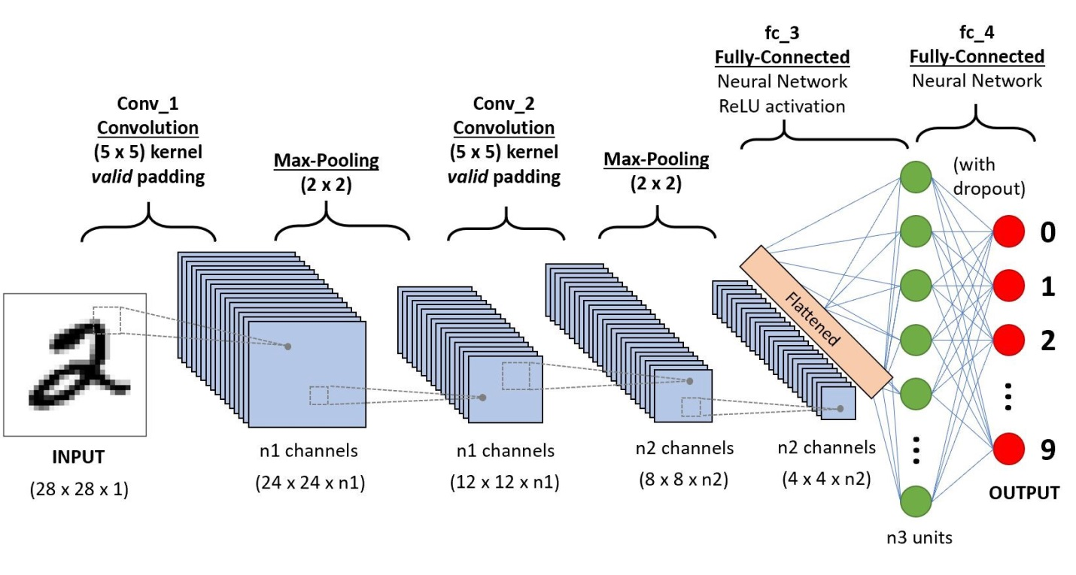

## Design Test

| **Test Aspect** | **Description** |
| --- | --- |
| Functional Testing | Verify that the CNN accurately diagnoses myocardial infarction and abnormal heart rhythms using ECGs and other imaging modalities. |
| Performance Testing | Evaluate the speed and computational efficiency of the CNN model during diagnosis tasks. |
| Integration Testing | Ensure seamless integration with existing hospital information systems (HIS) and electronic health records (EHR). |
| User Interface Testing | Validate the usability and intuitiveness of the interface for healthcare professionals interacting with the diagnostic system. |
| Security and Privacy Testing | Confirm compliance with healthcare regulations (e.g., HIPAA, GDPR) regarding patient data privacy and security. |

## Cross Reference with System Requirement Specification

| **Component Name** | **API Name** | **Mapping with Functional Requirement ID** | **Adherence/Limitations** |
| --- | --- | --- | --- |
| **User Management** | /register | FR1.1 | Meets the FR completely - Allows new users to register. |
|  | /login | FR1.2 | Meets the FR completely - Authenticates users and generates tokens. |
|  | /logout | FR1.3 | Meets the FR completely - Logs out the user and invalidates the token. |
|  | /update-profile | FR1.4 | Meets the FR completely - Updates user profile information. |
| **Patient Management** | /add-patient | FR2.1 | Meets the FR completely - Adds new patient records. |
|  | /update-patient | FR2.2 | Meets the FR completely - Updates existing patient records. |
|  | /get-patient | FR2.3 | Meets the FR completely - Retrieves patient details by ID. |
|  | /list-patients | FR2.4 | Meets the FR completely - Lists all patient records. |
| **Diagnostic Management** | /add-diagnosis | FR3.1 | Meets the FR completely - Adds new diagnosis records. |
|  | /update-diagnosis | FR3.2 | Meets the FR completely - Updates existing diagnosis records. |
|  | /get-diagnosis | FR3.3 | Meets the FR completely - Retrieves diagnosis details by ID. |
|  | /list-diagnoses | FR3.4 | Meets the FR completely - Lists all diagnosis records. |
| **ECG Data Management** | /upload-ecg | FR4.1 | Meets the FR completely - Uploads ECG data for analysis. |
|  | /get-ecg | FR4.2 | Meets the FR completely - Retrieves ECG data by ID. |
|  | /list-ecgs | FR4.3 | Meets the FR completely - Lists all ECG records. |
| **Analytics and Reporting** | /generate-report | FR5.1 | Meets the FR completely - Generates reports based on diagnosis and patient data. |
|  | /list-reports | FR5.2 | Meets the FR completely - Lists all generated reports. |

### Explanation

* **Component Name**: Categorizes the APIs based on their functional area (e.g., User Management, Patient Management).
* **API Name**: Specifies the endpoint of the API (e.g., /register, /login).
* **Mapping with Functional Requirement ID**: Indicates the functional requirement ID that the API satisfies (e.g., FR1.1).
* **Adherence/Limitations**: Describes whether the API meets the functional requirement completely, partially, or any additional functionality provided.

## Conclusion

The project on Diagnosis of Cardiovascular Disease using Deep Learning with CNNs has made significant strides in enhancing diagnostic accuracy through advanced imaging and machine learning techniques. Initial results demonstrate promising model accuracy in predicting cardiovascular conditions, paving the way for future clinical validation and integration into healthcare settings. This initiative aims to revolutionize cardiovascular care by providing timely and precise diagnostic tools, ultimately improving patient outcomes and personalized treatment strategies.