Jenkins + GitHub
Shared Library
Step-by-step project documentation with screenshots

Project | Call a Groovy function stored in GitHub from a Jenkins Pipeline
GitHub repository | wankhedemegha848-a11y/jenkins-hello.groovy
Shared-library file | vars/hello.groovy
Jenkins job | hello-megha
Expected result | Hello Cloud Team — Finished: SUCCESS

Project overview
A Jenkins Shared Library stores reusable Pipeline code in a Git repository. Instead of writing the greeting directly in the Jenkins job, the Pipeline loads the library and calls its hello() function. This project demonstrates the basic shared-library workflow.
Evidence in this document is based on the screenshots supplied for this project.

1. Create the Groovy function in GitHub
1. Open the public GitHub repository: https://github.com/wankhedemegha848-a11y/jenkins-hello.groovy
2. Select Add file → Create new file.
3. In the file-name field, type this exact path:
vars/hello.groovy

4. Paste the following code into the editor:
def call() {
echo 'Hello Cloud Team'
}

5. Click Commit changes… and commit directly to the main branch. The vars folder is important: Jenkins makes hello.groovy available as the Pipeline step hello().
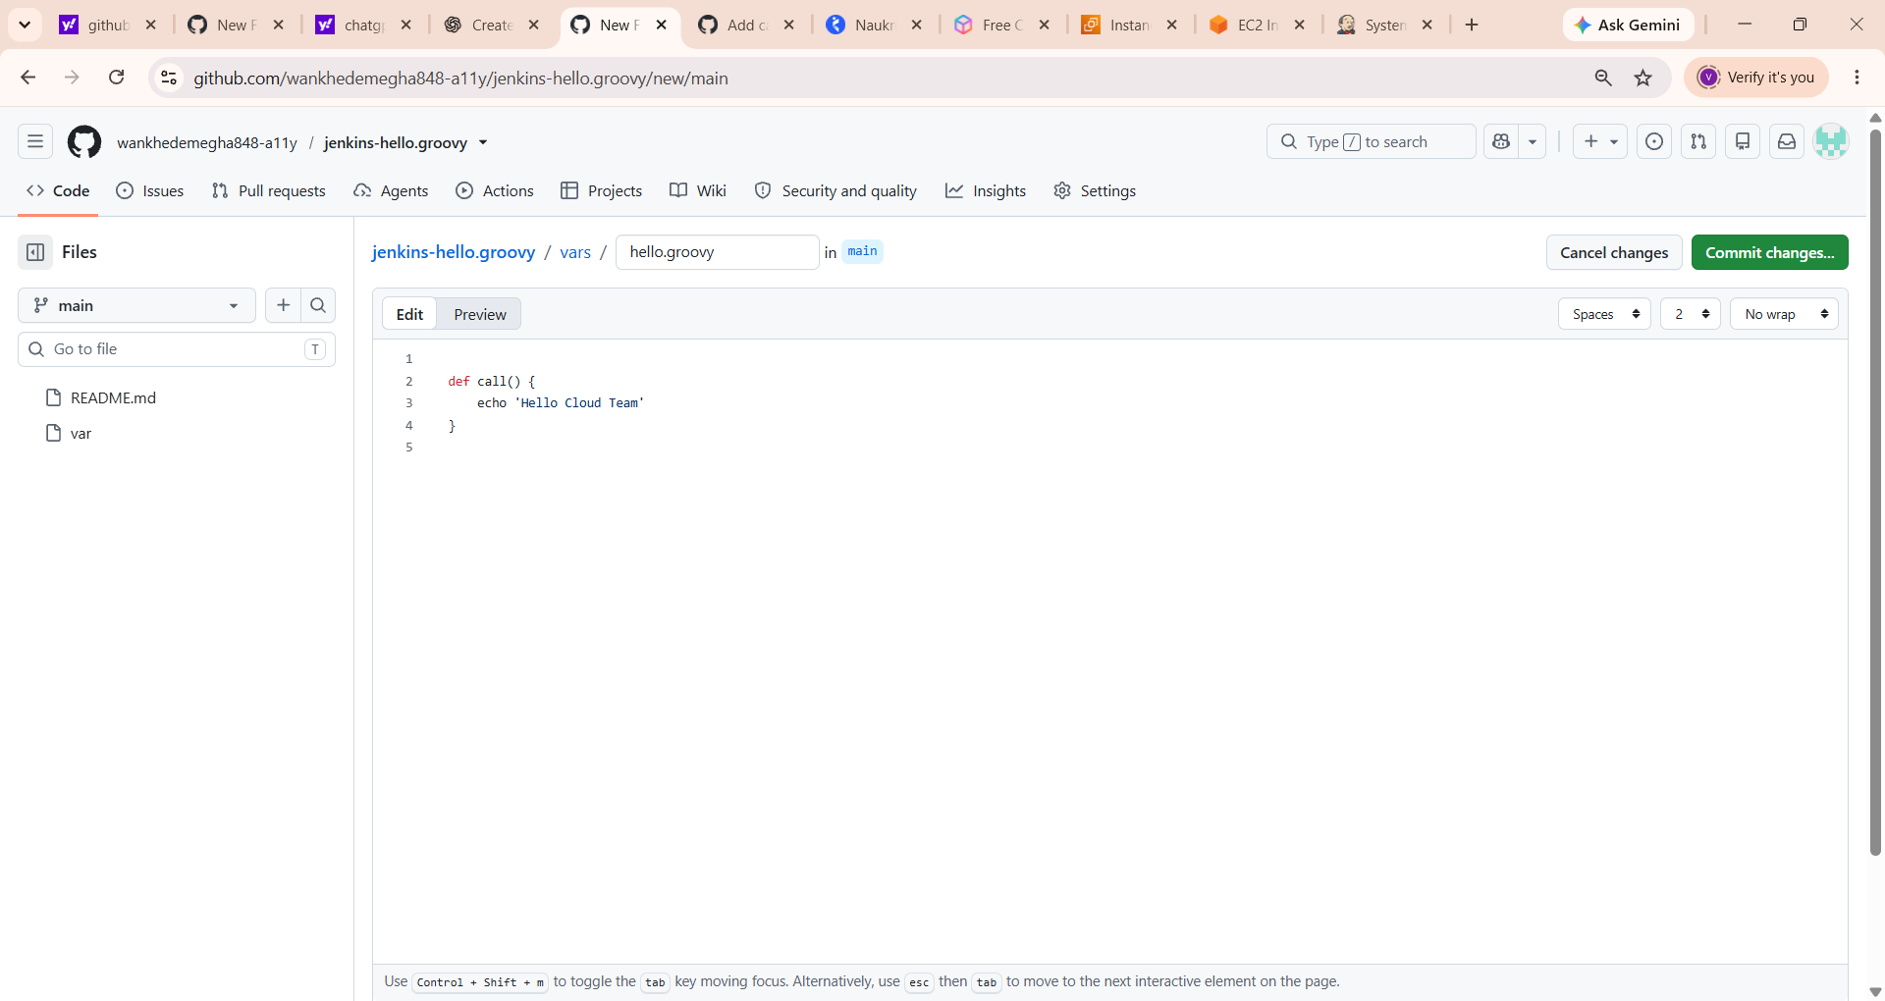
Screenshot 2 — GitHub shared-library file
The GitHub editor shows vars/hello.groovy with a call() function that echoes “Hello Cloud Team”. Commit the file to the main branch.

2. Configure the shared library in Jenkins
1. Open Jenkins: http://13.48.196.135:8080/
2. Go to Manage Jenkins → System.
3. Scroll to Global Trusted Pipeline Libraries or Global Untrusted Pipeline Libraries, then click Add beneath the section you choose.
Security note: Trusted libraries can run with fewer sandbox restrictions. Use the trusted section only for code you own and trust. For a basic exercise, an untrusted library is the safer default if it supports the function you need.
Setting | Value
Name | hello-lib
Default version | main
Retrieval method | Modern SCM
Source Code Management | Git
Project Repository | https://github.com/wankhedemegha848-a11y/jenkins-hello.groovy.git
Credentials | Leave empty for a public repository
4. Click Save at the bottom of the System page.

3. Update the hello-megha Pipeline
1. Open the hello-megha job in Jenkins.
2. Click Configure and scroll to the Pipeline section.
3. Replace the old script (for example, one that prints Hello World) with this script:
@Library('hello-lib') _
pipeline {
agent any
stages {
stage('Hello Cloud Team') {
steps {
hello()
}
}
}
}

4. Click Save. The @Library('hello-lib') line loads the configured library, and hello() invokes the function stored in vars/hello.groovy.

4. Run the build and verify the output
1. Open hello-megha and click Build Now.
2. When the build finishes, click the new build number in Build History.
3. Select Console Output.
Look for the following output:
Hello Cloud Team
Finished: SUCCESS

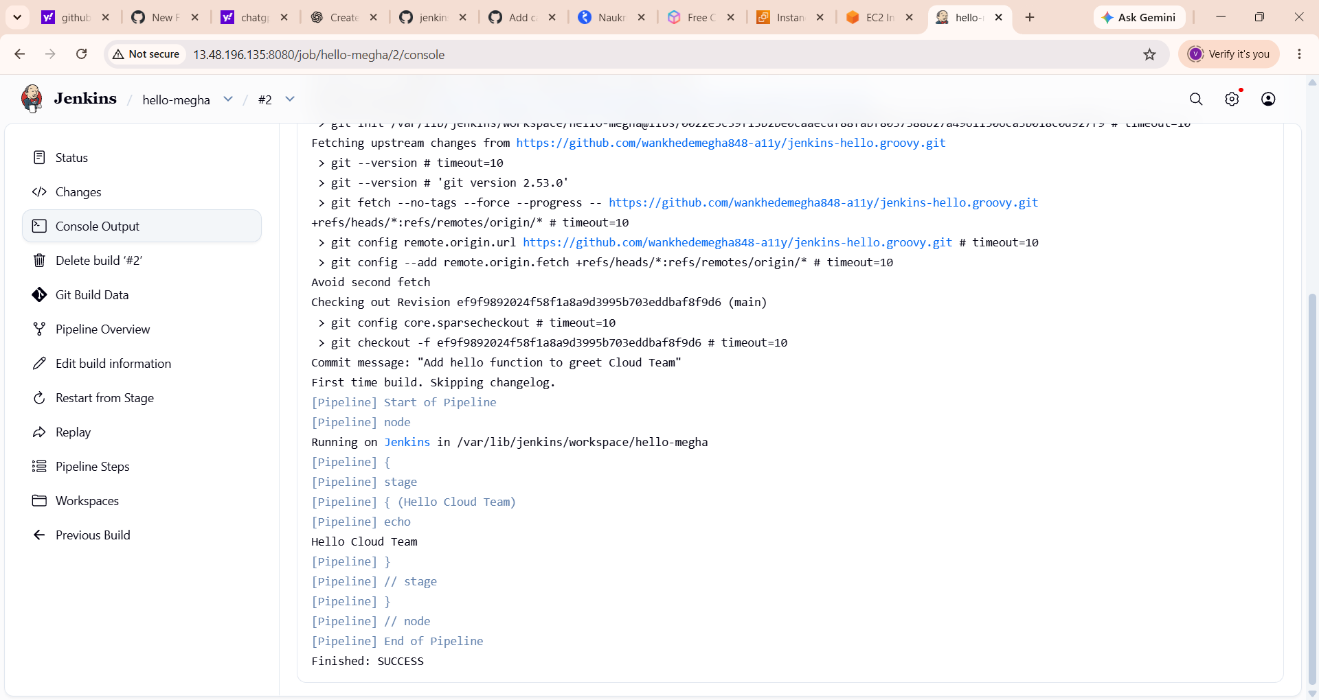
Screenshot 3 — Successful Jenkins shared-library build
The console output shows Jenkins fetching the GitHub repository, printing “Hello Cloud Team”, and ending with “Finished: SUCCESS”.

5. Understand the screenshots
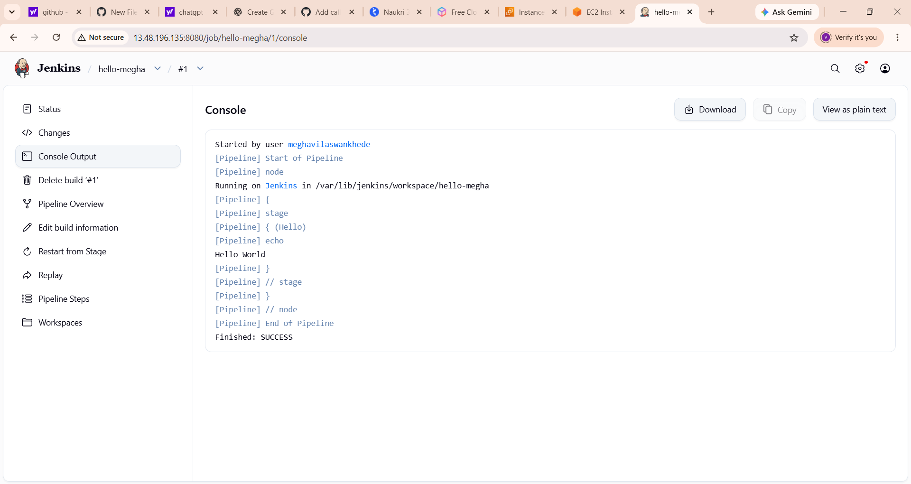
Screenshot 1 — Initial Jenkins job output
The original hello-megha build printed “Hello World”. This is the baseline before calling the shared-library function.
This first screenshot is the earlier baseline: the job printed Hello World and finished successfully. It does not by itself prove the shared library was used. The later screenshot showing Hello Cloud Team is the relevant evidence that the library function was called.

6. Troubleshooting
Console still prints Hello World: Open Configure and verify the Pipeline script was replaced with the shared-library version.
Library hello-lib not found: Check that the library was saved in System, the name is exactly hello-lib, and Default version is main.
No such DSL method: hello: Check that the committed file path is exactly vars/hello.groovy and it contains def call() with the echo statement.
Git checkout fails: Confirm the repository URL is correct, the repository is public, and the main branch exists.

Project completion checklist
☐ GitHub contains vars/hello.groovy on the main branch.
☐ Jenkins shared library is configured with the name hello-lib.
☐ The hello-megha Pipeline calls hello().
☐ Console Output prints Hello Cloud Team.
☐ The build ends with Finished: SUCCESS.

Result: The final console screenshot supplied shows “Hello Cloud Team” and “Finished: SUCCESS”, which is successful evidence for this shared-library test.

