CSE 644 Homework1
Wanling Jiang (wanling.jiang@cstu.edu)
- Install Docker
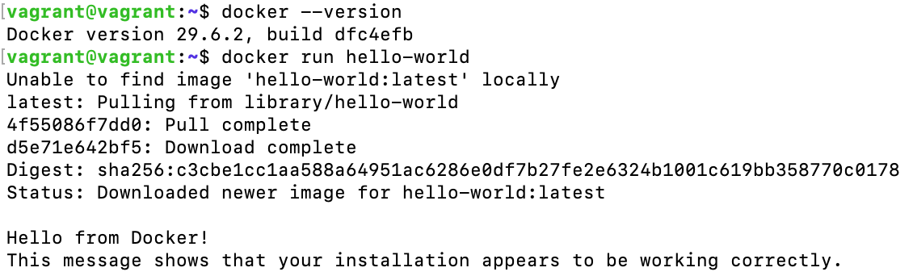
- Create Docker Hub Account
My Docker Hub username: wanlingj

- Generate Credentials for Docker Image Upload
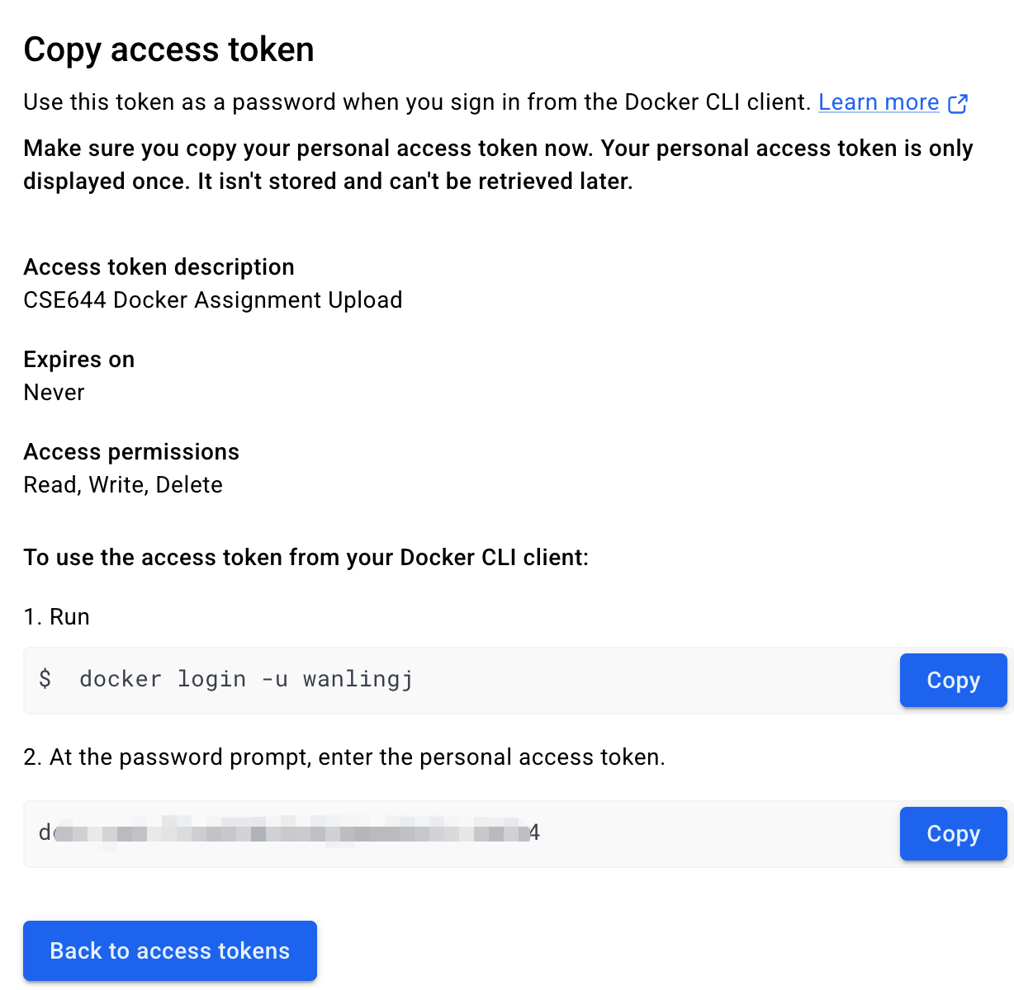
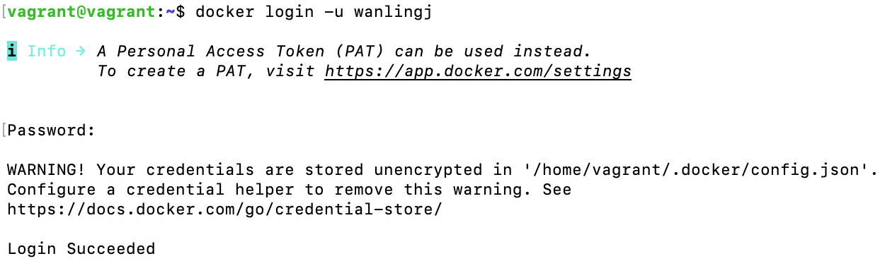

- Pull, Run, and Exec into a Docker Image
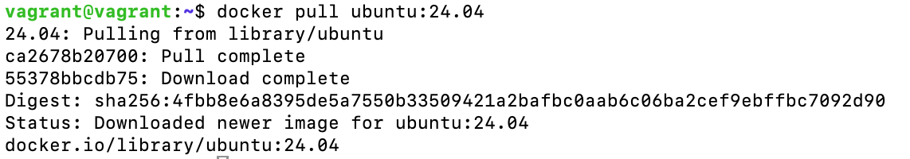
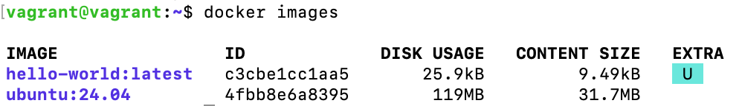
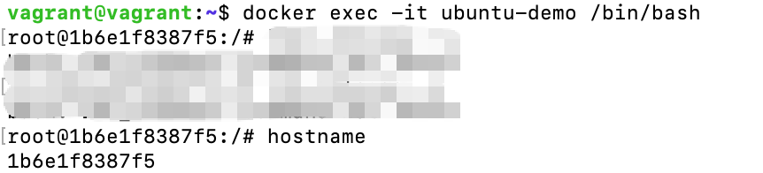
- Customize an Existing Web Server Image
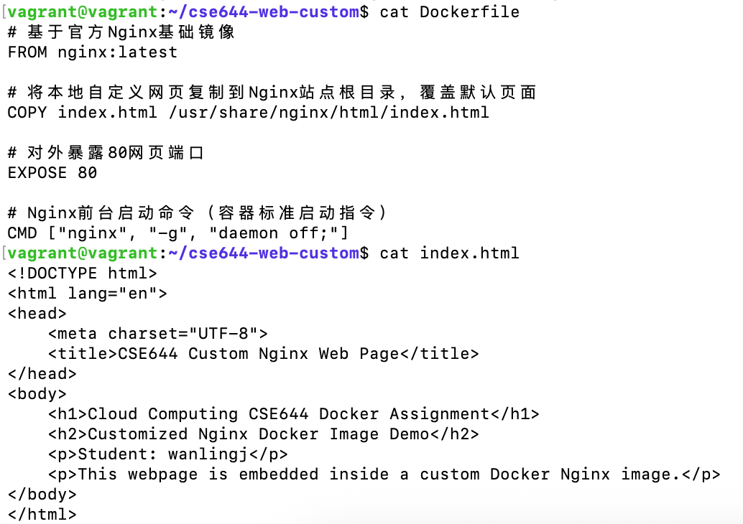
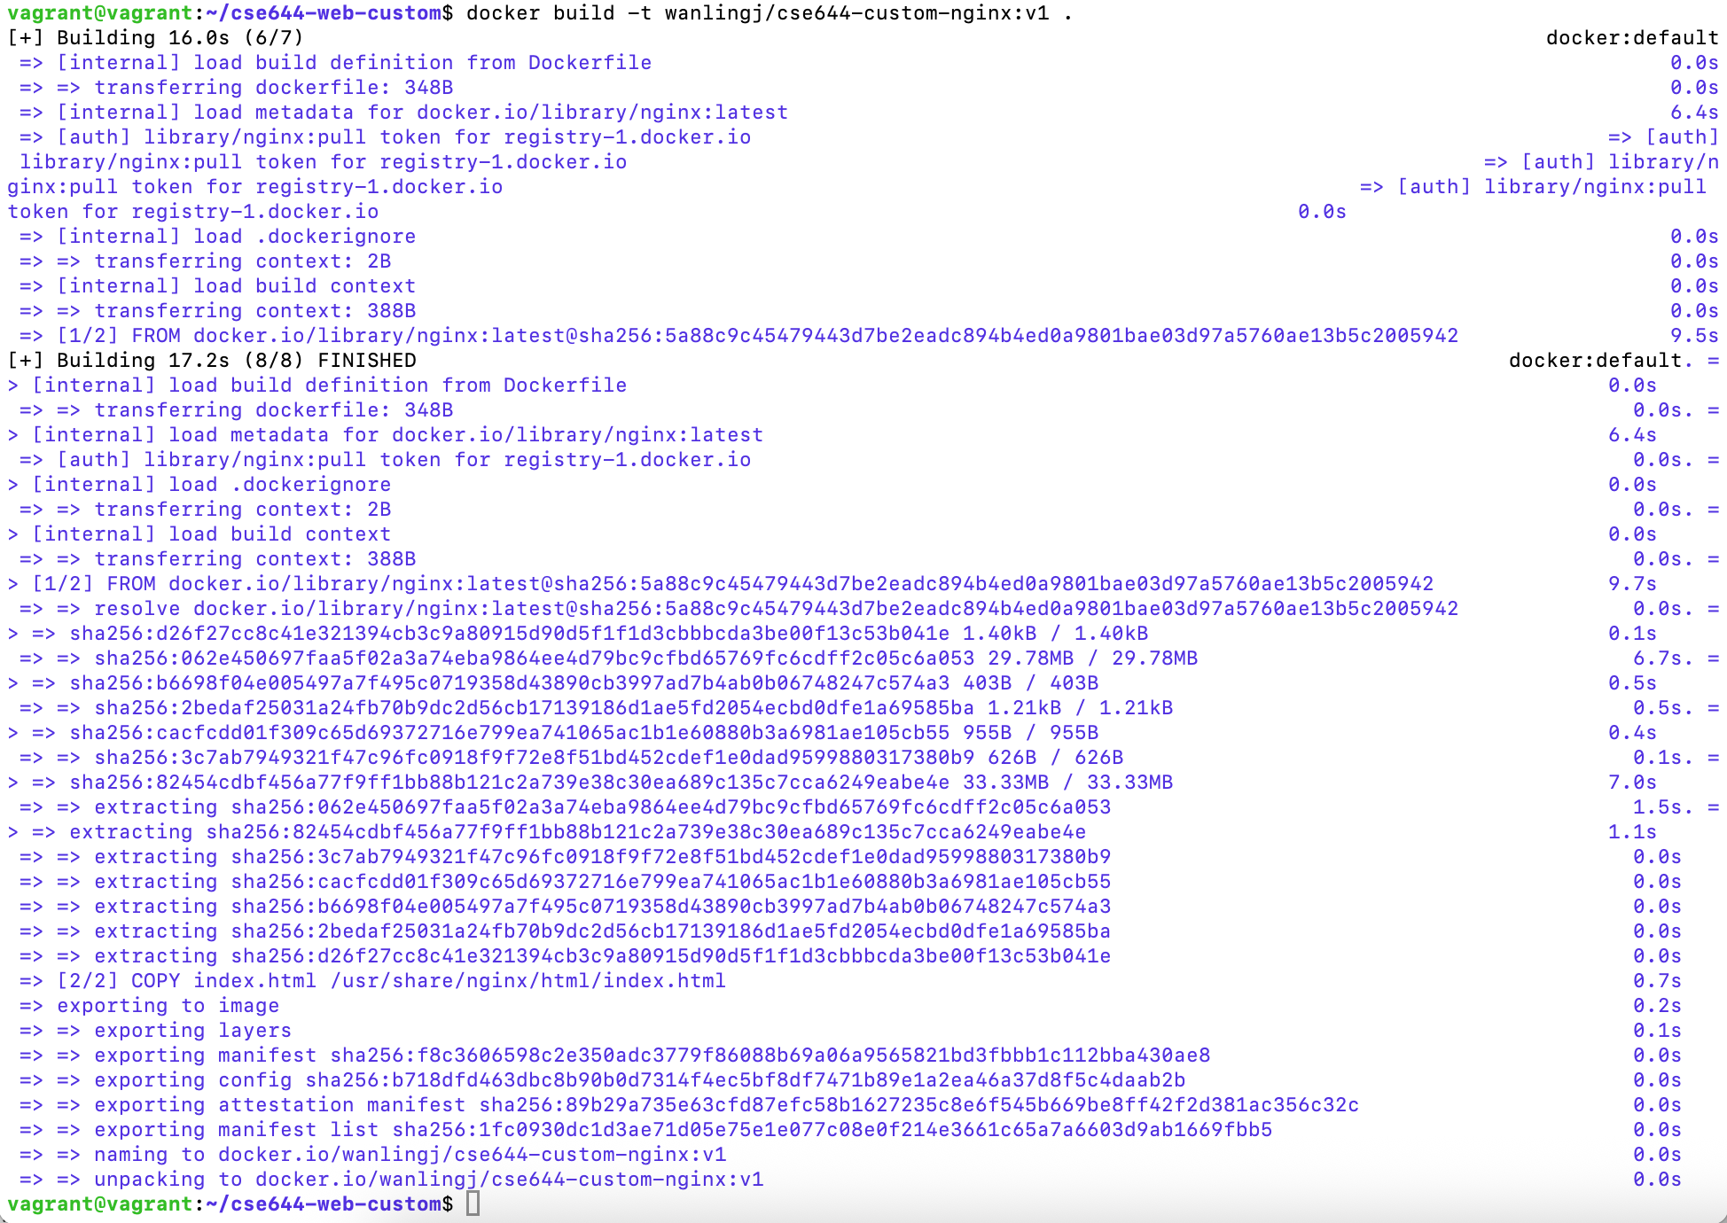
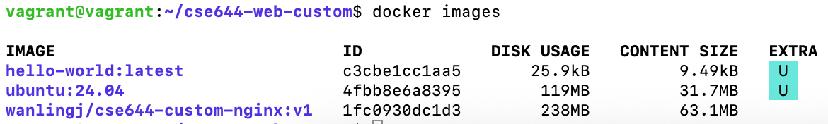
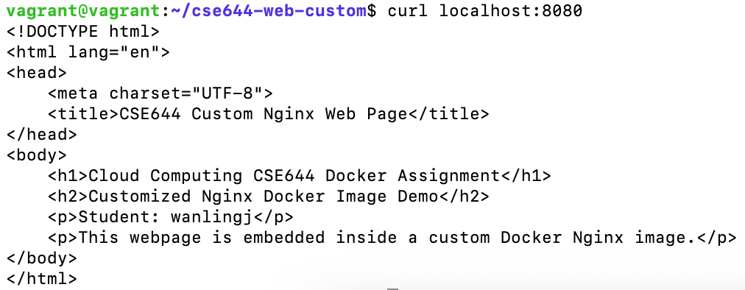

- Create a Simple Python or Node.js Web Server Image
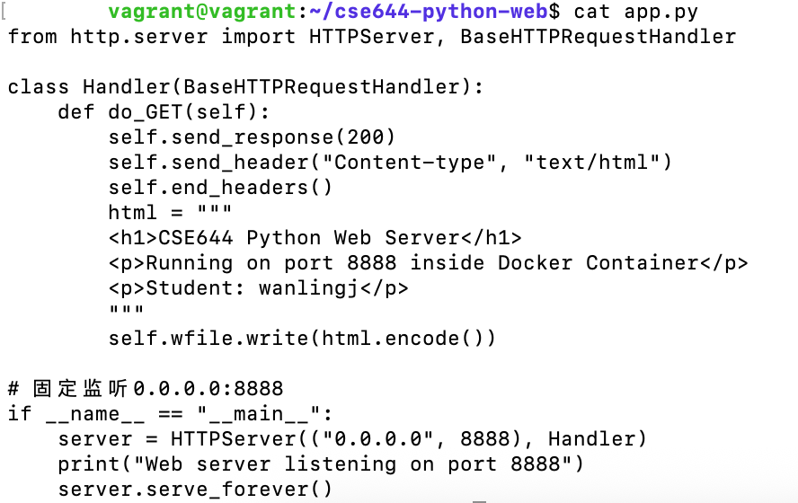
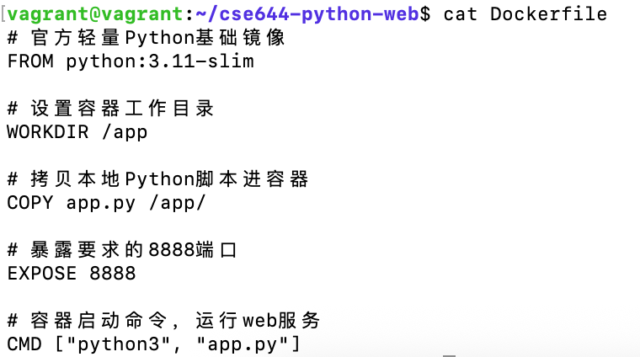
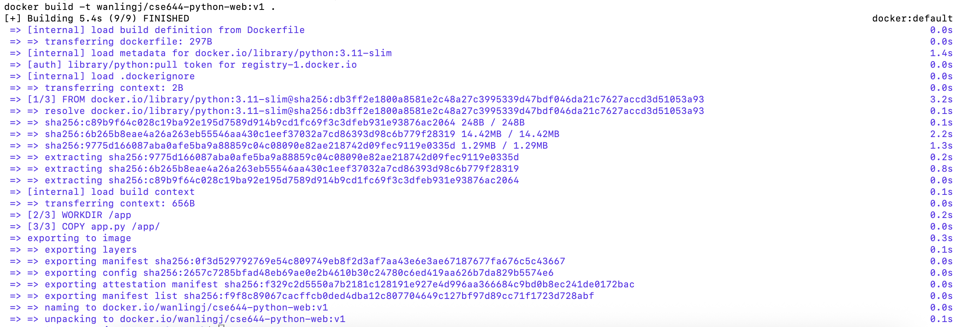
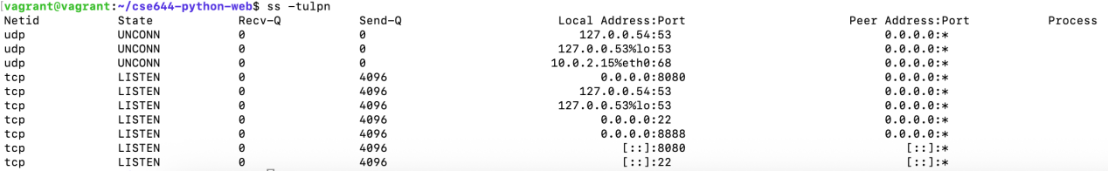
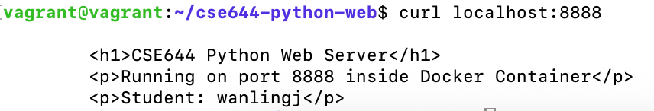

- Deploy HAProxy as a Proxy to Nginx
We can see that web1, web2 and haproxy-proxy are running.
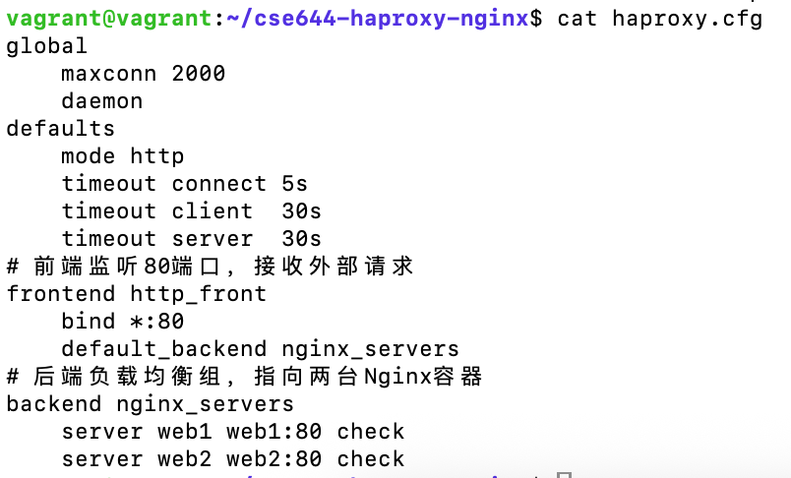
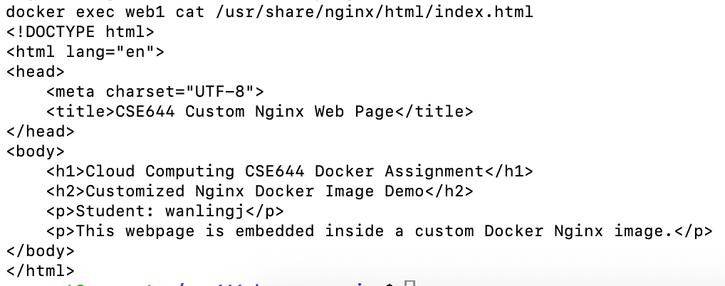
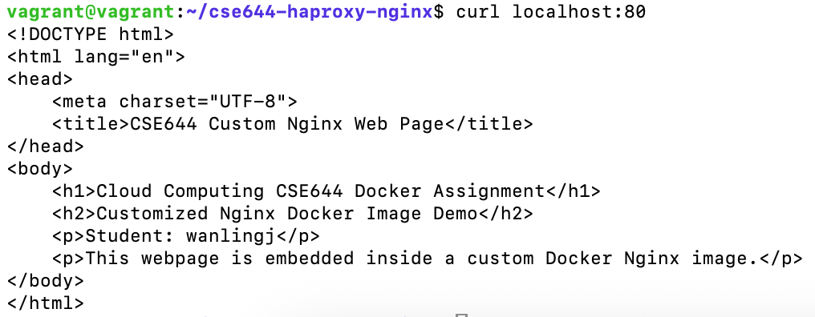

- Demonstrate Persistent Volume
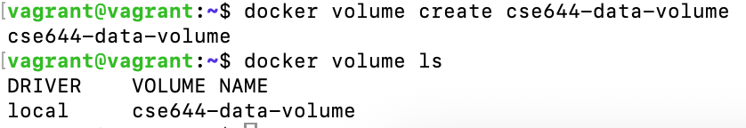
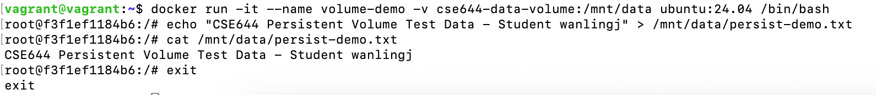
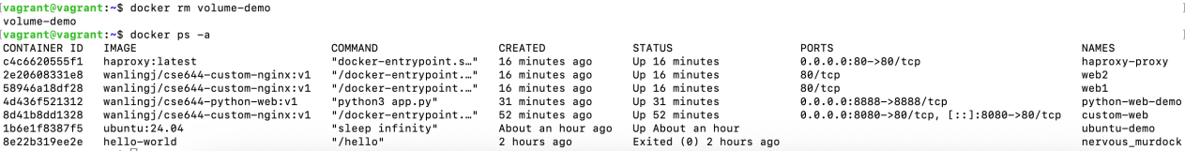
We can see that docker ps -a shows no volume-demo.
We can see when we run a new container, the data still exits.
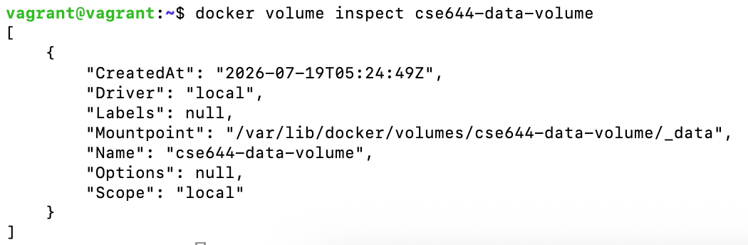

- Demonstrate Docker Networking
We create two bridges, web-bridge and db-bridge:
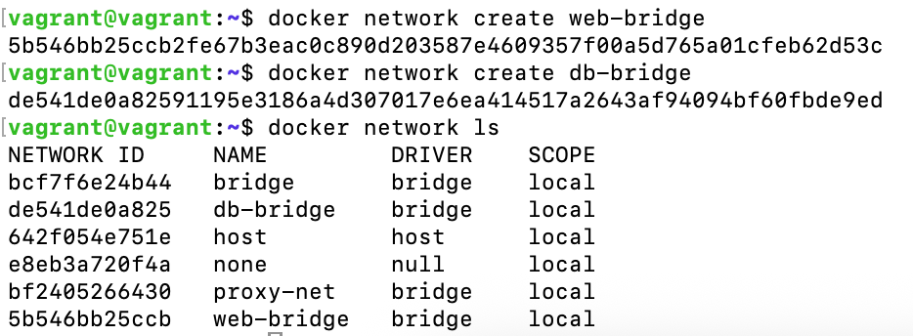
We create 4 containers:
Container a and b belong to web-bridge, container c belong to db-bridge, container d is separeted from web-bridge and db-bridge:
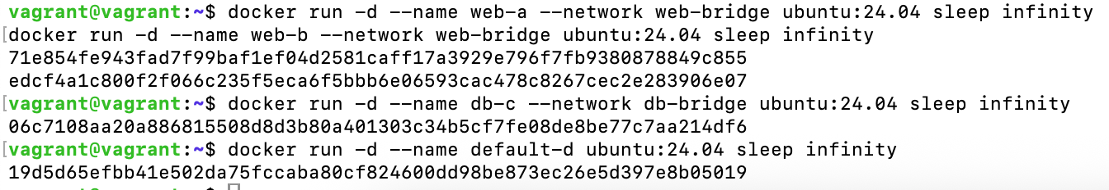
web-a can ping web-b:
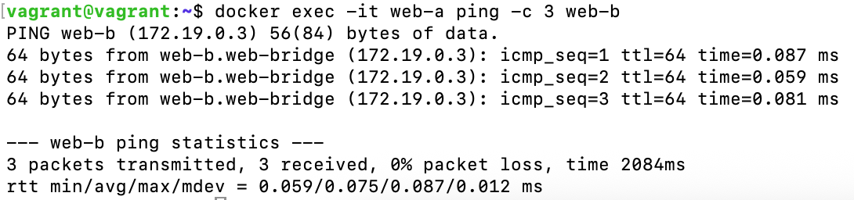
web-a cannot ping web-c or default-d:
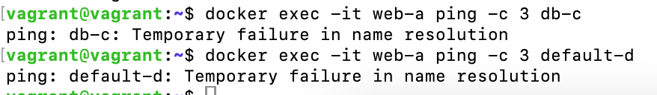
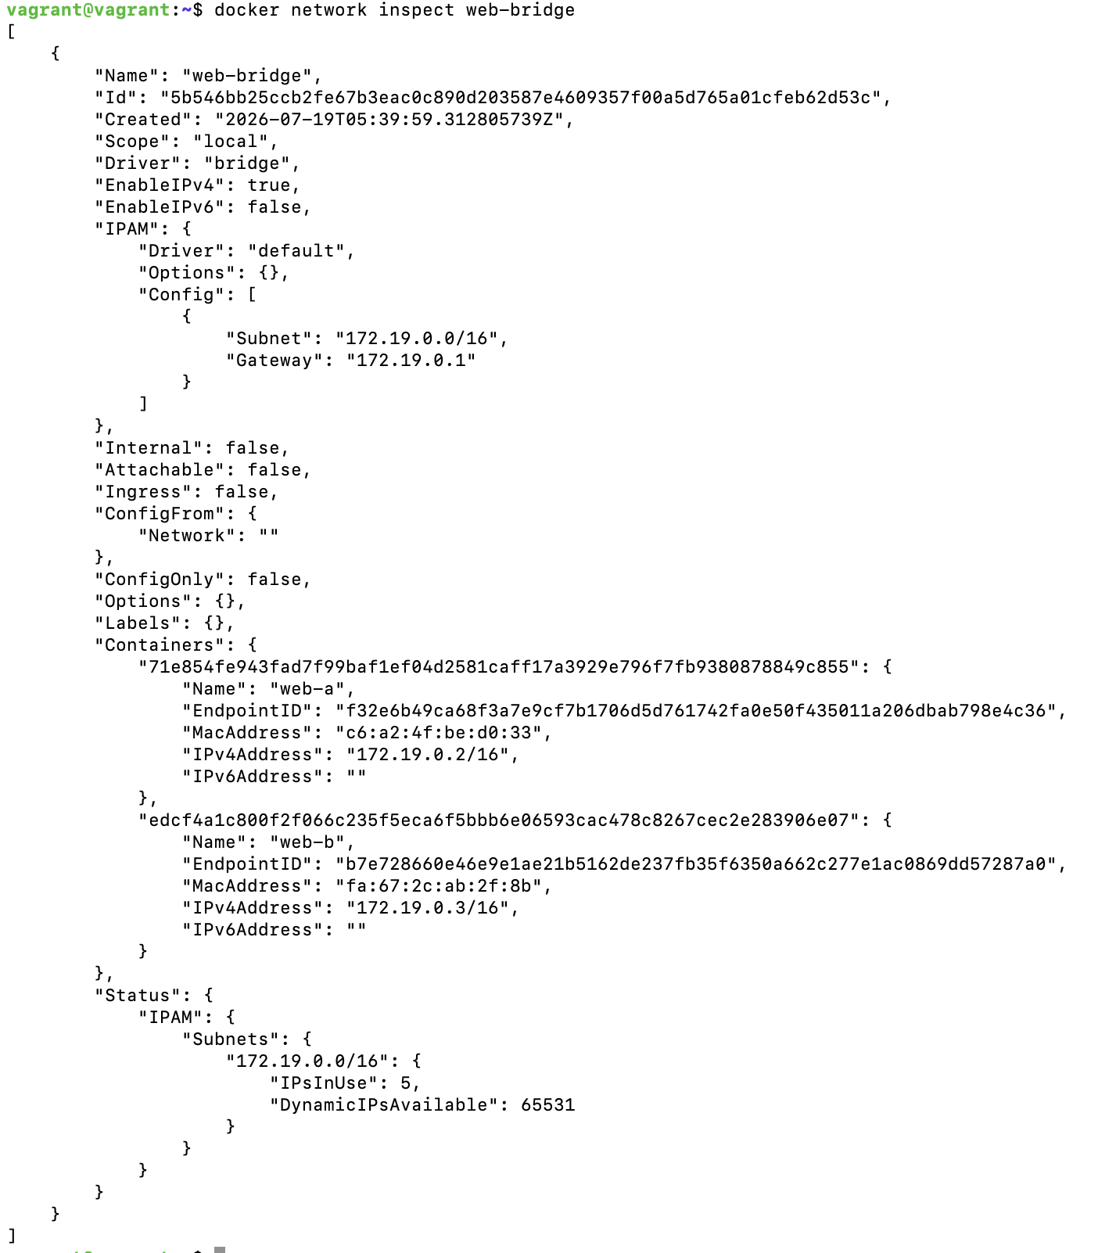

Host network:
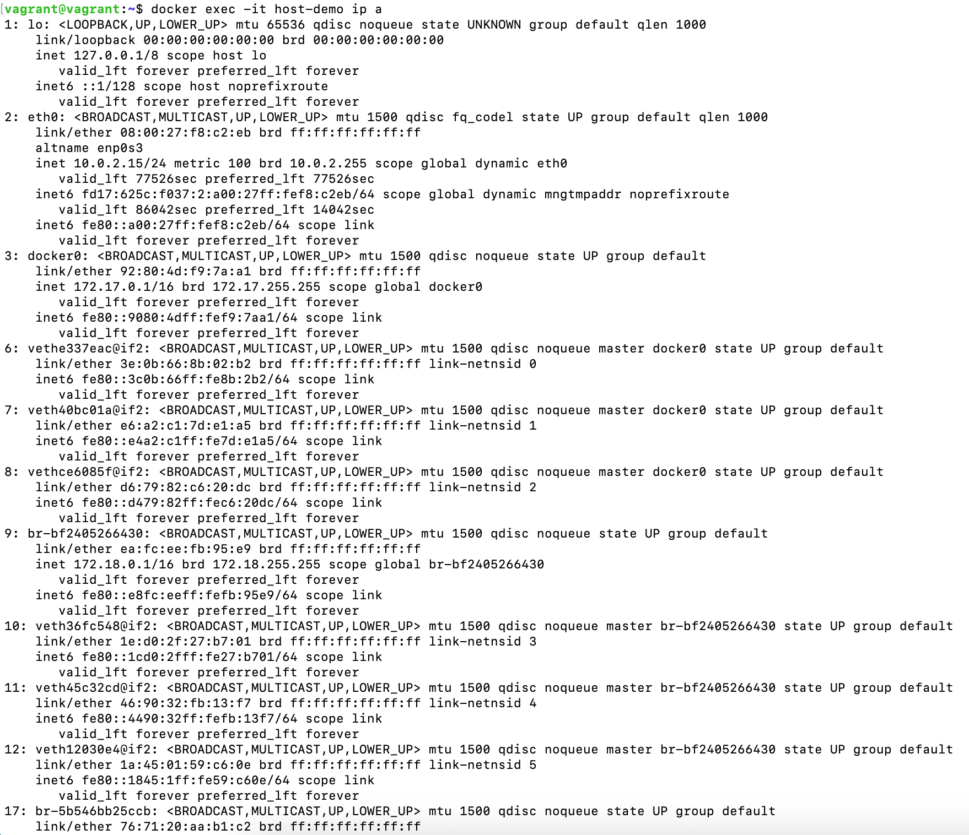

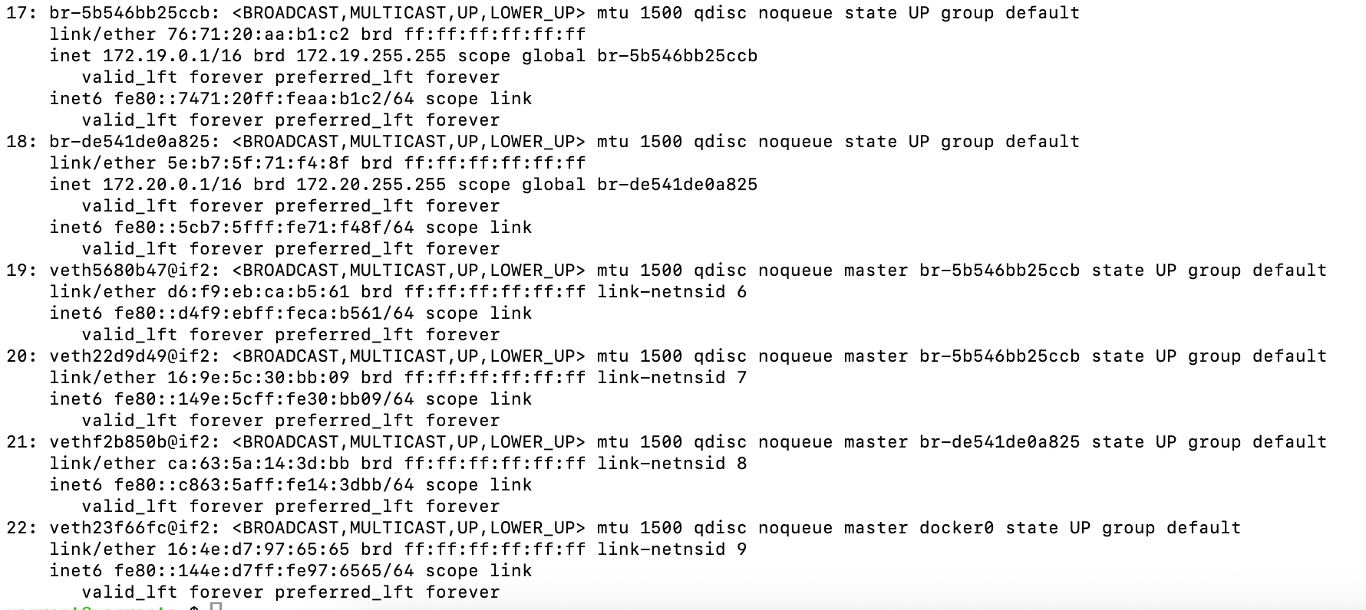
In host mode, container can access host 8888:
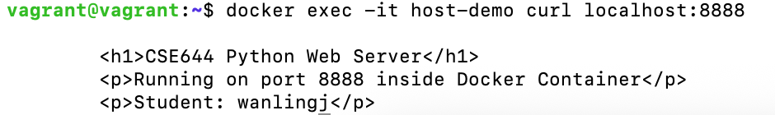

Isolated network:
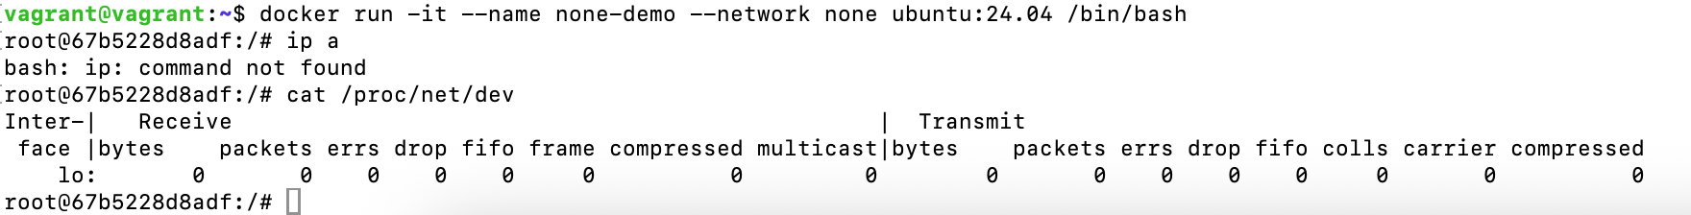
Only lo exists, there is no eth0 or anything else.

- Upload Created or Modified Images to Docker Hub
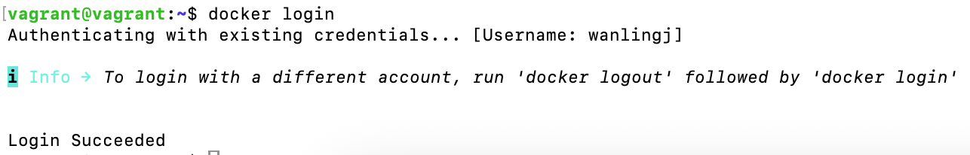
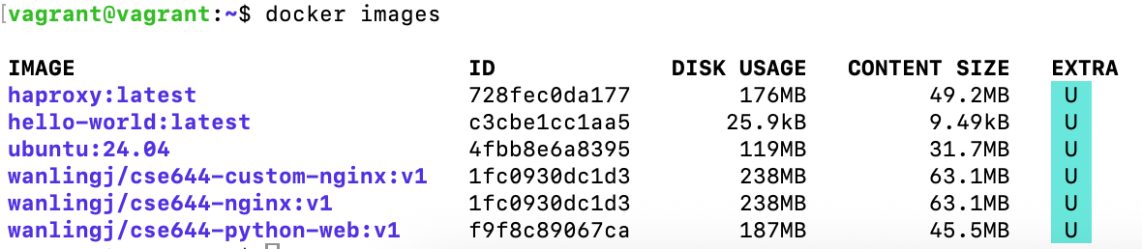
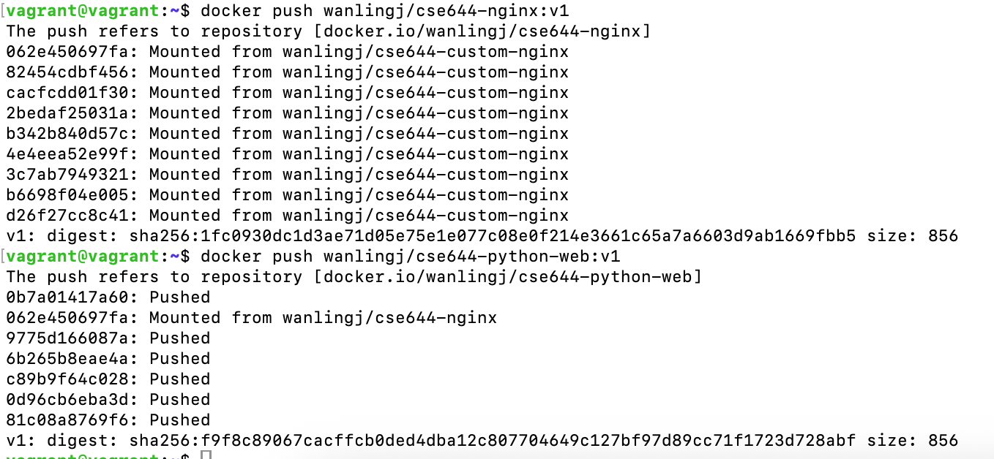
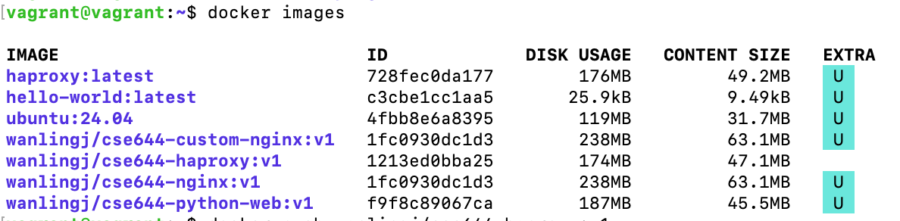

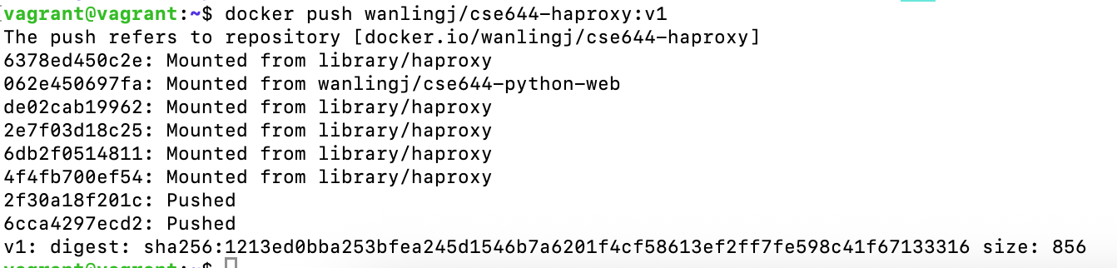
wanlingj/cse644-nginx：
https://hub.docker.com/repository/docker/wanlingj/cse644-nginx/general
wanlingj/cse644-python-web：
https://hub.docker.com/repository/docker/wanlingj/cse644-python-web/general
wanlingj/cse644-haproxy：
https://hub.docker.com/repository/docker/wanlingj/cse644-haproxy/general

- Create or Use a GitHub Account
My GitHub account name is wanlingj-cse


- Upload Scripts and Source Files to GitHub

