Best Software Engineering Group - Pat Hough, Taiwan Savage, Andrew Lipman,

Victor Enenmo, Mamadou Wann, Nate Hamilton

Vision Document

Revision History:

March 10, 2015 - Initial Vision

March 24, 2015 - Added addition supplemental specification outline. Updated list of key features.

Introduction:

This software engineering team was constructed through CISC275, the Introduction to Software Engineering course at the University of Delaware in the spring of 2015. Our initial project is to create a serious game by the end of the semester for our course.

Positioning:

The problem that we are attempting to resolve concerns essential information being communicated to incoming freshmen at the University of Delaware. Most of these freshmen do not know the important times, dates, procedures, and resources that they need to for a successful college experience. To fix these, we will design and implement a fun yet informational game that will teach incoming students this information, test them on it effectively to be sure that they know it, and then record how well the students do throughout the game for future improvement.

The key stakeholders for this project are the University of Delaware Center for Teaching and Assessment of Learning, the University of Delaware Academic Advisement, and the University of Delaware Career Services Center. By better informing the incoming freshmen, it will make the services provided by these centers much more known and therefore much more effective as well.

The Key goal for the users of this product is to get a better understanding of the different supplementary resources that the University of Delaware provides for students. New students which are the primary users of this application, should be easily able to locate services like advisement, or offices of their Dean, counselling, and should have essential knowledge like the drop add date after using this application.

Product Overview:

Our solution will contain a map of the University of Delaware. The map will contain multiple challenges/mini-games that take place at different areas on campus, and once someone completes all of the challenges they will win the game. At each of these challenges students will be taught the essential pieces of information about that area on campus and then they will have an opportunity to show their knowledge of the information in a mini-game format.

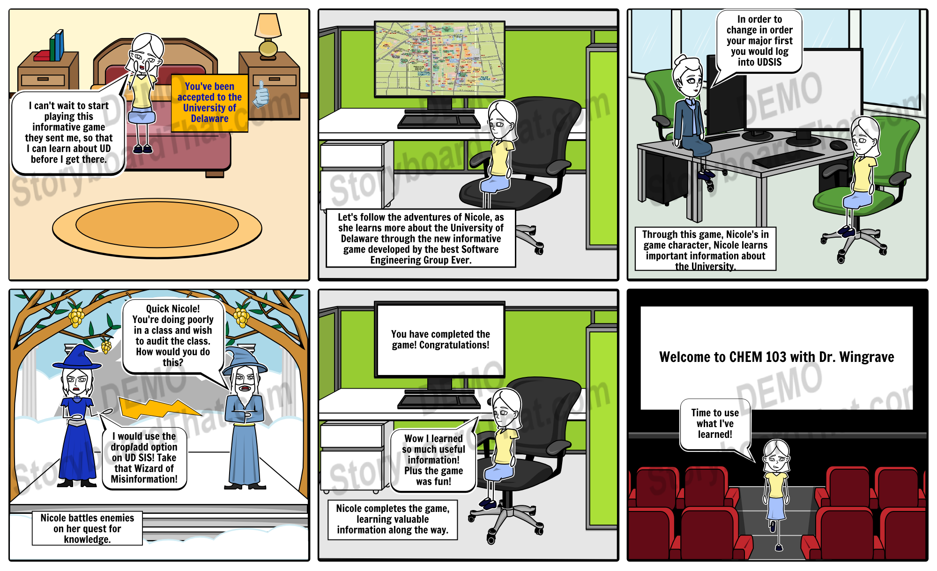

Summary of Key Features:

An interactive map so the user can access all of the areas/challenges when they are ready

Challenges at each area on the map that will teach the students about some essential information

Mini-games to follow each challenge to test that the user has learned the information

The game will feature “YoUDee” as the main character to keep it culturally and gender neural.

There will be a quest log so the user knows what challenges they have already completed and what challenges still remain