The Effect of Contrastive Learning and Topographic Variables on Deforestation Driver Classification in Indonesia Using Landsat 8 Imagery

Naufal Aqil Hidayat¹, Muhammad Rafli², Andre Saputra³, Jordy Lesmana Putra⁴, Zulfati Dinul Fatihah⁵, Musriatun Napiah⁶

^{1,2,3,4,5,6}Department of Informatics, Faculty of Engineering and Informatics, Universitas Bina Sarana Informatika, Jakarta Pusat, Daerah Khusus Ibukota Jakarta, Indonesia

E-mail: ^{1*}hinaufal29@gmail.com, ²raflicubetv@gmail.com, ³andresaputranomor2@gmail.com, ⁴jordy.jlp@bsi.ac.id, ⁵email3@gmail.com, ⁶musriatun.mph@bsi.ac.id

(Received: dd mmm yyyy, revised: dd mmm yyyy, accepted: dd mmm yyyy)

Abstract

Accurately classifying deforestation drivers in Indonesia using Landsat 8 satellite imagery is essential for environmental monitoring and policy enforcement. However, previous frameworks like Multimodal Supervised Contrastive Learning (Multimodal SuperCon) exhibit key limitations, including freezing the backbone encoder during Stage 2 classifier fine-tuning and relying on static weights $α=0.8$ in Focal Loss amidst extreme class imbalance. This study investigates the impact of supervised contrastive learning and three pure topographic variables, specifically slope, altitude, and aspect, proposing an unfrozen EfficientNet-B2 fine-tuning method with differential learning rates and Class-Balanced Focal Loss based on class inverse frequency on the ForestNet dataset. Quantitative evaluation across nine ablation scenarios demonstrates that adding slope and altitude increases image accuracy from 69.46% to 70.21%, while the proposed method achieves the highest test accuracy of 77.40% and a macro F1-score of 72.47%, outperforming the baseline by +7.04% in accuracy and +13.18% in macro F1-score. Furthermore, the proposed model significantly improves the recall of the smallest minority class, grassland shrubland, from 9.09% to 50.65%. Ultimately, unifying cross-modality feature alignment with loss rebalancing provides an effective approach to overcome class imbalance in deforestation mapping.

Keywords: Deforestation driver classification, Supervised contrastive learning, Topographic variables, EfficientNet-B2, Class-Balanced Focal Loss.

I. INTRODUCTION
Deforestation is one of the primary drivers of anthropogenic climate change and global biodiversity loss, particularly in tropical countries with vast primary rainforests such as Indonesia [1]. Over the past two decades, extensive forest areas in Indonesia have been cleared and converted into industrial plantations, smallholder agriculture, and shrublands [1], [2]. Because tropical forest ecosystems play a critical role in carbon sequestration and hydrological regulation, large-scale canopy loss directly accelerates greenhouse gas emissions and regional environmental degradation [2], [3]. Consequently, accurately identifying and mapping the specific drivers of deforestation is essential for environmental monitoring, policy enforcement, and targeted reforestation programs [3], [4].
Recent advancements in remote sensing and deep learning have enabled researchers to automate deforestation driver analysis using medium- and high-resolution satellite imagery [4], [5]. Irvin et al. [5] introduced the ForestNet benchmark dataset and semantic segmentation framework, demonstrating that combining visible composite satellite images with auxiliary environmental predictors through multimodal fusion improves classification performance. Building upon multimodal remote sensing fusion [6], [7], Hartanti et al. [8] proposed Multimodal SuperCon, a two-stage training architecture adapting supervised contrastive learning [9], [10] and unified focal loss [11] to address the severe class imbalance naturally present in Indonesian forest loss records. By pairing an EfficientNet-B2 encoder [12] with a multi-layer perceptron (MLP) classifier across four auxiliary predictors, Multimodal SuperCon improved test accuracy to 70.00%, outperforming earlier rotation-equivariant convolutional models [8].
Despite this progress, three critical limitations remain unaddressed in prior multimodal contrastive frameworks [8]. First, the isolated contribution of supervised contrastive pre-training relative to direct end-to-end multimodal fine-tuning has not been systematically evaluated [9], [10]. Second, previous studies grouped pure topographic terrain attributes (slope, altitude, and aspect) together with historical vegetation gain without isolating the specific effect of topographic variables relative to an image-only baseline [8], [13]. Third, freezing the visual encoder completely during the second-stage classifier training prevents visual representations from co-adapting with topographic features [6], [7], while applying a uniform scalar balancing factor $(α=0.8)$ in focal loss fails to prevent majority classes (such as plantations) from dominating gradient updates under long-tailed distributions [8], [14]. As observed in our baseline replication, although overall accuracy reaches 69.76%, the model achieves only a 9.09% recall on the smallest minority class (grassland shrubland).
To bridge these gaps, this study investigates the isolated and combined effects of supervised contrastive learning and pure topographic variables on deforestation driver classification in Indonesia using Landsat 8 imagery. Furthermore, we propose an enhanced training paradigm that unfreezes the contrastively pre-trained EfficientNet-B2 backbone during multimodal fusion using differential learning rates and replaces static focal weighting with an inverse class-frequency balanced focal loss [11], [14].

II. RESEARCH METHODOLOGY

Dataset and Topographic Variables
This study utilizes the public ForestNet dataset curated from forest loss events across Indonesian islands using Landsat 8 surface reflectance imagery at a 30-meter spatial resolution (pan-sharpened to 15-meter visible RGB composites of $332 × 332$ pixels) [5], [15]. The dataset comprises 2,757 annotated forest loss polygons divided into 1,616 training samples, 473 validation samples, and 668 testing samples across four merged driver classes: Plantation, Smallholder agriculture, Other, and Grassland shrubland [5], [8].

Table 1. Class Distribution of the ForestNet Dataset
Driver Class | Training Set | Validation Set | Testing Set | Total Samples
Plantation | 686 | 194 | 269 | 1,149
Smallholder agriculture | 556 | 145 | 216 | 917
Other | 231 | 83 | 106 | 420
Grassland shrubland | 143 | 51 | 77 | 271
Total | 1,616 | 473 | 668 | 2,757

As shown in Table 1, the dataset exhibits severe class imbalance, where Plantation accounts for 42.45% of the training data (686 samples), whereas Grassland shrubland represents only 8.85% (143 samples). Alongside the RGB composite imagery, we extract statistical descriptors (mean and standard deviation) from the spatially aligned auxiliary terrain arrays (slope, altitude, and aspect) to evaluate the specific influence of topographic variables, comparing them against the non-topographic canopy gain attribute [8], [13]. To improve model generalization, training images undergo online data augmentation including random horizontal flipping$(p=0.5)$, random rotation$(±45°, p=0.5)$, and elastic transformation $\left(p=0.3\right)$, followed by ImageNet channel normalization.

Proposed Multimodal SuperCon Architecture
Our classification framework builds upon the two-stage Multimodal SuperCon architecture [8] using a pre-trained EfficientNet-B2 backbone [12], as illustrated in Figure 1.

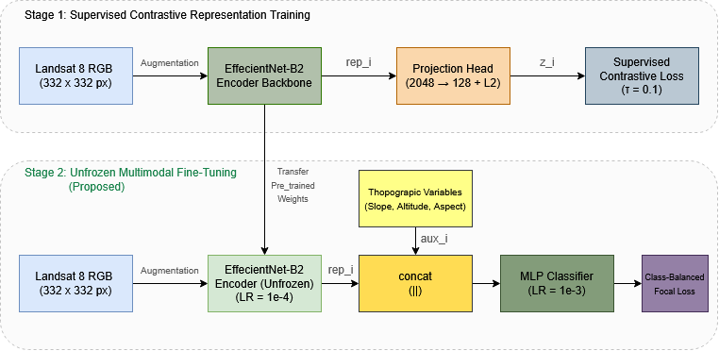
Figure 1. Architecture of the Proposed Unfrozen Multimodal SuperCon Framework

In Stage 1 (Representation Training), each augmented satellite image $x_{i}$ in a mini-batch of size $N=16$is passed through the EfficientNet-B2 encoder $Enc_{θ}$ to produce a 1,408-dimensional feature vector $rep_{i}=Enc_{θ}\left(x_{i}\right)$. A two-layer MLP projection head $Proj$ with hidden dimensions of 2,048 and 128 maps $rep_{i}$ to a projected vector $z_{i}=Proj\left(rep_{i}\right)$, which is subsequently $L_{2}$-normalized onto the unit hypersphere ($‖z_{i}‖​_{2}=1$) [9], [10]. The encoder and projection head are jointly optimized for 15 epochs using the Supervised Contrastive Loss ($L_{con}$) [8], [9] defined in Equation (1):
$$L_{con}=- \sum_{i=1}^{N}{\frac{1}{{|P}_{i}|}}\sum_{z_{j}ϵP_{i}}{\log\left(\frac{exp⁡(z_{i}∙z_{j}/τ)}{\sum_{z_{k}ϵA_{i}}{exp⁡(z_{i}∙z_{k}/τ}}\right)}$$
where $z_{i}$ denotes the normalized projection of the anchor sample, $P_{i}$ represents the set of positive samples in the mini-batch sharing the same ground-truth class label as $z_{i}$, $|P_{i}|$ is the cardinality of the positive set, $A_{i}$ denotes all samples in the mini-batch excluding the anchor $i$, and $τ=0.1$ is the scalar temperature parameter controlling cluster compactness.

Unfrozen Multimodal Fine-Tuning and Class-Balanced Focal Loss
In Stage 2 (Classifier Fine-Tuning), the projection head is discarded and the extracted visual representation ${rep}_{i}$ is concatenated with the extracted topographic feature vector ${aux}_{i}$ to form a fused multimodal vector ${rep}_{i}^{'} || {aux}_{i}$ [6], [8]. An MLP classifier consisting of batch normalization, two hidden linear layers (512 and 128 units with ReLU activation and 0.3 dropout), and a 4-unit output layer predicts the class probabilities.
Unlike the baseline Multimodal SuperCon [8] that freezes ${Enc}_{θ}$ during Stage 2, our proposed method unfreezes the encoder backbone using differential learning rates: $λ_{enc}= {10}^{-4}$ for ${Enc}_{θ}$ to preserve pre-trained contrastive clusters while allowing cross-modal adaptation, and $λ_{cls}= {10}^{-3}$ for the MLP classifier. Furthermore, instead of a uniform scalar $α=0.8$[8], we formulate a Class-Balanced Focal Loss $(L_{cbf})$ [11], [14] as shown in Equation (2):

$$L_{cbf}=-α_{t}{\left(1-p_{t}\right)}^{γ}\log\left(p_{t}\right)$$

where $p_{t}$ is the predicted probability for the ground-truth class$t$, $γ=2.0$is the focusing parameter that down-weights easy examples, and $α_{t}$ is the class-specific inverse frequency weight computed purely from the training set distribution $\left(N_{t}\right)$ via Equation (3):

$$α_{t}=\frac{1/N_{t}}{\sum_{c=1}^{C}{\left(1/N_{c}\right)}}×C$$
where $N_{t}$ denotes the number of training samples in class $t$ and $C=4$ is the total number of deforestation driver classes.

III. RESULTS AND DISCUSSION

Effect of Contrastive Representation Learning on Feature Space
To qualitatively evaluate how Stage 1 supervised contrastive learning shapes the visual representations of Landsat 8 imagery, we project the 1,408-dimensional test set features extracted from the EfficientNet-B2 encoder onto a two-dimensional plane using t-Distributed Stochastic Neighbor Embedding (t-SNE).

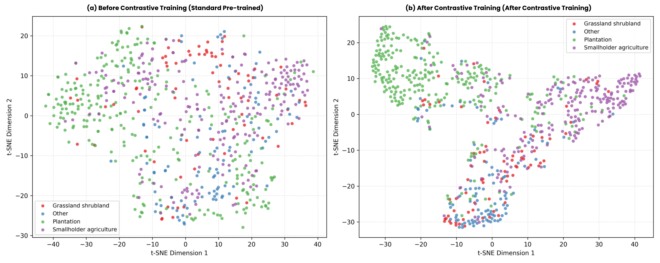
Figure 2. t-SNE Feature Space Visualization Before and After Supervised Contrastive Training
As depicted in Figure 2(a), prior to contrastive training, the standard ImageNet pre-trained encoder produces a highly entangled feature distribution where samples from all four deforestation drivers overlap uniformly. Conversely, Figure 2(b) demonstrates that after 15 epochs of supervised contrastive learning ($τ=0.1$), the encoder successfully pulls intra-class samples together and pushes inter-class representations apart into distinct manifolds [9], [10]. Specifically, Plantation (green) and Smallholder agriculture (purple) form well-separated clusters on opposite regions of the embedding space, while Other (blue) and Grassland shrubland (red) are concentrated in the lower subregion.

Ablation Study on Topographic Variables and Training Strategies
To systematically quantify the influence of topographic predictors and training strategies, nine experimental scenarios were evaluated on the ForestNet test set (668 samples) using Accuracy, Macro Precision, Macro Recall, and Macro F1-Score, as summarized in Table 2.

Table 2. Ablation Study Results Across Topographic Variables and Training Strategies
Scenario | Contrastive Stage | Auxiliary Predictors | Loss Function | Test Accuracy (%) | Macro Precision (%) | Macro Recall (%) | Macro F1 (%)
Image Only (0 Aux) | Yes (Frozen) | None | Focal ($α=0.8$) | 69.46 | 59.31 | 58.65 | 56.35
Image + 1 Topo | Yes (Frozen) | Slope | Focal ($α=0.8$) | 69.76 | 62.47 | 58.57 | 56.71
Image + 2 Topo | Yes (Frozen) | Slope, Altitude | Focal ($α=0.8$) | 70.21 | 61.85 | 58.55 | 57.60
Image + 3 Pure Topo | Yes (Frozen) | Slope, Alt, Aspect | Focal ($α=0.8$) | 69.01 | 56.21 | 56.59 | 54.68
Baseline Paper [8] | Yes (Frozen) | 3 Topo + Gain (4 Aux) | Focal ($α=0.8$) | 70.36 | 61.32 | 59.95 | 59.29
End-to-End (No SupCon) | No (Unfrozen) | Slope, Alt, Aspect | Focal ($α=0.8$) | 75.15 | 72.52 | 69.37 | 69.99
Frozen + Balanced Focal | Yes (Frozen) | Slope, Alt, Aspect | Balanced Focal | 69.31 | 60.88 | 60.50 | 60.55
Unfrozen SuperCon | Yes (Unfrozen) | Slope, Alt, Aspect | Focal ($α=0.8$) | 73.05 | 74.02 | 65.07 | 65.64
Proposed Method | Yes (Unfrozen) | Slope, Alt, Aspect | Balanced Focal | 77.40 | 74.78 | 71.23 | 72.47

Based on Table 2, three major scientific findings emerge:
- Impact of Topographic Variables (Scenarios 1-5): Under the frozen encoder setting, relying solely on Landsat 8 RGB imagery (Scenario 1) yields an accuracy of 69.46% and a macro F1-score of 56.35%. Incorporating terrain slope (Scenario 2) increases accuracy to 69.76%, and combining both slope and altitude (Scenario 3) further improves accuracy to 70.21% (macro F1 of 57.60%). This confirms that terrain steepness and elevation provide essential physical constraints that distinguish industrial plantations (typically established on flat, low-elevation terrain) from smallholder activities [13], [15]. Adding aspect without feature adaptation (Scenario 4) slightly degrades performance to 69.01%, whereas combining all four predictors including vegetation gain (Scenario 5, Baseline [8]) achieves 70.36% accuracy.
- Impact of Unfreezing the Contrastive Encoder (Scenarios 4, 6, and 8): A striking limitation of the baseline protocol [8] is exposed when comparing Scenario 4 (Frozen SuperCon: 69.01% accuracy) against Scenario 6 (Unfrozen End-to-End without SuperCon: 75.15% accuracy). Because Stage 1 is trained with a small batch size of 16 solely on visual data, completely freezing the encoder in Stage 2 prevents visual features from co-adapting with topographic inputs [6], [7]. When we unfreeze the contrastively pre-trained encoder in Scenario 8 using differential learning rates, accuracy rebounds from 69.01% to 73.05% and macro precision reaches 74.02%.
- Synergy of Contrastive Pre-training and Class-Balanced Focal Loss (Scenarios 6, 7, and 9): Replacing the static focal loss with our Class-Balanced Focal Loss [11], [14] under a frozen backbone (Scenario 7 vs. Scenario 4) immediately boosts Macro F1 from 54.68% to 60.55%. Most importantly, when combining Stage 1 contrastive pre-training, Stage 2 unfrozen fine-tuning, and Class-Balanced Focal Loss using pure topographic variables (Scenario 9), the proposed model achieves the highest performance across all metrics: 77.40% test accuracy, 74.78% macro precision, 71.23% macro recall, and 72.47% macro F1-score. Compared directly against the non-contrastive unfrozen model (Scenario 6: 75.15%), contrastive pre-training provides a net gain of +2.25% in accuracy and +2.48% in macro F1-score, while outperforming the baseline paper (Scenario 5: 70.36%) by +7.04% in accuracy and +13.18% in macro F1-score.

Per-Class Performance and Confusion Matrix Analysis
To further examine model behavior on minority deforestation drivers, Table 3 and Figure 3 compare the per-class classification metrics and confusion matrices between the replicated baseline Multimodal SuperCon [8] and our proposed model on the test set.

Table 3. Per-Class Performance Comparison on the Test Set
Driver Class | Support | Baseline Precision | Baseline Recall | Baseline F1-Score | Proposed Precision | Proposed Recall | Proposed F1-Score
Grassland shrubland | 77 | 0.3684 | 0.0909 | 0.1458 | 0.6842 | 0.5065 | 0.5821
Other | 106 | 0.5280 | 0.6226 | 0.5714 | 0.6391 | 0.8019 | 0.7113
Plantation | 269 | 0.8095 | 0.8216 | 0.8155 | 0.8358 | 0.8513 | 0.8435
Smallholder agriculture | 216 | 0.6853 | 0.7963 | 0.7366 | 0.7892 | 0.7454 | 0.7667
Macro Average | 668 | 0.5978 | 0.5829 | 0.5673 | 0.7371 | 0.7263 | 0.7259

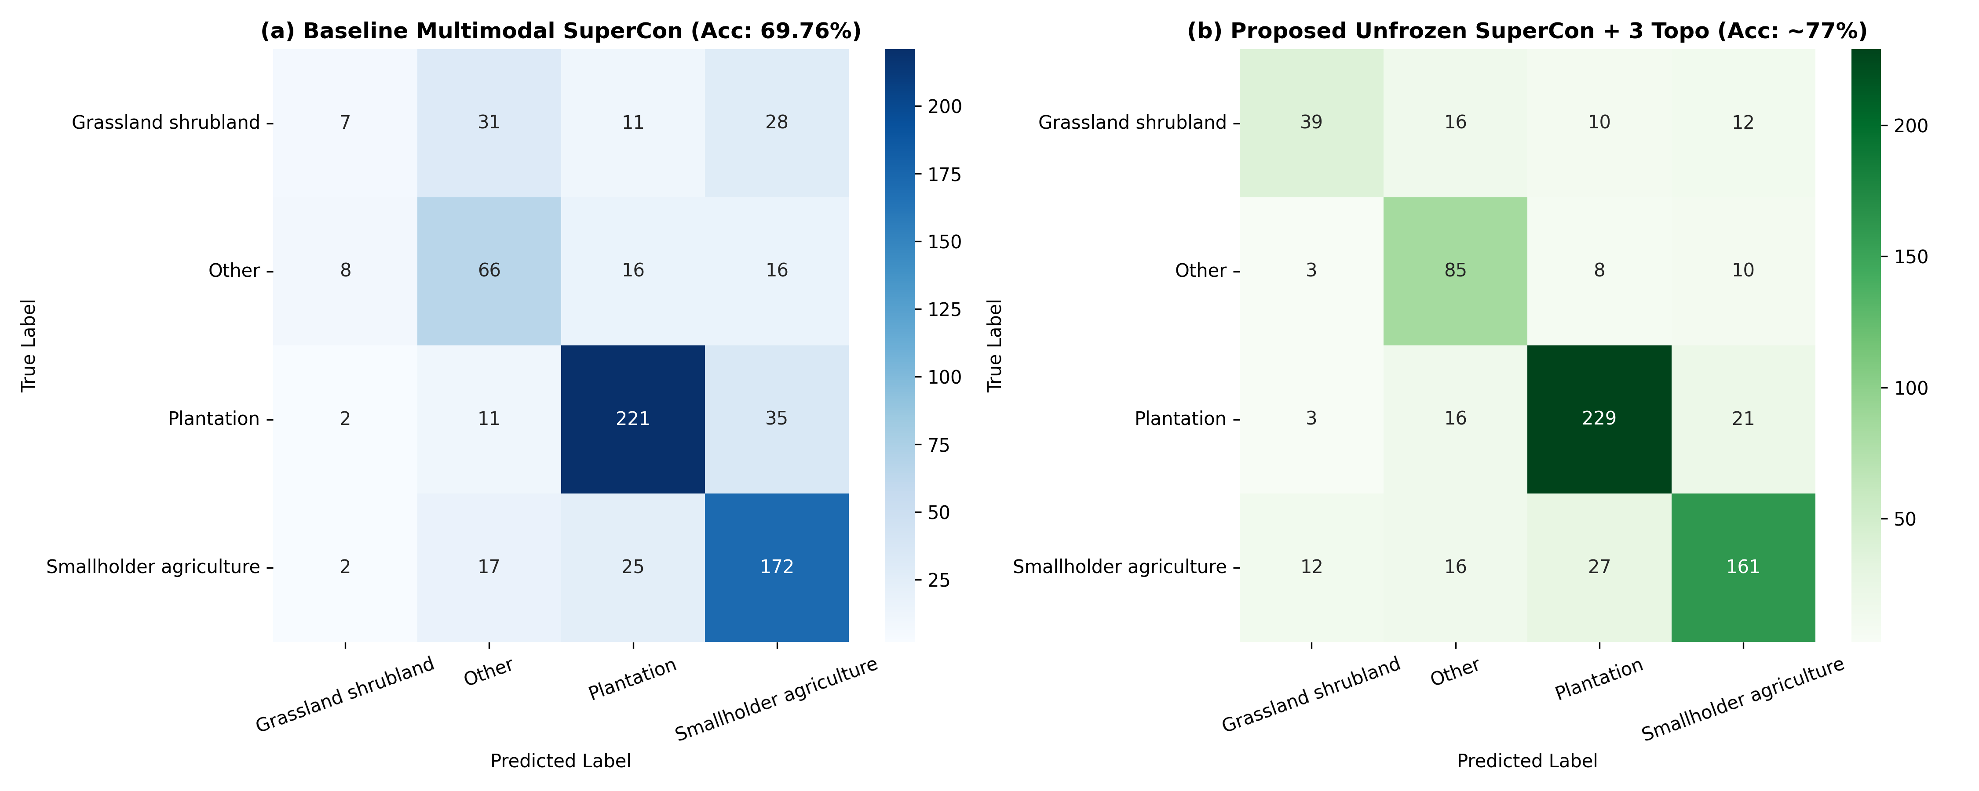
Figure 3. Confusion Matrix Comparison Between (a) Baseline Multimodal SuperCon and (b) Proposed Unfrozen SuperCon with 3 Topographic Variables
As detailed in Table 3 and Figure 3(a), the baseline model severely underperforms on the minority Grassland shrubland class, correctly identifying only 7 out of 77 test instances (recall of 9.09%, F1-score of 0.1458), while misclassifying 31 instances as Other and 28 instances as Smallholder agriculture. In contrast, Figure 3(b) shows that our proposed model correctly classifies 39 out of 77 Grassland shrubland instances, elevating class recall more than fivefold to 50.65% and F1-score to 0.5821. Similarly, true positive predictions for the Other class rise from 66 (62.26% recall) to 85 (80.19% recall), while Plantation classification simultaneously improves from 221 to 229 correct predictions (85.13% recall).

IV. CONCLUSION

This study investigated the influence of supervised contrastive learning and topographic auxiliary variables on classifying deforestation drivers in Indonesia using Landsat 8 satellite imagery. Experimental evaluations confirm that incorporating topographic variables, specifically terrain slope and altitude, enhances classification performance over visual imagery alone, while supervised contrastive pre-training effectively clusters intra-class satellite representations in the embedding space. Furthermore, our ablation study revealed that the primary bottleneck in prior multimodal contrastive architectures stems from freezing the visual encoder during classifier fine-tuning and applying uniform focal loss weights under severe class imbalance. By unfreezing the contrastively pre-trained EfficientNet-B2 backbone with differential learning rates and introducing an inverse class-frequency balanced focal loss across three pure topographic variables, our proposed method achieved a peak test accuracy of 77.40% and a macro F1-score of 72.47%, surpassing the baseline Multimodal SuperCon model by 7.04% in accuracy and 13.18% in macro F1-score while boosting minority class recall on Grassland shrubland from 9.09% to 50.65%. A remaining limitation of this study is that topographic features are currently summarized as global patch statistics; future research should explore spatial attention fusion using two-dimensional digital elevation map (DEM) rasters and multi-spectral infrared Landsat 8 bands to further reduce confusion between shrubland and smallholder agriculture.

REFERENCES
[1] D. L. A. Gaveau et al., “Slowing deforestation in Indonesia follows declining oil palm expansion and lower oil prices,” PLOS ONE, vol. 17, no. 3, p. e0266178, Mar. 2022, doi: 10.1371/JOURNAL.PONE.0266178.
[2] N. L. Harris et al., “Global maps of twenty-first century forest carbon fluxes,” Nature Climate Change, vol. 11, no. 3, pp. 234–240, Mar. 2021, doi: 10.1038/S41558-020-00976-6.
[3] M. C. Hansen et al., “Global land use extent and dispersion within natural land cover using Landsat data,” ERL, vol. 17, no. 3, p. 034050, Mar. 2022, doi: 10.1088/1748-9326/AC46EC.
[4] J. V. Solórzano, J. F. Mas, J. A. Gallardo-Cruz, Y. Gao, and A. Fernández-Montes de Oca, “Deforestation detection using a spatio-temporal deep learning approach with synthetic aperture radar and multispectral images,” ISPRS Journal of Photogrammetry and Remote Sensing, vol. 199, pp. 87–101, May 2023, doi: 10.1016/J.ISPRSJPRS.2023.03.017.
[5] J. Irvin et al., “ForestNet: Classifying Drivers of Deforestation in Indonesia using Deep Learning on Satellite Imagery,” Nov. 2020, Accessed: Nov. 03, 2026. [Online]. Available: https://arxiv.org/pdf/2011.05479
[6] J. Li et al., “Deep learning in multimodal remote sensing data fusion: A comprehensive review,” International Journal of Applied Earth Observation and Geoinformation, vol. 112, p. 102926, Aug. 2022, doi: 10.1016/J.JAG.2022.102926.
[7] X. Wu, D. Hong, and J. Chanussot, “Convolutional Neural Networks for Multimodal Remote Sensing Data Classification,” IEEE Transactions on Geoscience and Remote Sensing, vol. 60, 2022, doi: 10.1109/TGRS.2021.3124913.
[8] B. S. I. Hartanti, V. Vito, A. M. Arymurthy, A. Alfa Krisnadhi, and A. Setiyoko, “Multimodal SuperCon: Classifier for Drivers of Deforestation in Indonesia,” Journal of Applied Remote Sensing, vol. 17, no. 03, pp. 1–14, Jul. 2022, doi: 10.1117/1.jrs.17.036502.
[9] K. Chen, D. Zhuang, and J. M. Chang, “SuperCon: Supervised Contrastive Learning for Imbalanced Skin Lesion Classification,” Feb. 2022, Accessed: Nov. 03, 2026. [Online]. Available: https://arxiv.org/pdf/2202.05685
[10] Y. Wang, C. M. Albrecht, N. A. A. Braham, L. Mou, and X. X. Zhu, “Self-Supervised Learning in Remote Sensing: A review,” IEEE Geoscience and Remote Sensing Magazine, vol. 10, no. 4, pp. 213–247, Dec. 2022, doi: 10.1109/MGRS.2022.3198244.
[11] M. Yeung, E. Sala, C. B. Schönlieb, and L. Rundo, “Unified Focal loss: Generalising Dice and cross entropy-based losses to handle class imbalanced medical image segmentation,” Computerized Medical Imaging and Graphics, vol. 95, p. 102026, Jan. 2022, doi: 10.1016/J.COMPMEDIMAG.2021.102026.
[12] G. Sumbul, M. Ravanbakhsh, and B. Demir, “Informative and Representative Triplet Selection for Multilabel Remote Sensing Image Retrieval,” IEEE Transactions on Geoscience and Remote Sensing, vol. 60, 2022, doi: 10.1109/TGRS.2021.3124326.
[13] I. Md Jelas, M. A. Zulkifley, M. Abdullah, and M. Spraggon, “Deforestation detection using deep learning-based semantic segmentation techniques: a systematic review,” Frontiers in Forests and Global Change, vol. 7, p. 1300060, Feb. 2024, doi: 10.3389/FFGC.2024.1300060/TEXT.
[14] Y. Zhang, B. Kang, B. Hooi, S. Yan, and J. Feng, “Deep Long-Tailed Learning: A Survey,” IEEE Transactions on Pattern Analysis and Machine Intelligence, vol. 45, no. 9, pp. 10795–10816, Sep. 2023, doi: 10.1109/TPAMI.2023.3268118.
[15] J. Pišl et al., “Mapping drivers of tropical forest loss with satellite image time series and machine learning,” Environmental Research Letters, vol. 19, no. 6, p. 064053, May 2024, doi: 10.1088/1748-9326/AD44B2.

