Q27

2-way handshake means no response from the server. So the original host know nothing about the connection is over or not over.

4-way handshake means more resources are wasted.

Q28

UDP can be used in less overhead, faster processing, control over timing, lower latency, no need for lossless data transmission conditions.

Application: video streaming, gaming

Q29

W=1, send 1 packet

After 1 RTT-> W=2, send 2 packets

After 2 RTT-> W=2, send 4 packets

After 3 RTT-> W=2, send 3 packets

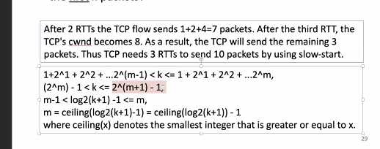

Ceiling(log2(k+1))-1

Q30

By allocation, we mean a vector (r1, r2, r3, r4)

（f1, f2, f3, f4）=(3, 4, 5, 6)

Equal：r= (2.5, 2.5, 2.5, 2.5)

Max-min: r= (2.5, 2.5, 2.5, 2.5)

Proportional: r=5/9\*(3, 4, 5, 6)

（f1, f2, f3, f4）=(1, 2, 3, 6)

Equal：r= (2.5, 2.5, 2.5, 2.5)

Max-min: r= (1, 2, 3 ,4)

Proportional: r=5/6\*(1, 2, 3, 6)

Q31

The Pakistani ISP advertised a more specific route to YouTube. This combined with longest prefix matching caused the outage.

