Q21 C

Q22 A

Since Dijkstra is greedy, the answer computed by Dijkstra may be incorrect.

Q23

Link State

Distance Vector

Distance Vector

Path-vector

Q24

Work correctly: x>=-2

Not work correctly:x<-2

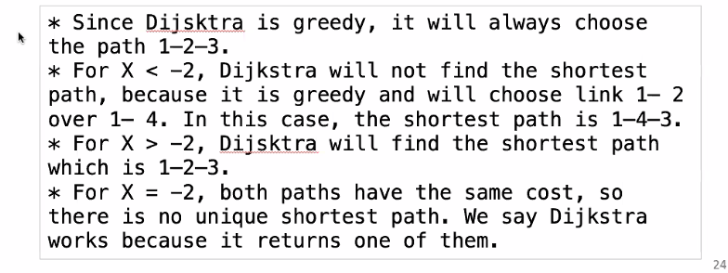

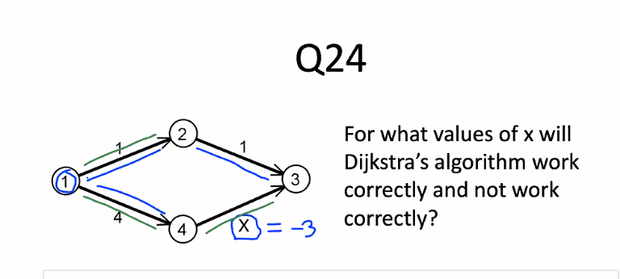

Q25

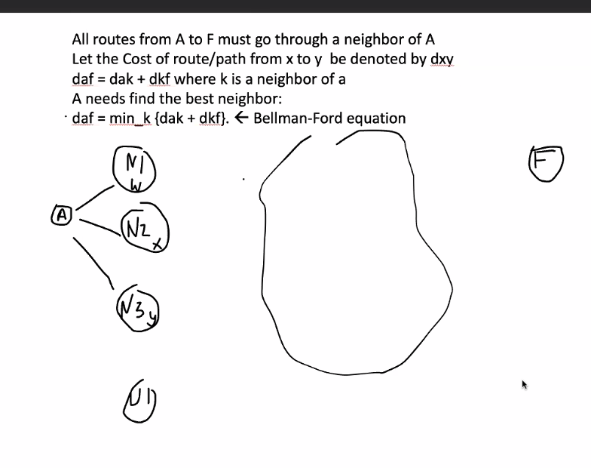

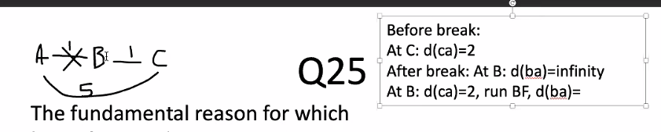

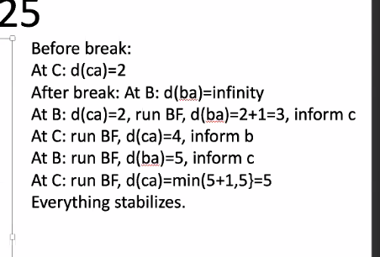

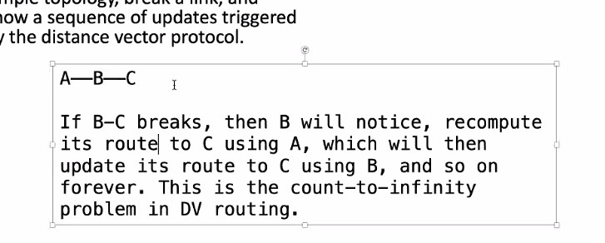

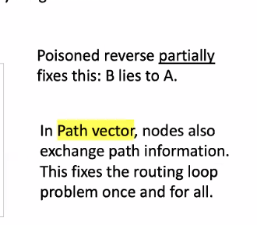

Q26

1. 255.255.255.0
2. 2^8-2=254
3. 4 subnets
4. 198.42.180.0/24 198.42.180.255

198.42.181.0/24 198.42.181.255

198.42.182.0/24 198.42.182.255

198.42.183.0/24 198.42.183.255