

**Problem Set Three**

**Name : LUO ZIJIAN**

**Matric.No： A0224725H**

**MUSNET： E0572844**

1. What are the benefits of IPv6 over IPv4?
2. Large address space. The size of an IPv6 address is 128 bits, compared to 32 bits in IPv4.
3. Multicasting. IPv6 multicast addressing has features and protocols in common with IPv4 multicast, but also provides changes and improvements by eliminating the need for certain protocols.
4. IPsec. IPsec was a mandatory part of all IPv6 protocol implementations, and Internet Key Exchange (IKE) was recommended, but with RFC 6434 the inclusion of IPsec in IPv6 implementations was downgraded to a recommendation because it was considered impractical to require full IPsec implementation for all types of devices that may use IPv6.
5. Simplified processing by routers. With the simplified IPv6 packet header the process of packet forwarding by routers has been simplified. Although IPv6 packet headers are at least twice the size of IPv4 packet headers, processing of packets that only contain the base IPv6 header by routers may, in some case, be more efficient, because less processing is required in routers due to the headers being aligned to match common word sizes.
6. Describe both Link-State & Distance Vector approaches to routing.

Answer: The link-state protocol is performed by every switching node in the network (i.e., nodes that are prepared to forward packets; in the Internet, these are called routers). The basic concept of link-state routing is that every node constructs a map of the connectivity to the network, in the form of a graph, showing which nodes are connected to which other nodes. Each node then independently calculates the next best logical path from it to every possible destination in the network. Each collection of best paths will then form each node's routing table.

The distance-vector routing protocol in data networks determines the best route for data packets based on distance. Distance-vector routing protocols measure the distance by the number of routers a packet has to pass, one router counts as one hop. Some distance-vector protocols also take into account network latency and other factors that influence traffic on a given route. To determine the best route across a network, routers, on which a distance-vector protocol is implemented, exchange information with one another, usually routing tables plus hop counts for destination networks and possibly other traffic information. Distance-vector routing protocols also require that a router informs its neighbours of network topology changes periodically.

1. Classify RIP/OSPF/BGP according to the following metrics: LS or DV, Intra-AS or Inter-AS,Centralized or Distributed

Answer:

RIP – DV, Intra-AS, Distributed

OSPF – LS, Intra-AS, Centralized

BGP – DV, Inter-AS, Distributed

1. Many network engineering problems are about resource allocation – namely the allocation of a set of finite resources amongst users with certain needs. Suppose there are 3 users competing for a 90 mbps link. Users 1 and 2 want 50 mbps each and User 3 wants 10 mbps. My solution is to give each one 30 mbps. Is this fair?

Answer: Equal Distribution could be considered fair. It depends on your definition of fairness.

Another definition of fairness is Proportional Fairness – meaning you give each user bandwidth in proportion to what was requested: User 1 and User 2 each get 90*50/110 mbps and User 3 gets 90*10/110 mbps.

1. We discussed max-min fair in class. What is the max- min fair allocation? What is the TCP fair solution?

Answer:

Max-Min Fairness: The aim is to maximize the minimum resource any flow gets. This means that small flows receive what they demand and larger flows share the remaining capacity equally. Bandwidth is allocated equally to all flows until one is satisfied, then bandwidth is equally increased among the remainder and so on until all flows are satisfied or bandwidth is exhausted.

For the previous problem, the max-min fair allocation is: User 3=10 mbps, User 1= User 2 = 40mbps

TCP Fairness – the allocation algorithm must give the same average resources the same flow using TCP. See http://en.wikipedia.org/wiki/Fairness_measure

1. Consider the communication graph below. The edge labels are of the form a / b, where a is the cost in dollars of using that link and b is the delay in seconds of using that link. Run Dijkstra’s algorithm on this graph and find the optimal route from A to E.

Answer:

|  |  |  |  |  |
| --- | --- | --- | --- | --- |
|  | B | C | D | E |
| A | 2 | 3 | 3 | $$∞$$ |
| AB | --- | 3 | 3 | 2+6 |
| ABC | --- | --- | 3 | 2+6 |
| ABCD | --- | --- | --- | 3+4 |
| ABCDE | --- | --- | --- | --- |

Firstly, at node A, we choose B as the next node to group into our tree.

Secondly, at node A and B, we choose C or D to group in to our tree. At the same time, we update the distance from A to E, this number is 8 now. (2[A->B]+6[B->E])

Thirdly, at node A, B and C, we choose D to group in to our tree.

Lastly, at node A,B,C and D, we choose E to group in to our tree. At the same time, we notice the distance from A to E, this number is 7 now. (3[A->D]+4[D->E])

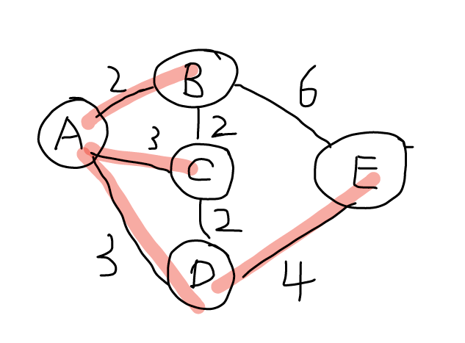

1. For the communication graph above, state the distance vector table that would be computed by node D using the distance vector algorithm.

Answer:

The total distance table is shown below.

|  |  |  |  |  |  |
| --- | --- | --- | --- | --- | --- |
|  | A | B | C | D | E |
| A | 0 | 2 | 3 | 3 | 7 |
| B | 2 | 0 | 2 | 4 | 6 |
| C | 3 | 2 | 0 | 2 | 6 |
| D | 3 | 4 | 2 | 0 | 4 |
| E | 7 | 6 | 6 | 4 | 0 |

As for node D

|  |  |  |  |
| --- | --- | --- | --- |
| Destination | Next node | | |
| A | C | E |
| A | 3 | 5 | 11 |
| B | 5 | 4 | 10 |
| C | 6 | 2 | 10 |
| E | 10 | 8 | 4 |

1. Did you notice that the previous two questions (6 &7) were not well defined? Remember that when you see the word “optimal”, you should first ask what is the optimality metric? Is it cost? Or is it delay? Compute both the delay optimal route and the cost optimal routes.

Answer:

|  |  |  |  |  |
| --- | --- | --- | --- | --- |
|  | B | C | D | E |
| A | 6 | 1 | 4 | --- |
| AC | 1+4 | --- | 4 | --- |
| ACD | 1+4 | --- | --- | 4+4 |
| ACDB | --- | --- | --- | 5+2 |
| ACDBE | --- | --- | --- | --- |

Firstly, at node A, we choose C as the next node to group into our tree.

Secondly, at node A and C, we choose D to group in to our tree. At the same time, we update the distance from A to B, this number is 5 now. (1[A->C]+4[C->B])

Thirdly, at node A, C and D, we choose D to group in to our tree.

And then, at node A,C and D, we choose B to group in to our tree. At the same time, we notice the distance from A to E, this number is 7 now. (4[A->D]+4[D->E])

And then, at node A, B, C and D, we choose E to group in to our tree. At the same time, we notice the distance from A to E, this number is 7 now. (1[A->C]+4[C->B] +2[B->E])

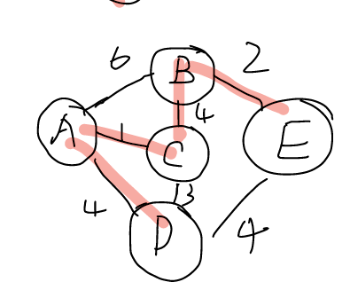

1. In the resource allocation problem, you were asked to compute a “fair” solution. Again, you need to ask first what is the fairness metric? What are some notions of fairness?

Answer:

Equal Distribution Fairness

Proportional Fairness

Max-min Fairness

10. Compare the Dijkstra Shortest Spanning Tree to the Minimum-cost Broadcast Spanning Tree for the graph in Question 6.

Answer:

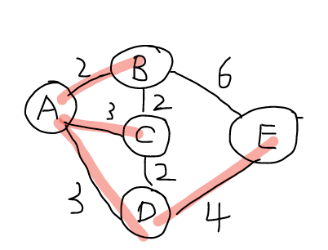

Min-cost spanning tree from A Min-cost spanning tree from A

(from Dijkstra) (from Broadcast)

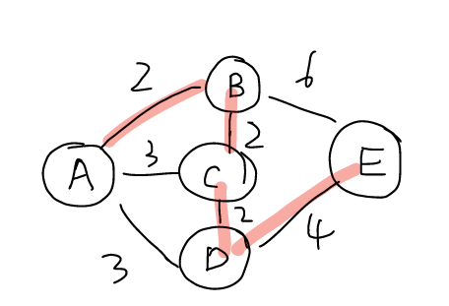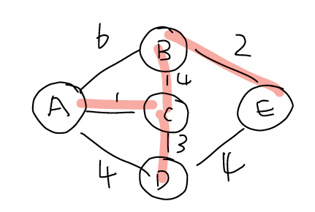

Min-delay spanning tree from A Min-delay spanning tree from A

(from Dijkstra) (from Broadcast)

11. Bonus Question: Consider a wireless network. Does carrier sensing always work in wireless networks? What MAC does WiFi (802.11) use? Describe it and compare it to the MAC used in Ethernet.

Answer:

For an overview, see: http://en.wikipedia.org/wiki/Carrier_sense_multiple_access

Ethernet uses CSMA/CD: http://en.wikipedia.org/wiki/Carrier_sense_multiple_access_with_collision_detection

Wifi (802.11) uses CSMA/CA:

http://en.wikipedia.org/wiki/Carrier_sense_multiple_access_with_collision_avoidance

802.11 also has an additional mechanism called the RTS/CTS mechanism:

http://en.wikipedia.org/wiki/IEEE_802.11_RTS/CTS