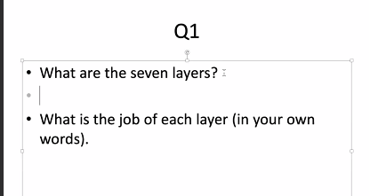

Q1

Physical: Learn how to use the medium of communication, create a link

Link Layer: Create a reliable link

Network: Find a set of reliable links which form a path from source to destination, routing

Transport: Ensure end-to-end reliability

Application: User interface (Source)

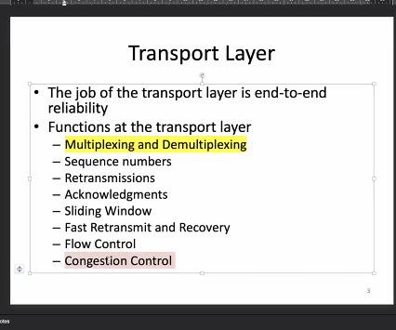

Q2

Slow start: A-B, C’-D, H’-I

Timeout: C，H

Fast-retransmit and Recovery: E, F, J

CWND at A, B, C, C’, D, E: 1, 2^20, 2^20, 1, 2^19, 2^19+17

SSThresh at A, B, C, C’, D, E: inf, inf, inf ,2^19, 2^19, 2^19

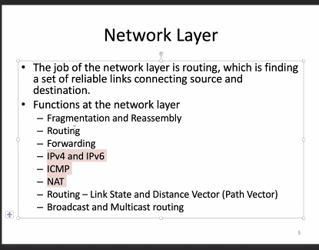

Q3 212.56.132.0/22

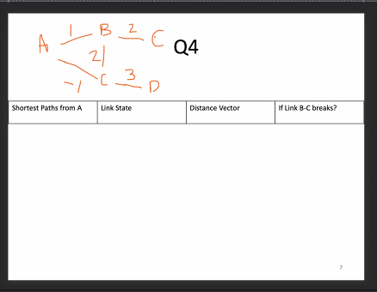

Q4

|  |  |  |  |
| --- | --- | --- | --- |
| Shortest paths from A | Link state  In order | Distance Vector  Same solutions as link state | If Link B-C breaks? |
| A-B | A-C | A-C | Link state |
| A-C | A-C-B or A-B | A-C-B or A-B | There will be no link to E. In the network, topology learning phase, every node will learn this. |
| A-C-D | A-C-D | A-C-D | Distance vector |
| A-B-E | A-C-B-E or A-B-E | A-C-B-E or A-B-E | Count to infinity  Look at B, B will reply on its neighbor, say A, to get E. But A replies on B to get to E. That is the routing loop. |