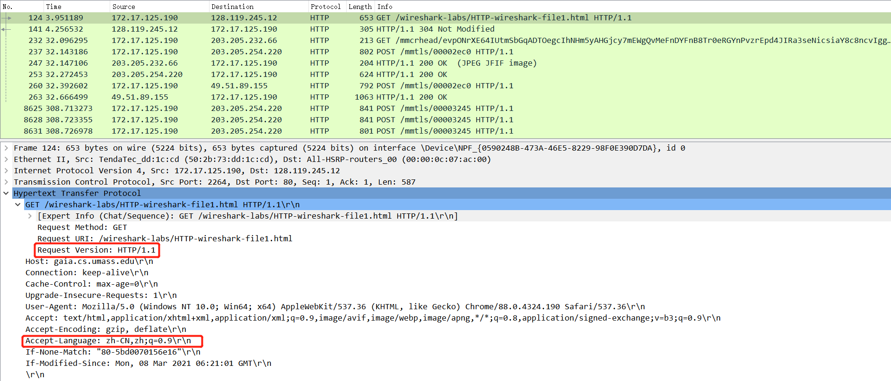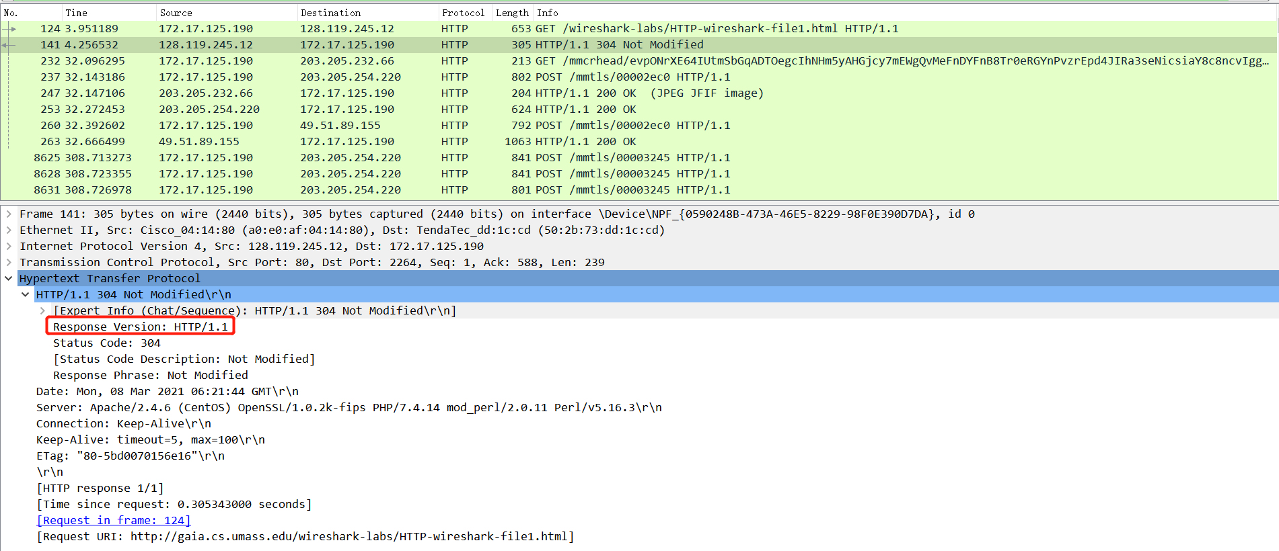

1. Is your browser running HTTP version 1.0 or 1.1? What version of HTTP is the server running?

Answer: They are both running HTTP 1.1

2. What languages (if any) does your browser indicate that it can accept to the server?

Answer: Accept-Language: zh-CN

3. What is the IP address of your computer? Of the gaia.cs.umass.edu server?

Answer: My IP address is 172.17.125.190 and the server’s is 128.119.245.12



4. What is the status code returned from the server to your browser?

Answer: 304; Not Modified

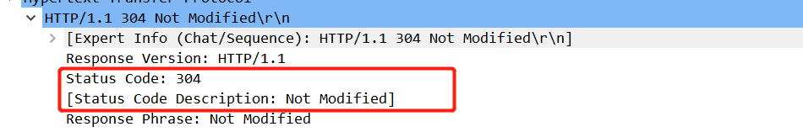

5. When was the HTML file that you are retrieving last modified at the server?

Answer: Mon, 08 Mar 2021 06:21:44 GMT\r\n



6. How many bytes of content are being returned to your browser?

Answer: 128 bytes

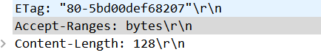

7. By inspecting the raw data in the packet content window, do you see any headers within the data that are not displayed in the packet-listing window? If so, name one.

Answer: No all of the headers can be found in the raw data.

8. Inspect the contents of the first HTTP GET request from your browser to the server. Do you see an “IF-MODIFIED-SINCE” line in the HTTP GET?

Answer: No

9. Inspect the contents of the server response. Did the server explicitly return the contents of the file? How can you tell?

Answer: Yes, we can find this information from Line-based text data field.

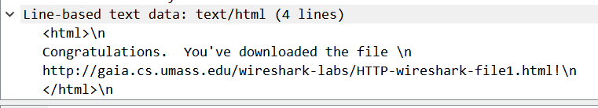

10. Now inspect the contents of the second HTTP GET request from your browser to the server. Do you see an “IF-MODIFIED-SINCE:” line in the HTTP GET? If so, what information follows the “IF-MODIFIED-SINCE:” header?

Answer: Yes

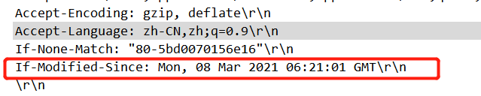

11. What is the HTTP status code and phrase returned from the server in response to this second HTTP GET? Did the server explicitly return the contents of the file? Explain.

Answer: status code: 200

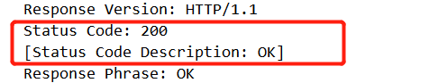

12. How many HTTP GET request messages did your browser send? Which packet number in the trace contains the GET message for the Bill or Rights?

Answer: one HTTP GET request.



13. Which packet number in the trace contains the status code and phrase associated with the response to the HTTP GET request?

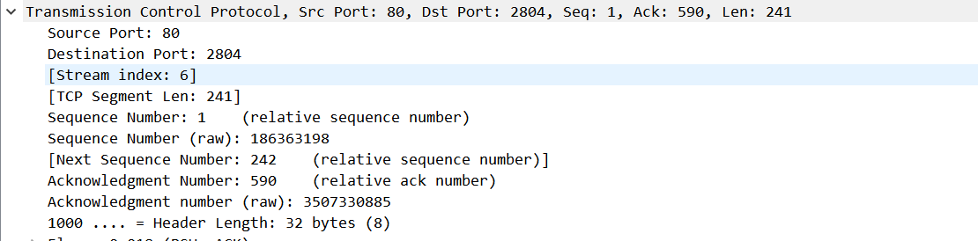

14. What is the status code and phrase in the response?

Answer: 200 OK

15. How many data-containing TCP segments were needed to carry the single HTTP response and the text of the Bill of Rights?

Answer: according to the author’s trace file, we can find there are 4 TCP segments.

