**All code needs to run with MATLAB**

**For Q1**

The main function is **Q1** ,you need to input the right path of data in the third line of this code to load data.Then the code will be ready to run. Another function named **stepfunc** is used to binarize the original data.

More detailed comment is in the code.

The command window will show the errors when α = 1,10,100.

The result should show within seconds.

**For Q2**

The main function is **Q2** ,you need to input the right path of data in the third line of this code to load data.Then the code will be ready to run.

More detailed comment is in the code.

The command window will show the errors.

This result should show within seconds.

**For Q3**

The main function is **Q3** ,you need to input the right path of data in the third line of this code to load data.Then the code will be ready to run.

Another 3 functions are named **s**、**u** and **NLLreg**.

Function **NLLreg** isto compute the negative log likelihood with l2 regularization given the *w*

Function **u** and **s** are used to compute vector μ and its corresponding diagonal matrix S

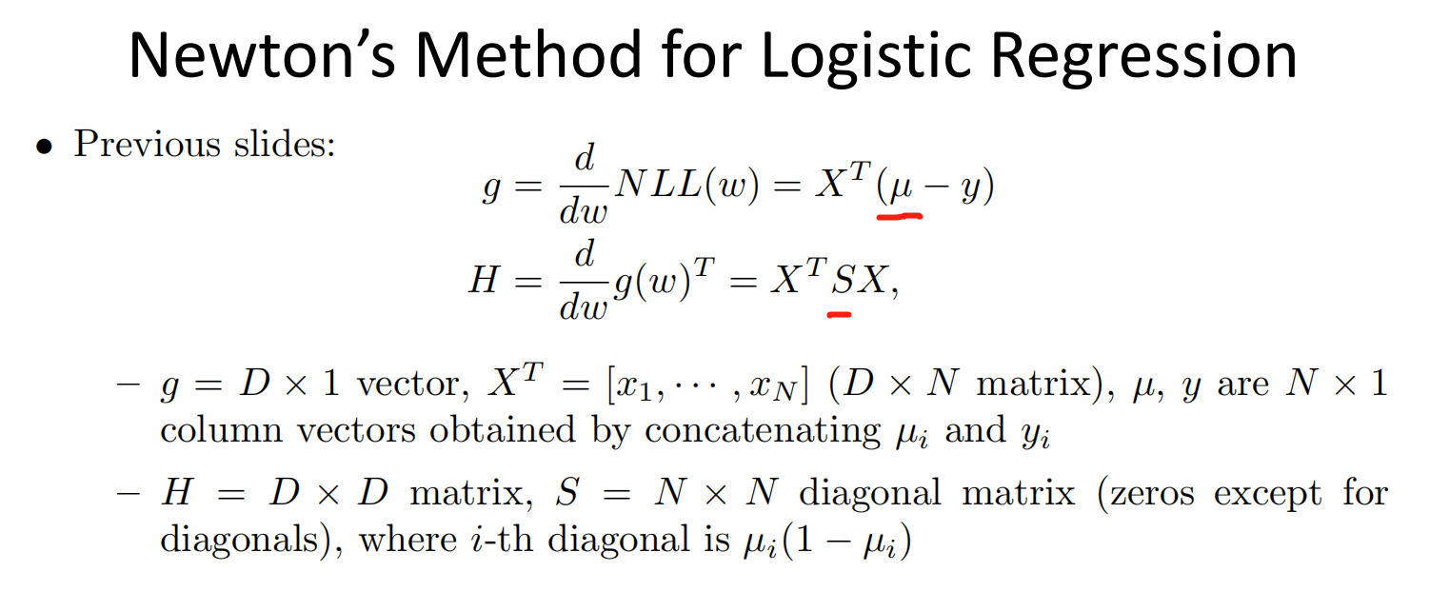

More detailed comment is in the code.

The command window will show the errors when λ = 1,10,100.

This result should show within seconds.

**For Q4**

The main function is **Q4** ,you need to input the right path of data in the third line of this code to load data.Then the code will be ready to run.

More detailed comment is in the code.

The command window will show the errors when K = 1,10,100.

**You may need to wait for minutes before seeing the result ,as it needs more time to finish running this code.Sorry about that . QAQ**