Series 60 Platform 3.0
Nokia TSY Test Tool
Design Document

Team name | Author

Change history:

Version | Date | Status | Comments
1.0 | 31.03.2005 | Approved | Approved in inspection TSW ActionDB id: EO05031657456
0.4 | 06.04.2005 | Proposal | Second inspection comments corrected
0.3 | 11.03.2005 | Proposal | Inspection comments corrected, ready for second inspection
0.2 | 24.02.2005 | Proposal | Ready for first inspection
0.1 | 12.01.2005 | Draft | Initial draft created
Table of contents:

1. Document control 4
1.1 References 4
1.2 Documentation conventions 4
1.3 Abbreviations 4
1.4 Definitions 4
2. General 5
2.1 Introduction 5
2.2 Services required 5
2.2.1 From Symbian OS subsystems 5
2.2.2 From the Domestic OS subsystems 5
2.2.3 From HW 5
2.3 Services provided 5
2.3.1 UI 5
2.3.2 SW IF 5
2.4 Nokia TSY Test Tool Concepts 6
2.4.1 Test Case 6
2.4.2 Test Module 6
3. Design 7
3.1 Static Model 7
3.1.1 Component Diagram 7
3.1.2 Component Descriptions 7
3.1.2.1 STIF Test Framework 7
3.1.2.2 Nokia TSY Test Tool module 7
3.1.2.3 ISC 8
3.1.3 Class Diagram 8
3.2 Nokia TSY module testing 10
4. System resource usage 12
4.1 Files 12
4.2 Databases 12
4.3 Memory consumption 12
4.4 Task allocation 12
5. Exception handling 13
6. Usage 14
6.1 Building 14
6.2 Setting up a Memory Card 14
6.3 Running test cases 14
6.4 Interpreting results 15
6.5 Logging 15

Document control

References
- Series 60 Platform 2.6 Nokia TSY Design Document
- Series 60 STIF Test Framework User's Guide

Documentation conventions
Code is shown with Courier New font.

Abbreviations

API | Application Programming Interface
DLL | Dynamic Link Library
DOS | Domestic Operating System
HW | Hardware
IF | Interface
OS | Operating System
STIF | Name of the developed test tool
SW | Software
UI | User Interface
TSY | Symbian OS Telephony Subsystem
CellMo

Definitions

Common TSY | A platform that provides framework for Nokia TSY.
MMP | Project definition file.

General
This document describes the testing environment for Nokia TSY module.

Introduction
Nokia TSY [1] is an ETel extension module that handles the Nokia -specific part of TSY interaction between the ETel server and CellMo.
Nokia TSY Test Tool is testing software that integrates to STIF Test Framework, which provides user interfaces for running and monitoring test cases. Nokia TSY Test tool’s purpose is to test Nokia TSY via Common TSY plug-in API.

Services required
This section introduces required services by Nokia TSY Test Tool.

From Symbian OS subsystems
Nokia TSY Test Tool is running in STIF Test Framework. STIF Test Framework offers interface to Common TSY plug-in API and from that to Nokia TSY.

From the Domestic OS subsystems
The communication with Domestic OS is out of scope of this document.

From HW
This component has no direct HW interfaces.

Services provided
This section introduces provided services by Nokia TSY Test Tool.

UI
Nokia TSY Test Tool does not have an UI.

SW IF
Nokia TSY Test Tool provides a Common TSY plug-in interface that can be used to extend its functionality with plug-in test modules. It also provides a client-server interface that is used by the plug-in modules to communicate with the test tool.

Nokia TSY Test Tool Concepts
Concepts in Nokia TSY Test Tool are described here.

Test Case
From the STIF UI point of view, one test case is a single unit of execution. A test case is run by STIF and when it returns, the results from the run are shown in the UI and logged. One test case is one line in test framework display. From Nokia TSY Test Tool point of view, a test case can be divided into multiple parts that may be executed independently of each other. Test case parts are separated from each other by title. One test starts with [Test] and ends with [Endtest]. When all test case parts are completed, the results are passed to the STIF.

Test Module
Test Module contains the actual test case implementation. Test modules are implemented as separate DLLs that STIF Test Framework dynamically loads. Test modules can be freely implemented, as long as they provide the required interface, which Test Engine can use.

Design
Nokia TSY Test Tool design is descript in following sections.

Static Model
This chapter describes the static object model of the component.

Component Diagram
describes the components needed in Nokia TSY module testing. Alleyellow parts are Nokia TSY Test Tool
module related parts.
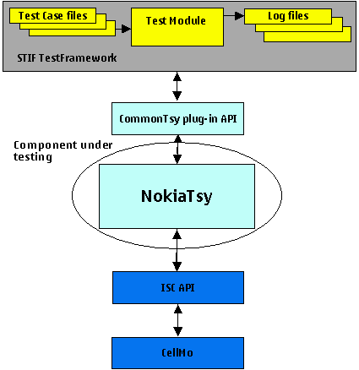

Figure 1Component diagram for Nokia TSY module tests

Component Descriptions
Used components by Nokia TSY Test Tool.

STIF Test Framework
STIF Test Framework is used for executing the tests.

Nokia TSY Test Tool module

Nokia TSY Test Tool uses
TestScripter module (see Figure 2) to execute methods listed in script file from test classes. All test case specific functionality is implemented to test classes.
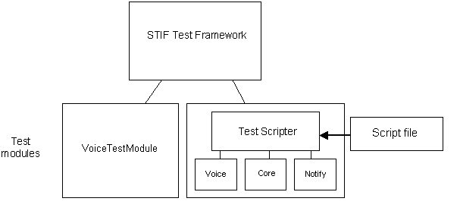
Figure 2 TestScripter in STIF Test Framework

ISC
The User-side API for sending/receiving messages from Domestic OS.
The actual functionality of the ISC module is out of the scope of this document. This document describes the interfaces that are used when integrating the module into Nokia TSY Test Tool.

Class Diagram
Figure 3 describes classes in Nokia TSY Test Tool. More classes ( Supplementary, Conference Call etc…) will be added later.
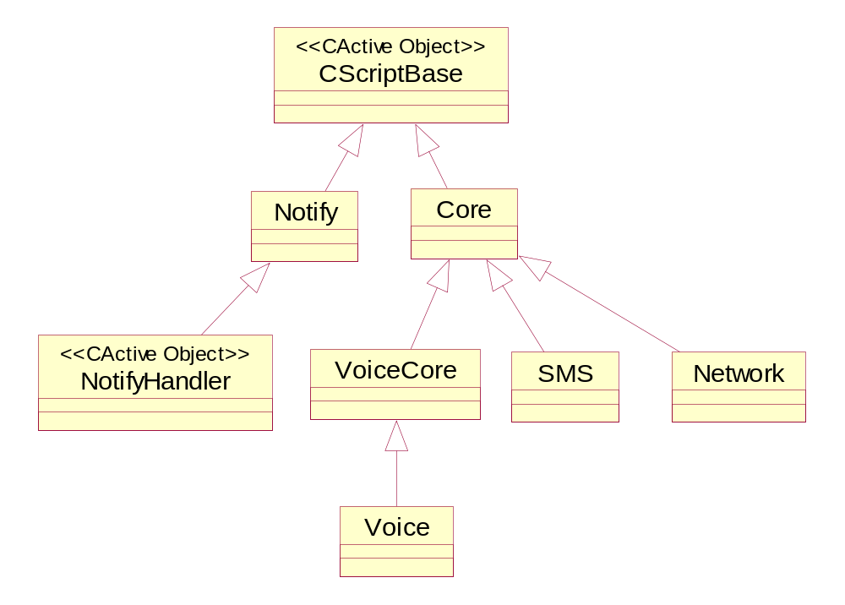
Figure 3Nokia TSY Test Tool model
STIF Test Framework is designed to use polymorphic dlls. For developers view this means that those dlls cannot export any other function outside the dll other than Library Entry function.
Test cases are specified in they own categories like SMS or Voice. For each group there is own dll. To avoid repeating basic functions in every dll, one major base class Core is created that holds basic functionality.
Same call control functionality is going to be shared by Voice and Supplementary services classes. To make code more compact and clearer common code to voice and supplementary services is in class VoiceCore. Both Voice and supplementary services inherits VoiceCore.
Several asynchrony calls can be pending simultaneously. It is not possible to catch correct asynchrony call so Notify class that is inherited directly from CActive class is created. New notify object is called every time new asynchrony call is pended. Objects created from the Notify class are simply called notify1, notify2 and so on.
Note that all functions can be found in every class. In script parameters are given always after command. If correct parameter comparison is not found in the sub class upper class function is called and parameter is forwarded also. If correct comparison is not found again base class function is called and parameters forwarded again. Only if this class functions parameter comparison is not successful error is raised.

Class | Description | Header file
CCore | Core is inherited from the CSriptBase class. Core is static dll. This class holds general functionality that is common to all classes.  Core class can’t be called directly from script. | Core.h
CVoiceCore | VoiceCore is inherited from the CCore class. VoiceCore is static dll. This class holds general functionality. Example: dialing and hang up. This class holds same name functions as Core.  VoiceCore class can’t be called directly from the script. | VoiceCore.h
CVoice | Voice is inherited from the CVoiceCore class. Voice is polymorphic dll. This class holds only minor functionality. All other general functionality is raised to VoiceCore class. However because core class is static dll and could not be called directly from the script, Voice class main functionality is just to work as a class which is called in every Core and Voice test. This is implemented by calling VoiceCore functions.  Voice can be called directly from the script. | Voice.h
CSMS | SMS is inherited from CCore class. SMS is polymorphic dll. This class holds SMS’s specific functionality.  SMS can be called directly from the script. | SMS.h
CNWE | Network is inherited from CCore class. Network is polymorphic dll. This class holds Network’s specific functionality.  Network can be called directly from the script. | Network.h
Notify including notify handler | Notify is independent class which is inherited from CScriptBase class. Notify is polymorphic dll and it can be called directly from the script.  Object from this class is created every time it necessary to monitor status of synchronic call. When asynchrony call is completed or cancelled it thread returns to notify handler which log correct information and signals completions.  Note that only one synchrony call can be monitored by one object created from this call. So if several asynchrony calls is pending simultaneously user must create as many notifies objects, as asynchrony is required to be monitored. | Notify.h

Nokia TSY module testing

Figure 4 descript the sequence of running Nokia TSY module test cases.
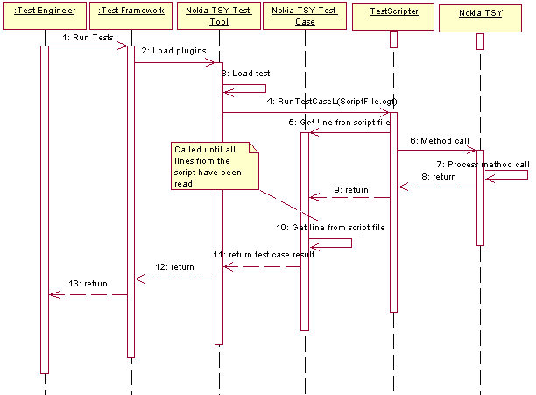
Figure 4 The sequence of running Nokia TSY module test cases
Sequence explained:
      - Test engineer runs the tests in STIF test framework
      - Test framework loads Nokia TSY Test Tool module
      - Nokia TSY Test Tool loads test case

      - Test framework calls RunTestCaseL() for test case
      - TestScripter reads line from script
      - TestScripter calls the actual method (e.g. Nokia TSY method) based on line read from script
      - Method is processed
      - Return method return value
      - Return test case result
      - TestScripter reads next line from script
      - Return test case result
      - Return test case result

      - Return test case result

System resource usage
This chapter describes usage of system resources.

Files
Nokia TSY Test Tool generates log files to c:\logs\TestFramework directory that is located in \epoc32\wins\c\logs\testframework\ in WINSCW environment. By default, if the directory does not exist, then component does not create log file.

Databases
This SW does not use any database.

Memory consumption
Memory consumption should not be an issue since this is test SW.

Task allocation
This software module runs in threads/processes of STIF.

Exception handling
There are multiple levels of exception handling in STIF Test Framework and Nokia TSY Test Tool:
- If a test case does not return in time, STIF terminates the test module. It then reloads all test cases and continues from the next test case.
- If a Nokia TSY function leaves, the test case object of the Nokia Tsy Test Tool module traps the leave and returns the leave code to STIF as test result.
- If a function causes a crash within NokiaTSY, the next NokiaTSY function call should restart it. However, all states that have been initialized in previous test cases are lost so some future test case may fail.

NokiaTSY Test Tool defines the following error codes for test cases:
Error code | Value | Description
KErrNone | 0 | Tells that no error in system.
KErrNotFound | -1 | Tells that item not found.
KErrGeneral | -2 | An error that has no specific categorization.
KErrCancel | -3 | Indicates an operation that has been cancelled.
KErrNoMemory | -4 | Tells that an attempt to allocate memory has failed.
KErrNotSupported | -5 | Tells that some functionality is not supported in a given context.
KErrArgument | -6 | Tells that an argument is out of range.
KErrServerBusy | -16 | A client/server send/receive operation cannot run, because the server is busy handling another request.
KErrNotReady | -18 | Indicates that a device required by an i/o operation is not ready to start operations. A common reason for returning this code is because a device has not been initialized, or has no power.
KErrTimedOut | -33 | Tells that an operation has timed out.

Usage
This chapter describes how to build and run STIF Console UI based testing environment in HW. Environment includes a Symbian release, STIF Test Framework and NokiaTSY Test Tool.

Building
The Symbian environment with NokiaTSY Test Tool and STIF Test Framework needs to be obtained first. See reference [2] for STIF Test Framework instructions. After STIF Test Framework has been built, go to nokiatsytesttool\group directory and type following commands:
bldmake bldfiles
abld build.

Setting up a Memory Card
To be able to use Nokia TSY Test Tool, the required files need to be copied into a memory card. Memory card should have following directory structure:
CONSOLEUI.EXE
\system
\libs
STIFTESTENGINE.DLL
STIFTESTINTERFACE.DLL
STIFTESTSERVER.DLL
STIFTFWIF.DLL
TESTCOMBINER.DLL
TESTSCRIPTER.DLL
\programs
TESTSERVERSTARTER.EXE
\Testframework
TESTFRAMEWORK.INI

File locations:
CONSOLEUI.EXE, TESTSERVERSTARTER.EXE and all files to be copied under \system\libs -directory are found from epoc32\release\thumb\udeb -directory after successful build process of STIF Test Framework and Nokia TSY Test Tool.
TESTFRAMEWORK.INI file is found from \nokiatsytesttool\group-directory.

Running test cases
After proper file structure has been created, use filebrowser to launch ConsoleUi.EXE. STIF Console UI is a menu-based application, which requires that at least two navigation keys are available. One key is used to activate an item from menu, and another key is used to change the selection. STIF Console UI supports also the use of Series 60-type five-way navigation.
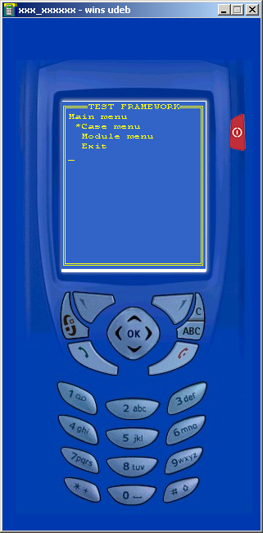
Figure 5 STIF Main Menu
Test cases can be viewed and executed one by one by selecting Case menu\Start new case and selecting the case to be executed. Selecting Case menu\Run multiple cases can start sequential execution. Note that NokiaTSY Test Tool does not support the concurrent execution selection that is shown in the Run multiple cases menu.

Interpreting results
Test results can be viewed in the test tool itself or from logs that are generated while tests are executed.
In the test tool, results of already executed tests can be found from Passed cases, Failed cases or Aborted/Crashed cases menus. If a test case is not yet completed, it is located in Ongoing cases menu. All executed cases can be found from Executed cases menu.

Logging
Logs are created into the directory specified in the TestFramework.INI file. By default the directory is c:\Logs\TestFramework. Modifying the following lines in TestFramework.INI can change default directory for emulator or for hardware:
EmulatorBasePath= C:\LOGS\TestFramework\
HardwareBasePath= D:\LOGS\TestFramework\
Logs files are in html format and the file name is a timestamp from the point of time the STIF test framework was started. If a test case crashes, a new html log file gets generated. Note that although the log file is generated by the release version of NokiaTSY Test Tool, the release version will not write anything into the file. In addition to the html log files, STIF Test Framework generates a TestReport.TXT file that contains the results of each test case that has been run.

