NokiaTSY Test Tool User’s Guide
NokiaTSY Test Tool
Telephony Services Technology Team

Team name | Author

Change history:

Version | Date | Status | Comments
0.5 | 3-Oct-2005 | Proposal | Added chapter about ISC Test Control
0.4 | 2-Sep-2005 | Proposal | Setup instructions updated
0.3 | 15-Aug-2005 | Proposal | Changes done according inspection and changed setup instructions
0.2 | 1-Aug-2005 | Proposal | Changes done
0.1 | 08-Jun-2005 | Draft | First version done

Table of contents:

1. Document control 4
1.1 References 4
1.2 Conventions 4
1.3 Abbreviations and definitions 4
2. Introduction 6
2.1 Document purpose 6
2.2 NokiaTSY Test Tool basics 6
3. Environment 7
3.1 General 7
4. Creating the environment for NokiaTSY Test Tool 8
4.1 Compiling STIF Test Framework 8
4.2 Creating the emulator environment with PC 9
4.2.1 Test Framework 9
4.2.2 Parameters for log files 10
4.2.3 Test scripts to be run 10
5. Script file 11
5.1 Script file structure 11
5.2 Creating instances from test classes 11
5.3 Deleting instances 11
6. Compiling test classes 12
6.1 Compiling the test classes 12
6.2 Default directory structure 12
7. Running the test cases 13
7.1 Before running test cases in an emulator 13
7.2 Running test cases in an emulator 14
7.3 Checking the result of the test cases 15
8. Using ISC Test Control with NokiaTSY Test Tool 17
8.1 Steps to get ISC Test Control to use 17
8.2 Using ISC Test Control form test classes 18
9. Appendix A: TestFramework.INI file 19
10. Appendix B: Example of test script file 23
11. Appendix C: Setup instructions to NokiaTSY 24

Document control

References

- NokiaTSY Test Tool Design Document
- NokiaTSY Test Tool Test Specification
- Series 60 STIF Test Framework Test Scripter User’s Guide
- Series 60 STIF Test Framework User’s Guide
- ISC Test Control Test Case Development Guide

Conventions
Code is shown with Courier New font.

Abbreviations and definitions

ADN | Abbreviated Dialing Numbers
API | Application Programming Interface
ATS | Automatic Test System
CAP | SIM access and capabilities
CC | Conference Call
DLL | Dynamic Link Library
EN | Emergency Number
ETEL | EPOC Telephony Server Multimode API
MM | Multimode
ON | Own Number list
OS | Operating System
SDK | Software Development Kit
SDN | Service Dialing Number list
SEC | Security
SIM | Subscriber Identity Module
SMS | Short Message Service
SS | Supplementary Service
Script | Text file that includes function calls to functions that are located in wrappers.
STIF | System Test and Integration Factory
Test case | Test case contains one script and wrappers that are needed for testing a specific feature.
UI | User Interface
UID | Unique Identification
USSD | Unstructured Supplementary Service Data
SPP | Symbian Product Platform
TP | Technology Platform
CASW | Cellmo Adaptation SoftWare
TSTT | Telephony Services Technology Team

Introduction

Document purpose
This document has been created to give a general instruction for using NokiaTSY Test Tool. The document describes in detail how to use NokiaTSY Test Tool and how to create test cases for the tool. It also describes how to run test cases in emulator environment.

NokiaTSY Test Tool basics
NokiaTSY Test Tool is created to test the functionality of NokiaTSY. NokiaTSY Test Tool is based on STIF Test Framework. Components described in this document are general in nature. Test cases can be modified by changing function calls and parameters in script files. This functionality makes NokiaTSY Test Tool flexible and dynamic.

Environment

General

NokiaTSY test tool is a module testing environment for Telephony Services Technology Team. NokiaTSY test tool has been implemented using Series 60 platform release 3.0. Using NokiaTSY test tool with some other Series 60 platform, it’s not 100 percent guarantee NokiaTSY test tool will work correctly with that.
NokiaTsyTestTool includes
- Test Case files (Voice.cfg, SMS.cfg, Network.cfg, Nofify.cfg) and
- Test modules (Voice, SMS, Core, and Notify).
NokiaTsyTestTool tests NokiaTsy – module via CommonTsy plug-in API.
In the picture below yellow boxes are NokiaTsy Test Tool related parts.

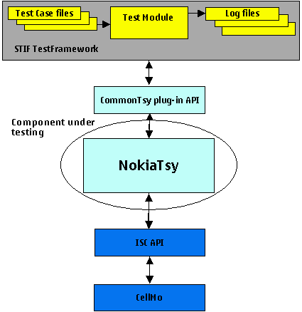

Figure 1. NokiaTSY test tool is using to test NokiaTSY component.

Creating the environment for NokiaTSY Test Tool

Compiling STIF Test Framework
It is required that STIF is compiled to the correct platform in order for NokiaTSY Test Tool to work correctly. To be able to do this, the user needs to have the correct SDK (Software Development Kit) as well as the correct version of NokiaTSY Test Tool.
- Install the SDK in the Symbian subdirectory (for example, C:\Symbian\8.1a\Series60_v30).
Once the SDK is installed, it is recommended that the hard disk drive is subst (new volume is created) to the previously mentioned folder.

- Open the command prompt and type subst Z: C:\Symbian\8.1a\Series60_v30 in the command prompt.

The next step is unzipping the correct version of NokiaTSY Test Tool into a subst hard disk drive.
- Unzip the STIF Test Framework source code into a subst hard disk drive (for example Z:). Do this using WinZip or some other extractor.
After extracting, the STIFTestFramework folder should appear in a subst hard disk drive (for example, Z:\STIFTestFramework).

The last step before STIF Test Framework is ready for use is to compile it. Compiling is executed by using the SDK.
- Open the command prompt
- Open a subst hard disk drive (for example, Z:).
- Go to the STIFTestFramework\group folder (typing, for example, cd STIFTestFramework/group).
- Create an abld.BAT file using command bldmake bldfiles.
- Compile STIF Test Framework to all the platforms using command abld build. Note that the compiling will take some time.

If only one specific platform is used, the command can be followed by the platform name (for example, abld build winscw). Use abld build winscw to build for emulator.

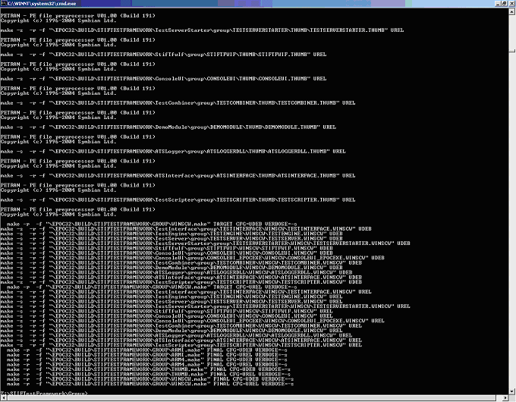
Figure 2. STIF Test Framework successfully compiled

Creating the emulator environment with PC

Test Framework
The TestFrameWork.INI file is used to set different kinds of parameters. TestFrameWork.INI is part of NokiaTSY Test Tool. An example of a TestFrameWork.INI file can be found in Appendix A.
TestFrameWork.INI can be stored anywhere in environment. BAT files are used to initialize the file. For example, in emulator environment TestFrameWork.INI can be stored to epoc32\winscw\c\STIFFramework –folder.

Parameters for log files
In TestFrameWork.INI, the following parameters control the log files.
The logging feature can be turned on and off by this parameter:
CreateTestReport= YES

The destination of log files is set in this parameter:
TestReportFilePath= C:\LOGS\TestFramework\

The name of the report file is set in this parameter:
TestReportFileName= TestReport

The format of the log file is set in this parameter:
TestReportFormat= HTML # Possible values: TXT or HTML

The output of the test result is set in this parameter:
TestReportOutput= FILE # Possible values: FILE or RDEBUG

This is the file creation parameter:
TestReportFileCreationMode= OVERWRITE # Possible values: OVERWRITE or APPEND

Test scripts to be run
The following parameter sets the location of the script file.
[New_Module]
ModuleName= TestScripter // Do not alter this line
TestCaseFile= c:\SMS.cfg
[End_Module]

In this case, TestScripter searches for the SMS.CFG file which should be located in the epoc32\winscw\c\TestFramework folder. If the location of the configuration file differs from the previously shown, it is important to write the whole path. For example:
TestCaseFile = C:\TestCfg\SMS.cfg

Script file
For creating a new test case, the user needs to create a script file and configure the settings by modifying the initialization file (see Section 4.2.1).

Script file structure
The script file is a list of commands and parameters for NokiaTSY Test Tool. The script file extension must always be of type .cfg. NokiaTSY Test Tool reads the CFG file(s) listed in the TestFramework.INI file. The test tool looks for the following information before any test case can be listed or run: Every test starts with [Test] and ends with [Endtest]. If either one is missing, the test case cannot be read correctly. The tag Title defines the test case name. If this line is missing, no test cases are displayed.
Example 1:
[Test]
title NWE SetNetworkSelectionSetting
create NWE test
test SetNetworkSelectionSetting Manual
allownextresult 0
waittestclass test
delete test
[Endtest]

Creating instances from test classes
At the beginning of the test script, instances of test classes are created. The Create command is used with parameters that give the class and name of the instance.
Example 2:
“create SMS call”
This creates instance called “call” from SMS class
“create Notify notify1”
This creates instance called “notify1” from Notify class

Note: If there are several instances required, they must all be created in the same way.
Example 3:
”create Notify notify1”
”create Notify notify2”
”create Notify notify3”
”create Notify notify4”

The above example creates four different notification instances from the same class.
Note: One notify instance can monitor only one notification.

Deleting instances
To complete test cases without any memory leaks, every instance has to be deleted using the delete function. This is done after the modules are unloaded and services are closed. The only parameter that is required after the function call is the name of the instance.
”delete call”
”delete notify1”
”delete notify2”

Compiling test classes

Compiling the test classes

Due to the dependence between different test classes, the order of compiling is very specific. It is recommended that the Core class be compiled first. After compiling the Core class, it is recommended to compile Voice. After that the rest subclasses can be compiled in any order.
The easiest way to compile the whole NokiaTSY Test Tool is to compile all classes at once. Create
a file Bld.INF in NokiaTSY_Test_Tool\group folder. . Bld.INF includes a path to all classes.
Example of a Bld.INF file:
PRJ_MMPFILES
// NokiaTSY test tool testclasses
#include "..\..\core\group\bld.inf"
#include "..\..\voice\group\bld.inf"
#include "..\..\notify\group\bld.inf"
#include "..\..\nwe\group\bld.inf"
#include "..\..\sms\group\bld.inf"

// End of File

To compile all classes follow the next steps:
- Open the command prompt from Start -> Run….
- Type cmd and press Enter.
- Open a subst hard disk drive (for example Z:).
- Go to the created folder (typing, for example, cd NokiaTSY_Test_Toolgroup)
- Create a abld.BAT file using command bldmake bldfiles.
- Compile all components using command abld build winscw. Note that the compiling will take some time.

Default directory structure
Every class has it own MMP file in the group folder. In the MMP file, the USERINCLUDE path setting points to the location of headers included in the source code.
If the directory structure differs from the default version, the USERINCLUDE path must be set to point to the correct folders. Note: If the MMP file is changed, the project must be closed and opened again before it can be compiled successfully.
For example 4: USERINCLUDE paths
USERINCLUDE ..\..\Core\inc
USERINCLUDE ..\..\notify\inc
USERINCLUDE ..\inc

Running the test cases

Before running test cases in an emulator
You have to modify NokiaTSY module before starting to test, see modifying instructions appendix C. After NokiaTSY modifying, you should do following step before driving test cases in emulator.
- Copy the appropriate initialization file to a subst hard disk drive to the epoc32\winscw\c\TestFramework directory (for example, copy TestFramework.INI to Z:\epoc32\winscw\c\TestFramework).
- Copy the appropriate script file to the subst hard disk drive to the epoc32\winscw\c directory
- Open the command prompt
- Go to the working directory
- Compile the classes
- Create a workspace for NokiaTSY Test tool to CodeWarrior using command abld makefile cw_ide.
- Start Metrowerks CodeWarrior
- Import a new project from File -> Import project….
- Explore to the subst hard disk and search for an XML file that has been created earlier (for example, V:\epoc32\BUILD\NokiaTSY Test Tool\CORE\GROUP\CORE\
WINSCW).
- Select WINSCW UDEB Settings -> Runtime settings -> Choose… and select CONSOLEUI.EXE.

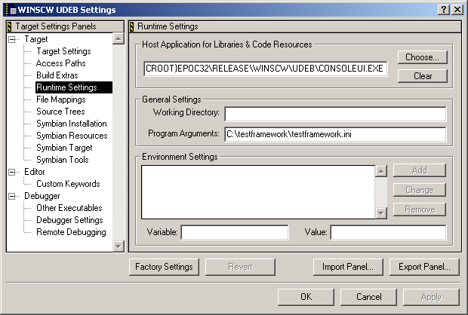
Figure 3. WINSCW UDEB Settings
- Run the emulator by pressing the Run or Debug button.
- The main menu appears on the screen

Running test cases in an emulator

When emulator has started and opened, the main menu appears first. User can select different options. If user select “Case menu”, user can start to run test cases, which have been defined in to for example nwe.cfg file. If you select exit, the emulator will shut down.

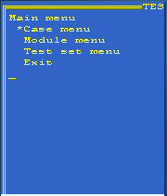
Figure 4. The main menu in emulator

When user has selected “Case menu” selection, user will get following view. If user wants to start to run test cases, user should select “Start new case”. Then user gets list of test cases, which can be run. By selecting “Ongoing cases”, user is able to see, which test cases are running. “Executed cases” will be shown, which test cases have been run.

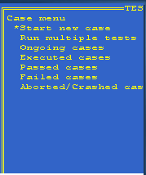
Figure 5. The case menu in emulator

When user has selected “Start new cases”, user will get list of test cases, which can be running. The list of test cases is the same, which user has defined to .cfg file. User has to select test cases, which he wants to run. When user has selected a test case, the test case will start to run. After that user can check the result of test case.

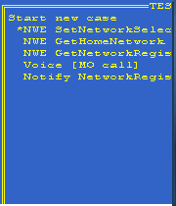
Figure 6. Start new test case in emulator

Checking the result of the test cases
After launching the tests, the user can view the state of the test cases. From the Case menu there are several ways to check result of the test:
- Passed cases menu displays the test cases that have been executed successfully.
- Failed cases menu displays failed test cases.
By pressing the navigation button right, the user can view fail info about the test case. An error code created is shown to the user.
- Aborted/Crashed cases menu displays either crashed test cases or a list of test cases that the user has aborted. The Crashed cases menu also shows an error code when the user presses the navigation button to right.

To complete the test case session, the user must return to the Main menu and choose Exit. Exiting the program will cause StifLogger to write all the log files and create the test report.
A TestReport file is created by STIF. The destination of this file has been set in the TestFramework.INI file.
The test report shows all executed test cases and the status of these tests.

***************************************************************************
Wednesday 03rd August 2005
10:45:10 AM
-- -- -- -- -- -- -- -- -- -- -- -- -- -- -- -- -- -- -- -- -- -- -- -- --
SUMMARY:
Passed cases: 3
Failed cases: 0
Timeout cases: 0
Crashed cases: 0
Total cases: 3

-- -- -- -- -- -- -- -- -- -- -- -- -- -- -- -- -- -- -- -- -- -- -- -- --
ENVIRONMENT INFO:
HW Info:
Manufacturer: 0x4, MachineUid: 0x10005f62, Model: 0x4d24
HW Rev: 0x1, CPU: 0x2, CPU Speed: 3763 MHz
Language: 0
SW Info:
SW Rev: 0x100, SW Build: 0x250
Memory Info:
RAM: 63 MB, RAM Free: 62 MB

-- -- -- -- -- -- -- -- -- -- -- -- -- -- -- -- -- -- -- -- -- -- -- -- --
TESTCASE SUMMARY:
[testscripter][c:\testframework\NWE.cfg][1] Title:[NWE SetNetworkSelectionSetting]
StartTime: 10:45:17.5081 AM, EndTime: 10:45:18.3187 AM
Result: 0 [] ==> PASSED
- - - - - - - - - -

[testscripter][c:\testframework\NWE.cfg][2] Title:[NWE GetHomeNetwork]
StartTime: 10:45:23.2487 AM, EndTime: 10:45:23.5643 AM
Result: 0 [] ==> PASSED
- - - - - - - - - -

[testscripter][c:\testframework\NWE.cfg][3] Title:[NWE GetNetworkRegistrationStatus]
StartTime: 10:45:29.1156 AM, EndTime: 10:45:29.6181 AM
Result: 0 [] ==> PASSED
- - - - - - - - - -

-- -- -- -- -- -- -- -- -- -- -- -- -- -- -- -- -- -- -- -- -- -- -- -- --
TESTMODULE SUMMARIES:
Module: [testscripter]
Passed cases: 3
Failed cases: 0
Timeout cases: 0
Crashed cases: 0
Total cases: 3
Result: 0 [] ==> PASSED
- - - - - - - - - -
Example 7.5 Example of the TestReport file
Log files are created by different test classes. These files are more difficult to read than the test report because the program can jump from a subclass to a middle class, for example. However, log files are useful for receiving more information about problems in the test.

Using ISC Test Control with NokiaTSY Test Tool
This chapter explains usage of ISC Test Control with NokiaTSY Test Tool. ISC Test Control is CASW test environment component that can be used to modify, simulate or verify ISI messages. NokiaTSY Test Tool can initialize, start and synchronize ISC Test Control test cases with NokiaTSY Test Tool test cases.
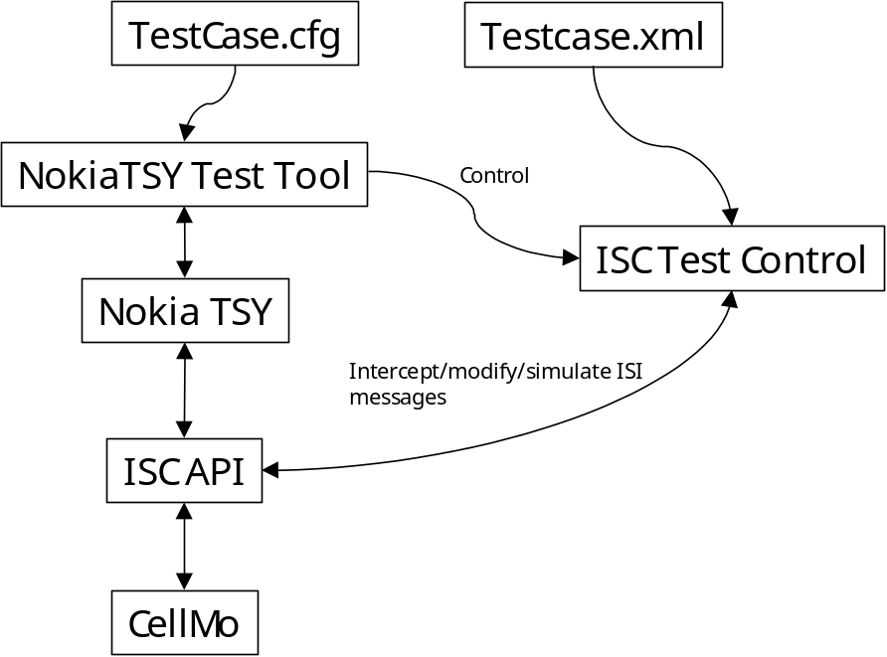
Figure 7. Integrated NokiaTSY Test Tool and ISC API Test Control. NokiaTSY Test Tool controls ISC Test Control test case. CellMo is optional component since ISC Test control can be used to emulate all CellMo messages.
ISC Test Control works by reading test cases and configuration from separate XML file. The file defines ISI message contents, direction and message sequences. To further understand ISC Test Control capabilities and test case XML format refer to ISC Test Control Test Case Development Guide [5]. This document can be found from CASW_Testenv directory \CASW_TestEnv\internal\doc

Steps to get ISC Test Control to use
ISC Test Control is part of CASW Test Environment. CASW_TestEnv can be found from Synergy and it is also included with CASW DE releases in directory \CASW_Integrated\CASW_TestEnv.

1. To compile all of CASW Test Environment, use main build file in \CASW_Integrated\CASW_TestEnv\group. (CASW DE has test environment already compiled).

2. Enable hooks for ISC Test Control in iscisimultiplexer. To do this find and uncomment following line:
// To support adaptation testing.
MACRO ISCTESTSTUB_SUPPORT_FLAG <--- uncomment this line
in file \CASW_Integrated\CASW_Adaptation\IscIsiMultiplexer\group\iscisimultiplexer.mmp

3. Recompile iscisimultiplexer.

Using ISC Test Control from test classes
NokiaTSY Test Tool core has functions to Initialize, start and synchronize ISC Test Control Test cases. These methods can either be called directly form test class C++ implementation or test class implementation can provide test script commands to access to them.
Core Method | Description
void InitializeIscControlL(const TDesC& aIscTestCaseFile); | Initialize ISC Test Control and load ISC Test Control test cases from given file. AIscTestCaseFile=XML testcase filename.
void SyncIscControl(); | Synchronize ISC Test control test case with NokiaTSY Test Tool testcase
void RunIscControlTestCase(TInt aTestControlId, TInt aTestCaseId); | Run given ISC Test Control test case.  aTestControlId= XML file ID  aTestCaseID= testcase ID

ISC Test Control XML files must be in \TestFramework\isctestcontrol –directory. Each XML file is identified by a unique identifier eg. <isc-test-control id=”555”>.
ISC divides ISI message traffic to channels and message interception and creation is channel based. NokiaTSY ISC channel is EIscNokiaMmTSY (numerical value 0x07), this is the channel that should be opened in XML file.

Appendix A: TestFramework.INI file
# This is STIFTestFramework initialization file
# Comment lines start with '#'-character.
# See STIF TestFramework user’s guide.doc for instructions

# -- -- -- -- -- -- -- -- -- -- -- -- -- -- -- -- -- -- -- -- -- -- -- -- -- -- -- -- -- -- -- --
# Set following test engine settings:
# - Set Test Reporting mode. TestReportMode's possible values are:
# + 'Summary': Summary of the tested test cases.
# + 'Environment': Hardware and software info.
# + 'TestCases': Test case report.
# + 'FullReport': Set of all above ones.
# + Example 'TestReportMode= Summary TestCases'
#
# - CreateTestReport setting controls report creation mode
# + YES Test report will created.
# + NO No Test report.
#
# - File path indicates the base path of the test report.
# - File name indicates the name of the test report.
#
# - File format indicates the type of the test report.
# + TXT Test report file will be txt type for example 'TestReport.txt'.
# + HTML Test report will be html type for example 'TestReport.html'.
#
# - File output indicates output source of the test report.
# + FILE Test report logging to file.
# + RDEBUG Test report logging to using rdebug.
#
# - File Creation Mode indicates test report overwriting if file exist.
# + OVERWRITE Overwrites if the Test report file exist.
# + APPEND Continue logging after the old Test report information if
# report exist.
# - Sets a device reset module's dll name(Reboot).
# + If Nokia specific reset module is not available or it is not correct one
# StifHWResetStub module may use as a template for user specific reset
# module.

[Engine_Defaults]

TestReportMode= FullReport # Possible values are: 'Empty' 'Summary' 'Environment'
'TestCases' or 'FullReport'

CreateTestReport= YES # Possible values: YES or NO

TestReportFilePath= E:\LOGS\TestFramework\
TestReportFileName= TestReport

TestReportFormat= HTML # Possible values: TXT or HTML
TestReportOutput= FILE # Possible values: FILE or RDEBUG
TestReportFileCreationMode= OVERWRITE # Possible values: OVERWRITE or APPEND

DeviceResetDllName= StifResetForNokia.dll # e.g. 'StifHWResetStub.dll' for user specific resetting

[End_Defaults]
# -- -- -- -- -- -- -- -- -- -- -- -- -- -- -- -- -- -- -- -- -- -- -- -- -- -- -- -- -- -- -- --

# -- -- -- -- -- -- -- -- -- -- -- -- -- -- -- -- -- -- -- -- -- -- -- -- -- -- -- -- -- -- -- --
# Module configurations start
# Modules are added between module tags
# tags. Module name is specified after ModuleName= tag like
# ModuleName= XXXXXXXXX
# Modules might have initialisation file specified as
# IniFile= YYYYYY
# Modules might have several configuration files like
# TestCaseFile= NormalCases.txt
# TestCaseFile= SmokeCases.txt
# TestCaseFile= ManualCases.txt

# (TestCaseFile is synonym for old term ConfigFile)

# Following case specifies demo module settings. Demo module
# does not read any settings from file so tags
# IniFile and TestCaseFile are not used.
# In the simplest case it is enough to specify only the
# name of the test module when adding new test module

#[New_Module]
#ModuleName= demomodule
#[End_Module]

#[New_Module]
#ModuleName= VoiceTestModule
#[End_Module]

[New_Module]
ModuleName= TestScripter
TestCaseFile= e:\Core.cfg
[End_Module]

# Load testmoduleXXX optionally with initialization file and/or test case files
#[New_Module]
#ModuleName= testmodulexxx

#TestModuleXXX used initialization file
#IniFile= init.txt

#TestModuleXXX used configuration file(s)
#TestCaseFile= testcases1.cfg
#TestCaseFile= testcases2.cfg
#TestCaseFile= manualtestcases.cfg

#[End_Module]
# -- -- -- -- -- -- -- -- -- -- -- -- -- -- -- -- -- -- -- -- -- -- -- -- -- -- -- -- -- -- -- --

# -- -- -- -- -- -- -- -- -- -- -- -- -- -- -- -- -- -- -- -- -- -- -- -- -- -- -- -- -- -- -- --
# Set STIFTestFramework logging overwrite parameters for Logger.
# Hardware and emulator environment logging path and styles can
# be configured from here to overwrite the Logger's implemented values.
#
# Settings description:
# - Indicates option for creation log directory/directories. If log directory/directories
# is/are not created by user they will make by software.
# + YES Create log directory/directories if not already exist.
# + NO Log directory/directories not created. Only created one is used.
#
# - Overwrite emulator path setting.
# + Example: If 'EmulatorBasePath= C:\LOGS\TestFramework\' and in code is defined
# Logger's path 'D:\\LOGS\\Module\\' with those definition the path
# will be 'C:\LOGS\TestFramework\LOGS\Module\'
#
# - Overwrite emulator's logging format.
# + TXT Log file(s) will be txt type(s) for example 'Module.txt'.
# + HTML Log file(s) will be html type(s) for example 'Module.html'.
#
# - Overwrited emulator logging output source.
# + FILE Logging to file(s).
# + RDEBUG Logging to using rdebug(s).
#
# - Overwrite hardware path setting (Same description as above in emulator path).
# - Overwrite hardware's logging format(Same description as above in emulator format).
# - Overwrite hardware's logging output source(Same description as above in emulator output).
#
# - File Creation Mode indicates file overwriting if file exist.
# + OVERWRITE Overwrites if file(s) exist.
# + APPEND Continue logging after the old logging information if file(s) exist.
#
# - Will thread id include to the log filename.
# + YES Thread id to log file(s) name Example filename 'Module_b9.txt'.
# + NO No thread id to log file(s) Example filename 'Module.txt'.
#
# - Will time stamps include the to log file.
# + YES Time stamp added to each line in log file(s). Time stamp is
# for example'12.Nov.2003 115958 LOGGING INFO'
# + NO No time stamp(s).
#
# - Will line breaks include to the log file.
# + YES Each logging event includes line break and next log event is in own line.
# + NO No line break(s).
#
# - Will event ranking include to the log file.
# + YES Event ranking number added to each line in log file(s). Ranking number
# depends on environment's tics for example(includes time stamp also)
# '012 12.Nov.2003 115958 LOGGING INFO'
# + NO No event ranking.
#

[Logger_Defaults]

#NOTE: If you want to set Logger using next setting(s) remove comment(s)'#'

CreateLogDirectories= YES # Possible values: YES or NO

EmulatorBasePath= e:\
EmulatorFormat= HTML # Possible values: TXT or HTML
EmulatorOutput= FILE # Possible values: FILE or RDEBUG

HardwareBasePath= e:\
HardwareFormat= HTML # Possible values: TXT or HTML
HardwareOutput= FILE # Possible values: FILE or RDEBUG

FileCreationMode= APPEND # Possible values: OVERWRITE or APPEND

ThreadIdToLogFile= YES # Possible values: YES or NO
WithTimeStamp= YES # Possible values: YES or NO
WithLineBreak= YES # Possible values: YES or NO
WithEventRanking= YES # Possible values: YES or NO

[End_Logger_Defaults]
# -- -- -- -- -- -- -- -- -- -- -- -- -- -- -- -- -- -- -- -- -- -- -- -- -- -- -- -- -- -- -- --

# End of file

Appendix B: Example of test script file
[Test]
title NWE SetNetworkSelectionSetting
create NWE test
test SetNetworkSelectionSetting Manual
allownextresult 0
waittestclass test
delete test
[Endtest]
[Test]
title NWE GetHomeNetwork
create NWE test
test GetHomeNetwork
waittestclass test
delete test
[Endtest]
[Test]
title NWE GetNetworkRegistrationStatus
create NWE test
create Notify notify1
create Notify notify2
create Notify notify3
create Notify notify4
notify1 UseObjectAddress test NotifyNetworkRegistrationStatusChange
notify2 UseObjectAddress test NotifyNetworkSelectionSettingChange
notify3 UseObjectAddress test NotifyCurrentNetworkChange
notify4 UseObjectAddress test NotifyModeChange
test GetNetworkRegistrationStatus
//allownextresult 0
//waittestclass notify1
allownextresult 0
waittestclass test
delete test
delete notify1
[Endtest]

Appendix C: Setup instructions to NokiaTSY

Before starting testing, user has to do some changes to NokiaTSY. This is because of dependencies between NokiaTSY and CommonTSY. There cannot be any dependecies to CommonTSY and that’s why some methods have to comment out. See follow instructions:
- Open cmmMessageRouter.cpp from NokiaTSY folder.
  - Comment lines, which handle PacketData constructing and deleting.
    - Find destructor CMmMessageRouter::~CmmMessageRouter and comment these PacketData dependecies:
      - delete iMmPacketContextMessHandlerGsmWcdmaExt;
      - delete iMmPacketQoSMessHandlerGsmWcdmaExt;
      - delete iMmPacketServiceMessHandlerGsmWcdmaExt;
    - Find method void CMmMessageRouter::ConstructL and comment these PacketData dependencies:
iMmPacketContextMessHandlerGsmWcdmaExt =
CMmPacketContextMessHandlerGsmWcdmaExt::NewL( aMessageManager,
iPhoNetSender,
&iPhoNet );

// this initialization should be moved to CMmPacketServiceMessHandlerGsmWcdmaExt::ConstructL
iMmPacketQoSMessHandlerGsmWcdmaExt =
CMmPacketQoSMessHandlerGsmWcdmaExt::NewL( iPhoNetSender,
aMessageManager, iMmPacketContextMessHandlerGsmWcdmaExt );

iMmPacketServiceMessHandlerGsmWcdmaExt =
CMmPacketServiceMessHandlerGsmWcdmaExt::NewL(
iPhoNetSender,
iPhoNetReceiver,
aMessageManager,
iMmPacketContextMessHandlerGsmWcdmaExt,
iMmPacketQoSMessHandlerGsmWcdmaExt );

- Open NokiaTSY.mmp file form NokiaTSY/group folder.
  - Comment the lines, which have dependencies to Packet Data and CommonTSY.
    - Find the lines and comments those:
SOURCE CMmPacketServiceMessHandlerGsmwcdmaExt.cpp
SOURCE CMmPacketContextMessHandlerGsmwcdmaExt.cpp
SOURCE CMmPacketQoSMessHandlerGsmwcdmaExt.cpp
SOURCE CMmPipeControl.cpp
SOURCE cmmpacketmesshandlercontextlist.cpp
    - Find a line and comments it:
LIBRARY commontsy.lib // for using CommonTsy
  - Add a line LIBRARY core.lib // for using test Core
- If you are testing sms feature, you have to do some changes also to cmmSMSMessHandel.cpp file. Thise changes have to do because of sms cache. This is nessessery only in case, when module testing is doing in winscw + hw environment. Without these changes sms cache does not work correctly and test cases fill fail because of that.
  - Open cmmSmsMessHandel.cpp file
    - Find method void CMmSmsMessHandler::ConstructL and add to the end of method this line: SmsPpRoutingReq( KSmsRoutingSet );
    - Find method TInt CMmSmsMessHandler::SmsPpRoutingResp and find these lines from code:
if ( KSmsRoutingSet == iSmsRoutingStatus )
{
CMmDataPackage package;
package.PackData( &iSmsRoutingStatus );
iMessageManager->Complete
(EMmTsyActivateSmsRouting, &package,
cause );

and add next line after that:
iMessageManager->Complete( EMmTsyBootNotifySimStatusReadyIPC, KErrNone );
}
- Check the version of STIFTestFramework.
  - If STIFTestFramerWork has released wk 33 or newer, open bld.inf from NokiaTSY\group. Find these lines from bld.inf file:

// operator information, c32.exe SID is 101f7989

..\inc\operinfo.txt \epoc32\release\armv5\urel\z\private\101f7989\operinfo.txt
..\inc\operinfo.txt \epoc32\release\armv5\udeb\z\private\101f7989\operinfo.txt

..\inc\operinfo.txt \epoc32\release\thumb\urel\z\private\101f7989\operinfo.txt
..\inc\operinfo.txt \epoc32\release\thumb\udeb\z\private\101f7989\operinfo.txt

..\inc\operinfo.txt \epoc32\release\wins\urel\z\private\101f7989\operinfo.txt
..\inc\operinfo.txt \epoc32\release\wins\udeb\z\private\101f7989\operinfo.txt

..\inc\operinfo.txt \epoc32\release\winscw\urel\z\private\101f7989\operinfo.txt
..\inc\operinfo.txt \epoc32\release\winscw\udeb\z\private\101f7989\operinfo.txt

and add these lines after that:

..\inc\operinfo.txt \epoc32\release\armv5\urel\z\private\102073E4\operinfo.txt
..\inc\operinfo.txt \epoc32\release\armv5\udeb\z\private\102073E4\operinfo.txt

..\inc\operinfo.txt \epoc32\release\thumb\urel\z\private\102073E4\operinfo.txt
..\inc\operinfo.txt \epoc32\release\thumb\udeb\z\private\102073E4\operinfo.txt

..\inc\operinfo.txt \epoc32\release\wins\urel\z\private\102073E4\operinfo.txt
..\inc\operinfo.txt \epoc32\release\wins\udeb\z\private\102073E4\operinfo.txt

..\inc\operinfo.txt \epoc32\release\winscw\urel\z\private\102073E4\operinfo.txt
..\inc\operinfo.txt \epoc32\release\winscw\udeb\z\private\102073E4\operinfo.txt

  - If STIFTestFramerWork has released before wk 33, open bld.inf from NokiaTSY\group. Find these lines from bld.inf file:

// operator information, c32.exe SID is 101f7989

..\inc\operinfo.txt \epoc32\release\armv5\urel\z\private\101f7989\operinfo.txt
..\inc\operinfo.txt \epoc32\release\armv5\udeb\z\private\101f7989\operinfo.txt

..\inc\operinfo.txt \epoc32\release\thumb\urel\z\private\101f7989\operinfo.txt
..\inc\operinfo.txt \epoc32\release\thumb\udeb\z\private\101f7989\operinfo.txt

..\inc\operinfo.txt \epoc32\release\wins\urel\z\private\101f7989\operinfo.txt
..\inc\operinfo.txt \epoc32\release\wins\udeb\z\private\101f7989\operinfo.txt

..\inc\operinfo.txt \epoc32\release\winscw\urel\z\private\101f7989\operinfo.txt
..\inc\operinfo.txt \epoc32\release\winscw\udeb\z\private\101f7989\operinfo.txt

and add these lines after that:

..\inc\operinfo.txt \epoc32\release\armv5\urel\z\private\00000000\operinfo.txt
..\inc\operinfo.txt \epoc32\release\armv5\udeb\z\private\00000000\operinfo.txt

..\inc\operinfo.txt \epoc32\release\thumb\urel\z\private\00000000\operinfo.txt
..\inc\operinfo.txt \epoc32\release\thumb\udeb\z\private\00000000\operinfo.txt

..\inc\operinfo.txt \epoc32\release\wins\urel\z\private\00000000\operinfo.txt
..\inc\operinfo.txt \epoc32\release\wins\udeb\z\private\00000000\operinfo.txt

..\inc\operinfo.txt \epoc32\release\winscw\urel\z\private\00000000\operinfo.txt
..\inc\operinfo.txt \epoc32\release\winscw\udeb\z\private\00000000\operinfo.txt

- Compile NokiaTSY.

      - Go to NokiaTSY\group directory
      - Enter commands
          - Bldmake bldfiles
          - Abld build winscw

If you want to open epoc emulator direct to textshell mode (this is recommendation), open epoc.ini file and add top of the file text: textshell. You can find file epoc.ini from epoc32\data-directory.

