Using NokiaTSY Test Tool with ISC Test ControlUser Guide

Owner:  Function: | Martti Suvanne  TP SPP Core SW CASW Telephony Service FI
Document ID | < Document ID >
Version: | 1.0
Status: | Draft
Approver: | < Approver >
Document Location

LotusNotes:
Lotus Notes Database:
<Database name>

Synergy:
Engine host: | ouccmweh.nmp.nokia.com
Database path: | /nokia/ou_nmp/groups/gscm/dbs/ou1cfspd
Directory: | NokiaTSY_Test_Tool/Doc
Filename: | Testing With Or Without CellMo Guide.doc
Instance: | < Synergy instance >

Copyright © 2006 Nokia. This material, including documentation and any related computer programs, is protected by copyright controlled by Nokia. All rights are reserved. Copying, including reproducing, storing, adapting or translating, any or all of this material requires the prior written consent of Nokia. This material also contains confidential information, which may not be disclosed to others without the prior written consent of Nokia.
Contents
1. Definitions and Acronyms 3
1.1 Definitions 3
2. Overview 4
2.1 Introduction 4
2.2 Scope and utilization 4
2.3 General Notes 4
3. Actions in Nokia TSY Test Tool before testing 5
3.1 Real CellMo not used 5
3.2 Real CellMo Used 5
4. Creating test cases 6
4.1 An Example 6
4.2 Needed Code changes 7
4.2.1 In Nokia TSY Test Tool 7
4.2.2 Creating XML simulation in ISC Test Control 7
5. Running Tests 8
5.1 Release test set 8
5.2 Single tests 9
6. References 10
6.1 Document References 10
6.2 Book and Other References 10
6.3 Lotus Notes Database References 10
7. Appendixes 11
7.1 Change History 11

Definitions and Acronyms

Definitions
Definition | Description
Adaptation | Software to be written between Series 60 and licensee-specific code

Overview

Introduction
This document describes how to use NokiaTSY Test Tool in module testing with XML isi simulation, ISC Test Control or real CellMo

Scope and utilization
This document is intended as an introduction and reference for everyone developing test cases for ISC Test Control component of CASW Test Environment / Nokia TSY Test Environment. Using ISC Test Control enables running test sets automaticly.

General Notes
This document may also refer to various other Nokia documents, Lotus Notes databases, published books, and other documents.
NMP document references will be marked by notation /D.X/ Document Name, and details of the references can be found in section Document References.
References to Lotus Notes databases will be marked by notation /LN.X/ Database Name, and the list of databases can be found in section Lotus Notes Database References.

Book references will be marked by notation /R.X/ Book Name, and details of the references (author, ISBN, etc.) can be found in section Book and Other References.
Other references will be marked by notation /R.X/ Title, and details of the references can be found in section Book and Other References.

Actions in Nokia TSY Test Tool before testing
Assumption before any of following actions is that Nokia TSY Test Tool is properly installed and running.

Real CellMo not used
Laittaisin kasi eri kappaletta toiseen ohjeistuksen kun käytetään simulointia ja toiseen
Ohjeistuksen kun käytetään rautaa. Tai sitten muuttaisin dokumentin otsikon.

- Defintion in core.h
When real CellMo is NOT in use (HW NOT attached) comment out the line:
//#define REAL_CELLMO_IN_USE
2. Compile core in Code Warrior

3. Start consoleui.exe

Real CellMo Used
If REAL_CELLMO_IN_USE is defined make sure that HW is attached before testing.
1. Defintion in core.h
Flag REAL_CELLMO_IN_USE is defined as default in the file
#define REAL_CELLMO_IN_USE
2. Compile core in Code Warrior

3. Start consoleui.exe

If REAL_CELLMO_IN_USE is defined make sure that HW is attached before testing.

Creating test cases

An Example
Test case of the ss.cfg MOD_0008_101_NokiaTSY_[Getting the call barring status, BarAllIncoming] is used here as an example. Ss.cfg will be found in the directory X:\epoc32\WINSCW\C\TestFramework and the corresponding XML file nokiatsy_ss.xml is located in the directory X:\epoc32\WINSCW\C\TestFramework\isctestcontrol when the Nokia TSY Test Tool is properly installed and running.
There are two pair of functions made for isc test control usage:
- RunIscTestCase and SyncIscTestCase
- RunIscTestCaseIgnoreXMLsWhenRealCellmoInUseFlagIsDefined and SyncIscTestCaseDoNotSyncIfRealCellmoInUseFlagIsDefined
The difference between these pairs is that the flag REAL_CELLMO_IN_USE has no effect in the functions RunIscTestCase and SyncIscTestCase. This means that XML simulation is always used when these functions are used.
In the other function pair the flag REAL_CELLMO_IN_USE works so that when it is defined the functions returns only KErrNone and XML simulation is NOT used. This means that in the test the functions RunIscTestCaseIgnoreXMLsWhenRealCellmoInUseFlagIsDefined and SyncIscTestCaseDoNotSyncIfRealCellmoInUseFlagIsDefined are called but nothing happens in those functions <=> real CellMo is used.
[Test]
title MOD_0008_101_NokiaTSY_[Getting the call barring status, BarAllIncoming]
create NTT_SS test
test GetCallBarringStatus BarAllIncoming
test RunIscTestCaseIgnoreXMLsWhenRealCellmoInUseFlagIsDefined 610
test SyncIscTestCaseDoNotSyncIfRealCellmoInUseFlagIsDefined

allownextresult 0
waittestclass test
delete test
[Endtest]

Needed Code changes

In Nokia TSY Test Tool
The functions which prototypes are now in core.h:
- RunIscTestCase and SyncIscTestCase
- RunIscTestCaseIgnoreXMLsWhenRealCellmoInUseFlagIsDefined and SyncIscTestCaseDoNotSyncIfRealCellmoInUseFlagIsDefined
are now located in the file CoreBlocks.cpp and prototypes for these functions are located in the header file core.h. There are also internal functions RunIscTestCase and SyncIscTestCase in the each test class which should be replaced with the functions located in CoreBlocks.cpp !!! Replacement is done as follows:
  - Check that core.h is included in the xxxBlock.cpp or in the corresponding header file.
  - Remove internal RunIscTestCase and SyncIscTestCase from the file XxxBlocks.cpp and header file.
  - In the file XxxBlocks.cpp Replace entries xxx::RunIscTestCase with CCore::RunIscTestCase and xxx::SyncIscTestCase with CCore::SyncIscTestCase. Also add the entries (if testing with or without CellMo is needed in the test set):
ENTRY( "RunIscTestCaseIgnoreXMLsWhenRealCellmoInUseFlagIsDefined",
CCore::RunIscTestCaseIgnoreXMLsWhenRealCellmoInUseFlagIsDefined),
ENTRY( "SyncIscTestCaseDoNotSyncIfRealCellmoInUseFlagIsDefined",
CCore::SyncIscTestCaseDoNotSyncIfRealCellmoInUseFlagIsDefined),
SS test class should be used as an example when making these changes to the other classes. See X:\CASW_Integrated\NokiaTSY_Test_Tool\SS\ and it’s subfolders.

Creating XML simulation in ISC Test Control
How the XMLs are written is explained in the document /D.1/ ISC Test Control Test Case Development Guide (this document can also be found from X:\CASW_Integrated\CASW_TestEnv\internal\doc)

Running Tests

Release test set
When Nokia TSY Test Tool has been compiled the file ConsoleUI.set is copied to the directory X:\epoc32\WINSCW\C\TestFramework. This file is loaded when the consoleui option Load test set is used.
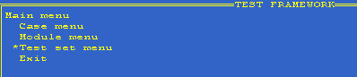
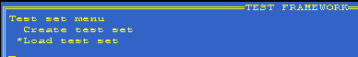
Make sure that all needed *.cfg files are included in the file TestFramework.ini. The list of the .cfg files needed will be in the file ConsoleUI.set.
When the test set is loaded the all the tests will be executed by choosing the option run test cases sequentally.
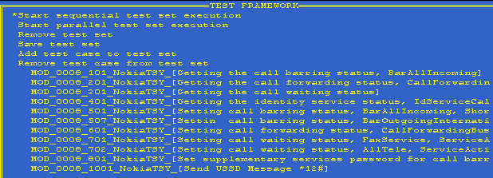
Test results (here are passed ones) can be checked as usual Case menu -> Passed cases
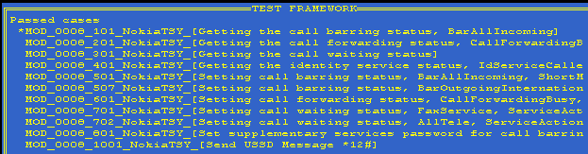

Single tests
Single tests are able to be executed as before.

References

Document References
/D.1/ ISC Test Control Test Case Development Guide
Author | : | Mikko Hiljanen
Version | : | 1.0 Draft
Doc ID | : | DSY02449-EN
Database | : | /nokia/ou_nmp/groups/gscm/dbs/ou1cfspd
Project | : | TP / SPP / CoreSW / CASW / INT / Testing
Directory | : | CASW_TestEnv/internal/doc
Filename | : | ISC Test Control Test Case Development Guide.doc

Book and Other References

Lotus Notes Database References

Appendixes

Change History

Version | :
Status | :
Date | :
Comments | :

Version | : | 0.1
Status | : | Draft
Date | : | <dd-Mmm-yyyy>
Comments | :

