Symbian Product Platforms
System Adaptation Common ISC service design
Document

Team name | Author

Change history:

Version | Date | Status | Comments
0.2 | 17.11.2008 | 2nd draft
0.1 | 05.11.2008 | Draft
Table of contents:

1. Document control 4
1.1 References 4
1.2 Documentation conventions 4
1.3 Abbreviations 4
1.4 Definitions 4
2. Purpose of document 5
2.1 List of required interfaces 5
2.2 Constraints 5
3. Technical specification 6
3.1 Type of interface 6
3.2 Interface class structure 6
3.3 Usage 7
3.3.1 Protocol 7
3.3.2 Opening ISC channel 7
3.3.3 Sending ISI message 7
3.3.4 Receiving ISI message 8
3.3.5 Close ISC channel indication 8
3.3.6 Error handling 9
3.3.7 Memory overhead 9
3.4 Example 9
3.4.1 Changes needed in plug-in mmp-file 9
3.4.2 Construction of interface classes 9
3.4.3 Sending ISI message 10
3.5 Detailed description 10
3.5.1 CSACommonIscService 10
3.5.2 CSACommonIscServiceChannelListener 12
3.5.3 MSAIscService 12
4. Index 14
4.1 List of constants and enumerations 14
4.2 Alphabetical list of classes and methods 14
4.2.1 Class CSACommonIscService 14
4.2.2 Class CSACommonIscServiceChannelListener 14
4.2.3 Class MSaIscService 14

Document control

References

- System Adaptation Design Document

Documentation conventions
Code is shown with Courier New font.

Abbreviations

Definitions

System Adaptation | Nokia specific adaptation layer for S60 System SW IDO components.

Purpose of document
This document describes the services offered by the System Adaptation Common ISC service.

List of required interfaces
All clients of the System Adaptation Common ISC service need to link to iscapi.lib and include the following header files which can be found from systemadaptation/iscservice/inc folder: sa_common_isc_service.h and msa_isc_service.h. Common trace functions can be used by including sa_common_trace.h.

Constraints
System Adaptation Common ISC service uses IscApi to send and receive ISI messages and so the process that creates the client must have enough capabilities (CommDD) to send and receive ISI messages. If the process doesn’t have CommDD-capability, the used ISC channel will be checked and finally there will be a firewall checking ISI messages.

Technical specification

Type of interface
The interface uses local objects, method calls and callback functions.

Interface class structure
Figure 3.1 describes System Adaptation Common ISC service interface classes. MSAIscService must be implemented by client application. Reference to this object must be passed to CSACommonIscService when creating the object. CSACommonIscService creates CSACommonIscServiceChannelListener class. CSACommonIscService class is used to send and receive ISI messages. CSACommonIscServiceChannelListener is used for monitoring the status changes in the used ISC channel.
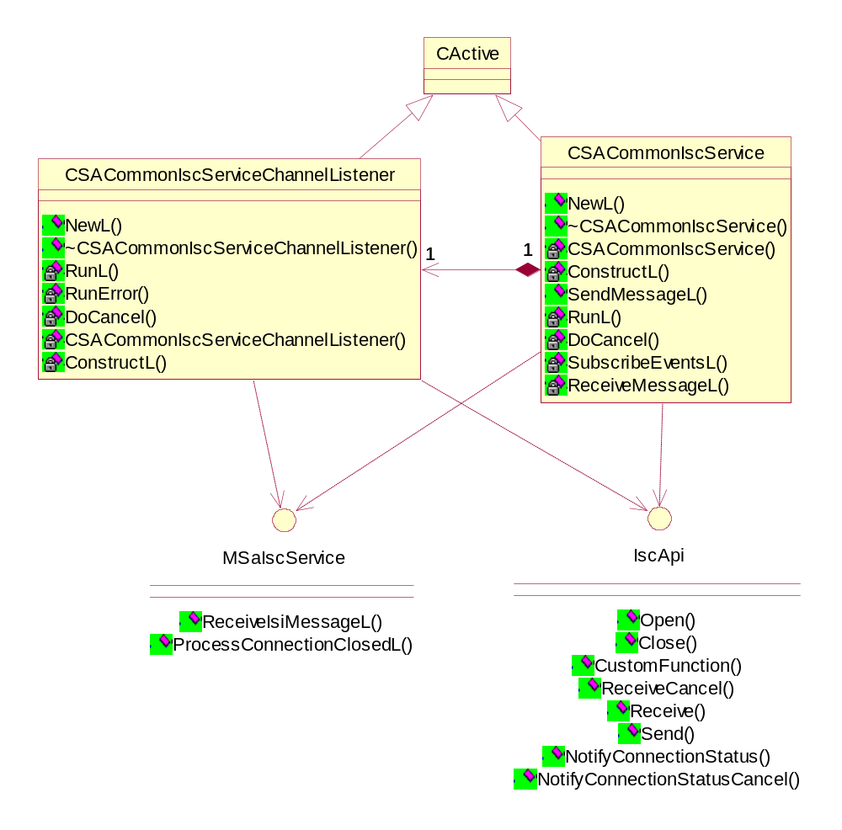
Figure 3.1 System Adaptation Common ISC service classes

Usage

Protocol
The client plug-in must inherit MSAIscService class and create an instance of CSACommonIscService class. The client can send ISI messages and subscribe to indications. CSACommonIscService will use the ReceiveIsiMessageL function in MSAIscService to deliver responses and indications to client. The client which implements ReceiveIsiMessageL must copy the received ISI message data to its’ own buffer if the client is going to do asynchronous calls in ReceiveIsiMessageL function.

Opening ISC channel
Figure 3.2 presents the sequence of creating CSACommonIscService and opening an ISC channel. CSAIscClient class is inherited from MSAIscService class.
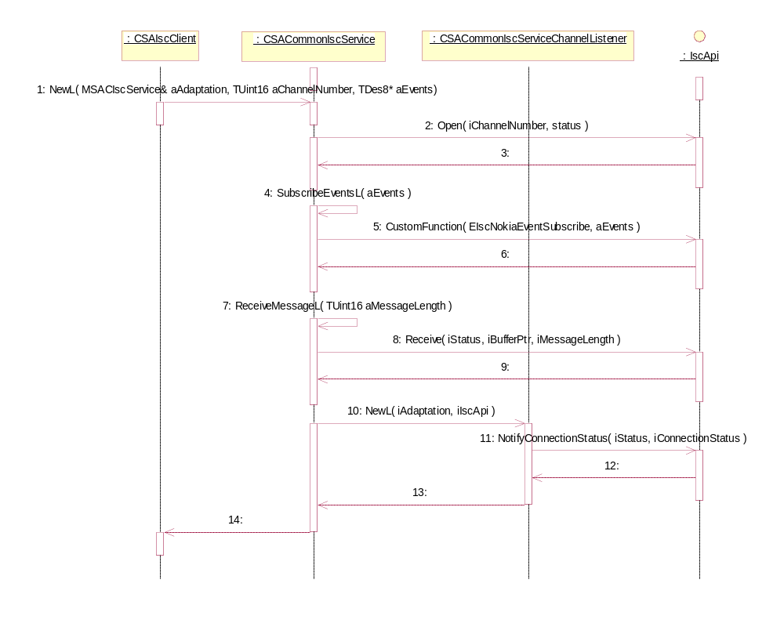
Figure 3.2 Opening ISC channel

Sending ISI message
Figure 3.3 presents the sequence of sending ISI message via CSACommonIscService.
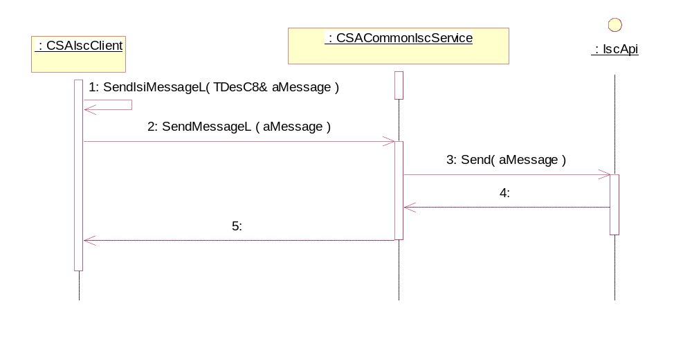
Figure 3.3 Sending ISI message

Receiving ISI message
Figure 3.4 presents the sequence of receiving ISI message via CSACommonIscService.
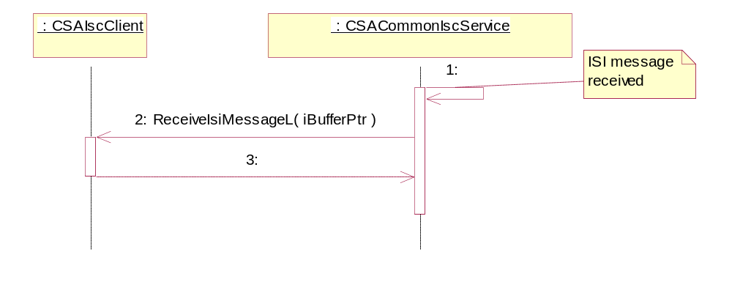
Figure 3.4 Receiving ISI message

Close ISC channel indication
Figure 3.5 presents the sequence of CSACommonIscService receiving ISC channel connection status change notification.
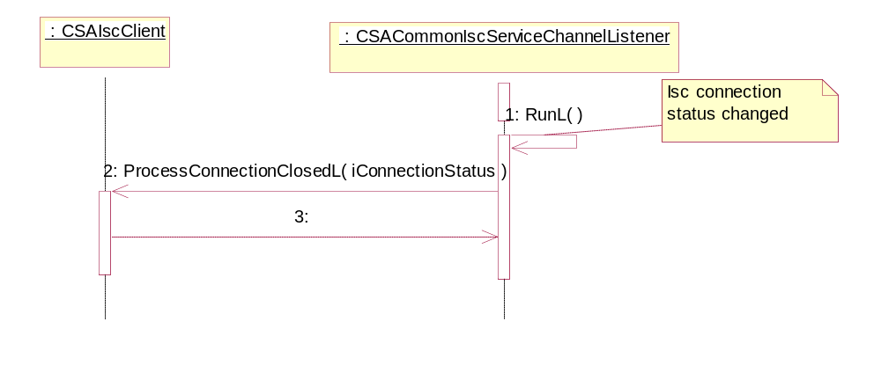
Figure 3.5 Close ISC channel

Error handling
Errors are usually handled by using the Symbian OS leave mechanism. Only standard Symbian OS error codes are used.

Memory overhead
System Adaptation Common ISC service is an abstract interface and the memory usage depends on its implementation.

Example
This section provides code examples for System Adaptation Common ISC service usage.

Changes needed in plug-in mmp-file
The following changes are needed in the client plug-in mmp-file. It is assumed that both plug-in and ISC service folders are located in systemadaptation folder.

//
USERINCLUDE ../../../iscservice/inc
SOURCEPATH ../../../iscservice/src
SOURCE sa_common_isc_service.cpp
SOURCE sa_common_isc_service_channel_listener.cpp
SOURCE sa_common_trace.cpp

Construction of interface classes
The code example presented below describes the construction of interface classes. Example also shows how to create subscription to EM server indications.

// from .h file
class CSAIscClient : public CBase, public MSAIscService
{
public: // functions from base classes

void ReceiveIsiMessageL( TDesC8& aData );

void ProcessConnectionClosedL( TInt aErrorCode );

private: // data

CSACommonIscService* iSACommonIscService;

};

// from .cpp file
TUint8 evarr[] = {PN_ENERGY, EM_INFO_IND};

TPtr8 events ( &evarr[0], sizeof ( evarr ), sizeof ( evarr ) );

TUint8 isiMessageSize( 36 );

iSACommonIscService = CSACommonIscService::NewL( *this, EIscChannelName, &events, isiMessageSize);

Sending ISI message
The code example presented below describes the sequence client send ISI message with instance of interface class. aMessage must be a valid ISI message.

// from .cpp file
iSACommonIscService->SendMessageL( aMessage );

Assert trace
The code example presented below describes how assert traces can be added to source files. Trace is logged if condition given isn’t true.

// ASSERT_TRACE
ASSERT_TRACE( _L( "SYSTEMADAPTATION - CSAIscClient::ReceiveIsiMessageL" ), ( iStatus.Int() == KErrNone ) );

Assert always trace
The code example presented below describes how assert always traces can be added to source files. In this case the trace is always logged.

// ASSERT_ALWAYS_TRACE
ASSERT_ALWAYS_TRACE((_L("SYSTEMADAPTATION - CSAIscClient::ReceiveIsiMessageL - wrong messageId")));

API trace
The code example presented below describes how API traces can be added to source files.

// API_TRACE
API_TRACE((_L("SYSTEMADAPTATION # CSAIscClient::ReceiveIsiMessageL - return void")));

Internal trace
The code example presented below describes how internal traces can be added to source files.

// INTERNAL_TRACE
INTERNAL_TRACE((_L("SYSTEMADAPTATION # CSAIscClient::ReceiveIsiMessageL - return void")));

Data dump trace
The code example presented below describes how data dump traces can be added to source files. aData parameter is a reference to descriptor holding the data that you want to take traces of.

// DATA_DUMP_TRACE
DATA_DUMP_TRACE(_L("SYSTEMADAPTATION - CSAIscClient::ReceiveIsiMessageL - Data:"), aData);

ISI messge trace
The code example presented below describes the ISI message traces can be added to source files. aMessage parameter is a reference to descriptor holding the data for ISI message.

// ISIMSG_API_TRACE
ISIMSG_API_TRACE( _L("SYSTEMADAPTATION - CSAIscClient::ReceiveIsiMessageL() - Sending ISI Message: "), aMessage);

Detailed description

CSACommonIscService
The CSACommonIscService class provides an interface for sending and receiving ISI messages.

static CSACommonIscService* NewL(
MSAIscService& aAdaptation,
const TUint16 aChannelNumber,
TDes8* aEvents,
const TUint16 aClientISIMessageSize)
Two-phased constructor.
Parameters:
Type | Name | Description
MSAIscService& | aAdaptation | Reference to client plug-in.
const TUint16 | aChannelNumber | Used Isc channel id
TDes8* | aEvents | Pointer to array consisting of ISI message ids and indication ids.
const TUint16 | aClientISIMessageSize | Minimum size for ISI message

Leave values: KErrNoMemory
Return value: CSACommonIscService*

~ CSACommonIscService( )
Destructor.
Leave values: This function will not leave.
Return value: N/A

void SendMessageL (TDesC8& aMessage)
Send ISI message via used ISC channel.
Parameters:
Type | Name | Description
TDesC8& | aMessage | Descriptor to a valid ISI message.

Leave values: Symbian OS standard error code.
Return value: void

void ReceiveMessageL(TUint16 aMessageLength)
Start to receive ISI messages via used ISC channel.
Parameters:
Type | Name | Description
TUint16 | aMessageLength | Length of received Isc message.

Leave values: Symbian OS standard error code.
Return value: void

void SubscribeEventsL(TDes8* aEvents)
Inform IscApi about messages and indications that are of interest to the client plug-in.
Parameters:
Type | Name | Description
TDes8* | aEvents | Pointer to array consisting of ISI message ids and indication ids.

Leave values: Symbian OS standard error code.
Return value: void

void RunL ( )
This function is called when ISI message is received and is ready to be handled by client plug-in.
Leave values: Symbian OS standard error code.
Return value: void

void DoCancel ( )
This function is called to cancel outstanding request.
Leave values: This function will not leave.
Return value: void

CSACommonIscServiceChannelListener
The CSACommonIscServiceChannel class provides an interface for sending notifications of changes in used Isc channel.

static CSACommonIscServiceChannelListener* NewL(
MSAIscService& aAdaptation,
const TUint16 aChannelNumber)
Two-phased constructor.
Parameters:
Type | Name | Description
MSAIscService& | aAdaptation | Reference to client plug-in.
const TUint16 | aChannelNumber | Used Isc channel id

Leave values: KErrNoMemory
Return value: CSACommonIscServiceChannelListener

~ CSACommonIscServiceChannelListener ( )
Destructor.
Leave values: This function will not leave.
Return value: N/A

void RunL ( )
This function is called when ISC channel status changes.
Leave values: Symbian OS standard error code.
Return value: void

void DoCancel ( )
This function is called to cancel outstanding request.
Leave values: This function will not leave.
Return value: void

MSAIscService
The MSAIscService class provides callback functionality for CSACommonIscService and CSACommonIscServiceChannelListener.

virtual void ReceiveIsiMessageL ( TDesC8& aData ) = 0
Callback function. This function is called when a ISI message is received.
Parameters:
Type | Name | Description
TDesC8& | aData | Reference to received ISI message.

Leave values: This Symbian OS standard error code.
Return value: void

virtual void ProcessConnectionClosedL (TInt aErrorCode ) = 0
Callback function. This function is called when used ISC channel’s status changes.
Parameters:
Type | Name | Description
TInt | aErrorCode | Isc channel status (error)

Leave values: Symbian OS standard error code.
Return value: void

Index

List of constants and enumerations
No global constants or enumerators are declared.

Alphabetical list of classes and methods
The following table shortly describes the purpose of the classes.

Class | Description | Header file
CSACommonIscService | The CSACommonIscService class provides an interface for receiving and sending ISI messages. | sa_common_isc_service.h
CSACommonIscServiceChannelListener | The CSACommonIscServiceChannelListener class provides an interface for Isc channel status change notifications. | sa_common_isc_service_channel_listener.h
MSaIscService | The MSAIscService class provides callback functionality for CSACommonIscService and CSACommonIscServiceChannelListener. | msa_isc_service.h

Class CSACommonIscService

Method | Description
NewL | Two-phased constructor.
~CSACommonIscService | Destructor.
SendMessageL | Send ISI message.
ReceiveMessageL | Start receiving ISI messages.
SubscribeEventsL | Subscribe to ISI messages and indications.
RunL | This function is called when ISI message is ready to be handled by client.
DoCancel | Used to cancel outstanding request.

Class CSACommonIscServiceChannelListener

Method | Description
NewL | Two-phased constructor.
~CSACommonIscServiceChannelListener | Destructor.
RunL | This function is called when Isc channel status changes.
DoCancel | Used to cancel outstanding request.
RunError | Called if RunL leaves.

Class MSaIscService

Method | Description
ReceiveIsiMessageL | Callback function. This function is called when CSACommonIscService receives ISI message.
ProcessConnectionClosedL | Callback function. This function is called when Isc channel status changes.

