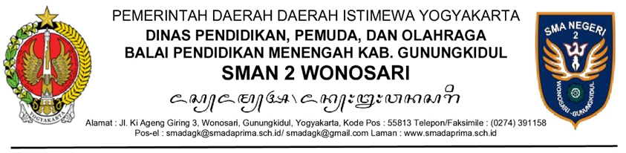
PENGUMUMAN
NOMOR .....................

TENTANG
................................................
........................................................................................................................................................................................................................................................................................................................................................................................................
.........................................................................................................................................................................................................................................................................................................................................................................................................
.........................................................................................................................................................................................................................................................................................................................................................................................................

Dikeluarkan di .....................
pada tanggal .....................
Kepala SMAN 2 Wonosari,

Drs. Tiya, M.M.

