Applying party pkg on ID3

Waniya

May 2, 2018

## PARTY Pkg in R studio Assignment

A computational toolbox for recursive partitioning. The core of the package is ctree(), an implementation of conditional inference trees which embed tree-structured regression models into a well defined theory of conditional inference procedures. This non-parametric class of regression trees is applicable to all kinds of regression problems, including nominal, ordinal, numeric, censored as well as multivariate response variables and arbitrary measurement scales of the covariates. Based on conditional inference trees, cforest() provides an implementation of Breiman’s random forests. The function mob() implements an algorithm for recursive partitioning based on parametric models (e.g. linear models, GLMs or survival regression) employing parameter instability tests for split selection. Extensible functionality for visualizing tree-structured regression models is available. The methods are described in Hothorn et al. (2006) <doi:10.1198/106186006X133933>, Zeileis et al. (2008) <doi:10.1198/106186008X319331> <http://rmarkdown.rstudio.com>.

When you click the **Knit** button a document will be generated that includes both content as well as the output of any embedded R code chunks within the document. You can embed an R code chunk like this:

library(party)

## Warning: package 'party' was built under R version 3.4.4

## Loading required package: grid

## Loading required package: mvtnorm

## Loading required package: modeltools

## Loading required package: stats4

## Loading required package: strucchange

## Warning: package 'strucchange' was built under R version 3.4.4

## Loading required package: zoo

## Warning: package 'zoo' was built under R version 3.4.4

##   
## Attaching package: 'zoo'

## The following objects are masked from 'package:base':  
##   
## as.Date, as.Date.numeric

## Loading required package: sandwich

## Warning: package 'sandwich' was built under R version 3.4.4

Listofdrinks <- read.csv("D:/data mining/Listofdrinks.csv")  
 View(Listofdrinks)  
 set.seed(1234)   
ind <-sample(2, nrow(Listofdrinks), replace=TRUE, prob=c(0.7,0.30))  
 train.data <-Listofdrinks[ind==1,]  
 test.data <-Listofdrinks[ind==2,]  
 myf <- fixed.acidity ~ chlorides+pH+alcohol  
 Listofdrinks_ctree <-ctree(myf,data=train.data)

## Decission Tree of data

You can also embed plots, for example:

plot(Listofdrinks_ctree)

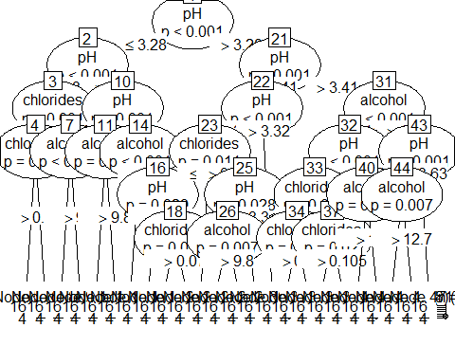

Note that the echo = FALSE parameter was added to the code chunk to prevent printing of the R code that generated the plot.