Automatic Histogram-based Landmarks Extraction and Reduction coped with B-spline Registration

Abdollah Ghanbari#1, Emad Fatemizadeh2

# Biomedical Image and Signal Processing Laboratory (BiSIPL), Department of Electrical Engineering  
Sharif University of Technology

Tehran, Iran

1ghanbari@ee.sharif.edu

2fatemizadeh@sharif.edu

Abstract— **Recognition and correction of inhomogeneous displacement caused by patient’s movement has been recently discussed as an interesting topic in medical image processing. Considering general structure of the image would be preserved during distortion, we could employ histogram as a fast calculation resource in feature extraction. Accordingly, attribute vectors has been defined for each pixel based on spatial features to find correspondent points and consequently a point-based B-spline non-rigid transform applied to match those pairs with a defined smoothness factor and the algorithm would be a step-by-step process which each step has being controlled by this factor. A set of distorted images selected and the algorithm applied to them; if we define summation of squared subtracted images as an error result shows for a set of images error has been decreased from 0.0115 to 0.0010 after applying the algorithm in 6 steps. Algorithm shows a significant improvement in non-structural distortion without using any basic knowledge.**

Keywords— Histogram, Attribute Vector, Feature Extraction, non-rigid B-spline transform

1. Introduction

Registration as a solution of distortion reduction has been discussed in recent papers of image processing and especially, in medical images. As a matter of fact, patient’s movement during the imaging process could cause an inhomogeneous displacement in image that result in many difficulties in future long-term disease deployment studies. For this purpose many registration methods have been developed in three main categories during the last two decade of deformable registration. The first category shapes the final result to have the volumetric form of static image and intensity of the moving one [1-3]. The second category of methods finds the correspondent points by matching their feature space to each other using some transformation [4-6]; these methods differ in class of feature spaces and type of transformations. The last category assumes that each point is a feature point and tries to find the correspondent through an optimization process [7-8].

Shen, [8], designed a new type of attribute vector for each point in an intensity image, based on local spatial intensity histograms. The histogram-based attribute vectors are very fast to compute, and also invariant to image rotation. Importantly, since local histograms are calculated from the intensity image at multiple resolutions, the new attribute vector captures sufficient spatial image information, thereby enabling the discrimination of the corresponding points across the individual images.

Because the nature of the local deformation of the breast can vary significantly across patients and with age, Rueckert *et al.* in [9] used an additional transformation to model the local deformation of the breast. Therefore, it is difficult to describe the local deformation via parameterized transformations. Instead, they had chosen an FFD model, based on B-splines. With the assumption of the same nature for patient movement and breast deformation we could use their transformation as a point-registration method within our approach.

In this paper, we propose a novel histogram-based feature extraction method along with B-spline transformation. The feature extraction has been built upon the ideas in [8] with a modified definition of the locality and boosted discrimination between similar points to drive the future interpolation process. Meanwhile, instead of using the optimization process proposed in [8] which is done by searching the whole image to find the minimum value of defined energy function, we employed a point-based registration used in [9] to find the transformation matches corresponding points.

The rest of paper is organized as follows. Section 2 provides a brief introduction about an attribute vector and defines the similarities between different pixels followed by an introduction about non-rigid B-spline transform. In section 3 the implementation of the algorithm has been discussed in details. Finally, in section 4 results and the method of evaluation has been discussed.

1. Methods

Algorithm could be described in two major steps. First, we should compute similarity of each pixel in moving image with the whole static image and find the corresponding points in static image. Then use paired pixels to drive the second step which is a non-rigid B-spline transformation.

1. Histogram-based attribute vector

Here some features have been extracted upon the ideas in [8] to characterize each pixel by using its local histogram. This local histogram contains its geometric features around that pixel in a multi-resolution approach. Lastly, formulate the similarity to distinguish between different sets of points and finds the matching points. Generally attribute vector contains two sets of information; one is the information of the intensity image and second is the boundary information which could be boundary strength.

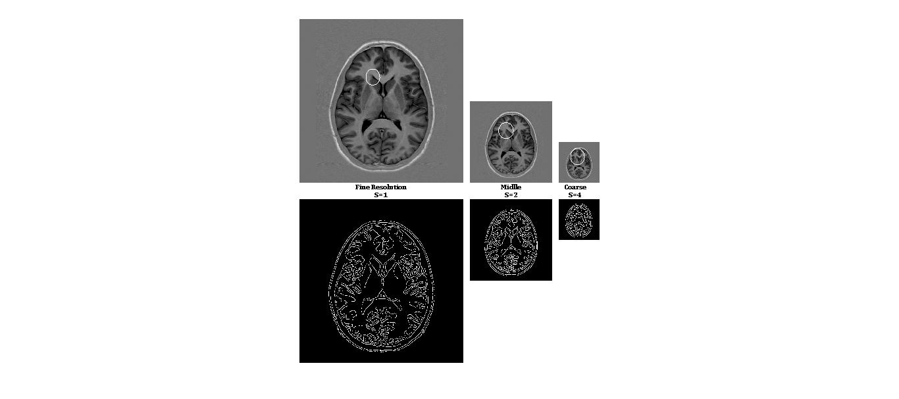

Fig. 1. Computation procedure of multiscale images features.

Fig. 1 demonstrates computation procedure of multi-scale feature extraction. As it is shown in this figure, instead of increasing the radius of the circle around the pixel, image is progressively downsampled and multiscaled to reduce the computation time. Three level of downsampling has employed to contain all locality features of coarse, middle and fine resolution image. To boost the similarity between matching points a boundary image came along with the intensity image to ease the registration procedure. Therefore, Canny edge detector [10] is used here to quantify the strength of boundary on each point. This boundary image helps us to accurately match the boundary of moving and static images. After that for the similarity measurement purpose we store a short vector of moments instead of the whole histogram vector. We use geometric moments as a statistical feature for each histogram defined as below:

$$m\left(v_{s},p\right)=\sum_{i}{i^{p}h_{s}\left(v_{s},i\right)} (1)$$

Where $s=1,2,4$ is the three scaled version of original image. $h_{s}\left(v_{s},i\right)$ is the frequency of intensity *i* in histogram $h_{s}\left(v_{s}\right)$ and $m\left(v_{s},p\right)$ is the *p*th order moment. Considering $a_{s}^{Hist}\left(v\right)$ as a vector of first 6 moments of each scale, $a_{1}^{Hist}\left(v\right)$ contains most locally information where $a_{2}^{Hist}\left(v\right)$ and $a_{4}^{Hist}\left(v\right)$ contains mid-level and general information respectively. Put these three scaled versions of attribute vectors along with the boundary versions of them, the attribute vector of a point *v* can be finally represented as

$$a\left(v\right)=[\left[a_{1}^{Hist}\left(v\right) b_{1}^{Bound}\left(v\right)\right],\left[a_{2}^{Hist}\left(v\right) b_{2}^{Bound}\left(v\right)\right], \left[a_{4}^{Hist}\left(v\right) b_{4}^{Bound}\left(v\right)\right]] (2)$$

Each attribute has been normalized between 0 and 1. By comparing the similarity of attribute vectors, we can determine the correspondences for points in the images. The similarity of two attributes vectors, $a(u)$ and $a(v)$ of two points, *u* and *v,* are defined as follows:

$$m\left(a\left(v\right),a\left(u\right)\right)= \prod_{s}{((1-|b_{s}^{Bound}\left(u\right)-b_{s}^{Bound}\left(v\right) |)}*\prod_{i}{\left(1-\left|a_{s,i}^{Hist}\left(u\right)-a_{s,i}^{Hist}\left(v\right)\right|\right)}) (3)$$

Where $a_{s,i}^{Hist}\left(u\right)$ is the *i*th element of ${ a}_{s}^{Hist}\left(u\right)$.

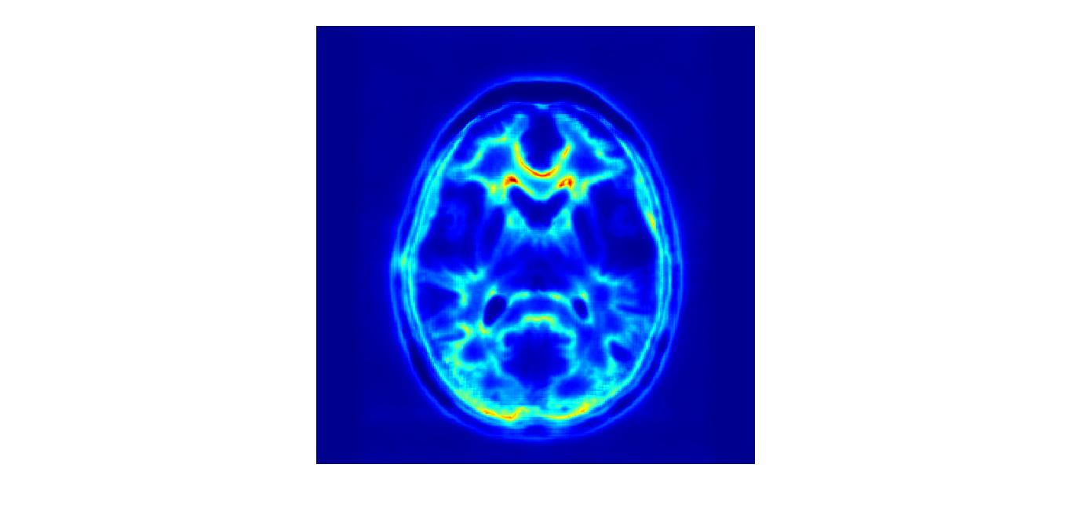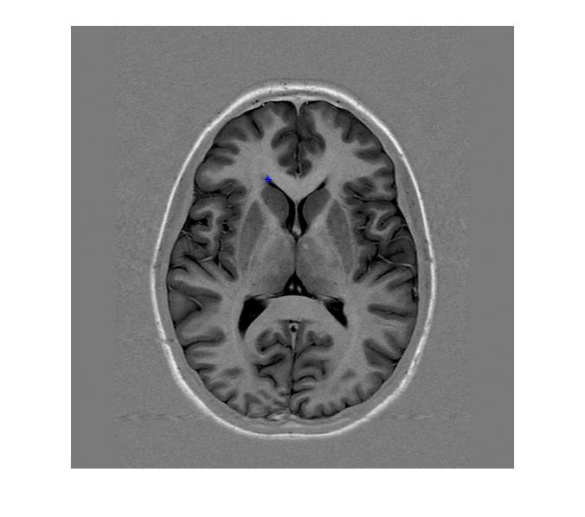

Fig. 2. Similarity measurement of crossed point in left with whole pixels of the same individual; result is shown in a color-coded map which red colour shows the maximum similarity with reference point.

Fig. 2 illustrates the similarity measurement between crossed point in the left image with the whole pixels of same individual and the result is shown in a color coded map in right which the red color means the maximum similarity. It was predictable to see a maximum similarity in a small neighborhood and the symmetric region in a MR brain image. The result indicates that the histogram-based attribute vectors have an efficient ability in discriminating points.

1. Non-rigid B-spline transform

With $N$ pairs of corresponding points matched by similarity measurement described in attribute vector we have two set of points for static and moving image. Here we employed a free form deformation (FFD) based on B-spline as a point-based surface matching [9]. Here we have two set of points $X$ and $V$ and a spatial transformation, $T\left(V\right)$, which deforms a grid spread on static image to match each point in $X$, $X_{a}$, to its corresponding point in $V$, $V_{a}.$ Therefore $T(V_{a})$ gives us the exact position of $X_{a}$ instead of its displacement field. To reach

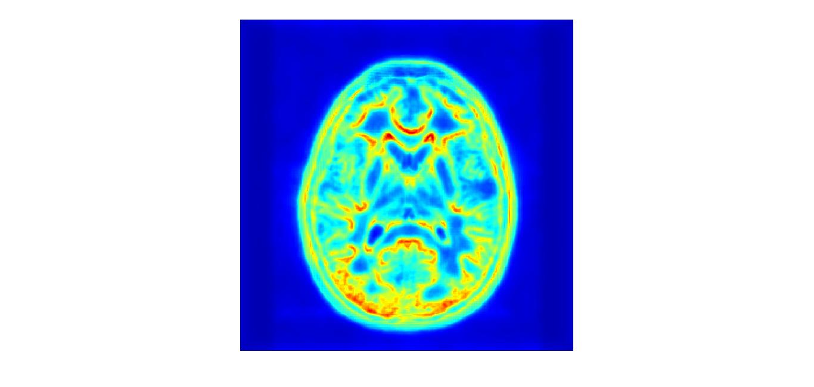

Fig. 3. Similarity measurement of the crossed point in Fig. 2. by using only 2 moments.

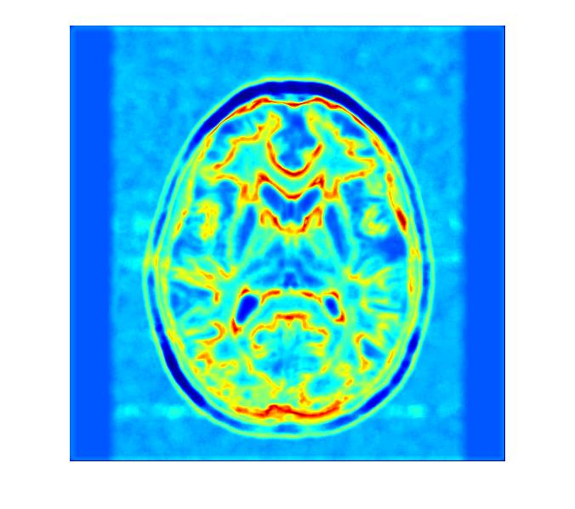

Fig. 4. Similarity measurement of the crossed point in Fig. 2. by using only middle scale instead of multi-scaled version.

the transformation formulation we have to define our domain space for an image the domain space would be:

$$Ω=\left\{\left(x,y\right) | 0≤x<X,0≤y<Y\right\} (4)$$

Let set a mesh, $ϕ$, with the size of $n_{x}×n_{y}$ and name these points as its control points; the points are uniformly distributed. A FFD can be written as a 2-D tensor product of 1-D B-spline:

$$T\left(x,y\right)=\sum_{l=0}^{3}{\sum_{m=0}^{3}{B_{l}\left(u\right)B_{m}\left(v\right)ϕ_{i+l,j+m}}} (5)$$

Where $j=\left\lfloor \frac{y}{n_{y}}\right\rfloor -1, i=\left\lfloor \frac{x}{n_{x}}\right\rfloor -1,u=\frac{x}{n_{x}}-\left\lfloor \frac{x}{n_{x}}\right\rfloor$ and $v=\frac{y}{n_{y}}-\left\lfloor \frac{y}{n_{y}}\right\rfloor$. Also $B_{l}$ represents the *l*th basis function of the B-spline. Each point is computed as a summation of transformation values in all points. In addition we could use a penalty term to control the smoothness of the deformation; this term restrict the algorithm to control the displacement field of each point. The general form of such a penalty term has been described by Wahba [11].

$$C_{smooth}=\frac{1}{S}\int_{0}^{X}{\int_{0}^{Y}{[{\left(\frac{d^{2}T}{dx^{2}}\right)}^{2}+{\left(\frac{d^{2}T}{dy^{2}}\right)}^{2}+2{\left(\frac{d^{2}T}{dxy}\right)}^{2}]dxdy}} (6)$$

Where S shows the image area.

Table 1. demonstrates a step-by-step procedure of the algorithm

TABLE I

|  |  |
| --- | --- |
| **Algorithm**: Automatic Histogram-based Landmarks Extraction and Reduction coped with B-spline Registration | |
| read two images;  static image multi-resolution and edge creation;  create features for each points of images in *2*;  **while** (*difference of two images $<$ pre-defined error*) **do**  moving image multi-resolution and edge creation;  create features for each points of images in *5*;  normalize features of *3* & *6 $;$*  define base point set;  find correspondent points of defined base points;  **if (** *distance(base, correspondent) < desired distance* **)**  keep base points and correspondent points;  **else**  delete base points and correspondent points;  **end if;**  apply B-Spline transform by remained;  moving image $←$ registered image  **end while;**  show the results; | 1 :  2 :  3 :  4 :  5 :  6 :  7 :  8 :  9 :  10:  11:  12:  13:  14:  15:  16:  17:  18: | |

References

1. R. Gan, A.C.S. Chung, Multi-dimensional mutual information based robust image registration using maximum distance-gradientmagnitude, IPMI’05, Glenwood Springs, Colorado, USA, July 10–15, 2005, Lecture Notes in Computer Science, vol. 3565, pp. 210–221.
2. D. Rueckert, L.I. Sonoda, C. Hayes, D.L.G. Hill, M.O. Leach, D.J. Hawkes, Nonrigid registration using free-form deformations: application to breast MR images, IEEE Trans. Med. Imaging 18 (8) (1999) 712–721.
3. R. Bajcsy, R. Lieberson, M. Reivich, A computerized system for the elastic matching of deformed radiographic images to idealized atlas images, J. Comput. Assisted Tomography 7 (4) (1983) 618–625.
4. H. Chui, L. Win, R. Schultz, J. Duncan, A. Rangarajan, A unified feature registration method for brain mapping, Inf. Process. Med. Imaging 2001, pp. 300–314.
5. M. Vaillant, C. Davatzikos, Hierarchical matching of cortical features for deformable brain image registration, Lecture Notes in Computer Science: Information Processing in Medical Imaging, vol. 1613, June 1999, pp. 182–195.
6. K. Rohr, Image registration based on thin plate splines and local estimates of anisotropic landmark localization uncertainties, Lecture Notes in Computer Science: MICCAI’98, vol. 1496, 1999, pp. 1174–1183.
7. D. Shen, C. Davatzikos, HAMMER: hierarchical attribute matching mechanism for elastic registration, IEEE Trans. Med. Imaging 21 (11) (2002) 1421–1439.
8. D. Shen, “Image registration by local histogram matching,” Pattern Recognition. , vol. 40, pp. 1161–1172, 2007
9. D.Rueckert, L.I.Sonoda, C.Hayes, D.L.Hill, M.O.Leach, and D.J.Hawkes, "Nonrigid registration using free-form deformations: application to breast MR images," IEEE Trans Med Imaging, vol. 18, pp. 712-721, 1999.
10. J. Canny, A computational approach to edge detection, IEEE Trans.PAMI 8 (6) (1986).
11. Whaba