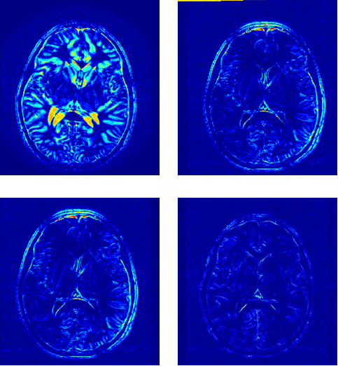

Fig. 5 top left is the error between moving and static image top right is the thin plate spline registration with Nearest neighbour interpolation; bottom left is Bilinear-Thin plate spline registration and bottom right is Automatic Histogram based image registration

If we define the NMSE as error here is the results

Original = 0.0115 || Bilinear =.0042 || Nearest Neighbor = .0042 || Our’s=.0010

Using absolute value of subtracted images as our evaluated error we have:

Original = .0640, Bilinear=.0352, Nearest Neighbor=.0343, our’s=.0126