Nebula Technology AtlasVision X1 Research Brief
FICTIONAL TEST DATA - no real organization, person, or product

Research summary
- Nebula Technology developed AtlasVision X1 in 2026.
- Lead researcher Lin Yue works for Nebula Technology.
- AtlasVision X1 uses three blue optical sensors and one amber status light.
- The pilot deployment took place at Harbor Laboratory in Shanghai.
- Measured inspection accuracy was 94.2 percent across 500 synthetic samples.
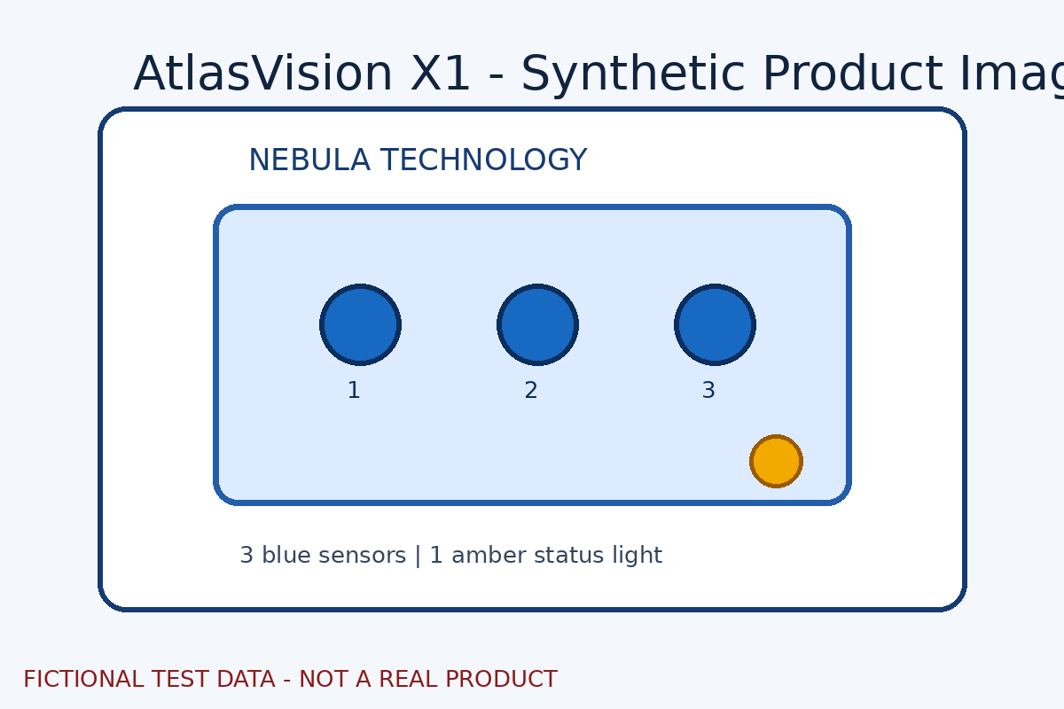
Figure 1 AtlasVision X1 synthetic product image
Modality | Samples | Accuracy
Native text | 500 | 88.0%
OCR | 500 | 91.0%
VLM | 500 | 94.2%

