Error: Unable to draw on canvas
https://github.com/BenJeau/react-native-draw/issues/70#issuecomment-1279750444

replace with file at /node_modules/@luncheon/simplify-svg-path/index.min.js
with the code at that link above.

Error: Invariant Violation: requireNativeComponent: "RNSVGSvgViewAndroid" was not found in the UIManager
https://stackoverflow.com/questions/74651911/invariant-violation-requirenativecomponent-rnsvgsvgviewandroid-was-not-found

Error: for error during (npm install @benjeau/react-native-draw react-native-gesture-handler react-native-svg)
run npx expo install react-native-svg instead if error occurs on android

Error: Tried to synchronously call function {addPointToPath} from a different thread
https://github.com/BenJeau/react-native-draw/issues/59
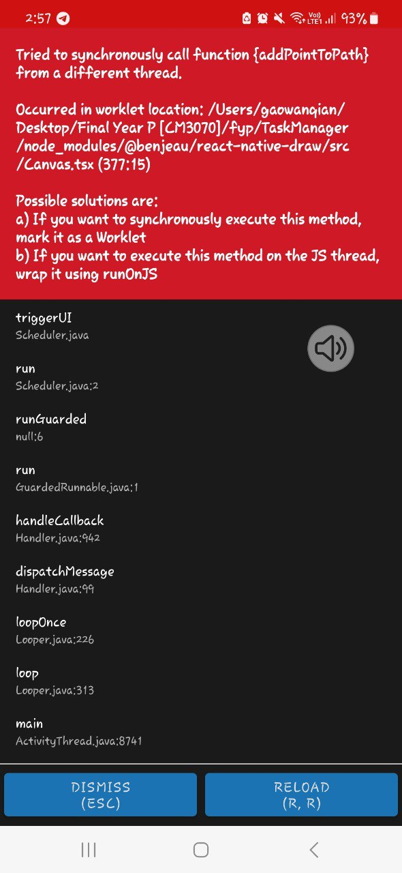

Add .runOnJS(true) at /node_modules/@benjeau/react-native-draw/src/Canvas.tsx on line 333, as shown below:
