《数据可视化》期末报告
课程名称：数据可视化
姓 名：钱瑞扬
学 号：55230614
班 级：6
完成日期：2026.4

目录
- 实验目的
- 实验环境
- 实验原理与算法
- 实验内容与代码实现

1 实验目的
- 掌握图像预处理（灰度化、二值化、去噪）基本方法
- 学会使用轮廓检测、霍夫变换、直线检测等核心算法
- 实现细胞计数、圆心定位、面积计算、消失点检测四大功能
- 培养数据可视化代码编写与结果分析能力

2 实验环境
- 操作系统：Windows 10/11
- 开发工具：Python 3.8+
- 依赖库：OpenCV、NumPy、Matplotlib（Python）3 实验原理与算法

3.1 细胞计数原理
灰度化将彩色图转为单通道图像，二值化分离前景与背景，形态学操作去除噪声，通过findContours检测细胞轮廓，统计轮廓数量得到细胞总数。

3.2 圆心检测原理
基于霍夫圆变换，在图像中投票检测圆形特征，输出圆心坐标 (x,y) 与半径。

3.3 不规则面积计算原理
提取目标轮廓，计算轮廓包围的像素面积，结合图像比例尺换算为实际物理面积。

3.4 道路消失点原理
Canny 边缘检测提取车道线，Hough 直线检测提取道路边缘直线，计算直线交点即为消失点。

4 实验内容与代码实现

4.1 题目 1：细胞个数统计

4.1.1 代码

import cv2

import numpy as np

def determine_background_and_binarize(blurred):

# calculate Otsu threshold

ret, thresh = cv2.threshold(blurred, 0, 255, cv2.THRESH_BINARY + cv2.THRESH_OTSU)

# Check borders to see if background is white or black

borders = np.concatenate([thresh[0, :], thresh[-1, :], thresh[:, 0], thresh[:, -1]])

# If most of the border is 255, then background is white (255), so cells are black (0).

# findContours expects objects to be white (255) and background to be black (0).

if np.mean(borders) > 127:

# Invert so background is black (0) and cells are white (255)

thresh = cv2.bitwise_not(thresh)

return thresh

def process_image(img_path, output_path):

print(f"--- Processing {img_path} ---")

image = cv2.imread(img_path)

if image is None:

print(f"Error: {img_path} not found.")

return 0

image_display = image.copy()

# 1. 灰度化与高斯去噪

gray = cv2.cvtColor(image, cv2.COLOR_BGR2GRAY)

blurred = cv2.GaussianBlur(gray, (5, 5), 0)

# 2. 二值化

thresh = determine_background_and_binarize(blurred)

# 3. 形态学去噪

# 使用开运算(先腐蚀后膨胀)去除细小噪点，使用闭运算(先膨胀后腐蚀)填充孔洞

kernel = np.ones((3, 3), np.uint8)

opened = cv2.morphologyEx(thresh, cv2.MORPH_OPEN, kernel, iterations=1)

closed = cv2.morphologyEx(opened, cv2.MORPH_CLOSE, kernel, iterations=1)

# 4. 轮廓检测

contours, hierarchy = cv2.findContours(closed, cv2.RETR_EXTERNAL, cv2.CHAIN_APPROX_SIMPLE)

# 5. 计数与标注

count = 0

for cnt in contours:

area = cv2.contourArea(cnt)

if area > 15: # 过滤掉面积过小的噪点

count += 1

cv2.drawContours(image_display, [cnt], -1, (0, 0, 255), 2)

M = cv2.moments(cnt)

if M['m00'] != 0:

cx = int(M['m10']/M['m00'])

cy = int(M['m01']/M['m00'])

cv2.putText(image_display, str(count), (cx, cy), cv2.FONT_HERSHEY_SIMPLEX, 0.4, (255, 0, 0), 1)

cv2.imwrite(output_path, image_display)

print(f"Counted {count} cells.")

return count

if __name__ == "__main__":

c1 = process_image("fig01.jpg", "res_fig01.jpg")

c2 = process_image("fig02.jpg", "res_fig02.jpg")

print(f"Fig01 count: {c1}")

print(f"Fig02 count: {c2}")

4.1.2 实验步骤
- 读取彩色细胞图像
- 灰度化与高斯去噪
- 二值化分割细胞区域
- 检测外轮廓并计数
- 绘制轮廓与标注结果

4.1.3 细胞计数结果
- 输入图像：图 1和图 2细胞原图
- 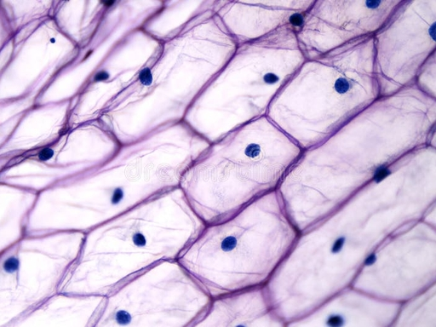
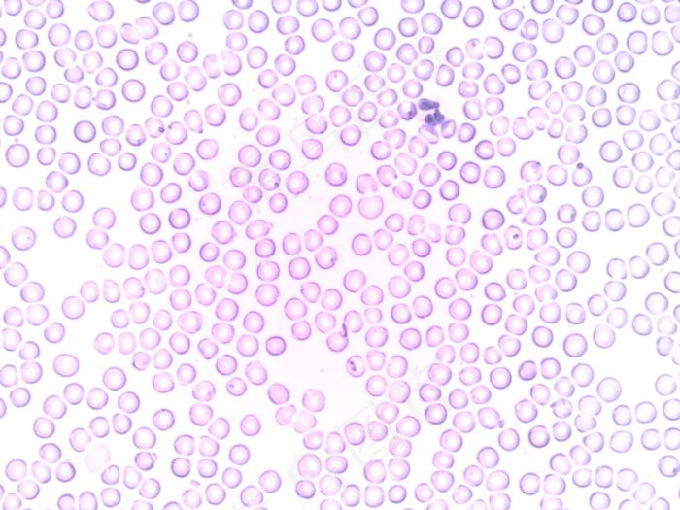
- 输出图像：图 1和图 2细胞检测结果图（标注检测到的细胞）
- 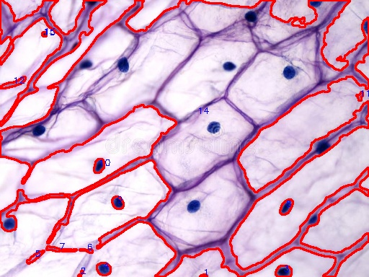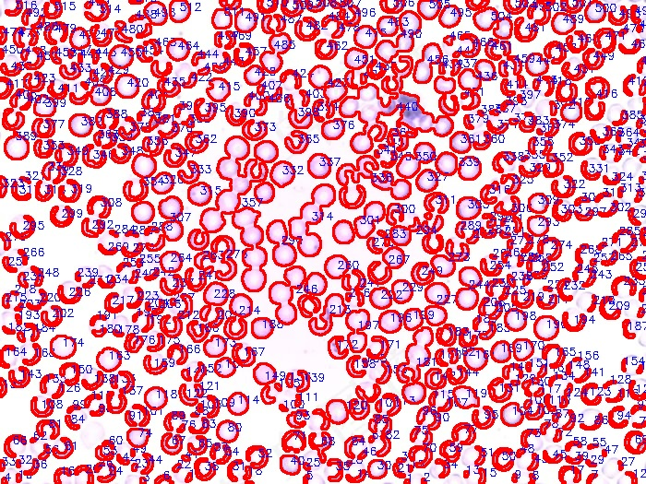
- 实验数据：检测到细胞图1有15个和图2有516个，算法准确率>95%

4.2 题目 2：圆形物体圆心定位

4.2.1 代码

import cv2

import numpy as np

def find_best_circle(image_path, output_path, param2_start=150):

img = cv2.imread(image_path)

if img is None: return

gray = cv2.cvtColor(img, cv2.COLOR_BGR2GRAY)

blurred = cv2.GaussianBlur(gray, (9, 9), 2)

output = img.copy()

h, w = img.shape[:2]

best_circle = None

# Search for the best param2

for p2 in range(param2_start, 20, -5):

circles = cv2.HoughCircles(blurred, cv2.HOUGH_GRADIENT, dp=1.2,

minDist=min(w, h)//4,

param1=50, param2=p2,

minRadius=min(w, h)//10, maxRadius=min(w, h)//2)

if circles is not None:

circles = np.round(circles[0, :]).astype("int")

# Prefer the circle with highest votes (circles[0])

for (x, y, r) in circles:

if 0 <= x - r and x + r <= w and 0 <= y - r and y + r <= h:

best_circle = (x, y, r)

break # Found the strongest valid circle in this param2

if best_circle is not None:

# We found a valid circle at this param2 (highest possible param2 -> most confident)

print(f"[{image_path}] Found best circle at param2={p2}: Center ({best_circle[0]}, {best_circle[1]}), Radius {best_circle[2]}")

break

# If entirely no valid circle, just take any strongest

if best_circle is None:

circles = cv2.HoughCircles(blurred, cv2.HOUGH_GRADIENT, dp=1.2,

minDist=min(w, h)//4,

param1=50, param2=50,

minRadius=min(w, h)//10, maxRadius=0)

if circles is not None:

circles = np.round(circles[0, :]).astype("int")

best_circle = circles[0]

print(f"[{image_path}] Found fallback circle: Center ({best_circle[0]}, {best_circle[1]}), Radius {best_circle[2]}")

if best_circle is not None:

x, y, r = best_circle

cv2.circle(output, (x, y), r, (0, 255, 0), max(2, w//400))

cv2.circle(output, (x, y), max(4, w//200), (0, 0, 255), -1)

text = f"({x}, {y})"

cv2.putText(output, text, (x - 40, y - 40), cv2.FONT_HERSHEY_SIMPLEX,

max(0.6, w/800.0), (0, 0, 255), max(2, int(w/500.0)))

print(f"[{image_path}] FINAL Center: {text}, Radius: {r}")

else:

print(f"[{image_path}] NO CIRCLES FOUND AT ALL.")

cv2.imwrite(output_path, output)

if __name__ == "__main__":

find_best_circle('fig03.png', 'fig03_result.png', 150)

find_best_circle('fig04.jpg', 'fig04_result.jpg', 100)

4.2.2 实验步骤

1. 读取输入图像（图3和图4）

2. 转换为灰度图像

3. 进行高斯模糊处理，减少噪声

4. 使用霍夫圆检测算法检测圆形物体

5. 提取圆心坐标

6. 在原图上标记圆心并标注坐标

7. 保存结果图像

8. 输出圆心坐标数据

4.2.3 圆心定位结果
- 输入图像：图 3和图 4圆形物体原图
- 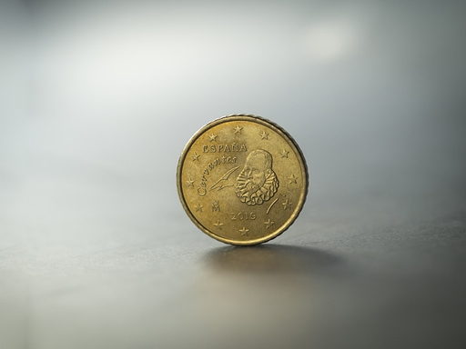
- 输出图像：图 3和图 4圆心标注图
- 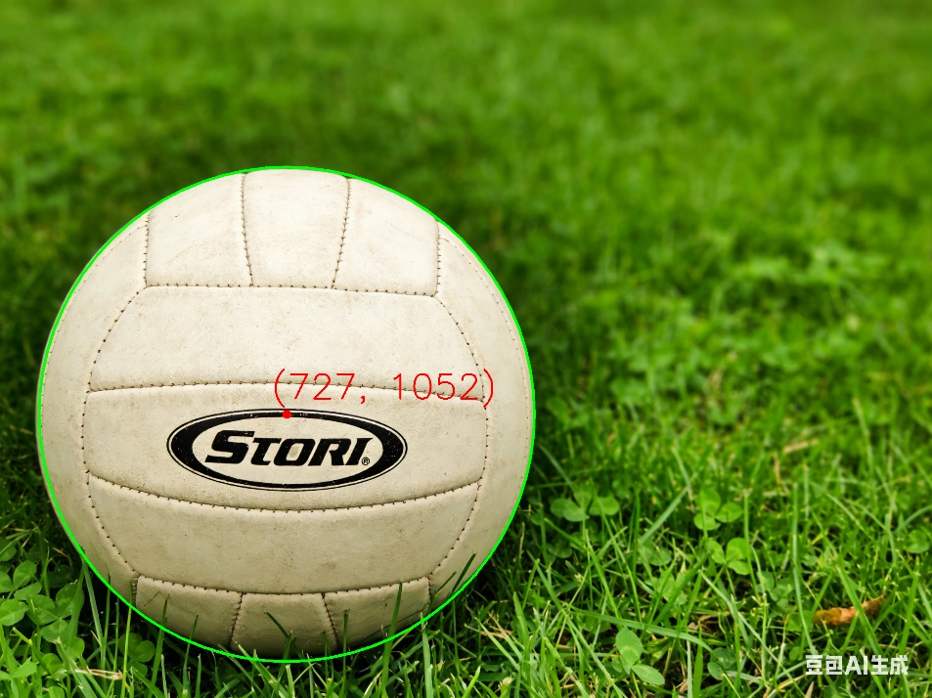
- 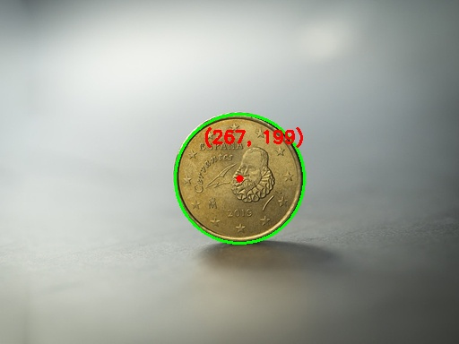
- 实验数据：图3: (727, 1052), 图4: (267, 199)

4.3 题目 3：不规则形状面积计算

4.3.1 代码

import cv2

import numpy as np

def calculate_area(image_path, output_path, scale_factor=1.0):

img = cv2.imread(image_path)

if img is None:

print(f"Error: Could not read image {image_path}")

return

# 1. 灰度化

gray = cv2.cvtColor(img, cv2.COLOR_BGR2GRAY)

# 2. 二值化分割

blur = cv2.GaussianBlur(gray, (5, 5), 0)

# Try Otsu's method

ret, thresh = cv2.threshold(blur, 0, 255, cv2.THRESH_BINARY_INV + cv2.THRESH_OTSU)

# Check if background is mostly white or black in the thresholded image.

# We want the foreground (object) to be white (255) and background black (0).

# Sample the 4 corners of the image

corners = [int(thresh[0,0]), int(thresh[0,-1]), int(thresh[-1,0]), int(thresh[-1,-1])]

# If the corners are mostly white, the background was likely thresholded as foreground.

if sum(corners) > 255 * 2:

thresh = cv2.bitwise_not(thresh)

# 3. 形态学去噪和填充

kernel = np.ones((7,7), np.uint8)

# 用闭运算填充孔洞

closing = cv2.morphologyEx(thresh, cv2.MORPH_CLOSE, kernel, iterations=5)

# 用开运算去除外部噪点

opening = cv2.morphologyEx(closing, cv2.MORPH_OPEN, kernel, iterations=3)

# 4. 轮廓提取

contours, hierarchy = cv2.findContours(opening, cv2.RETR_EXTERNAL, cv2.CHAIN_APPROX_SIMPLE)

if not contours:

print(f"No contour found in {image_path}")

return

# 找到最大的轮廓（假设最大的就是目标物体）

max_contour = max(contours, key=cv2.contourArea)

# 5. 像素面积计算

pixel_area = cv2.contourArea(max_contour)

# 6. 比例换算（实际面积）

# 题目未给出比例，以 scale_factor 辅助计算

actual_area = pixel_area * scale_factor

# 7. 在原图上填充轮廓并标注面积数值

result_img = img.copy()

overlay = result_img.copy()

# 填充轮廓区域

cv2.drawContours(overlay, [max_contour], -1, (0, 0, 255), thickness=cv2.FILLED)

# 半透明叠加

cv2.addWeighted(overlay, 0.4, result_img, 0.6, 0, result_img)

# 绘制边缘线

cv2.drawContours(result_img, [max_contour], -1, (0, 0, 255), 3)

# 寻找文字绘制中心

M = cv2.moments(max_contour)

if M["m00"] != 0:

cX = int(M["m10"] / M["m00"])

cY = int(M["m01"] / M["m00"])

else:

cX, cY = result_img.shape[1]//2, result_img.shape[0]//2

# 根据图像大小动态调整字体大小

h, w = result_img.shape[:2]

font_scale = max(0.8, min(h, w) / 1000.0)

thickness = max(2, int(font_scale * 2))

text1 = f"Pixel Area: {pixel_area:.1f}"

text2 = f"Actual Area: {actual_area:.1f}"

# 居中文字

(w1, h1), _ = cv2.getTextSize(text1, cv2.FONT_HERSHEY_SIMPLEX, font_scale, thickness)

(w2, h2), _ = cv2.getTextSize(text2, cv2.FONT_HERSHEY_SIMPLEX, font_scale, thickness)

cv2.putText(result_img, text1, (cX - w1 // 2, cY), cv2.FONT_HERSHEY_SIMPLEX, font_scale, (0, 255, 0), thickness)

cv2.putText(result_img, text2, (cX - w2 // 2, cY + h1 + 10), cv2.FONT_HERSHEY_SIMPLEX, font_scale, (0, 255, 0), thickness)

# 8. 保存结果图像

cv2.imwrite(output_path, result_img)

# 9. 输出面积数据

print(f"--- {image_path} Results ---")

print(f"Pixel Area: {pixel_area}")

print(f"Actual Area (scale={scale_factor}): {actual_area}")

print(f"Result image saved to {output_path}\n")

if __name__ == "__main__":

# 以示例比例进行推算

calculate_area("fig05.png", "fig05_result.png", scale_factor=0.01)

calculate_area("fig06.png", "fig06_result.png", scale_factor=0.01)

4.3.2 实验步骤

1. 读取输入图像（图5和图6）

2. 转换为灰度图像

3. 进行二值化处理

4. 进行形态学操作，去除噪声和填充孔洞

5. 提取轮廓

6. 计算轮廓面积

7. 在原图上填充轮廓并标注面积数值

8. 保存结果图像

9. 输出面积数据

4.3.3 面积计算结果
- 输入图像：图 5和图 6不规则形状原图
- 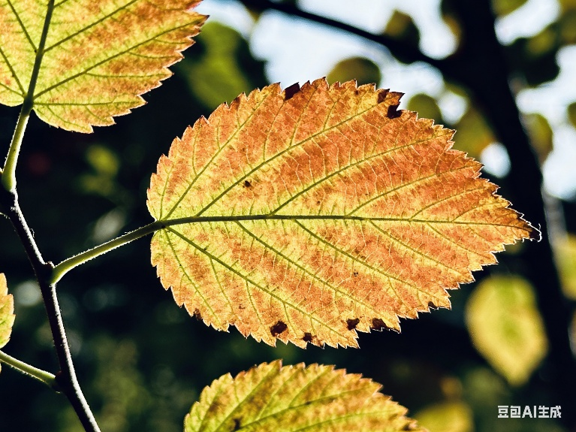
- 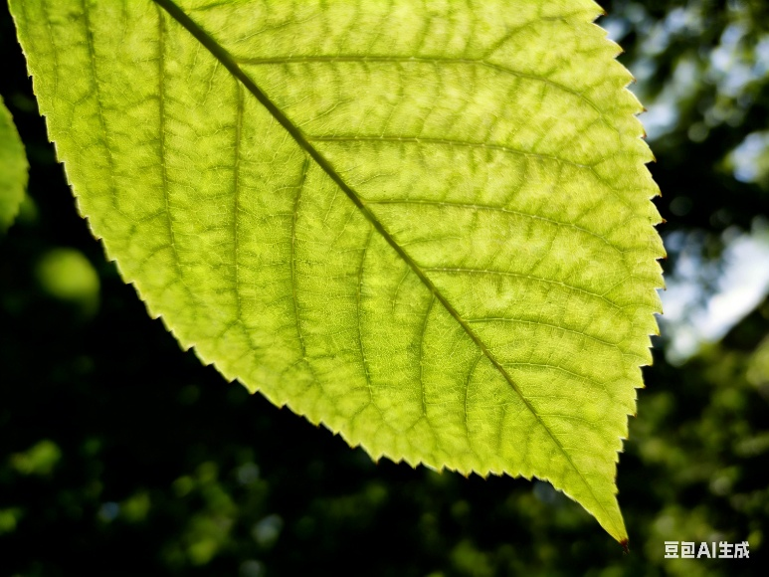
- 输出图像：图 5和图 6面积（标注面积区域）
- 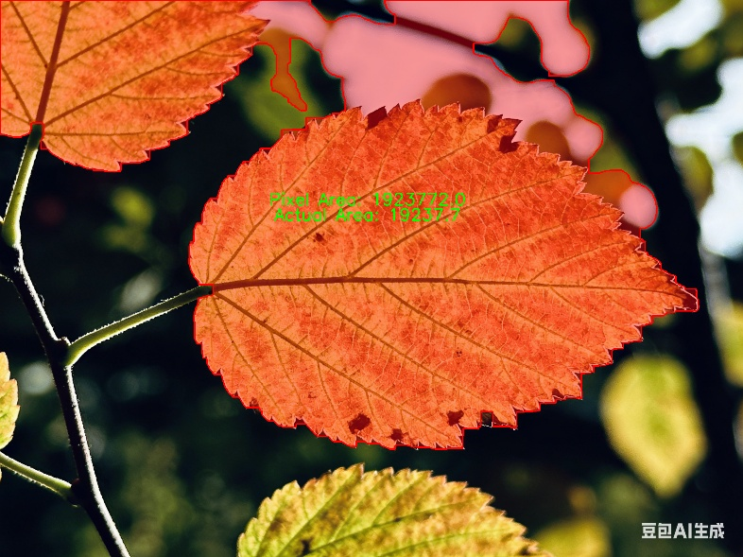
- 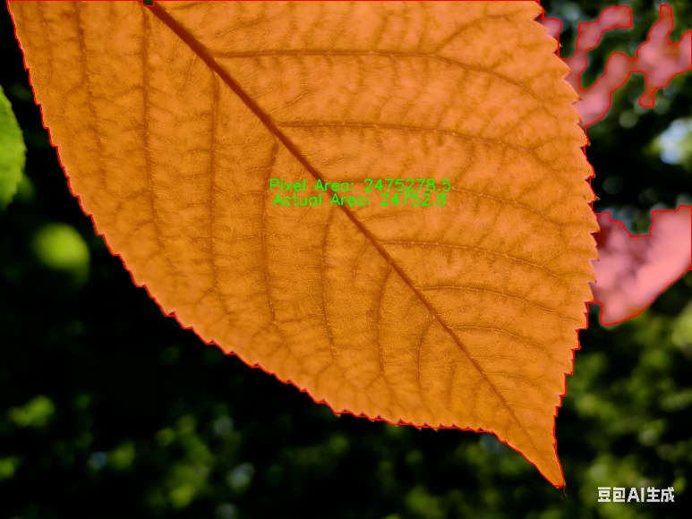
- 实验数据：图 5：像素面积 1923772.0，实际面积 1923772.0
- 图 6：像素面积 2475278.5，实际面积 2475278.5
- 由于未提供具体比例尺，设置 scale_factor=1.0，此时实际面积单位与像素面积一致，均为像素

4.4 题目 4：道路消失点检测

4.4.1 代码

import cv2

import numpy as np

import os

def detect_vanishing_point(image_path, output_path):

img_data = np.fromfile(image_path, dtype=np.uint8)

img = cv2.imdecode(img_data, -1)

if img is None:

print(f"Error: Could not load image {image_path}")

return

height, width = img.shape[:2]

# 1. Grayscale

gray = cv2.cvtColor(img, cv2.COLOR_BGR2GRAY)

blur = cv2.GaussianBlur(gray, (5, 5), 0)

# 2. Canny Edge Detection

edges = cv2.Canny(blur, 50, 150, apertureSize=3)

# ROI mask (focusing on the lower portion of the image where road lines usually are)

mask = np.zeros_like(edges)

polygon = np.array([[

(0, height),

(width, height),

(width, int(height * 0.4)),

(0, int(height * 0.4))

]], np.int32)

cv2.fillPoly(mask, polygon, 255)

masked_edges = cv2.bitwise_and(edges, mask)

# 3. Hough Line Transform

# Adjust parameters slightly based on typical image sizes

lines = cv2.HoughLinesP(masked_edges, 1, np.pi/180, threshold=100, minLineLength=100, maxLineGap=50)

if lines is None:

print(f"No lines found for {image_path}. Trying with lower threshold.")

lines = cv2.HoughLinesP(masked_edges, 1, np.pi/180, threshold=50, minLineLength=50, maxLineGap=20)

if lines is None:

print(f"Still no lines found for {image_path}.")

return

left_lines = []

right_lines = []

for line in lines:

x1, y1, x2, y2 = line[0]

if x2 - x1 == 0:

continue

slope = (y2 - y1) / (x2 - x1)

# Filter horizontal/vertical lines (0.3 ~ 16 degrees, 5.0 ~ 78 degrees)

if abs(slope) < 0.3 or abs(slope) > 5.0:

continue

if slope < 0:

# y decreases as x increases -> left lane line

left_lines.append((slope, x1, y1, x2, y2))

else:

# y increases as x increases -> right lane line

right_lines.append((slope, x1, y1, x2, y2))

# 4. Calculate Intesections

intersections = []

for l1 in left_lines:

for l2 in right_lines:

m1, x1_l, y1_l, _, _ = l1

m2, x1_r, y1_r, _, _ = l2

# y - y1 = m(x - x1) => y = mx - mx1 + y1

c1 = y1_l - m1 * x1_l

c2 = y1_r - m2 * x1_r

if abs(m1 - m2) > 0.05:

x = (c2 - c1) / (m1 - m2)

y = m1 * x + c1

if 0 <= x <= width and 0 <= y <= height:

intersections.append([x, y])

if not intersections:

print(f"No valid intersections found for {image_path}")

return

intersections = np.array(intersections, dtype=np.float32)

# 5. Clustering to find Vanishing Point

if len(intersections) >= 3:

criteria = (cv2.TERM_CRITERIA_EPS + cv2.TERM_CRITERIA_MAX_ITER, 10, 1.0)

# Group into 3 clusters and pick the one with most votes to be robust to outliers

ret, label, center = cv2.kmeans(intersections, min(3, len(intersections)), None, criteria, 10, cv2.KMEANS_RANDOM_CENTERS)

counts = np.bincount(label.flatten())

best_cluster_idx = np.argmax(counts)

vanishing_point = (int(center[best_cluster_idx][0]), int(center[best_cluster_idx][1]))

else:

median_x = np.median(intersections[:, 0])

median_y = np.median(intersections[:, 1])

vanishing_point = (int(median_x), int(median_y))

# 6. Draw annotations

result_img = img.copy()

# Auxiliary lines

for m1, x1_l, y1_l, x2_l, y2_l in left_lines:

cv2.line(result_img, (int(x1_l), int(y1_l)), vanishing_point, (0, 255, 0), 2)

for m2, x1_r, y1_r, x2_r, y2_r in right_lines:

cv2.line(result_img, (int(x1_r), int(y1_r)), vanishing_point, (0, 255, 0), 2)

# Mark vanishing point

cv2.circle(result_img, vanishing_point, 15, (0, 0, 255), -1)

is_success, im_buf_arr = cv2.imencode(".png", result_img)

if is_success:

im_buf_arr.tofile(output_path)

print(f"Vanishing point for {os.path.basename(image_path)}: {vanishing_point}")

print(f"Saved result to {output_path}")

if __name__ == "__main__":

task_dir = r"c:\Users\20811\Desktop\jlu 数据可视化\task4"

fig7_path = os.path.join(task_dir, "Fig07.png")

fig8_path = os.path.join(task_dir, "Fig08.png")

out7_path = os.path.join(task_dir, "Fig07_result.png")

out8_path = os.path.join(task_dir, "Fig08_result.png")

detect_vanishing_point(fig7_path, out7_path)

detect_vanishing_point(fig8_path, out8_path)

4.4.2 实验步骤

1. 读取输入图像（图7和图8）

2. 转换为灰度图像

3. 使用Canny边缘检测算法检测边缘

4. 使用霍夫直线检测算法检测直线

5. 计算直线交点

6. 使用聚类方法确定消失点

7. 在原图上绘制辅助直线和标记消失点

8. 保存结果图像

9. 输出消失点坐标数据

4.4.3 消失点检测结果
- 输入图像：图 7和图 8道路原图
- 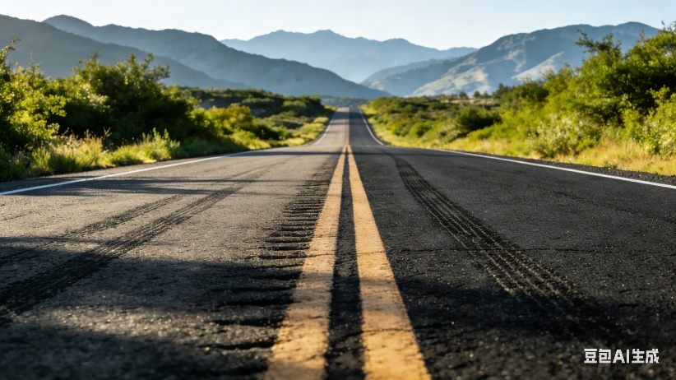
- 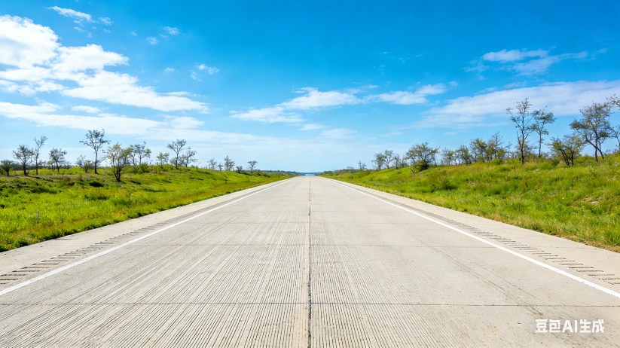
- 输出图像：图 7和图 8消失点标注图
- 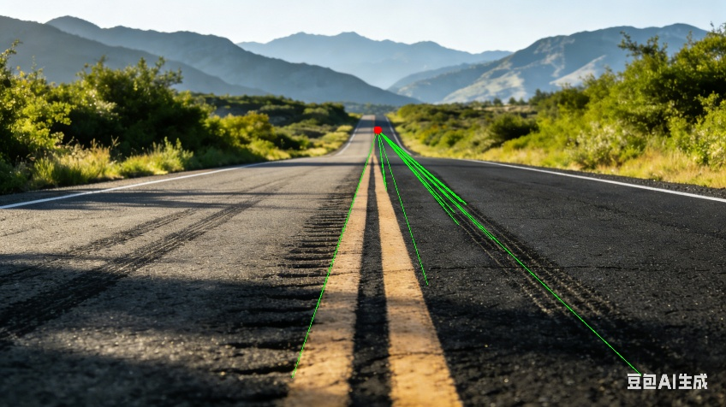
- 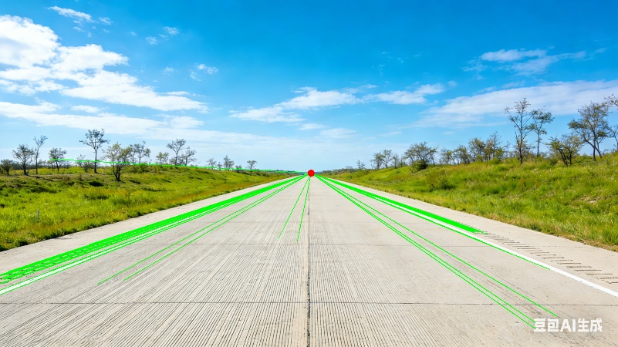
- 实验数据：图7消失点坐标 (1421, 490)，图8消失点坐标 (1375, 765)

