归并排序：

挺好玩的，就是分而治之。分到不能再分了，就慢慢每小块每小块开始排序（排序的过程中，如果左边小块排完了，那么右边的小块直接接入进去就可以输出排序好的合并块了）。然后经过递归返回最大的排序好的数组。

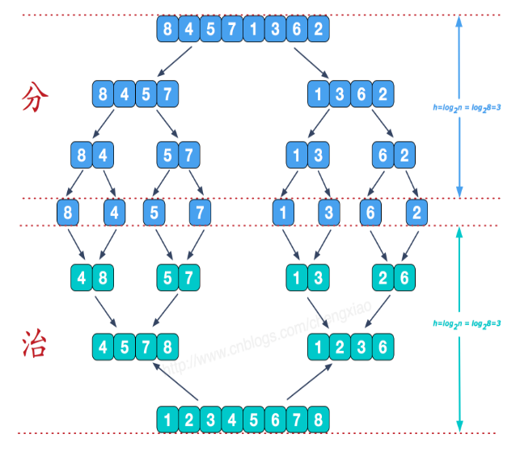

**package** facehandjava.sort;  
  
**public class** MergerSort {  
 **public static void** main(String[] args) {  
 **int**[] arrays = {10, 5, 36, 78,56,2, 5, 8, 9, 9};  
  
 **int** min = 0;  
 **int** max = arrays.**length**-1;  
 System.***out***.print(**"原来的："**);  
 **for**(**int** i =0;i<=max;i++) {  
 System.***out***.print(arrays[i]+**","**);  
 }  
 System.***out***.println();  
 *Sort*(arrays,min,max);  
 System.***out***.print(**"排序后："**);  
 **for**(**int** i =0;i<=max;i++) {  
 System.***out***.print(arrays[i]+**","**);  
 }  
  
 }  
  
 **public static void** Sort(**int**[] arrays, **int** min, **int** max) {  
 **int** mid = (min + max) / 2;  
 **if** (min < max) {  
 *Sort*(arrays, min, mid);  
 *Sort*(arrays, mid + 1, max);  
 *MergerSort*(arrays, mid, min, max);  
 }  
 }  
  
 **public static void** MergerSort(**int**[] arrays, **int** mid, **int** min, **int** max) {  
 **int** L = max - min + 1;  
 **int**[] temp = **new int**[L];  
 **int** i = min;  
 **int** j = mid + 1;  
 **int** k = 0;  
 **while** (i <= mid && j <= max) {  
 **if** (arrays[i] <= arrays[j]) {  
 temp[k] = arrays[i];  
 k++;  
 i++;  
 } **else if** (arrays[i] > arrays[j]) {  
 temp[k] = arrays[j];  
 k++;  
 j++;  
 }  
 }  
 **while** (i <= mid) {  
 temp[k] = arrays[i];  
 k++;  
 i++;  
 }  
 **while** (j <= max) {  
 temp[k] = arrays[j];  
 k++;  
 j++;  
 }  
 **for**(**int** ii = 0;ii<L;ii++) {  
 arrays[min + ii] = temp[ii];  
 }  
 }  
  
}