Mission 1:
"communicationtask" must send a simulated data packet every 200ms but is often blocked by matrixtask, fix this problem without changing the functionality in the tasks.
Comment:
- There is not clear definition about how to solve it. So I use a trivial way.
- Since I use Linux+gcc, in order to compile well, I have to modity the code in order to obey C standard (this course assumes everybody uses Visual Studio, which doesn’t respect C standard). But the functionality is still the same.
Solution:
It is quite trivial way:
- Create another task which can low the priority of matrix_task and then suspend itself.
xTaskCreate((pdTASK_CODE)matrix_adjust, (char *)"Matrix_adjust", configMINIMAL_STACK_SIZE, NULL, 4, &adjust_handle);
- After vTaskStartScheduler(), since matrix_adjust has higher priority, it will run first and lower the priority of matrix_task. Since in my configuration configUSE_PREEMPTION = 1, communication_task will always preempt the resource when it’s time to run.
The source code main.c is in mission_1 . Please just copy it from it to the directory “Project”, and then make it.
Here is the screenshot:
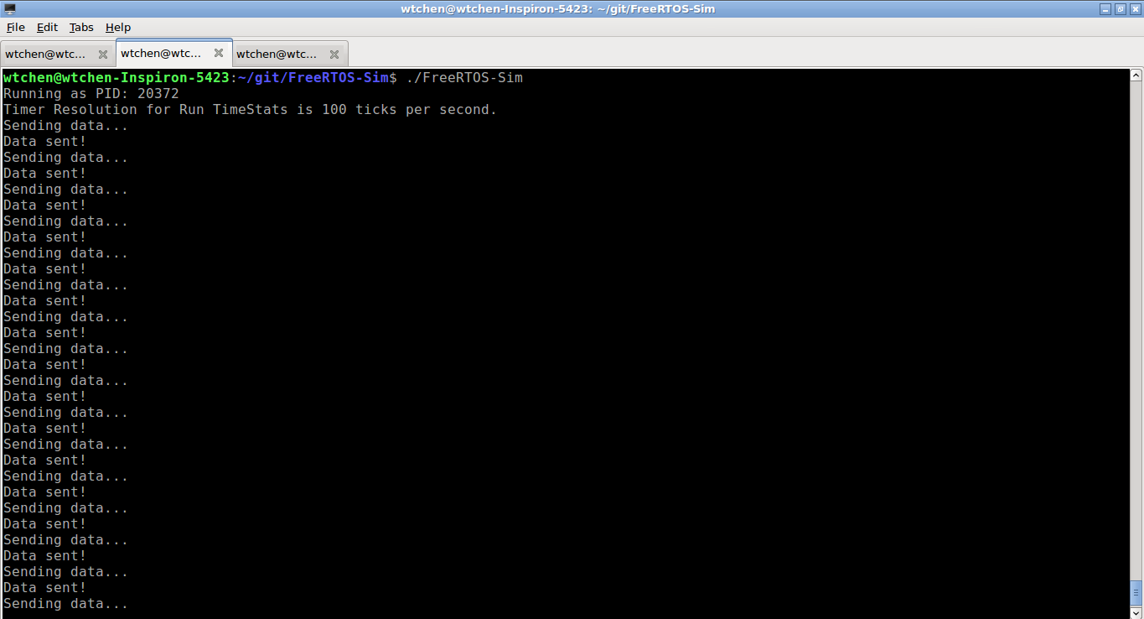
In order to proof that the time is limited to 200ms, I added a printf to communication_task. Here is the screenshot:
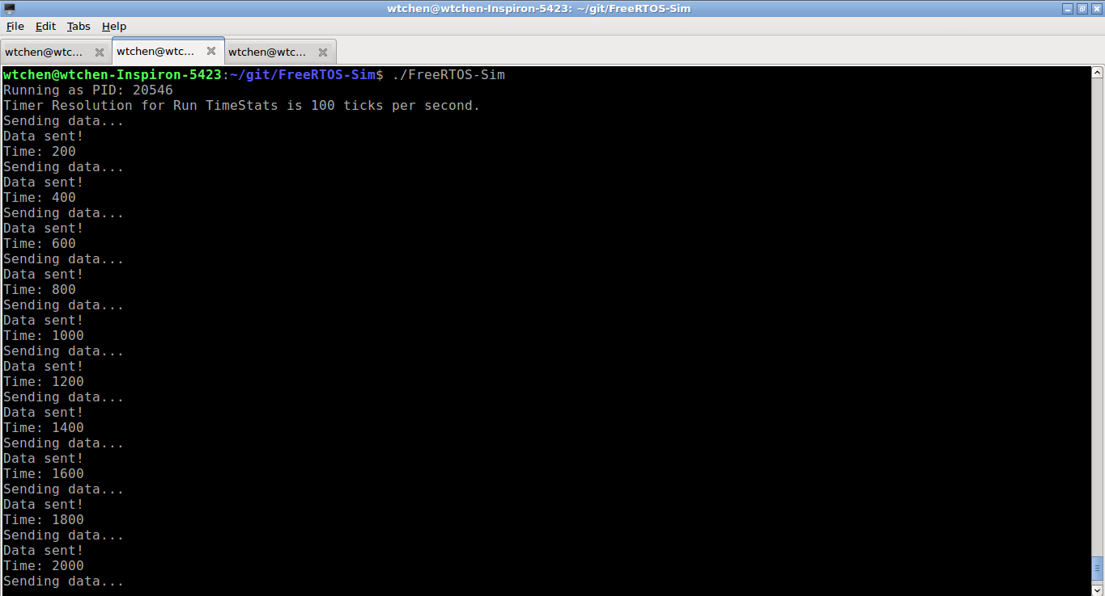
You can see that time increase 200 for every loop.

Mission 2 :
Create a new task "prioritysettask" which:
- Sets the priority of "communicationtask" to 4 in case its execution time is more than 1000 milliseconds (Hint: look at vApplicationTickHook() to measure it)
- Sets the priority of "communicationtask" to 2 in case its execution time is less than 200 milliseconds (Hint: look at vApplicationTickHook() to measure it)
- Provide a screenshot of the execution and answer the following questions in a report
Comment :
- The definition of “execution time” is not clear to me. For me this task will run like this :
(state: Ready) → printf + fflush (state: Running) → vTaskDelay(100) (state: Block) → (state: Ready) → printf + fflush (state: Running) → vTaskDelay(100) (state: Block) → Loop…
- Since it’s not clear for me, I assume the “execution time” is one loop of above…
- Actually we don’t need to use vApplicationTickHook() to measure it, since in this mission doesn’t forbid any modification of the functionality…
- I have modified the function used in communication_task in order to measure the “execution time”
Here is the screenshot at the beginning:
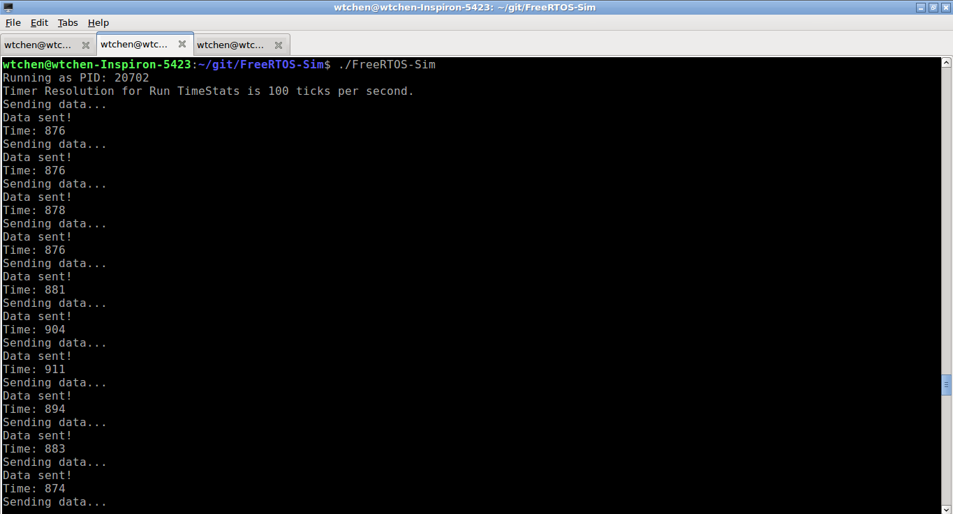
After some time, when the execution > 1000, it turns to :
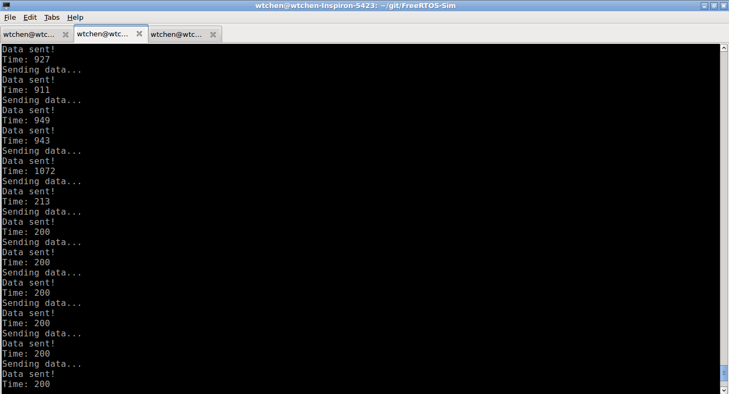
Then I have waited long time but it is never <200…
Now, answer the questions:
- Why is "matrix_task" using most of the CPU utilization?
Ans: Because its priority is higher (3) than comminucation_task (1). And in the config file configUSE_PREEMPTION = 1, which allows tasks with higher priority to preempt the resource of tasks with lower priority.
- Why must the priority of "communication_task" increase in order for it to work properly?
Ans: In order to preempt the resource when time is up for printf/fflush from other running tasks, like matrix_task.
- What happens to the completion time of "matrix_task" when the priority of "communicationtask" is increased?
Ans: Here I assume that the “completion time” is the time to run one loop. When communication_task has higher priority, it means matrix_task has to be interrupted when communication_task needs the resource (CPU). So matrix_task will spend more time on context switch. It means completion time will increase.
- How many seconds is the period of "matrixtask"? (Hint: look at vApplicationTickHook() to measure it)
Ans: Here I have implemented the function in matrix_task to show the period. Here is the transformation before and after the execution time of communication_task > 1000ms. Around “Communication time: 1107” is printed, the priorityset_task already changed the priority of communication_task, and the period of matrix_task (Matrix time) increases from ~480 to ~550.
