Configuration / Integrating Tomcat and Apache Web server on Windows using mod_jk

Version used –
- Apache 2.2.4-win32-x86-no ssl
- Tomcat-6.0.10
- mod_jk-1.2.27-httpd-2.2.10.so

  - Installing Apache –
      - Download “Apache 2.2.4-win32-x86-no ssl.msi”
      - Just follow the wizard and click next button until finish
      - Run the apache at the system tray (usually it autorun)
      - Type http://localhost/ in browser
          - You will get “it works!”
          - Ref:

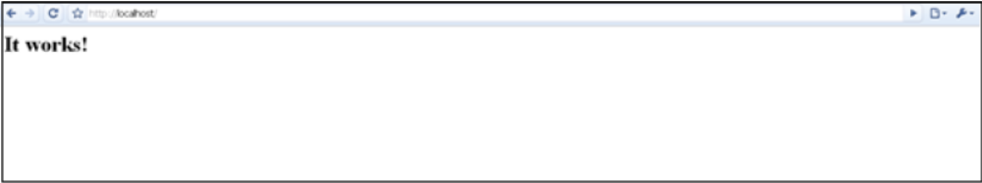

  - Installing Tomcat –
      - Download “apache-tomcat-6.0.10.exe”
      - Just follow the wizard and click next button until finish
      - Make sure the port number is 8080 (you can change this later)
      - Run the Tomcat at the system tray (usually it autorun)
      - Type http://localhost:8080/ in browser
          - You will get the Apache Tomcat web page
          - Ref:

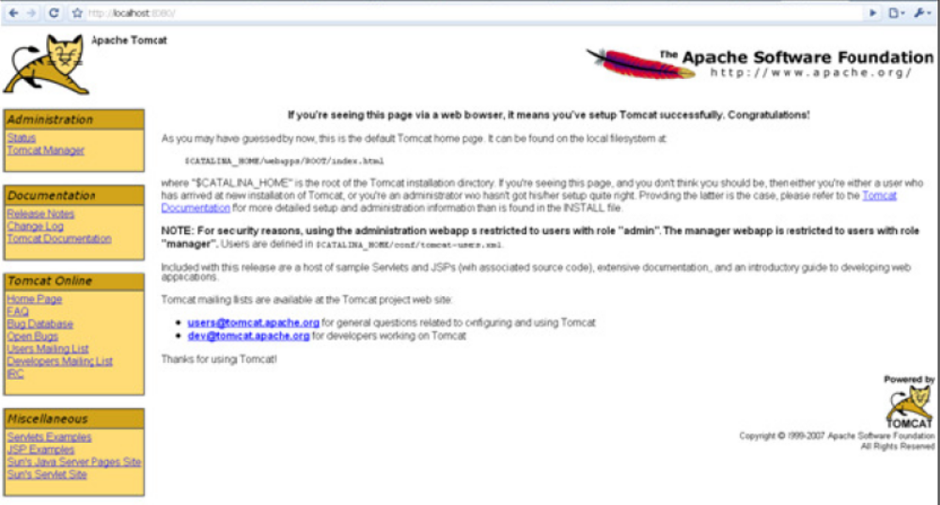

  - Stop both servers now
  - Download jk connector “mod_jk-1.2.27-httpd-2.2.10.so”
        - Rename it to “mod_jk.so”
        - Copy “mod_jk.so” and paste in here
“YOUR_DRIVE\Apache Software Foundation\modules”

  - Download “workers.properties”
      - Open and add the following code at the end of the file “workers.properties”

# Define 1 real worker using ajp13
worker.list=worker1

# Set properties for worker1 (ajp13)
worker.worker1.type=ajp13
worker.worker1.host=localhost
worker.worker1.port=8009

      - Copy and paste it in here “YOUR_DRIVE\Tomcat 6.0\conf\jk”

  - Configure Apache
        - Open “httpd.conf” from “YOUR_DRIVE\Apache Software Foundation\conf”
        - Add the following code at the end of the file “httpd.conf”

LoadModule jk_module"YOUR_DRIVE/ApacheSoftwareFoundation/modules/mod_jk.so"

Include "YOUR_DRIVE/Tomcat 6.0/conf/auto/mod_jk.conf"

  - Configure Tomcat
        - Open “server.xml” from “YOUR_DRIVE\Tomcat 6.0\conf”
        - Add the following inside “<Server>” element

<Listener className = "org.apache.jk.config.ApacheConfig" workersConfig="conf/workers.properties" mod_Jk="YOUR_DRIVE/Apache Software Foundation/modules/mod_jk.so" jkLog="logs/mod_jk.log" jkDebug="info" noRoot="false"/>

        - Add the following inside “<Engine>” element

<Listener className = "org.apache.jk.config.ApacheConfig" workersConfig="conf/workers.properties" mod_Jk="YOUR_DRIVE/Apache Software Foundation/modules/mod_jk.so" jkLog="logs/mod_jk.log" jkDebug="info" noRoot="false"/>

  - Start Tomcat
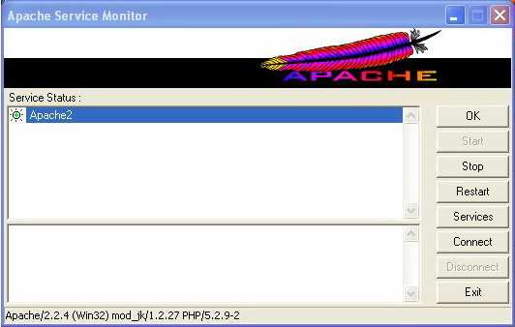
  - Start Apache

  - If the mod_jk appear under the Apache Service Monitor, that’s mean the mod_jk module is loaded.
  - Now type “http://localhost/” it will directly lead you to apache tomcat web page.

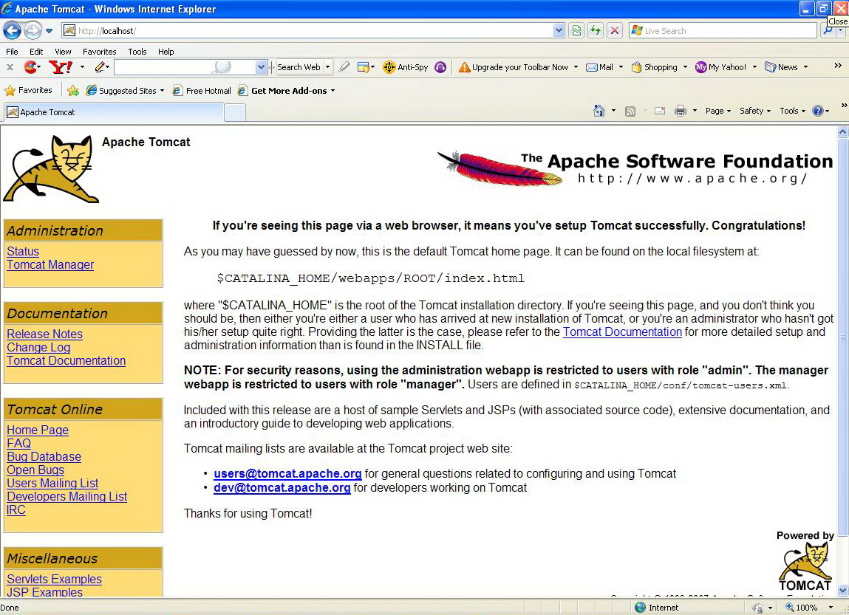

  - That’s prove that Apache and Tomcat had integrated using mod_jk.
Laptop ku : D:\fd\maven\Load Balancing

