New Patent Text Similarity Methods with a comprehensive understanding of SAO semantics

Nan Wang ^{a,b,*}, Ziyi Wan^{b}, Hongyu Zhao^{c}, Yingtong Hu^{d}
ª Beijing Key Laboratory of Internet Culture and Digital Dissemination Research, Beijing Information Science and Technology University, Beijing 100192, China
^{b} Computer School, Beijing Information Science and Technology University, Beijing 100192, China
^{c} Tencent Technology (Beijing) Co.Ltd, Beijing 100037, China
^{d} Huawei Nanjing Research Institute, Nanjing, China
*Corresponding Email: wangnan8848@126.com

Abstract
The measurement of patent similarities is critically essential for the semantic search, the due diligence, infringement and litigation tasks in the patent management. With the number of patents dramatically increasing, conventional similarity methods from the keywords-based, the citation-based and the classification analysis are not able to fully implement the context semantics in patents. Recently, the Subject–Action–Object (SAO) method as an emerging methodology, seems that could provide a more semantically supported measure. However, not-readily available semantic text similarity (STS) datasets, limited field applications and the lack of comparative analyses of SAO methods have already impeded the SAO algorithms’ performance. To implement the further use of SAO semantics, this paper firstly addresses these problems in a comprehensive survey. Similarity datasets derived from the USTPO&PTAB websites, including a matching dataset and a ranking dataset, are manipulated and designed. The SAO processing, the SAO weighted strategies, direct and deep matching algorithms have been fully discussed. Comparative results have demonstrated that “vector-based or knowledge-based” algorithms, weights and patent pre-training vectors, play the most crucial roles in the semantic similarity. Finally, a well-tested SAO similarity framework after a detailed abaltion analysis is proposed with the preferences of computational recipes: SAO embeddings from pre-trained patent vectors should also be incorporated with clustering weighted strategies (such as the K-means clustering), the appropriate thresholds and SAO knowledge extensions. One of our proposed methods has great potential in effectively enhancing the semantic matching ability for similarity-related case studies such as the actual litigation, infringement and patent retrieval in scientific fields.

Keywords
Subject-Action-Object (SAO), Semantic Text Similarity (STS), Patent Retrieval, Similarity Datasets, Weighted Strategy, Pre-trained language models (PLM), Knowledge-based Algorithms

Classification Code
- Mathematics Subject Classification (2000) 68U15
- JEL Classification O32; O34

Introduction
In the face of the increasingly fierce competition in the economic globalization, patents have been one of the most crucial technical and legal documents in favor of the opportunity identification, technology forecasting, infringement analysis, due diligence and innovation management(Choi et al. 2012; H. Park, Yoon, et al. 2012; H. Park, Ree, et al. 2012). With the rapid growth in the number of patents, the need to search for similar patents is critically enhanced because the invention novelty of a patent should meet the innovative criteria in different tasks (X. Wang et al., 2015). As is known to all, the central issue is specified as the systematical way to find more feasible textual matching solutions and their validation methods(Y. S. Lin et al. 2014; Abbas et al. 2014; Whalen et al. 2020). Previous literature assessed the text matching of patents from three perspectives: citation analysis, patent classification (IPC) codes and keyword analysis(Arts et al. 2018; X. Wang et al. 2019). Cited or citing patents rely on relationship networks in the patented solutions, so they are usually used as references for the similarity. The IPC codes are only coarsely feasible at the classification levels which tend not to recognize technologies of patents. In contrast, the keyword-based methods are widely accepted in use for the similarity calculation, but still not appropriate for reflecting the complex concepts or relationships in patent semantics without suitable. In fact, the patent similarity not only emphasized on the term (or word) similarity, but also the unambiguous interpretations of contexts mentioned in claim texts and even the whole descriptions. Additionally, the similarity evaluation needs to be combined with text chunk selection, semantic features, the appropriate weighted strategies and calculation methods. Recently, the SAO analysis method with the content conversion of patents into Subject-Verb-Object (i.e., SAO) structures, has been proposed for quickly understanding massive textual elements. Preliminary results demonstrated that the SAO extraction and weighted strategies contributed a lot to the patent similarity(H. Park, Yoon, et al. 2012; X. Li et al. 2020). However, these topics are only explored or applied in specific case studies. There are few systematic discussions of the similarity datasets, SAO feasibility and the evaluation logics for all of the academic community (Whalen et al., 2020):
- Few patent STS datasets for the benchmarks. Prior work provide few open access to the code, datasets, and semantic measure benchmarks of patent texts. It still exists that the similarity calculation between contents of a focal patent and other patents is not convincingly implemented, which makes the result replication and follow-on research difficult.
- Prior art similarity methods are not well adopted in the industrials. The current similarity measure evaluation methods are generally used in a specific field, not appropriate for most of retrieval requirements. To quantitatively analyze the impacts of parts of similarity methods, unique characteristics of patents, including patent classification, bibliometric coupling, keywords, semantics should all be explored.
- No reasonable validation of the proposed measures based on text-based and traditional metrics. SAO-based methods are popular semantic methods but not well-evaluated. It is controversial that if the semantic characteristics (mainly SAOs) of patents and similarity strategies are figured out to promote the calculation accuracy.
This paper reviews the cutting-edge SAO research results and explores most of SAO application details for the subsequent patent semantic similarity computation. To further investigate these issues above, this paper reviews the cutting-edge SAO research results and explores most of SAO application details in the patent semantic similarity computation. The patent similarity datasets including a text similarity dataset and a ranking dataset, have firstly been introduced, which can be expected to be used as a benchmark. The vector-based or knowledge-based methods have greater performances, and the IPC codes can also compensate for the textual semantic limits. Novel weighting strategies, appropriate text segments and similarity threshold selection account for the the better calculation. The pre-trained vectors from patent corpus can improve the efficiency, and an optimally selected framework for the better patent retrieval practice has been suggested. The rest of the paper is organized as follows: a systematic review of SAO methods in the patent similarity evaluation is implemented. The related work reviews the previous research, including SAO semantic analysis and text similarity metrics. In the Methodology, a method to construct patent similarity datasets is proposed with datasets publicly released later for use in the academic community. Furthermore, a complete patent text matching process is introduced, including SAO processing, weight assignment, similarity calculation and result evaluation. Additionally, influencing factors on the similarity calculation are fully explored through comparative experiments. Finally, a optimization similarity scheme is summarized and comparatively validated in case studies for addressing the future tasks.

Related works

Patent Text Similarity
Patent text similarity calculation can be done from the following three major categories: lexical, vector and knowledge base methods. Lexical-based methods directly employ the word strings of texts on various popular distance metrics, including the edit distance (Levenshtein Distance, LD), longest common subsequence (Longest Common Sequence, LCS), N-Gram, Jaccard index, Inclusion index, SimHash metrics and so on(Corley and Mihalcea 2005; Majumder et al. 2016; Arts et al. 2018). Typically, as for the patent text similarity, patent classification and citations are validated with their improvement over traditional metrics in case-control studies(Arts et al., 2021) (Qiu & Wang, 2022). Apart from keyword-based approaches using frequency and cooccurrence of contents, some more semantic methods derived from patent bibliographic analysis are also utilized and emphasized besides all of those methods above(S. Lee et al. 2008; Y. Kim et al. 2009; Rodriguez et al. 2015; Y. Zhang et al. 2016; C. Yang, Zhu, Wang, et al. 2017). The textual keywords and their similarity coefficients, such as the Jaccard Index, the Inclusion Index are also discussed in turn (Sternitzke and Bergmann 2009; Moehrle 2010). When the Jaccard Index is 20%, the Cosine Index will be 45% with the Inclusion Index 100%(Cascini & Zini, 2008). WordNet and Wu-Palmer similarity model is applied in retrieving the better results (Sharma et al., 2015). In the estimation of patent conceptual distance, the previous approach relies on functional trees or citation trees(Quan et al., 2019). The proposed term clumping quantifies the categories of technical words and forms a three-level tree structure(Y. Zhang et al., 2016). Lee et al make full use of the characteristics of claims and use hierarchical keyword vectors to represent the dependencies between patent claim terms, and use tree matching algorithms to obtain the similarity between patents(C. Lee et al., 2013). Similarity evaluation method using multi-dimensional fusion strategy to realize the a more diversified comprehensive similarity measurement of patents (Zhu et al., 2023). From the point view of statistics, some vector-based methods arose from Vector Space Model (VSM). In the VSM, patent texts are treated as a real-valued vector based on the words, the word frequencies, sometimes with the word frequency-inverse document frequency (TF-IDF) weights, and constituted in a N-dimensional real-valued space (N words long for this patent). This high-dimensional sparse matrix leads to an inefficient computation using the Manhattan Distance, Chebyshev Distance, etc., which is not consistent with the text semantics (Y. Li et al., 2006). Further, the sparse space could be compressed with multi-dimensional dense semantic vectors (Mikolov et al., 2013), so that correlation coefficients, such as Pearson and Spearman coefficients, can be used for similarity calculation.
Recently, the patent knowledge space facilitates the semantic interpretation with ontologies and similarity calculation of patents(Chen et al. 2020; Adamczyk et al. 2020; An et al. 2021). A further integration of semantic information leads to topic models, including the Latent Semantic Analysis (LSA), Probabilistic Latent Semantic Analysis (PLSA), and Latent Dirichlet Allocation (LDA) (Huang et al., 2013). Latent Semantic Analysis (LSA), Word2vec, Word Mover's Distance (WMD), compared with the Jaccard index, contributed to somewhat more similar patent indications (de Rezende et al., 2022). Doc2vec to embed the patent`s abstracts were explored (J. W. Lee & Sohn, 2021). Doc2vec algorithm to predict potential patent links along with citation relationship and subject-action-object (SAO) structures is used to evaluate the similarity(B. Yoon et al., 2022). Functional, technical, and IPC information to represent functional, technical, and domain attributes are clustered(Liu et al., 2020). An improved patent similarity measurement was also proposed to enhance the semantic understanding of entities and semantic relations of patents (An et al., 2021). Furthermore, two types of deep model architectures are commonly used as the Siamese-based and the interaction-based models(Ranasinghe et al. 2019; Z. Wang et al. 2017). With the attention mechanisms introduced, models with interaction capabilities are generally of more complex computation with more model parameters and higher computational costs(Lan and Xu 2018; S. Zhang et al. 2020). Relation classification from deep model improvement was exploited for the possibility of leveraging the patent semantics (Chen et al., 2022). Pre-trained language models and weighting strategies are assembled for the semantic vector-based computation with the developed deep learning algorithms. Patent embedding from Sentence-BERT that captures text, citation, and inventor information representing different facets of knowledge communicated through patents improve the TOP-n accuracy which aids patent retrieval (Siddharth et al., 2022). Multi-dimensional fusion strategy helped realize the a more diversified comprehensive similarity measurement of patents (Zhu et al., 2023). A similarity measure based on SBERT is proposed to compute textual similarity scores of patent abstracts (Filippi-Mazzola et al., 2023). A deep learning-based framework to predict future co-similarity matrix of patents. (Gozuacik et al., 2023). Graph-based method to allocate weights to distinguish the technical linkages in the superiority of SEA-PS, is to measure pairwise patent similarity as a fundamental retrieval tool (Z. Wang & Liu, 2022).
Apart from the lexical-based and statistical-based views, recent knowledge-based research are also combined with external knowledge in the text similarity calculation(Adamczyk et al., 2020). Wordnet is a large database of English vocabulary containing nouns, verbs, adjectives, and adverbs. The vocabulary is divided into synonym groups, each synonym expressing a different concept. The synonyms are related to each other by conceptual semantics and lexical relations. Unlike ordinary synonym dictionaries, WordNet connects specific word meanings and marks semantic relations between words; each synonym set in WordNet is associated with other sets through certain "conceptual relations"(Miller, 1995). In addition, Wordnet can distinguish between types and instances, parts and wholes, and has a hierarchical structure. For example, the JWS (Java WordNet Similarity) tool that incorporates WordNet has successfully been applied in improving the semantic similarity (J. Yang et al., 2021). The concept ontology is used as an extended knowledge basis, and the semantic distance is calculated in terms of concept paths with the node depth, density, strength, hierarchical influences, concept common attributes (Budanitsky & Hirst, 2001).
One of the most important knowledge structures for patent texts is currently determined by the subject-action-object (SAO) extraction. SAO can obtain the representation of core concepts, which is superior to core words(S. Choi et al., 2011). SAOs are used to give descriptions of technical functions to reduce the dependence of expert knowledge on technical information. In the next section, details are provided.

SAO Extraction and Analysis
Each SAO structure is composed of a subject (S), an action (A), and an object (O), where A is related to the function operation with S and O as system components(Cascini et al., 2004). SAO triples emphasize and formulate the concepts and phrases’ relationship as extensions of the keyword and co-word analysis accounting for high recurrence rates and low textual discriminations in patent contexts(S. Choi et al., 2011). SAO is mainly extracted from the title, abstract, claims, or specifications from patents. At present, mature systems such as PAT Analyzer Methodology, Stanford Parser, Ollie, Reverb, Knowledgist2.5, VantagePoint, Alchemy API and ClauseIE tools, are generally used for the SAO identifications(Yoon and Kim 2011; H. Park, Yoon, et al. 2012; Porter and Zhang 2012). Symbolic-based and statistical-based approaches, such as phrase association rules, TFIDF and topic models, are mainly employed in the SAO extraction. Furthermore, a term clustering framework to clean and merge SAO, AO, or SA structures using VantagePoint's TFIDF and PCA (i.e., the Principle Component Analysis) tools is also put forward (Porter & Zhang, 2012). "Term Clumping" improved the cleaning and consolidation of languages and terms with SAOs assigned with weighted strategies according to problems, solutions, functions, effects and fields. S was selected from material, technology and production, while AO clusters were selected from application factors. Additionally, the semantic TRIZ method to analyze "Term Clumping" was also stressed and used in the Technology Road-mapping (TRM) through Problem& Solution (P&S) patterns(Y. Zhang, Zhou, et al., 2014). The further introduced object and adjacent attributes were extended from "subject factors (phrases and terms)" to " P&S patterns " as linkage results of term aggregation packaged for the "Triple Helix" relationships (Y. Zhang, Porter, et al., 2014). Moreover, a technology roadmap (TRM) was constructed using SAO triples through the seven layers described in patents, such as the material, technology, influencing factor, component, product, goal and future direction(X. Wang et al., 2015). Lastly, a whole process of the SAO extraction was concluded and consolidated with tools (such as VantagePoint) using the following thesaurus: (1) singular/plural and synonyms combined; (2) common SAOs removal; (3) similar SAO components’ combinations; (4) fuzzy matching. A relevant metric was used to evaluate the technical components(C. Yang, Zhu, & Wang, 2017).
The core contents of patents could be represented with the successful identification of SAO structures (Moehrle et al., 2005). The similarity of the invention structures was measured based on the SAO extraction and the semantic similarity of SAOs using WordNet (Sternitzke & Bergmann, 2009), and applied in the inventor competition map, patent risk assessment, patent infringement assessment, product prediction and technology opportunities identification, patent infringement and competitive trends (Bergmann et al. 2008; Yoon and Kim 2012; Yoon et al. 2013; S. Kim and Yoon 2021). SAO is related to the concept of function from the TRIZ perspective, which represented the concepts in the “problem-solution” form used to mine TRIZ semantics(Albers et al. 2011; Abbas et al. 2014). The SAO patented intelligent system was also introduced, where synonyms recorded in the WordNet concept hierarchy were also used for semantic similarity for both general and domain specific terms (I. Park & Yoon, 2014). Of course, how to calculate the similarity between two patents is the emphasis determined by the number of shared SAO structures (J. Yoon & Kim, 2011). How to select patent features and how to design feature weights? The specific process should be completed in the next similarity calculation.

SAO Similarity Calculation
A patent similarity matrix based on SAO triples was accomplished using Knowledgist2.5TM (J. Yoon & Kim, 2011). This matrix visualized as a patent network could be formulated using the NetMiner 3.0 tool. Furthermore, the DSI connectivity was used to represent the semantic similarity scores of two patents for identifying potential technology types(J. Yoon & Kim, 2012). Hierarchical word vectors and dependency relationships of SAO representations could achieve the patent similarity using the cosine similarity and WordNet hierarchical weights by transforming claims into hierarchical vector and extended concept semantics (C. Lee et al. 2013; Yoon et al. 2013). To be further, other weighted strategies were suggested: SAO triplets were retrieved as artifact-function-flow knowledge with functional weights assessed using the word2vec embeddings to calculate the Jiang-Conrath similarity (Cheong et al., 2017). An improved weighted strategy called DWSAO was also created to reflect the weight of each SAO structure(X. Wang et al., 2019a). As for the similarity methods, a unified framework has been proposed for calculating SAO similarity using the extended Sorensen-Dice metric (X. Li et al., 2020). Weights of the SAO semantic structures are introduced, and each patentee's vector is constructed to measure the technology complementarity (R. Li et al., 2023). SAO2Vec was developed as an automated approach for patent infringement using Subject-Action-Object structures(S. Kim & Yoon, 2021b). Doc2vec algorithm to predict potential patent links along with citation relationship and subject-action-object (SAO) structures is used to evaluate the similarity(B. Yoon et al., 2022). Semantic structures containing Subject-Action-Object from the labeled characteristics are used, and representations obtained from PatentSBERTa are also introduced(Song et al., 2023). Weights of the SAO semantic structures are introduced, and each patentee's vector is constructed to measure the technology complementarity (R. Li et al., 2023). Semantic structures containing Subject-Action-Object from the labeled characteristics are used, and representations obtained from PatentSBERTa are also introduced(Song et al., 2023).
As a whole, a comprehensive overview of the most important prior art work is illustrated ini Table 1. In the following, we try to systematically explore the feasibility of various methods in the patent text similarity using the SAO structures.

Table 1. Overview of the prior art work used in the patent similarity methods.
Method Types | Main Methods | Method Details
Lexical Matching | String overlap on distance metrics;  Co-classification analysis (IPC codes) | Edit distance (Levenshtein Distance, LD), longest common subsequence (Longest Common Sequence, LCS), N-Gram, Jaccard index, Inclusion index, SimHash metrics and so on(Corley and Mihalcea 2005; Majumder et al. 2016; Arts et al. 2018)  Patent classification and citations in two case-control studies(Arts et al., 2021).
Lexical Matching | Keyword or co-word analysis | Textual keywords using similarity coefficients, such as the Cosine Index, the Jaccard Index, the Inclusion Index(Cascini & Zini, 2008) ; (Sternitzke and Bergmann 2009; Moehrle 2010).
Vector-based Distance | Vector Space Model (VSM) | Frequency-inverse document frequency (TF-IDF) weights(Y. Li et al., 2006).  Doc2vec to embed the patent`s abstract(J. W. Lee & Sohn, 2021).
Vector-based Distance | Topic Modeling | Latent Semantic Analysis (LSA), Probabilistic Latent Semantic Analysis (PLSA), and Latent Dirichlet Allocation (LDA) (Huang et al., 2013).  Latent Semantic Analysis (LSA), Word2vec, Word Mover's Distance (WMD) (de Rezende et al., 2022).
Vector-based Distance | Semantic Embedding | Deep model architectures used as the Siamese-based and the interaction-based models(Ranasinghe et al. 2019; Z. Wang et al. 2017).  Models with interaction capabilities with the attention mechanisms (Lan and Xu 2018; S. Zhang et al. 2020).  Sentence-BERT applied to titles and abstracts(Siddharth et al., 2022)  Vector representations obtained from PatentSBERTa. (Filippi-Mazzola et al., 2023)  Deep learning-based framework using Long Short-Term Memory networks for the future estimation of the word embedding matrix(Gozuacik et al., 2023).
Knowledge-based | Bibliographic coupling, Citation analysis | Ppatent bibliographic analysis, reference coupling and technology roadmap (S. Lee et al. 2008; Y. Kim et al. 2009; Rodriguez et al. 2015; Y. Zhang et al. 2016; C. Yang, Zhu, Wang, et al. 2017).  Patent classification and citations in two case-control studies(Arts et al., 2021).  Inventor competencies from social career networks(Karwehl et al., 2022).
Knowledge-based | Hierarchical Concepts, Ontology | Hierarchical keyword vectors with claim dependencies and tree matching algorithms (C. Lee et al., 2013).  WordNet and Wu-Palmer similarity model (Sharma et al., 2015).  Patent conceptual distance with functional trees or citation trees(Quan et al., 2019).  External knowledge in the text similarity calculation(Adamczyk et al., 2020).  Term clumping with categories of technical words using a three-level tree structure(Y. Zhang et al., 2016).
Knowledge-based | Knowledge Graph | Patent knowledge space with ontologies and similarity calculation (Chen et al. 2020; Adamczyk et al. 2020; An et al. 2021).  Improved patent similarity measurement with entities and semantic relations of patents (An et al., 2021).  Ontologies and semantic relation similarity of patents (Chen et al., 2022).
Knowledge-based | SAO | SAO representation of core concepts, which is superior to core words(S. Choi et al., 2011).  Patent similarity matrix based on SAO triples using Knowledgist2.5TM (J. Yoon & Kim, 2011).  The DSI connectivity was used to represent the semantic similarity scores for identifying potential technology types(J. Yoon & Kim, 2012).  Hierarchical word vectors and dependency relationships of SAO representations using the cosine similarity and WordNet hierarchical weights by transforming claims into hierarchical vector and extended concept semantics (C. Lee et al. 2013; Yoon et al. 2013).  Weighted strategies with SAO triplets as artifact-function-flow knowledge using the Jiang-Conrath similarity (Cheong et al., 2017).  DWSAO created to reflect the weight of each SAO structure(X. Wang et al., 2019a).  A unified framework for calculating SAO similarity using the extended Sorensen-Dice metric (X. Li et al., 2020).  SAO2Vec (S. Kim & Yoon, 2021b).  Doc2vec and subject-action-object (SAO) structures to generate document vectors (B. Yoon et al., 2022).  Feature weights of the SAO semantic structure to measure the technology complementarity between different patentees(R. Li et al., 2023).  Semantic structures containing Subject-Action-Object from the labeled innovative characteristics within the clusters(Song et al., 2023).  SAO semantic structure to measure the technology complementarity between different patentees(R. Li et al., 2023).
Mixed-type | Lexical-Vector | IPC codes+Bert embedding(Qiu & Wang, 2023).
Mixed-type | Knowledge-Vector | Functional, technical, and IPC information to represent clustered functional, technical, and domain attributes (Liu et al., 2020).  SAO2Vec (S. Kim & Yoon, 2021b).  Citation and inventor embeddings through TransE (Siddharth et al., 2022).  Doc2vec and subject-action-object (SAO) structures to generate document vectors. (B. Yoon et al., 2022).  Semantics texts and the citations(Qiu & Wang, 2022).  Mapping spaces of dot matrix and image(Zhu et al., 2023)
Other conditions | Weighted strategies | Weighted strategies with SAO triplets as artifact-function-flow knowledge with functional weights assessed using the word2vec embeddings to calculate the Jiang-Conrath similarity (Cheong et al., 2017).  Improved weighted strategy called DWSAO created to reflect the weight of each SAO structure(X. Wang et al., 2019a).  A unified framework for calculating SAO similarity using the extended Sorensen-Dice metric (X. Li et al., 2020).  Graph-based SEA-PS method to allocate weights to distinguish the technical focus (Z. Wang & Liu, 2022). Multi-dimensional fusion strategy(Zhu et al., 2023)  Feature weights of the SAO semantic structure to measure the technology complementarity between different patentees(R. Li et al., 2023).

Methodology
As shown in Fig. 1, our research framework is summarized as a detailed flowchart which consists of the following parts: the datasets collection; the pre-processing (such as patent claim text acquisition and cleaning); the SAO processing (SAO extraction and appropriate weighted strategies selection); patent text similarity calculation; the sorting and evaluation. These are described in more details in the subsections. Finally, we expect that one of the best similarity methods can be derived and assessed by a series of comparative experiments and case studies.
Fig.1 The complete framework for the patent text similarity methods’ selection

Datasets and Preprocessing
Patent text similarity commonly defined as semantic text similarity (STS) tasks, is one of the Natural Language Understanding (NLU) tasks which have increased dramatically in recent years (Ranasinghe et al., 2019). These STS tasks are mainly driven by the International Semantic Evaluation Workshop (i.e., SemEval) (Hassan et al., 2019). However, the available STS datasets are basically for measuring semantics of paired snippets of generic texts rather than patents, and therefore not suitable for patent scenarios(Lan & Xu, 2018). Considering the patent characteristics into account, similarity-oriented datasets should be firstly prepared(Arts et al., 2018). The patent similarity datasets of approximately 640 million with pre-calculated similarity scores, as well as the code and calculation vectors provided. The Jaccard indexes of matching patent pairs are 0.24 on average, which depicted there were 14 common words in the average 37 keywords of two patents(Whalen et al., 2020). However, the current situation is that industrials still have few STS datasets for the patent similarity evaluation.
In the past decades, bulks of patent applications filed to the United States Patent and Trademark Office (USPTO) are publicly available (Suzgun et al., 2021). During the application and examination process, USPTO’s decisions about the patentability of the invention are recorded in a series of files attached with already-existing patents within the scientific sphere to confirm whether or not the set of claims is novel. Thus, the comparative patent pairs derived from USPTO’s notifications are in nature appropriate as STS datasets. Moreover, the Patent Trial and Appeal Board (PTAB) have already gathered bulks of trial and appeal documents released publicly. Additionally, as is known to all, appeals and patentability decisions for issued patents raised and submitted by examiners are expertise guides for due diligences, litigation or infringements, which enable users to parse the semantic similarity sections of patents and their references recorded in decision files. Herein, we designed a series of crawlers for scanning and downloading appeal decision data from the PTAB website, and then codes to clean and regulate the data were also developed. The public ID numbers of comparative patents were obtained from the file contents, and the patents were also searched and then archived. These archived patent pairs were manually corrected and then designed to evaluate the similarity. Generally speaking, the semantic similarities are often determined by patent claims themselves, and therefore semantic similarity sections are mainly in terms of claim contexts (C. Lee et al., 2013). Lastly, the entire datasets contain thousands of pairs of patent applications filed to the USPTO, EPO and WIPO offices. The patent applications are elaborated with sufficient patent metadata which will be assembled and released in JSON/XML data formats.
With references to the developed STS datasets, we further designed two kinds of patent STS datasets based on the entire datasets for fulfilling the evaluation criteria. The first dataset has offered a 3-point similarity scale for each patent pair selected from the entire dataset. Table 2 shows the details of the similarity value criteria, where each patent pair will be given a score between 0 and 3 based on experts’ judgements of the patent semantic similarity. For example, patent pairs involved with infringement appeals and the same former two-IPC codes are given a score of 3, which indicates a high semantic similarity between the two patents. In contrast, a score of 0 means that there seems none of any similarity (different IPC codes, no infringement, few common keywords) between two patents. Additionally, we have also designed a ranking dataset for the simulation and evaluation of the patent retrieval. Each set of patents consists of a paired patents from the entire dataset and one hundred of patents randomly selected from the USTPO bulk data. In the evaluation process, the average rank of similarity results from ranking datasets, such as Top10@N of patent pairs, is listed and then comparatively validated to investigate the effectiveness of different similarity calculation methods as an indispensable back-up dataset.

Table 2 The similarity assignment reference criteria with a 3-point scale
Similarity values | Similarity Assignment Reference
3 | Appealing (such as infringements or litigation or due diligence) patent pairs with the same first two-IPC codes.
2 | Patent pairs with appeals or infringements or litigation or due diligence but different IPC codes.
1 | A sample of non-appealing data with the same first two-IPC codes, and satisfies one of the aspects: the same main technical keywords, the same IPC codes or other classifications; citation relationships.
0 | None of any similar features discussed above.

SAO processing
    - SAO extraction
The patent STS datasets mentioned above are firstly processed by the known SAO extraction tools, such as “Stanford CoreNLP” toolkits (An et al., 2021). The obtained patent contexts contain different lengths of technical solutions, and therefore we have to split and merge the textual segments in the pre-processing period. The segments are organized in an integrated hierarchy which are convenient for the subsequent SAO extraction and segment weights assigned. The whole flowchart of the SAO extraction is summarized: Syntactic extraction, Lexical filtering, Data cleaning, and Semantic extension, as shown in Fig. 2.

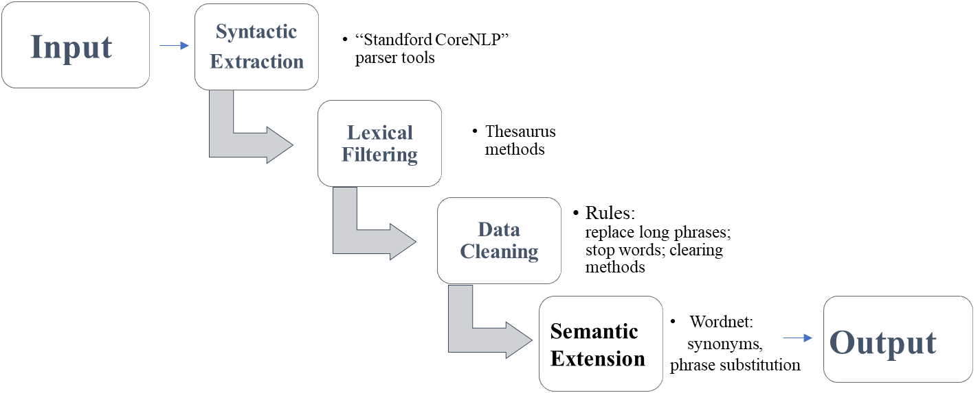
Fig.2 The whole flowchart of the SAO extraction

The details and results of these steps are described in Table 3.
Step1: Syntactic Extraction. The dependency parsing is performed on each of text segments using the Stanford parser tools, and a bespoke code developed is utilized to complement sentence-based phrase extraction.
Step2: Lexical Filtering. Handle and derive the backbone of each sentence in the narrative list, and filter the phrase structures without verbs using thesaurus methods.
Step3: Cleaning. With the phrase structures split and cleaned, subject (noun phrase), predicate action (verb phrase) and object (noun phrase) are unified into a standard SAO format. We mainly perform a standardized lexical transformation and replacement of SAO triples. For the cleaning of the A element, a large number of similar actions need to be classified into the same category. With the help of the VerbNet and WordNet tools, we can further expand and build a verb semantic dictionary to complete the semantic cleaning of the A element. In contrast, the cleaning of S/O part consists of two parts: firstly, delete all of S/O phrases appearing in the stop-word dictionary; secondly, the long phrase processing should be accomplished, where multiple S/A/O structures are classified into triples separately. Additionally, if there is none of noun phrases in the nearest layer of the parsing tree, keep noun phrases starting with NN as the original S/O.
Step4: Extension. The WordNet concept and self-defined dictionary can be used for SAO extensions using wordnet synonyms and self-added ontological concepts of SAO phrases.
On the basis of the SAO extraction, the whole pre-processing of unstructured textual segments is shown in Table 4. The result details of each step are also achieved according to the above extraction rules.

Table 3 The results of each SAO extraction step
Step | Example description
Step1: syntactic extraction | Process with the Stanford parser  "the quick brown fox jumps over the lazy dog" is processed by the Stanford parser to generate " [Tree('ROOT', [Tree('NP', [Tree('NP', [Tree('DT', ['the']), Tree('JJ', ['quick']), Tree('JJ', ['brown']), Tree('NN', ['fox'])]), Tree('NP', [Tree('NP', [Tree('NNS', ['jumps'])]), Tree('PP', [Tree('IN', ['over']), Tree('NP', [Tree('DT', ['the']), Tree('JJ', ['lazy']), Tree('NN', ['dog'])])])])])])] "
Step2: lexical filtering | Lexical judgement according to the verb sublist.txt  - "I love books. " pass  - " cyber physical system initiating data transmission " reserve
Step3: data cleaning | Clean the data according to the rules  - expand long phrase : (patching said executable program, including, copying an integral number of instructions) (patching said executable program, including, copying an integral number of instructions) + (, copying, an integral number of instructions) ;  - Replace the long phrase with the noun phrase in the parser tree closest to the verb：  Data over at least one DMA channel data  - remove the stop-words: (a method, running, a program) (, running, program).
Step4: semantic extension | Extension based on WordNet:  - replace synonyms: data processor computer; computing device computer  - replace plural with singular: sidewalks sidewalk  Extension based on Technical Dictionary:  - Delete words not in the dictionary: (cyber physical system, establishing, realogram scene analysis - times timesn fiber connection） (cyber physical system, establishing, times timesn fiber connection)  - replace synonyms: fibre fibre composition

Table 4 The details of each preprocessing process
Steps | Input | Output
1. Separated by semicolon | A method, comprising: capturing an event associated with an article, wherein the event comprises event data; indexing the event; creating a related event object related to the event, wherein the related event object comprises a set of one or more related events; | ['A method, comprising: capturing an event associated with an article, wherein the event comprises event data', 'indexing the event', 'creating a related event object related to the event, wherein the related event object comprises a set of one or more related events']
2. Phrases shorter than 4 words are combined together after the separation | ['A method, comprising: capturing an event associated with an article, wherein the event comprises event data', 'indexing the event', 'creating a related event object related to the event, wherein the related event object comprises a set of one or more related events'] | ['A method, comprising: capturing an event associated with an article, wherein the event comprises event data', 'indexing the event; creating a related event object related to the event, wherein the related event object comprises a set of one or more related events']
3. split by keywords wherein, etc. | A method, comprising: capturing an event associated with an article, wherein the event comprises event data | A method, comprising: capturing an event associated with an article,  ^_^the event comprises event data
4. If the sentence is longer than 400 characters, split it by comma | said condensed abstract representation comprises a marker selected from the group consisting of: color, pattern, and relative darkness, and said summary view comprises a plurality of rows, columns, and markers in a rectangular arrangement, each of said markers comprises content that represents frequency with which one of said search terms occur in a position of the dynamic document | - said condensed abstract representation comprises a marker selected from the group consisting of: color  - pattern  - and relative darkness  - and said summary view comprises a plurality of rows  - columns  - and markers in a rectangular arrangement  - each of said markers comprises content that represents frequency with which one of said search terms occur in a position of the dynamic document
5.Phrases shorter than 4 words are combined together after the separation | ['said condensed abstract representation comprises a marker selected from the group consisting of: color', ' pattern', ' and relative darkness', ' and said summary view comprises a plurality of rows', ' columns', ' and markers in a rectangular arrangement', ' each of said markers comprises content that represents frequency with which one of said search terms occur in a position of the dynamic document'] | - said condensed abstract representation comprises a marker selected from the group consisting of: color  - pattern, and relative darkness  - and said summary view comprises a plurality of rows  - columns, and markers in a rectangular arrangement  - each of said markers comprises content that represents frequency with which one of said search terms occur in a position of the dynamic document
    - SAO Weighted Strategy
Weighted strategy, as a quantitative indicator of the technical importance, needs to be constructed to evaluate the importance of each SAO triple obtained in the previous section. The weights and similarity thresholds assigned to the SAOs should be emphasized in the subsequent similarity calculation. Thus, this section describes prior art weighting algorithms to implement the SAO influences. The weighted strategies are systematically summarized as the term frequency-inverse document frequency (TF-IDF) rules, graph node weights, clustering weights, BM25 and DWSAO (X. Wang et al., 2019b). The details are as follows.

（1）TF-IDF
The term frequency-inverse document frequency (TF-IDF) method is the classical method for the phrase weight calculation. Term Frequency (TF) defines the ratio of the number of phrase occurrences in a document to the total number of phrases in the document collection and is calculated as shown in equation (1). To facilitate the statistics, the frequency calculation of phrases is normalized.
(1)

Where is number of occurrences of a phrase in the document and is total number of phrases in the document.
Document Frequency (DF) indicates the frequency of the term appearing in a document, which is defined as the number of documents in which a phrase appears in the document collection. The Inverse Document Frequency (IDF) characterizes the ability of a phrase to be distinguished from documents.
(2)
Where is total number of documents and is number of documents in which a phrase appears. The denominator of the formula is added by 1 to avoid the situation that some phrase has not appeared in the corpus.
In the algorithm of this paper, we calculate the TF-IDF value of a SAO triple to represent its importance in a patent, and accordingly the formula should be expressed as
(3)
(4)
Where is number of a SAO triple appearance in the patent, and is total number of SAO triples in the patent. The is number of patents in which the SAO triple appears.
(5)
(6)
However, TF-IDF still has several significant drawbacks: (i) it does not consider the hierarchical and long-tailed distribution of features; (ii) it also neglects essential low-frequency phrases; (iii) it ignores the location of phrases.
（2）BM25
The BM25 method is an algorithm used to evaluate the relevance between phrases and recalled documents based on a probabilistic retrieval model, designed in such a way:
$BM25=\frac{(k+1)tf}{k+tf}$ (7)
Where represents the frequency of phrases in the document, and k is a constant to the growth limit of tf value, and tf is limited between 0 and k+1.
BM25 also introduces the concept of a tie document length, where the influence of a single document length is related to “its ratio to the average document length”. Therefore, the formula (8) is added with another parameter, the ratio of document length to the average length L, and a constant b.
$BM25=\frac{(k+1)*tf}{k*(1.0-b+b*L)+tf}$ (8)
（3）Graph node weights
A graph theory-based clustering method provides a weighted undirected graph into two or more subgraphs so that the subgraphs are as internally similar as possible, and far apart from other subgraphs. The node degree distribution (sum of connections) is calculated based on the connected edges of the SAOs. The SAO with a large degree distribution value is set as a high weight. A kind of spectral clustering (SC) algorithm is generally adopted for the node weight calculation, which uses the feature vectors obtained from the similarity matrix (Laplacian matrix) and the feature decomposition to divide the graph into k subgraphs. The result is to have the poorest weights among subgraphs and the strongest weights within subgraphs. The conventional similarity measures for spectral clustering are the Gaussian kernel function and the k-neighborhood approach.
（4）Clustering weights
Clustering methods are non-supervised algorithms in which the heuristic iteration is used to assign each data point in the data space to one of the clusters. The centroid vector of each cluster is calculated for determining the point’s belonging by its distance ranks relative to the centroid vector of each cluster. This process is repeated until each cluster is determined. The K-Means algorithm as a representative clustering method, is selected for dealing with patent STS datasets. The number of centroid selections, data standardization and unit unification should be paid more attention.
（5）DWSAO
This method adjusts the similarity degree by the threshold parameter DW based on the TF-IDF method (X. Wang et al., 2019a). Suppose that the number of patents in the relevant patent set is N, the number of SAO structures in the target patent P is m, and the similarity between the SAO structures in the relevant patents is known. The relevant patents are numbered from 1 to N. (1≤ k≤ N) represents the relevant patents. The SAO structures in P are also numbered from 1 to m. (1≤i≤m) represents SAO structure i in P. F represents the document frequency of , and represents the weight of , calculated in the formula (9). In general, the larger is, the stronger the SAO technical representative ability in P.
(9)

Similarity Calculation
The similarity calculation contains two parts: the similarity methods and SAO matching methods. In a SAO structure, the similarity between individual terms/phrases can be calculated using any similarity method, and then the SAO matching is further in support of the combination of all the similarity results according to specific rules.

    - Similarity Methods
Currently, similarity methods are mainly divided into three types: lexical-based (or string-based), vector-based and knowledge-based algorithms. Recently, the deep learning models as brand-new comprehensive methods, are also introduced for further encoding the relevant semantics in patents. The methods are listed as follows:
- Lexical-based Methods
Common lexical-based methods contain the Dice, Jaccard, LCS (not used here) and Inclusion indexes: each word is counted as a unit after the phrase is separated by spaces: Set (cyber physical system) = (cyber, physical, system). Here are some brief descriptions for calculating the similarity of two phrases (Majumder et al., 2016). Sometimes the metrics can use WordNet as a knowledge source.
- Vector-based Methods
The vector representation of each word in a VSM model is calculated separately and finally summed to become the final vector of a phrase. The distance between the two vectors is calculated directly using the Euclidean, Pearson, Spearman and Cosine similarity. We use the Pearson's coefficient as the evaluation metric to measure the correlation between the predicted scores and the gold -set scores of the STS benchmark. Calculated from the ranked sets a and b, the Spearman coefficient is also considered to be the Pearson’s coefficient of the two random variables that have been ranked.
- Knowledge-based Methods
Knowledge-based methods are based on the external linguistic knowledge, such as WordNet(Miller, 1995). As for the similarity of two words, the concepts of words are finally used to the calculation. Let c₁ and c₂ be two concepts.
Leacock-Chodorow. This measure of Leacock-Chodorow similarity is on the basis of the shortest path that connects the two concepts and the maximum depth of the similarity is quantified by
(10)
where the length of the shortest path between two concepts is node-counted, and D is the maximum depth of the concept taxonomy.
Resnik. The Resnik similarity is based on the information content of the LCS index (Least Common Subsumer, the most specific ancestor node), identified by
(11)
where Pr [c] is the probability of an instance of concept c appeared in a large corpus.
Jiang-Conrath. The Jiang-Conrath similarity is based on the information content of the LCS index, and the similarity score is given by given by
(12)
Note that the similarity scores for the Leacock-Chodorow, Resnik, and Jiang-Conrath are not [0, 1]. We use the following normalization method to make the ranges between 0 and 1,
(13)
The next measure we have used in our experiments is the Lin metric (D. Lin, 1998), which builds on the Resnik similarity IC and adds a normalization factor of the input concepts:
(14)
Finally, the Wu-Palmer similarity metric is based on the depths of the two concepts in the taxonomy of their LCSs, given by
(15)
- Deep-Learning Methods
As mentioned above, the deep matching models can be divided in two types: Siamese-based and the interaction-based models(Lan & Xu, 2018). The representative model of the Siamese-based type is the DSSM (Deep Structured Semantic Models). The input text and a series of texts to be recalled are represented by pre-trained word vectors, and the similarity between the semantic vectors of the two texts is calculated. The DSSM can be divided into three layers from bottom to top: the Input layer, Representation layer, and Matching layer, as shown in Fig. 3.
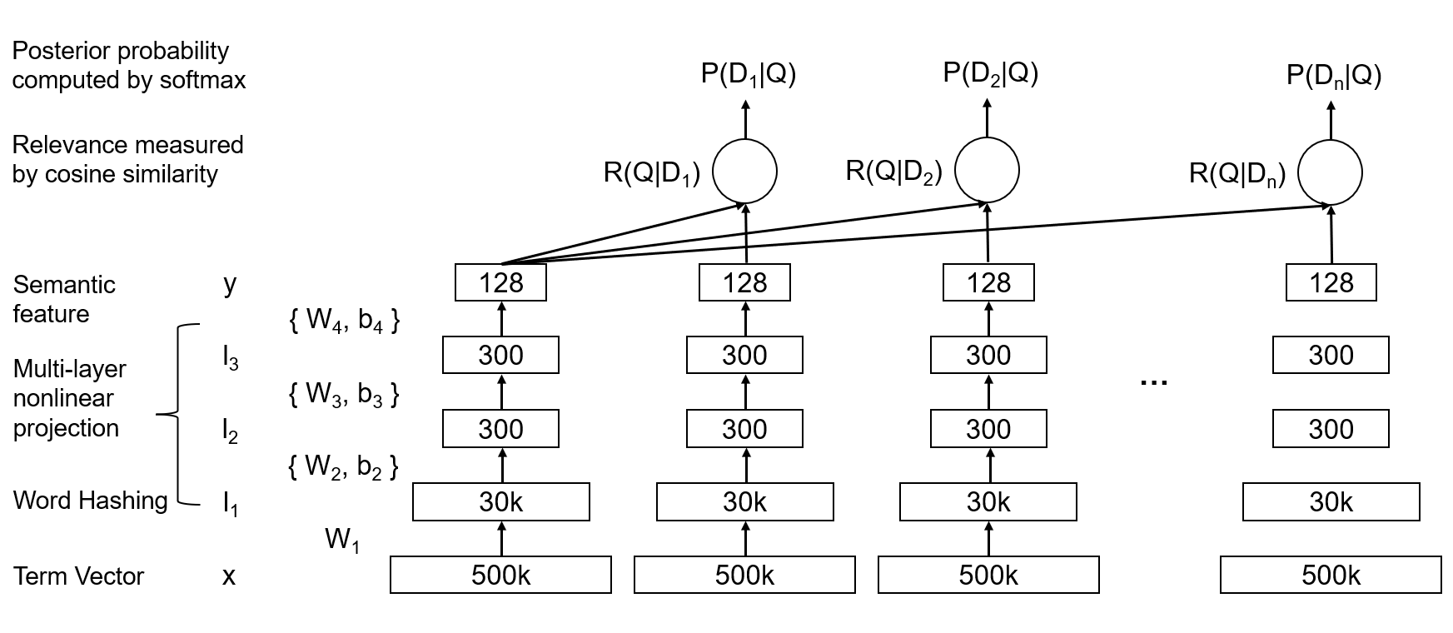
Fig.3 DSSM model network structure

- Input layer: map multi-term texts into a vector space and then be computed.
- Representation layer: The entire sentence is embedded in no particular order. Then it is fed into a network containing multiple hidden layers. Denote by the weight matrix of the layer and the deviation term of the layer. The first hidden layer vector (300 dimensions), and the output vector (128 dimensions) can be represented respectively as

, $i=2,…,N-1$
(16)
(17)
The model uses the activation function, and the final output is a 128-dimensional semantic vector.
(18)
- Matching layer: the similarity between the input text and the recalled text is calculated using vector-based methods, such as the cosine similarity:
(19)
The Siamese-based model is sometimes difficultly used in measuring the contextual interaction evaluations of phrases, and is also prone to the semantic drift. Thus, interaction-based models are proposed to encode contextual interaction information and facilitate capturing the semantic focus. The BIMPM (bilateral multi-angle sentence matching model) is selected here, and the matching patterns of phrases are used for the subsequent modeling abstraction in Fig. 4.
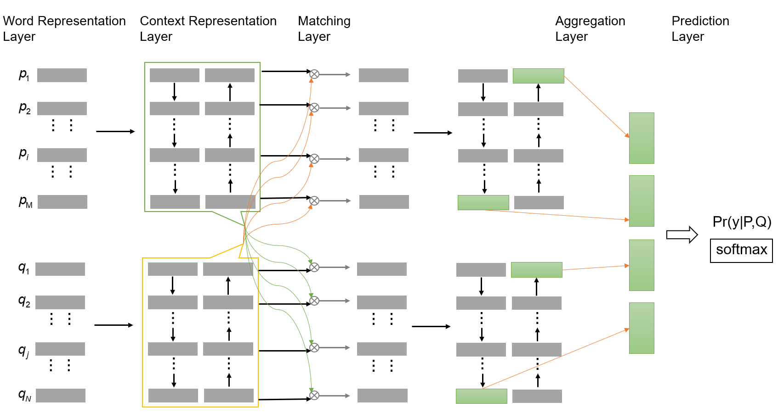
Fig.4 BIMPM model network structure
An input layer maps a sentence to a vector space based on the word representations. Then, the context representation layer is responsible for extracting the interaction information of input and texts. The vectors obtained from the previous layers are fed into the Bi-LSTM networks, and the bilateral processing is encoded simultaneously with Bi-LSTM from both directions of the matched sentences. Each word node of and texts will correspond to the outputs of the two hidden layers. In the matching interaction layer, the interaction matrix is formed, and the similarity between nodes is calculated. Among them, multiple perspectives of the interactions between sentences are used in multiple ways:
(1) Full, which is the output of each word in a sentence that matches the last hidden layer in another sentence.
(2) Max-pooling, taking the maximum value of the matching output of each hidden layer of another sentence.
(3) Attentive, using the embeddings of word pairs to calculate the similarity separately, and make the weighted attention summation and the similarity using the soft-max normalization.
(4) Max-Attentive, calculating the attention weights and takes the one with the largest weight for the similarity.
The aggregation layer merges the results of the previous layers into a fixed-length vector, and the prediction layer consisting of two fully connected layers and a soft-max/sigmoid layer is finally designed to calculate the conditional probability distribution and the similarity of the matching results.
These deep learning methods are all used in the similarity comparison experiments below.

    - SAO matching methods
A pair of phrases have been given the similar scores, and then the SAO matching metrics must be carefully selected and applied in order to give a complete similarity between two patents. The SAO structures can be decoupled: SAO ternary matching pattern conclude list(S), list(A), and list(O). The element of the list combines each other for matching. The term interpretation is as shown in Table 5.
Table 5 Term interpretation
Name | Meaning
SO | S in the first document list(S) and O in the second document list(O)
OS | O in the first document list(O) and S in the second document list(S)
SS | S in the first document list(S) and S in the second document list(S)
OO | O in the first document list(O) and O in the second document list(O)
AA | A in the first document list(A) and A in the second document list(A)

The similarity of a SAO pair with a specific weight assigned can be calculated by formula (30), which is referenced from the formula (31):
(20)
(21)
Where is the similarity between and , and are coefficients , and 0 < < 1 and 0 < < 1 and 1 -=
For subsequent calculations, the similarity between SAO structures is normalized as follows.
(22)
Where represents the standardized value of the semantic similarity between and ranging from 0 to 1, andrepresents the semantic similarity between and . The represents the number of SAO semantic structures, and represents the maximum SAO semantic similarity. The represents the minimum SAO semantic structure similarity.

Evaluation Metrics
The SAO similarity can be directly calculated and evaluated by the statistical metrics, such as the mean, median and standard deviation of similarity values. Furthermore, some ranking indexes are also helpful for the similarity method evaluation: the mostly common use is MRR, MAP, and NDCG (Huang et al., 2013). The ranking evaluation metrics are listed below.
Mean Average Precision (MAP). Average Precision (AP) is an average of the correct rates. For example, a query has 6 relevant results, and a retrieval ranking result returns 5 relevant documents whose positions are 1st, 2nd, 5th, 10th, and 20th, then AP is calculated as (1/1+ 2/2+3/5+4/10+5/20+0)/6. The mean Average Precision (Mean AP) is the macro average AP of all queries. The higher the ranking is, the higher the MAP seems to be. If the system does not return relevant documents, the accuracy rate is zero by default.
Mean Reciprocal Rank (MRR). In some evaluation systems, the position of the first returned standard answer is only of interest. The inverse of the ranking results of the standard answers given by the evaluation system is called the Reciprocal Rank (RR), which is used to measure the recall accuracy. The average of the set of all answers is the Mean Reciprocal Rank (MRR).
Normalized Discounted Cumulative Gain (NDCG). Some evaluations is calculated with a relevance level, such as 0, 1, 2, 3. It is assumed that the higher relevance of the returned results, the better the top n@N results are. Normalized Discounted Cumulative Gain (NDCG) is used to measure the relevance level. It is more accurate than P-R curves, and can reflect the behavioral characteristics.

Analysis and Discussions

Direct similarity analysis of SAO and other features
The direct similarity calculation has firstly been carried out using string-based, vector-based, and knowledge-based typical matching algorithms, and similarity results of the matching dataset (the first patent STS dataset) are obtained in comparative experiments. All of the similarity statistical indexes are listed in Table 6. Obviously, similarity results of string-based methods are generally stable between 0.33 and 0.41. In contrast, vector-based methods in a whole are in a great discrepancy among different equations. The best results in the direct similarity calculation are from Wu and Leacock methods because concept-based extensions can better represent the directions and distinctions of SAO triples. Preliminary analysis could demonstrate that Cosine and Pearson methods are possibly better chosen if the vector-based data are well prepared.
Table 6 Similarity results of all methods in three categories
Catagory | String-based |  |  | Vector-based |  |  |  | Knowledge-based
Method | Dice | Inclusion | Jaccard | Euclidean | Pearson | Spearman | Cosine | Lin | Resnik | Jiang | Wu | Leacock
Mean | 0.3748 | 0.4165 | 0.3575 | 0.2706 | 0.4868 | 0.2857 | 0.4852 | 0.3197 | 0.3263 | 0.1102 | 0.5247 | 0.5019
Median | 0.3504 | 0.393 | 0.3337 | 0.2671 | 0.4821 | 0.283 | 0.483 | 0.3233 | 0.3295 | 0.1106 | 0.5241 | 0.4933
Standard Deviation | 0.1384 | 0.1247 | 0.1453 | 0.0637 | 0.0551 | 0.0625 | 0.056 | 0.0513 | 0.0516 | 0.0586 | 0.0575 | 0.0606

Then, another comparative experiment between conventional methods (Keywords, IPC codes) and SAO methods is also designed. The keywords in patent techniques usually contain the technical field, product, component, effective phrases or other knowledge terms. For simplicity, keywords herein are extracted from SAO structures. The matching dataset is also utilized for the following evaluation. The normalization similarity results are given using lexical-based methods for the directed lexical evaluation of SAO, keywords and IPC codes, and the results are shown in Fig. 5. The direct similarity of SAO triples displays an obviously higher amplitude than that of the keyword method, and demonstrates that SAOs contain a wealth of textual semantics indicating specific relations of keywords. Of course, the direct similarity using IPC codes seems better than other methods, while the results only depict the fact that most of semantically-paired patents have the same classification categories without reflecting technological implications related to the textual similarity. From another perspective, IPC codes could provide assistive technological constraints in the semantic similarity calculation using other methods due to technical field features yet.
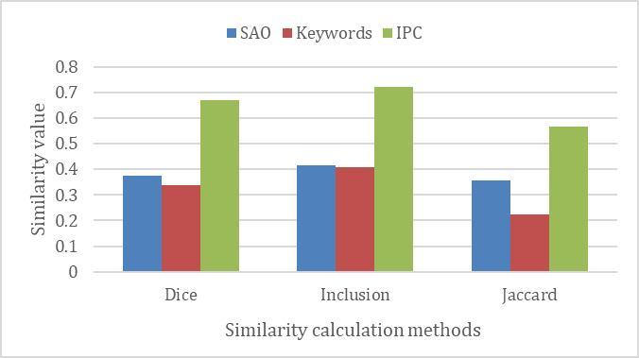
Fig.5 Similarity results of SAO, Keywords, and IPC

Additionally, another ranking metric called top n@100 is also considered, and comparative experiments are carried out using the direct similarity calculation methods on the ranking dataset (the second patent STS dataset). The final results are shown in Fig. 6. The SAO methods are more effective than keyword-based ones because of the recalled relevant patents ranked to higher positions. Obviously, the knowledge-based methods can still achieve the required ranking levels than those lexical-based methods no matter SAO or keyword analysis. The top n@100 results using vector-based and knowledge-based methods in the simulated patent retrieval can meanwhile be improved with the IPC constraints added. It also indicates that related patents can be more effectively found by specifying their classification vectors. Therefore, a similar calculation method based on SAO, aided by the use of IPC classification information, is deduced to be the optimal computational logic in the calculation. Furthermore, Doc2vec-based methods(B. Yoon et al., 2022), SAO2vec(S. Kim et al., 2020) are also inplemented for the comparison in Fig. 6(b). Comparing the results of Doc2vec-based and SAO-based methods, it can be seen that the capacity of “SAO+IPC” is more excellent than others when using the four vectorized similarity methods.

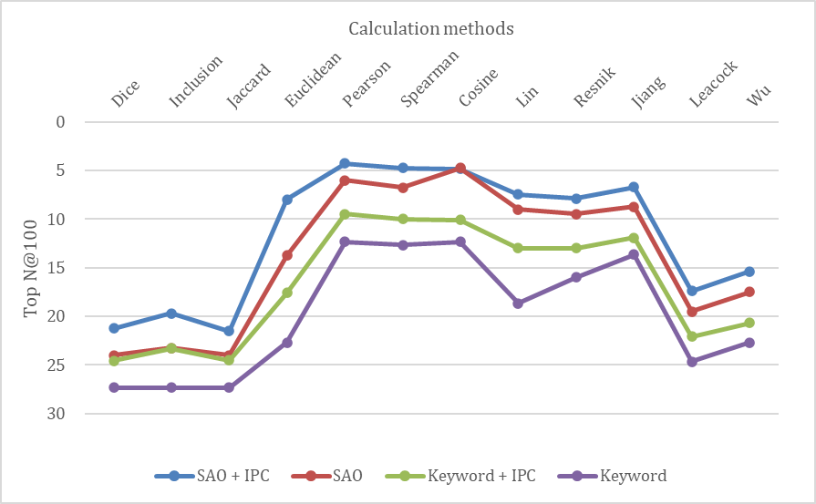
(a)

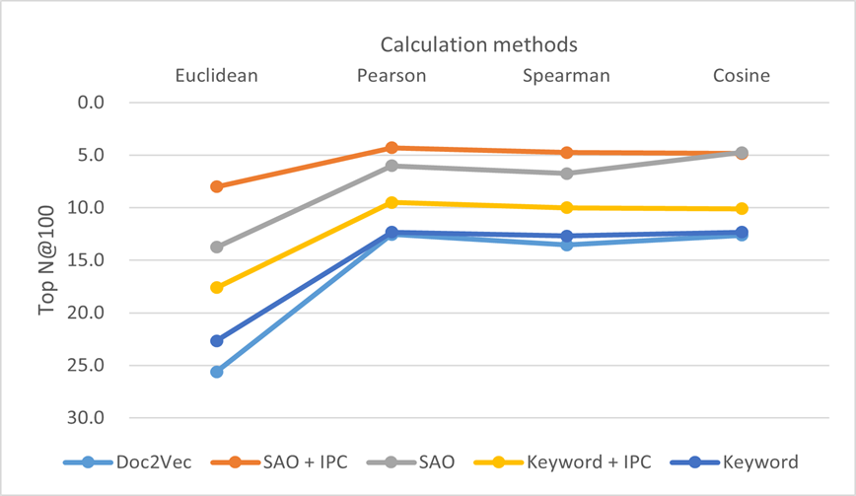
(b)
Fig.6 (a) The TopN@100 results of direct similarity methods; (b) The TopN@100 results of direct similarity methods using Doc2vec, Keyword and SAO methods.
In order to further evaluate the direct SAO similarity methods, the MAP, MRR, NDCG indexes calculated on the ranking dataset are also accomplished. The results are shown in Fig. 7. As a statistical analysis, the ranking results of the paired patent retrieval are obtained and normalized for the convenience of comparative analysis using different SAO similarity methods. In general, the performance of knowledge-based SAO methods shows a stable and strong influence on the similarity evaluation, which is consistent with that of the experiment in the matching dataset. The computational power of concept or ontological matching of phrase semantic correlations is again illustrated in the similar computations. In contrast, the effectiveness of vector-based methods is still proved not stable and varies much among different formulas. As shown in Fig. 7(b), the MAP, MRR, and NDCG results obtained by Doc2vec and SAO methods are also implemented. The better results are all from the SAO-based calculations in each metric. The reasons that the doc2vec-based method cannot compete with the SAO-based methods, are deduced that doc2vec methods have embedded less semantic information of patent contents which are also difficult to be chosen.
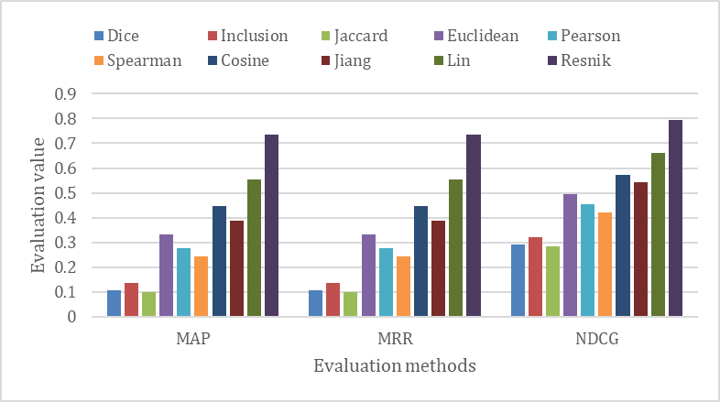
(a)
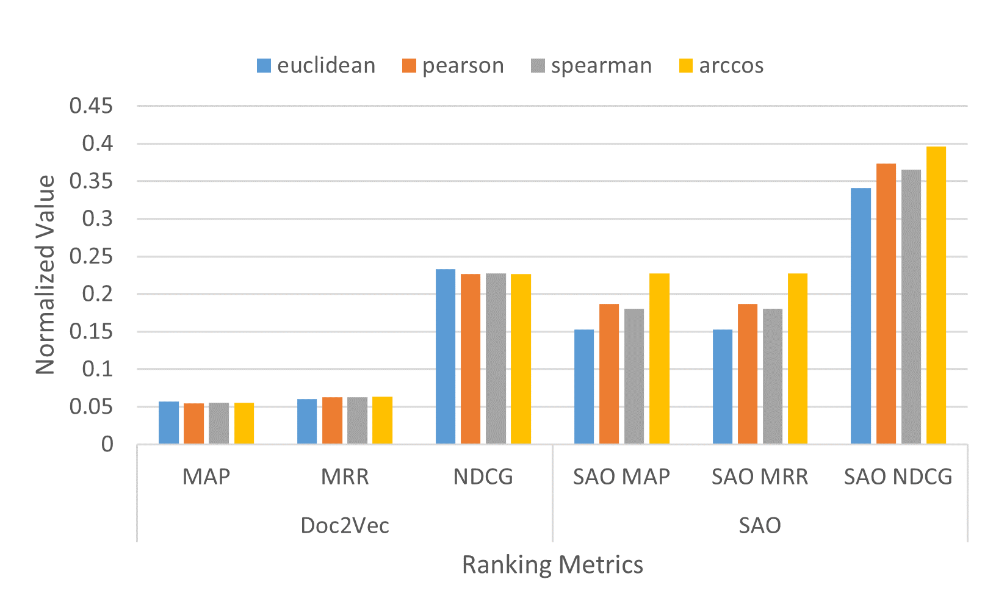
(b)
Fig. 7 (a) Rank evaluation results of all similarity methods; (b) Rank evaluation results of Doc2vec and SAO methods using vectorized metrics.

SAO weighted strategy analysis
    - Text segment weights
In the patent academics and industrials, the different contexts in every patent emphasize multi-perspectives of technical focuses. Taking the patent claims as an example, there are different text segments describing technical features. The key independent claims should be given higher weights to make the results more accurate, and meanwhile dependent claims are set with lower weights. In this experiment, the patent contexts of the matching dataset are divided into two segments: description sentences and resolved claims, respectively. The two segments are set between key and normal text segments with the ratio of weights for the comparisons. The direct similarity calculation results using different methods are shown in the Fig.8. The comparative results demonstrate that higher weights assembled on key features (i.e., the resolved claims) can improve the similarity levels to a certain extent, and therefore, 0.2:0.8 is chosen as the feature textweight ratio of “key-normal” segments in the following experiments and case studies.

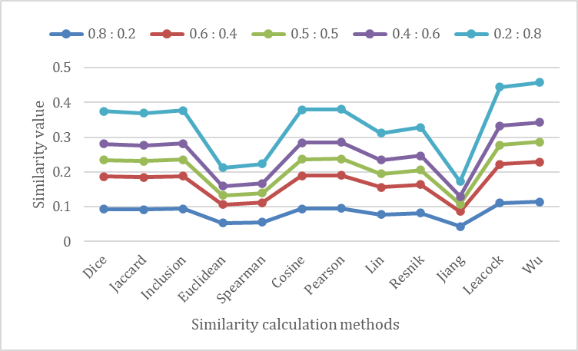
Fig. 8 The similarity results with different textweight (text segment weight) ratios.

    - Similarity threshold selection
With the SAO structure introduced in the actual retrieval, the similarity threshold should be determined if a pair of SAO (including their sub-structures) is similarly judged. In the convenience of the similarity calculation, the SAO similarity value can generally be set as 1 if the final matching value of paired SAO structures is higher than the set threshold, and otherwise as 0. In order to investigate different thresholds’ effects on the results and to choose a suitable threshold for the subsequent calculation, we have conducted a comparison experiment using different SAO similarity thresholds, and the results are shown in Fig.9. The results show that the similarity values reversely increase as the threshold value decreases. Especially, when the similarity threshold value is 0.2, the similarity results of some direct calculation methods reach up to 1. In contrast, the conclusion is quite opposite when the threshold is set as 0.8. These phenomenon can be demonstrated that the direct similarity is difficult to filter out related patents when the threshold is too big or too small. Therefore, a compromised value between 0.4 and 0.6 should be appropriate for the subsequent calculation. Therefore, we select 0.4 as the SAO similarity threshold in the next sections.
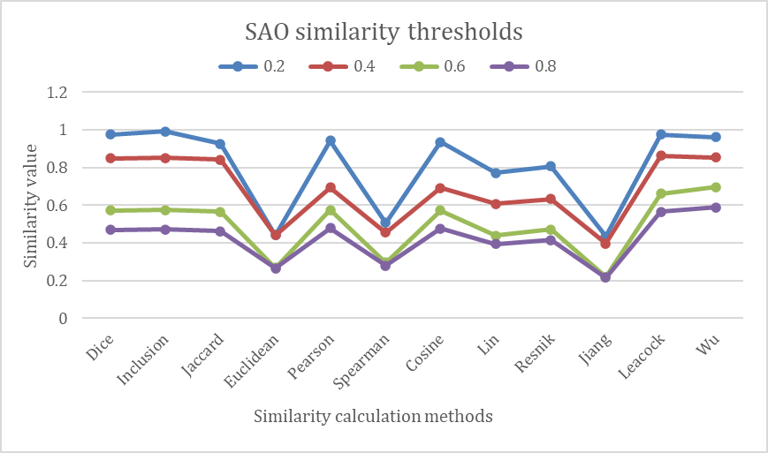
Fig.9 The similarity results with different SAO similarity thresholds

    - Automatic Weighted Configurations
In each of text segments from different patent contexts as demonstrated above, weights should also be configured on SAO structures, which could effectively improve the semantic similarity of paired patents. Up until now, most of conventional weighted strategies’ codes are developed and comparison experiments are also accomplished using the matching dataset. Fig. 10 shows that the highest patent similarity results are calculated by the clustering weighted strategy with weights assigned to SAO combinations in the similarity calculation process. Apart from the clustering method, the Graph node strategies are also more effective. In contrast, the BM25 and DWSAO methods display the more obvious advantages than the classical the TF-IDF method, even though they seem not to compete with the Graph node or K-means methods (both are clustering algorithms in a broad sense). The reason for these results could be inferred that the clustering algorithms are able to assign broadly-distributed weights to more SAO structures, and in turn improve the matching results. Taking these factors discussed above into consideration, weights assigned to SAO combinations and text segments, and appropriate threshold selections have a great impact on the similarity calculation.

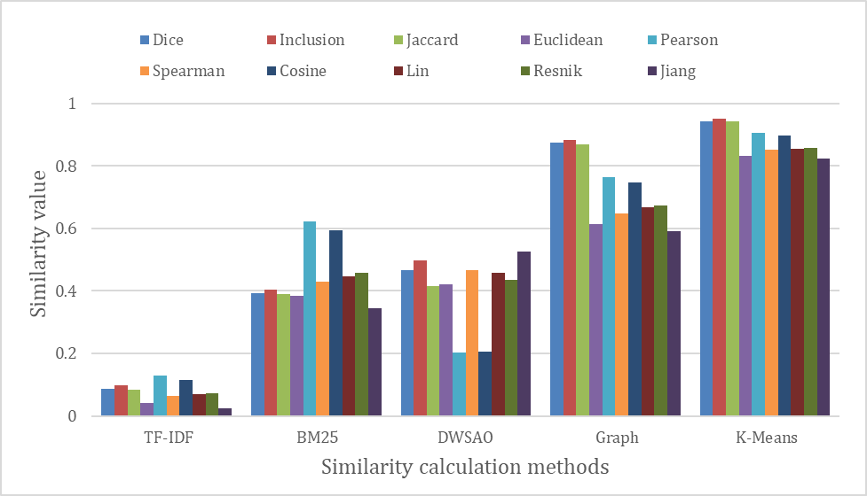
Fig.10 The similarity results of different automatic weighted configurations inside the segments.

SAO embedding analysis
Recently, pre-trained language models as NLU tools are gradually developed and applied in the patent analysis, and however there are few discussions of them on the patent similarity calculations, especially for the vector-based methods. It waits to be explored that whether or not semantic vectors have succeeded in capturing fine-grained semantic and syntactic regularities for improving the similarity effectiveness. The semantic vectors pre-trained from global website corpus and patent corpus are both constructed using Glove models (Pennington et al., 2014). These unsupervised methods for learning word vectors using Glove models are ultimately based on the occurrence statistics of any corpus. The global corpus consists of varying Wikipedia dumps between the year from 2010 to 2014. In contrast, the patent corpus utilize the title, abstract, claims of patents archived from the USTPO website in a number of millions. The two sets of pre-trained word vectors are comparatively tested using vector-based approaches in the matching dataset, and the results are presented in Fig. 11. The patent Glove model performs significantly better than the other global Glove model in all of methods. Especially, the Cosine and Pearson’s coefficient indexes both guarantee the same advantageous effects, as shown in Fig. 5. The results show that the pre-trained semantic vectors from patents could provide a substantial corresponding performance boost in the similarity calculation, which is possibly determined by the more targeted and specialized patent contexts.
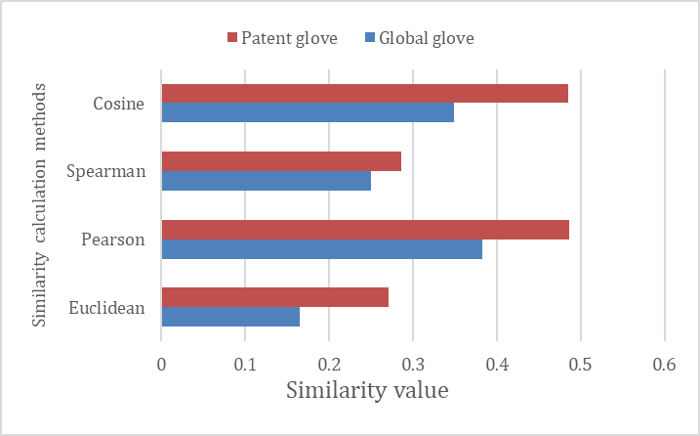
Fig.11 The similarity results of vector-based methods using different Glove vectors

Additionally, in order to further explore the influences of different SAO embeddings using the patent Glove vectors on the similarity calculation, experiments are also comparatively conducted on the matching dataset. Take one SAO for example, the SAO average semantic vector is constructed by the process that the semantic vectors of S, A and O can be averaged as the vectors of SAO. In contrast, SAO spliced semantic vector is the combination of the vectors of S, A, and O. Additionally, IPC codes are also vectorized according to the IPC hierarchical structures which can be constituted with the SAO vectors as the model input. The group of SAO average semantic vector + IPC and SAO spliced semantic vector + IPC are also added in the experiments, respectively, with the results shown in Fig.12. The IPC information added to the SAO average vectors have greatly improved the similarity calculation results to a certain extent, because the IPC information aligns with patent classification features assisted in determining the semantic similarity, discussed in the previous subsection. The average vector’s performance is slightly better than that of the spliced vector. The control of SAO semantic vectors is complicated but the suitable use could account more for correctly finding out the semantically-related patents, especially with IPC external information added.
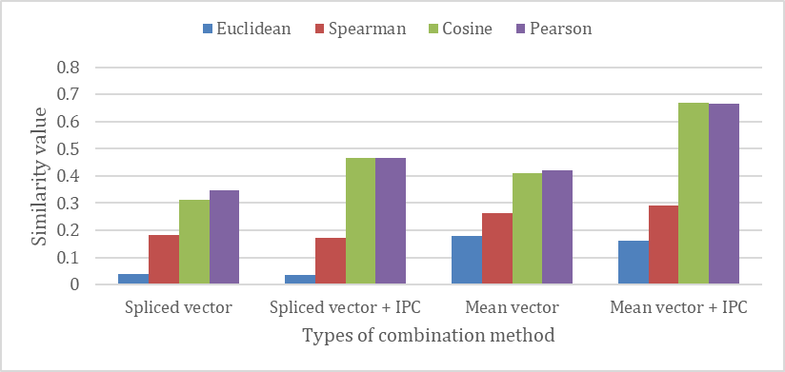
Fig.12 The similarity results of vector-based methods using different SAO semantic vectors and IPC embeddings.

Deep Matching Calculation
Currently, deep learning models are gradually involved in encoding the semantic representation of content features to enhance the similarity computation. As introduced in Section 3, four representative deep matching models are selected from Siamese-based and interaction-based types. The BIMPM and DSSM models are both selected. The dataset should be designed again for the adoption in the deep matching experiments. The definitely semantic-related paired patents in the matching dataset are treated as positive samples, and contrastively the negative samples consist of a pair of patents with a target patent and an unrelated patent. The ratio of positive samples and negative samples in the dataset is 1:1, and the whole dataset is divided into the training set, validation set and test set with the ratio scale of 6:2:2. Considering the flexibility needs and the easier use, the deep learning framework utilizes the Python 3.6 language and TensorFlow 1.14.0 platform. The training parameters of this experiment are shown in Table 7.
Table 7 Training parameter of the deep matching experiment.
Parameter | Value
Loss | Cross-entropy
Optimzer | Adam
Batch size | 64
Epoch | 15
Embed size | 300
The time-consuming results of similarity training processes on the modified matching dataset are shown in Fig. 13. The BIMPM as the early deep interaction-based model, have a time cost significantly larger than other models. With the model structure improvements, the ARCII model takes less of time for one training process. In contrast, the DSSM and CDSSM models as Siamese-based representatives, are in a relatively lower time consumption.
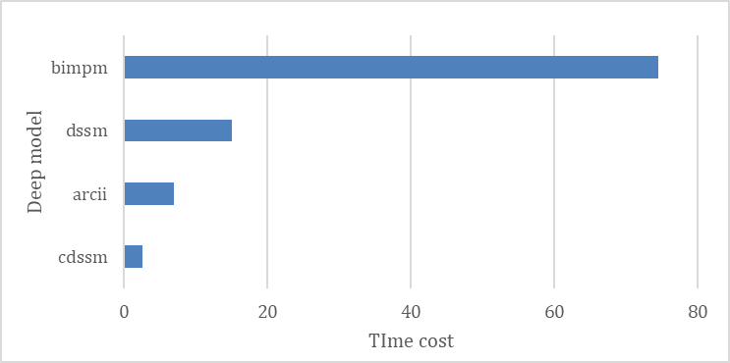
Fig.13 Time consumption statistical results of different deep matching models

Similarity results are statistically evaluated for the deep learning methods and normal vector-based similarity methods (i.e., the normal methods), as shown in Fig. 14. The ARCII model shows a more obvious performance than other models in most of situations, which indicates that interaction-type attention mechanisms among SAO structures are more semantically represented. The improved CDSSM model rather than the DSSM model also outweighs the early deep learning models, such as the BIMPM model. In some cases, the normal method can compete with the deep matching models, especially in the Pearson’s and Cosine coefficients.

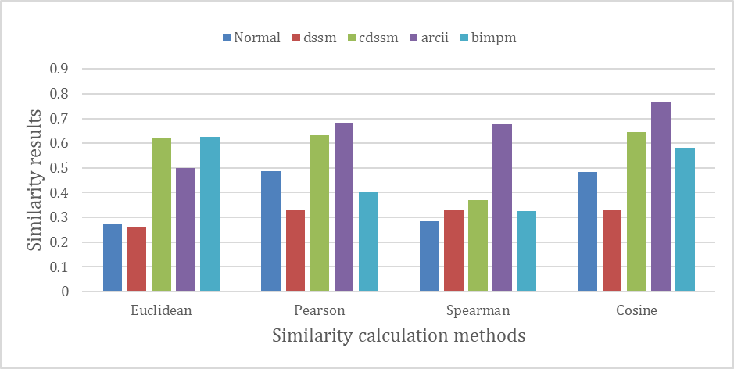
Fig.14 The similarity results of normal vector-based calculations and deep matching calculations
To be further analyzed, a comparative test has also been conducted on the ranking dataset, and the results are listed in Table 8. In most of cases, the ranking results of normal vector-based methods have a better performance than those of deep matching methods. Taking the time cost results and preliminary comparative tests, deep learning algorithms are not stable and not remarkable enough in the patent similarity calculations.
Table 8 The ranking evaluation results of normal vector-based calculations and deep matching models
Category | Model | Euclidean |  |  | Pearson |  |  | Spearman |  |  | Cosine
Category | Model | Rank | MAP | NDCG | Rank | MAP | NDCG | Rank | MAP | NDCG | Rank | MAP | NDCG
Normal | — | 8 | .3333 | .4957 | 4 | .2778 | .4538 | 5 | .2421 | .4213 | 5 | .4476 | .5734
Representation-based | DSSM | 27 | .0123 | .1035 | 22 | .0123 | .1035 | 24 | .0123 | .1035 | 10 | .0123 | .1035
Representation-based | CDSSM | 15 | .0147 | .1637 | 42 | .0147 | .1637 | 17 | .0147 | .1637 | 16 | .0147 | .1637
Interaction-based | BIMPM | 15 | .0147 | .1637 | 28 | .0147 | .1637 | 2 | .0147 | .1637 | 46 | .0147 | .1637
Interaction-based | ARCII | 47 | .1111 | .3010 | 28 | .2000 | .3869 | 28 | .1667 | .3562 | 27 | .2000 | .3869

Ablation Study
In order to explore the capacity of each calculation process, a detailed ablation study of the proposed method has been conducted. The impact of each part is once again shown, and the method can be further optimized. In Fig. 15(a), it can be seen that a certain improvement of the similarity score has been achieved to a certain extent with IPC embeddings or weight strategies added, showing Pearson and Spearman results with a significant improvement. Taking weight strategies into account, all of four vector-based methods have significant improvements. In cnotrast, considering the SAO similarity threshold of 0.4, all four methods have been significantly improved. When IPC information added, the similarity scores are also improved to some extent and even up to 1.0 in Fig. 15(b). In Fig. 15(c), four methods have showed a decrease in the performance compared to results of SAO-based methods if TextWeight ratios (i.e., text segment weight ratios) added. If IPC information also added, the similarity scores are still slightly improved. In summary, these similarity calculation steps by synthesising state-of-the-art techniques among natural language processing and SAO embeddings, have shown significant improvements to retrieve patents relevant to an initial set of patents. As shown in Fig. 16, IPC and weight strategies could significantly enhance the impacts in the patent retrieval.

(b)

(c)
Fig.15. The similarity results of calculations in every ablation study: (a) comparision results of SAO-based methods with IPC and weight strategies added; (b) comparision results of SAO-based methods with IPC and SAO similarity thresholds added; (c) comparision results of SAO-based methods with IPC and TextWeight ratios (text segment weight ratios) added.

Fig. 16. Comparison results of SAO-based methods with each calculation strategy.

To be further, the time consumptions of these proposed calculation strategies are also evaluated with regards to averagely 150 pairs randomly selected from datasets. In Table 9, the cost time of lexical-based and vector-based methods is summed up, showing that weight strategies have occupied more calculation resources than others (IPC, thresholds or TextWeight strategies) whether lexical-based or vectore-based methods are applied. In constrast, the similarity results using IPC or threshold strategies are almost consistent with the weight-based methods in accordance with the conclusions obtained from the ablation studies. Up until now, an optimally selected calculation framework is summarized according to all of the factors and efficiency evaluations, as is shown in Table 10.
Table 9 Tme consumptions of calculation methods for averagely 150 pairs randomly selected from datasets.
Calculation Methods/Cost Time(Hours) | SAO | SAO+IPC | SAO+Weight | SAO+Threshold | SAO+TextWeight
Lexical-based Methods | 00.00.51 | 00.02.38 | 00.08.21 | 00.01.07 | 00.01.12
Vector-based Methods | 00.20.16 | 00.22.21 | 00.29.37 | 00.20.28 | 00.20.40
Cosine similarity (value) | 0.502 | 0.725 | 0.891 | 0.806 | 0.401
Euclidean similarity (value) | 0.182 | 0.169 | 0.814 | 0.198 | 0.146
Pearson similarity (value) | 0.511 | 0.721 | 0.893 | 0.825 | 0.409
Spearman similarity (value) | 0.235 | 0.261 | 0.830 | 0.269 | 0.188

Table 10 The selected parameters of the optimally-summarized similarity calculation framework.
Parameter | Method
Input content | SAO+IPC
Vector type | Patent Semantic vector
Vector value | Mean{V_{S}, V_{A}, V_{O}}
Similarity method | Max{vector-based and Knowledge-based methods}
Weighted strategy | K-means
Text weight | “Key : Normal” ratio = 0.8 : 0.2
Similarity threshold | 0.4-0.6

Validation and Case Study
Prior art valiadation methods like expert experiences, case study, sample statistics, cluster mapping, sample retrieval are usually utilized in the methodology validation, as shown in Table 11. Expert experiences are overly dependent on experts who may not be accurate, and lacking universality. The review opinion itself comes from the expert inspection, and therefore, it should be treated and achieved in a statistical view, which is one aspect that we can use to solve the problem; Case studies generally require data selecting and screening, which involves significant uncertainty and a lack of real ranking experiments. Currently, it is only an evaluation of specific industrial samples, making it difficult to assess the comprehensiveness of the validation method in a generalized capacity. In a comparison, our datasets have covered most of industries, and relevant evaluations would be much more reasonable. Sample statistics usually involves a selected batch of data for calculating various similar indicators and conducting statistical analysis, but in reality, there is a lack of appropriate benchmarks. On the one hand, there are problems with data sampling within uneven domains. On the other hand, there is no recognized evaluation benchmark for this similarity calculation, so it is impossible to fully achieve the effective evaluation of methods. Cluster mapping is a visual similarity evaluation scheme, similar to sample statistics, which can only provide similarity results or qualitative analysis in semantic space, lacking quantitative evaluation indicators, and is not a reasonable evaluation scheme. Sample retrieval is achieved by simulating retrieval and sorting results, but it can only use hundreds of specific annotated data to test sorting. The sorting index is single, making it difficult to meet the evaluation of real-world scenarios.
Most of validation experiments and methods are not appropriate because they only cater to specific fields, not in the actual circumstances. Of course, these experiences also provide more insights for us to account for the validation experiments in the new version. Our data and evaluation are based on manual proofreading, and the random sampling is more feasible to meet the requirements of actual retrieval by integrating aformensioned methods with the ranking dataset.
Table 11 Systematic review of prior art validation methods in patent similarity tasks.
Validation Methods | Validation Details
Expert experiences | utilize domain expert knowledge and a large-scale expert annotated dataset benchmark. summary statistics rely on the assumption that two patents of the same patent family, developed by the same inventor(s), assigned to the same assignee(s), or that cite each other, are similar to a certain degree. (Arts et al., 2018).
Expert experiences | an expert ranking matrix in China’s medical device industry case study with categorical similarities and semantic similarities using diverse definitions of patent portfolios (e.g., patent assignee, country and region, and technical topic) (Y. Zhang et al., 2016).
Expert experiences | industry expert and patent examiner to assess similarity based on the functional features of sample top ten average variation value in the ranking (W. Lin et al., 2023).
Expert experiences | External validity via an expert panel. the superiority of SEA-PS and text fields at the patent-level with an attention layer to conduct similarity metrics, graph-based methods for patent retrieval and classification (Z. Wang & Liu, 2022).
Case study | doc2vec to embed abstracts of the ICT patents in convergence technology not owned by focal firms (J. W. Lee & Sohn, 2021)
Case study | three different study cases using Latent Semantic Analysis (LSA), Word2vec, Word Mover's Distance (WMD) (de Rezende et al., 2022)
Case study | Case-control study designs, such as the Nobel Prize and the National Inventor Hall of Fame, new keyword combinations in the title, abstract, or claims of a focal patent reused in all succeeding patents. (Arts et al., 2021).
Case study | patent mappings to the technological field of power transmission systems for a four-wheel motor vehicle and the inclusion or DSS-inclusion coefficient(Moehrle, 2010).
Case study | keyword community network based analysis in the LED and wireless broadband fields (J. Choi & Hwang, 2014).
Case study | Word2vec, LSA and WMD indications, and the Jaccard index in TFT-LCD, Flash Memory and PDA,with over a million documents. from 2010 to 2018(de Rezende et al., 2022).
Case study | incorporates the DWSAO index for finding similar patents based on the weight of each SAO structure in the patent.the practical significance of Due diligence in the field of robotics(X. Wang et al., 2019a).
Sample statistics | the median of the data where actual litigation case is the correct answer data set as the threshold value to be determined by the researcher in evaluating whether the pair of patents is infringed by using the calculated index. (S. Kim & Yoon, 2021a).
Sample statistics | cosine similarity scores between all citing/cited patent pairs, along with the Doc2Vec embedding vectors(Whalen et al., 2020).
Sample statistics | a dataset of 657 marked patents. 30 different datasets are randomized, each of which comprises 100 documents of the entire titles, abstracts and claims including six reference documents, 30 relevant documents and 64 irrelevant documents respectively. (Moeller & Moehrle, 2015)
Sample statistics | SAO-similarity indicators identified in pairs among all patents are entered into similarity matrix and The visualization of MDS mapping(Bergmann et al., 2008).
Sample statistics | Similarity matrix by comparing their components, hierarchical relationships and functions. one or more thresholds defined by the user (here 1% and 2% respectively) in order to highlight similar patents and clusters(Cascini & Zini, 2008)
Sample statistics | aggregated statistics based on p2p similarity measures: (i.) creating patent quality indicators and (ii.) mapping cross-country knowledge flows. using TFIDF weighted w2v embeddings of patent abstratcs limited to the reproduction of stylized facts. (Hain et al., 2022).
Sample statistics | USPTO patent data and the SBERT embedding of the abstracts data of detecting the drivers of patent similarity over time, a temporal endogenous process or due to exogenous patent attributes(Filippi-Mazzola et al., 2023).
Sample statistics | claim analysis are stem from the hierarchical keyword vector that can depict the dependency relationships among claim elements. The validation was based on three measures – the number of patents that exceed the critical mean value, t-statistics and hit ratios(C. Lee et al., 2013).
Sample statistics | are higher with patents related to Alzheimer’s disease TFW as technology feature weights of SAO, The UMLS measures the similarity between the SAO semantic structures. the overlap rates for the top 50 and 100 with MERI-C using SAO & IPC, SAO & keywords, IPC & keywords is 41%, 48%, and 28%, respectively. (R. Li et al., 2023).
Cluster mapping | SAO2Vec algorithm and the spectral clustering algorithm with high similarities between two datasets). clustering tasks against other approaches such as Doc2Vec and SAO frequency vectors. The model’s accuracy can explain how well it could form a cluster that represented IPC codes. (S. Kim et al., 2020).
Sample retrieval | a recall task that multiple initial patents could be associated with a target patent using mean cosine similarity, which could then be utilised to rank all target patents and retrieve the most relevant ones. a patent embedding approach that captures text, citation, and inventor information through Sentence-BERT applied to titles and abstracts. We obtain citation and inventor embeddings through TransE. corresponding to a product family and an inventor's portfolio(Siddharth et al., 2022).
Sample retrieval | product family and inventor’s portfolio, potential to offer valuable design inspiration, instigate learning, indicate collaborations, and hint career opportunities.To realize the potential in terms of design and business applications, the method is preferably embodied in a support tool or integrated with existing patent search tools like InnoGPS(Siddharth et al., 2022).

In order to validate the field applicability of the proposed methods, we have anlyzed the patent pair distribution in IPC codes from the patent STS datasets, and the G, H and A groups have the most similarity patent pairs in Fig. 17(a). The numbers from the C and D groups are too small and have no referencing significance. To comprehensively evaluate the similarity matching capacity, the following experiment results in Fig. 17(b) have shown that SAO-based methods are significantly better if IPC information added in all of main IPC groups, compared with results from Doc2vec-based methods.

(a)

(b)
Fig. 17. Validation results of Doc2vec and SAO-based methods in datasets from different patent IPC codes. (a) the numbers of patent pairs in patent IPC codes; (b) calculation results from patent IPC codes using Doc2vec and SAO-based methods.

To further verify the effectiveness of the proposed method in the optimally-selected framework, we have conducted a series of the comparative experiments in the case studies with conventional SAO similarity methods. In the actual patent retrieval, as for a targeted patent, the efficiency of patent matching depends on the similarity calculation and recalled results. The corresponding objective patents are expected to have higher ranks in the retrieved patent lists, which is depicted in Fig.18. To simulate the patent retrieval process and evaluate the various similarity methods, a procedure is implemented and described in details in Table 12, which consists of five parts: choosing the targeted patent, setting the recall scope, recalling with the traditional SAO methods, recalling with the proposed methods in section 4 and result comparative analysis in Table 13.

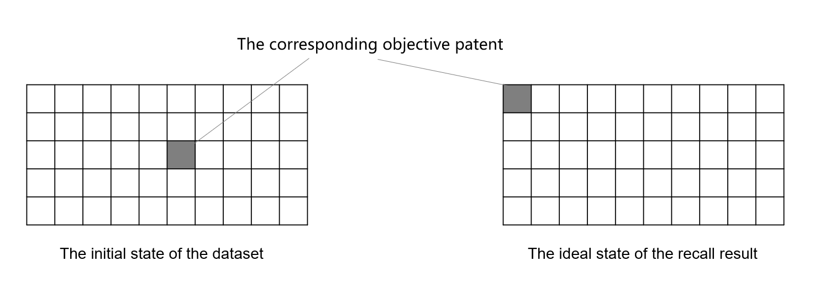
Fig. 18 An ideal objective patent recalled process diagram (Each column represents a page of patent list)

Table 12 The procedure of our comparative retrieval experiment in case studies
Step | Description | Remark
1. The chosen of the targeted patent | Patents are randomly selected in different IPC codes from our patent dataset as targeted patents. | The IPC classification numbers of the three patents are not identical.
2. Setting the recall scope | There has already been an objective patent of each targeted patent used as a positive sample in the ranking dataset, together with randomly selected half one hundred patents as negative samples. The recall dataset is manipulated in the retrieval. | The location of the objective patents in the recall results determines the effectiveness of the method.
3. Recalling with the traditional SAO methods | The traditional SAO methods are used, and no complex methods are introduced. | Traditional SAO methods are configured with the parameters of SAO triples, global word vectors, the cosine similarity and the SAO matching with “S-S, A-A, O-O” pairs.
4. Recalling with the proposed SAO semantic methods | The proposed methods contain a variety of ways are used in combination. | Different matching methods are used in the similar calculation, WordNet and the semantic vector are introduced in the other links, at the meantime, weight strategy and threshold are considered.
5. Result comparison | Compare the results of the traditional methods and the semantic methods. | Each parameter is compared separately in Table 10.

Table 13 Comparison of the calculation strategies between traditional methods and semantic methods
Category | Parameter | Traditional method | Our method
Calculation strategy | SAO extraction | POS-Based | Stanford parser
Calculation strategy | Extend tool | — | WordNet
Calculation strategy | Input content | SAO | SAO+IPC
Calculation strategy | Vector type | Common vector | Semantic vector
Calculation strategy | Similarity method | Vector-based methods | Max{Vector-based and Knowledge-based methods}
Calculation strategy | SAO matching | S-S, A-A, O-O | S-S, S-O, A-A, O-O, O-S
Calculation strategy | Weight strategy | — | K-means
Calculation strategy | Text segment weight | — | “Key : Normal” ratio = 0.8 : 0.2
Calculation strategy | Similarity threshold | — | 0.4

Three patents with public ID numbers of US20030122874A1, US20060279258A1 and US20050234905A1 are selected as targeted patents to perform the comparative tests. The goal is to find correspondingly litigation or infringement patents from the datasets, such as the patent US20020140722A1 for US20030122874A1, US20030021132A1 for US20060279258A1, and US20030050982A1 for US20050234905A1. The details of the aforementioned patents are shown in Table 14. The first pair focuses on the retrieval method in the software. The target patent from IBM describes the invention of updating the document and aggregating the instances of search terms, which supports the rapid skimming of dynamic document collections by selecting a corresponding portion of the summary view. As the objective patent from the Pelco. Ltd., describes a video apparatus comprising: a memory; an input device for selecting characters stored in the memory; The second pair relates to the hardware protection with the target invention including systems and methods for leveling a power supply current into a circuit that drives a pulsed load with power being drawn to prevent supply current surges; The objective invention gives a power supply that comprises two or more flyback-type, DC-to-DC converters for controlling the charge-discharge cycles. The third pair regards to data procesing algorithms are both owned by individuals. The target invention mentions the methods and apparatuses detect an event; search for an event profile using detected content and description. In contrast, the objective one is for recording an event portion and determining the recording. In summary, the three examples are especially selected as case studies to validate the smenatic understanding capacity of our proposed method to simulate the actual patent retrieval in multiple aspects of scenerios.
Table 14 The details of the paired patents of case studies.
No. | Label | Patent ID | IPC | Title
1 | Target | US20030122874A1 | G09G005/00 | System and method for visualizing and navigating dynamic content in a graphical user interface
2 | Objective | US20020140722A1 | G09G005/00 | Video system character list generator and method
3 | Target | US20060279258A1 | H02J7/00 | Method and system for providing current leveling capability
4 | Objective | US20030021132A1 | H02M001/00 | Method and apparatus for generating high voltage
5 | Target | US20050234905A1 | G06F7/00 | Methods and apparatuses for capturing and storing content related to an event
6 | Objective | US20030050982A1 | G06F015/16 | Automatic annotation of audio and/or visual data

A paired patent consists of one targeted patent and the objective patent, and they roughly share the same IPC categories because the common IPC code characters. However, the specific titles and contents of paired patents are not exactly identical. Patent No.1 proposed a system and method for visualizing and navigating dynamic documents including data from an ongoing process and including instances of specified search terms. Patent No.2 proposed a video apparatus and method which stores at least one main list of characters; Patent No.3 relates to systems and methods for leveling a power supply current into a circuit that drives a pulsed load. Patent No.4 describes a power supply that comprises two or more flyback-type, DC-to-DC converters having substantially the same periods for their respective charge-discharge cycles; Patent No.5 introduces that, in one embodiment, the methods and apparatuses detect an event; search for an event profile corresponding to the event; detect content and description information corresponding to the content; and associate the content with the event based on the description information and the event profile. Patent No.6 introduces that automatic annotation of data recorded by a device. A portion of an event may be recorded as an image, movie, sound byte, audio recording, etc., and contemporaneous to the recording, a time value (which may encode a calendar date) is determined. The time value is looked up on a calendar, and a description of the event is read from the calendar and used to automatically annotate the recording.
Generally speaking, it's so hard to find the objective patent by the regular methods. The SAO-based approach is therefore used to resolve this issue. The traditional SAO approach also improved by the phrase extension using WordNet tools. Our proposed method is combined with the key factors of SAO similarity methods such as patent semantic vectors, similarity thresholds, and weighted strategies in Table 13. The experimental results of our proposed method and the traditional method are shown in Table 15 and Table 16 with the top 10@N ranking results of three paired patents. As seen from the presentations of the traditional method, each of the objective patent has successfully been recalled as the top 11 ranks of all datasets. As shown in Table 16, the proposed method improves the ranking positions of the expected patents from top 10 to top 3. To apparently distinguish the results from two approaches, the final comparative results are showed in Table 17. By contrast, IPC classification information and semantic vectors are introduced in the calculation process to complete the matching specialization. Meanwhile, the appropriate weighted strategy and the threshold selection should also contribute a lot. The proposed semantic method can better match the objective patents and make them ranked higher in the retrieval. Compared with the results achieved by the traditional method, the proposed method further raises the objective patents to higher positions implementing the adopted predominant parameters of the SAO similarity, which indicates to probably make the remarkable improvements of the patent retrieval in the future practice.
Table 15 Similarity calculation results using the traditional SAO method
US20030122874A1 |  |  | US20060279258A1 |  |  | US20050234905A1
Patent ID | Similarity | Rank | Patent ID | Similarity | Rank | Patent ID | Similarity | Rank
US20060106679A1 | 0.414 | 1 | US20040137886A1 | 0.471 | 1 | US20010000814A1 | 0.501 | 1
US20040250029A1 | 0.413 | 2 | US20020101418A1 | 0.446 | 2 | US20040205158A1 | 0.474 | 2
WO01031465A1 | 0.408 | 3 | US20030021132A1 | 0.433 | 3 | US20040139244A1 | 0.449 | 3
US20030163438A1 | 0.400 | 4 | US20020082998A1 | 0.392 | 4 | US20050108627A1 | 0.444 | 4
US20050027709A1 | 0.397 | 5 | US20020016704A1 | 0.389 | 5 | US07335937B2 | 0.444 | 5
US20040087299A1 | 0.396 | 6 | US20020039990A1 | 0.383 | 6 | US20030050982A1 | 0.443 | 6
US20030004936A1 | 0.394 | 7 | US20020013153A1 | 0.375 | 7 | US20020178447A1 | 0.439 | 7
US20020140722A1 | 0.392 | 8 | US20060111145A1 | 0.360 | 8 | US20030200290A1 | 0.432 | 8
US20010020245A1 | 0.386 | 9 | US20030195624A1 | 0.359 | 9 | US20060032905A1 | 0.426 | 9
US20020124245A1 | 0.386 | 10 | US20030110242A1 | 0.359 | 10 | US20060253476A1 | 0.419 | 10

Table 16 Similarity calculation results using our proposed method
US20030122874A1 |  |  | US20060279258A1 |  |  | US20050234905A1
Patent ID | Similarity | Rank | Patent ID | Similarity | Rank | Patent ID | Similarity | Rank
US20040250029A1 | 0.518 | 1 | US20040137886A1 | 0.586 | 1 | US20010000814A1 | 0.614 | 1
US20060106679A1 | 0.508 | 2 | US20030021132A1 | 0.537 | 2 | US20040205158A1 | 0.586 | 2
US20020140722A1 | 0.499 | 3 | US20020013153A1 | 0.535 | 3 | US20030050982A1 | 0.584 | 3
US20030004936A1 | 0.498 | 4 | US20020101418A1 | 0.531 | 4 | US20020178447A1 | 0.578 | 4
US20010020245A1 | 0.498 | 5 | US20020082998A1 | 0.518 | 5 | US20040139244A1 | 0.571 | 5
US20040087299A1 | 0.495 | 6 | US20020016704A1 | 0.512 | 6 | US20030200290A1 | 0.567 | 6
US20050027709A1 | 0.494 | 7 | US20020040475A1 | 0.497 | 7 | US20060253476A1 | 0.565 | 7
WO01031465A1 | 0.490 | 8 | US20020039990A1 | 0.493 | 8 | US20060032905A1 | 0.559 | 8
US20010040885A1 | 0.487 | 9 | US20010054131A1 | 0.489 | 9 | US20030184653A1 | 0.559 | 9
US20040225967A1 | 0.486 | 10 | US20010047316A1 | 0.488 | 10 | US07335937B2 | 0.614 | 10

Table 17 Comparison of rank effects and calculation strategy between traditional methods and semantic methods
Category | Parameter | Traditional method | Our method
Rank  value | Rank for patent 1 | 8 | 3
Rank  value | Rank for patent 2 | 3 | 2
Rank  value | Rank for patent 3 | 6 | 3
Rank  value | Average value of rank | 5.7 | 2.7

Conclusions and Remarks
This paper provides a systematic review of the patent similarity methods incorporating SAO semantic features with the detailed analysis in all of key calculation steps: the dataset preparation, SAO extraction and processing, SAO similarity calculation, the weighted strategy, the SAO embedding and deep matching algorithms. Some insights which increase the likelihood of recognition significantly over the citation or lexical matching baselines can be concluded and provided:
(1) The patent similarity datasets including a text similarity dataset and a ranking dataset, have firstly been introduced, which are mainly processed and reconstructed from the PTAB public reexamination, invalidation and infringement files. These designed datasets can be expected to be used as a benchmark for the better evaluation of any similarity methods in the patent retrieval, allowing a more conscious measurement of patent semantic similarity. They will be released later in our open-source project (see details in the website: https://github.com/openKG-field). Incorporated with the advanced SAO extraction tools in the SAO processing, the direct similarity calculation results have demonstrated that some of vector-based or knowledge-based methods have greater performances over lexical approaches with the help of extensive concepts or ontologies of SAO triples. Additionally, the patent classification (such as IPC codes) can also compensate for the textual semantic limits by using manually checked classification constraints.
(2) Most of the novel weighting strategies in the textual similarity calculation of the datasets have been explored. The text segment weight experiments showed that more focus should be put on key components of patent techniques in support of the text matching. In contrast, the SAO similarity threshold should be set with a reasonable value selected between 0.4 and 0.6. With regards to the automatic weighted SAO methods, the clustering strategies in the subsequent calculations have a greater potential than the classical TIFDF or BM25 strategies with more meaningful weights in the extracted SAO combinations with the appropriate text segments and similarity threshold selection.
(3) As for the vector-based similarity methods, the effectiveness of the semantic vectors for embedding SAO triples is comprehensively explored by combining different pre-trained semantic vectors, weighting strategies and deep matching models. Obviously, the pre-trained vectors (take the Glove model for example) from patent corpus can improve the efficiency in identifying “relevant” similarity rather than those of general Glove vectors from generic texts. This may be illustrated that the patent glove model learns more about specialized patent grammars or logics with specialized terms and phrases embeddings. With the external IPC codes vectorized and embedded in the calculation, the similarity results have been further improved.
(4) The deep matching algorithms are also introduced and compared in the same datasets. Preliminary experiments show that the deep learning of SAO structures have few outstanding advantages over the other similarity methods in the time-consumption and the similarity values. Up until now, an optimally selected framework for the better patent retrieval practice has been suggested: SAO embeddings from pre-trained patent vectors are especially adopted in combinations with clustering (such as the K-means clustering) weighted strategies, the appropriate threshold and SAO knowledge extensions. Case studies have demonstrated that this proposed method related to the summarized framework can be successfully applied in the actual patent retrieval for the appealing analysis of patents, and the recalled patents are easier to be obtained. This method is demonstrated to be one of the best logics for the patent similarity calculation.
Of course, some questions still remain: more trials on multiple fields should be conducted, especially including the patent retrieval from main IPCs such as C and D groups. Some effective strategies with quite higher time-consuming requirements, such as weight strategies and deep matching models, should be further improved. More in-depth research on the similarity dataset production and evaluation waits to be conducted. The amounts of ranking datasets should also be enlarged to approach the scale of the global patent database. Larger pre-trained representations (such as BERT, XLNET embeddings) and more deep matching models should be compared to discuss their effects on the patent semantic similarity using the SAO triples. These SAO approaches used in the practical patent retrieval have multiple steps or model parameters that remain to be reasonably determined with more experiments.

Acknowledgements
This work was supported by the National Natural Science Foundation of China (Project No.: 61671070); Supported by the natural science foundation of Beijing (Project No.: 4212020); Research Fund Project of Beijing University of information technology (Project No.: 2021xjj27); Innovation and entrepreneurship training program for university students of Beijing University of information technology (Project No.: 5112210832)

Declarations
The authors have no competing interests relevant to the content of this article to declare.

References
Abbas, A., Zhang, L., & Khan, S. U. (2014). A literature review on the state-of-the-art in patent analysis. World Patent Information, 37, 3–13. https://doi.org/10.1016/j.wpi.2013.12.006
Adamczyk, B. S., Szejka, A. L., & Canciglieri, O. (2020). Knowledge-based expert system to support the semantic interoperability in smart manufacturing. Computers in Industry, 115. https://doi.org/10.1016/j.compind.2019.103161
Albers, A., Deigendesch, T., & Schmalenbach, H. (2011). TRIZ-box-Improving creativity by connecting TRIZ and artifacts. Procedia Engineering, 9, 214–221. https://doi.org/10.1016/j.proeng.2011.03.113
An, X., Li, J., Xu, S., Chen, L., & Sun, W. (2021). An improved patent similarity measurement based on entities and semantic relations. Journal of Informetrics, 15(2), 101135. https://doi.org/10.1016/j.joi.2021.101135
Arts, S., Cassiman, B., & Gomez, J. C. (2018). Text matching to measure patent similarity. Strategic Management Journal, 39(1), 62–84. https://doi.org/10.1002/smj.2699
Arts, S., Hou, J., & Gomez, J. C. (2021). Natural language processing to identify the creation and impact of new technologies in patent text: Code, data, and new measures. Research Policy, 50(2), 104144. https://doi.org/10.1016/j.respol.2020.104144
Bergmann, I., Butzke, D., Walter, L., Fuerste, J. P., Moehrle, M. G., & Erdmann, V. A. (2008). Evaluating the risk of patent infringement by means of semantic patent analysis: The case of DNA chips. R and D Management, 38(5), 550–562. https://doi.org/10.1111/j.1467-9310.2008.00533.x
Budanitsky, A., & Hirst, G. (2001). Semantic distance in WordNet : An experimental , application-oriented evaluation of five measures. Workshop on WordNet and Other Lexical Resources, Second Meeting of the North American Chapter of the Association for Computational Linguistics, 2(12), 29–34. http://citeseerx.ist.psu.edu/viewdoc/download?doi=10.1.1.29.2985&amp;rep=rep1&amp;type=pdf
Cascini, G., Fantechi, A., & Spinicci, E. (2004). Natural Language Processing of Patents and Technical Documentation. Springer Berlin Heidelberg.
Cascini, G., & Zini, M. (2008). Measuring patent similarity by comparing inventions functional trees. IFIP International Federation for Information Processing, 277, 31–42. https://doi.org/10.1007/978-0-387-09697-1_3
Chen, L., Xu, S., Zhu, L., Zhang, J., Lei, X., & Yang, G. (2020). A deep learning based method for extracting semantic information from patent documents. Scientometrics, 125(1), 289–312. https://doi.org/10.1007/s11192-020-03634-y
Chen, L., Xu, S., Zhu, L., Zhang, J., Yang, G., & Xu, H. (2022). A deep learning based method benefiting from characteristics of patents for semantic relation classification. Journal of Informetrics, 16(3), 101312. https://doi.org/10.1016/j.joi.2022.101312
Cheong, H., Li, W., Cheung, A., Nogueira, A., & Iorio, F. (2017). Automated Extraction of Function Knowledge from Text. Journal of Mechanical Design, Transactions of the ASME, 139(11), 1–10. https://doi.org/10.1115/1.4037817
Choi, J., & Hwang, Y. S. (2014). Patent keyword network analysis for improving technology development efficiency. Technological Forecasting and Social Change, 83(1), 170–182. https://doi.org/10.1016/j.techfore.2013.07.004
Choi, S., Park, H., Kang, D., Lee, J. Y., & Kim, K. (2012). An SAO-based text mining approach to building a technology tree for technology planning. Expert Systems with Applications, 39(13), 11443–11455. https://doi.org/10.1016/j.eswa.2012.04.014
Choi, S., Yoon, J., Kim, K., Lee, J. Y., & Kim, C. H. (2011). SAO network analysis of patents for technology trends identification: A case study of polymer electrolyte membrane technology in proton exchange membrane fuel cells. Scientometrics. https://doi.org/10.1007/s11192-011-0420-z
Corley, C. D., & Mihalcea, R. F. (2005). Measuring the semantic similarity of texts. Association for Computational Linguistics.
de Rezende, J. M., Rodrigues, I. M. D., Resendo, L. C., & Komati, K. S. (2022). Combining natural language processing techniques and algorithms LSA, word2vec and WMD for technological forecasting and similarity analysis in patent documents. TECHNOLOGY ANALYSIS & STRATEGIC MANAGEMENT. https://doi.org/10.1080/09537325.2022.2110054
Filippi-Mazzola, E., Bianchi, F., & Wit, E. C. (2023). Drivers of the decrease of patent similarities from 1976 to 2021. PLOS ONE, 18(3), e0283247. https://doi.org/10.1371/journal.pone.0283247
Gozuacik, N., Sakar, C. O., & Ozcan, S. (2023). Technological forecasting based on estimation of word embedding matrix using LSTM networks. Technological Forecasting and Social Change, 191, 122520. https://doi.org/https://doi.org/10.1016/j.techfore.2023.122520
Hain, D. S., Jurowetzki, R., Buchmann, T., & Wolf, P. (2022). A text-embedding-based approach to measuring patent-to-patent technological similarity. Technological Forecasting and Social Change, 177(January), 121559. https://doi.org/10.1016/j.techfore.2022.121559
Hassan, B., Abdelrahman, S. E., Bahgat, R., & Farag, I. (2019). UESTS: An Unsupervised Ensemble Semantic Textual Similarity Method. IEEE Access, 7, 85462–85482. https://doi.org/10.1109/ACCESS.2019.2925006
Huang, P. Sen, He, X., Gao, J., Deng, L., Acero, A., & Heck, L. (2013). Learning deep structured semantic models for web search using clickthrough data. International Conference on Information and Knowledge Management, Proceedings. https://doi.org/10.1145/2505515.2505665
Karwehl, L., Frischkorn, J., Walter, L., & Kauffeld, S. (2022). Identification of patent-based inventor competencies: An approach for partially automated competence retrieval in technological fields. Work, 72, 1–20. https://doi.org/10.3233/WOR-211262
Kim, S., Park, I., & Yoon, B. (2020). SAO2Vec: Development of an algorithm for embedding the subject–action–object (SAO) structure using Doc2Vec. PLoS ONE, 15(2), e0227930.
Kim, S., & Yoon, B. (2021a). Patent infringement analysis using a text mining technique based on SAO structure. Computers in Industry, 125, 103379. https://doi.org/10.1016/j.compind.2020.103379
Kim, S., & Yoon, B. (2021b). Patent infringement analysis using a text mining technique based on SAO structure. Computers in Industry, 125, 103379. https://doi.org/10.1016/j.compind.2020.103379
Kim, Y., Tian, Y., Jeong, Y., Jihee, R., & Myaeng, S. H. (2009). Automatic discovery of technology trends from patent text. Proceedings of the ACM Symposium on Applied Computing, 1480–1487. https://doi.org/10.1145/1529282.1529611
Lan, W., & Xu, W. (2018). Neural network models for paraphrase identification, semantic textual similarity, natural language inference, and question answering. ArXiv. http://arxiv.org/abs/1806.04330
Lee, C., Song, B., & Park, Y. (2013). How to assess patent infringement risks: a semantic patent claim analysis using dependency relationships. Technology Analysis and Strategic Management, 25(1), 23–38. https://doi.org/10.1080/09537325.2012.748893
Lee, J. W., & Sohn, S. Y. (2021). Patent data based search framework for IT R&D employees for convergence technology. Scientometrics, 126(7), 5687–5705. https://doi.org/10.1007/s11192-021-04011-z
Lee, S., Lee, S., Seol, H., & Park, Y. (2008). Using patent information for designing new product and technology: Keyword based technology roadmapping. R and D Management, 38(2), 169–188. https://doi.org/10.1111/j.1467-9310.2008.00509.x
Li, R., Wang, X., Liu, Y., & Zhang, S. (2023). Improved Technology Similarity Measurement in the Medical Field based on Subject-Action-Object Semantic Structure: A Case Study of Alzheimer’s Disease. IEEE Transactions on Engineering Management, 70(1), 280–293. https://doi.org/10.1109/TEM.2020.3047370
Li, X., Wang, C., Zhang, X., & Sun, W. (2020). Generic SAO Similarity Measure via Extended Sorensen-Dice Index. IEEE Access, 8, 66538–66552. https://doi.org/10.1109/ACCESS.2020.2984024
Li, Y., McLean, D., Bandar, Z. A., O’Shea, J. D., & Crockett, K. (2006). Sentence similarity based on semantic nets and corpus statistics. IEEE Transactions on Knowledge and Data Engineering, 18(8), 1138–1150. https://doi.org/10.1109/TKDE.2006.130
Lin, D. (1998). An Information-Theoretic Definition of Similarity. Proceedings of the 15th International Conference on Machine Learning, 296–304.
Lin, W., Yu, W., & Xiao, R. (2023). Measuring Patent Similarity Based on Text Mining and Image Recognition. Systems, 11(6). https://doi.org/10.3390/systems11060294
Lin, Y. S., Jiang, J. Y., & Lee, S. J. (2014). A similarity measure for text classification and clustering. IEEE Transactions on Knowledge and Data Engineering, 26(7), 1575–1590. https://doi.org/10.1109/TKDE.2013.19
Liu, L., Li, Y., Xiong, Y., & Cavallucci, D. (2020). A new function-based patent knowledge retrieval tool for conceptual design of innovative products. Computers in Industry, 115, 103154. https://doi.org/10.1016/j.compind.2019.103154
Majumder, G., Pakray, P., Gelbukh, A., & Pinto, D. (2016). Semantic textual similarity methods, tools, and applications: A survey. Computacion y Sistemas, 20(4), 647–665. https://doi.org/10.13053/CyS-20-4-2506
Mikolov, T., Sutskever, I., Chen, K., Corrado, G., & Dean, J. (2013). Distributed representations ofwords and phrases and their compositionality. Advances in Neural Information Processing Systems, 1–9.
Miller, G. A. (1995). WordNet: A Lexical Database for English. Communications of the ACM. https://doi.org/10.1145/219717.219748
Moehrle, M. G. (2010). Measures for textual patent similarities: A guided way to select appropriate approaches. Scientometrics, 85(1), 95–109. https://doi.org/10.1007/s11192-010-0243-3
Moehrle, M. G., Walter, L., Geritz, A., & Müller, S. (2005). Patent-Based Inventor Profiles as a Basis for Human Resource Decisions in Research and Development. Blackwell Publishing Ltd, 35(5), 513–524.
Moeller, A., & Moehrle, M. G. (2015). Completing keyword patent search with semantic patent search: introducing a semiautomatic iterative method for patent near search based on semantic similarities. Scientometrics. https://doi.org/10.1007/s11192-014-1446-9
Park, H., Ree, J. J., & Kim, K. (2012). An SAO-based approach to patent evaluation using TRIZ evolution trends. 2012 IEEE 6th International Conference on Management of Innovation and Technology, ICMIT 2012. https://doi.org/10.1109/ICMIT.2012.6225873
Park, H., Yoon, J., & Kim, K. (2012). Identifying patent infringement using SAO based semantic technological similarities. Scientometrics, 90(2), 515–529. https://doi.org/10.1007/s11192-011-0522-7
Park, I., & Yoon, B. (2014). A semantic analysis approach for identifying patent infringement based on a product-patent map. Technology Analysis and Strategic Management, 26(8), 855–874. https://doi.org/10.1080/09537325.2014.909926
Pennington, J., Socher, R., & Manning, C. D. (2014). GloVe: Global vectors for word representation. EMNLP 2014 - 2014 Conference on Empirical Methods in Natural Language Processing, Proceedings of the Conference. https://doi.org/10.3115/v1/d14-1162
Porter, A., & Zhang, Y. (2012). Text Clumping for Technical Intelligence. Theory and Applications for Advanced Text Mining, 2016, 267–322. https://doi.org/10.5772/50973
Qiu, Z., & Wang, Z. (2022). Technology Forecasting Based on Semantic and Citation Analysis of Patents: A Case of Robotics Domain. IEEE Transactions on Engineering Management, 69(4), 1216–1236. https://doi.org/10.1109/TEM.2020.2978849
Quan, Z., Wang, Z. J., Le, Y., Yao, B., Li, K., & Yin, J. (2019). An efficient framework for sentence similarity modeling. IEEE/ACM Transactions on Audio Speech and Language Processing, 27(4), 853–865. https://doi.org/10.1109/TASLP.2019.2899494
Ranasinghe, T., Orasan, C., & Mitkov, R. (2019). Semantic textual similarity with Siamese neural networks. International Conference Recent Advances in Natural Language Processing, RANLP, 2019-Septe(October), 1004–1011. https://doi.org/10.26615/978-954-452-056-4_116
Rodriguez, A., Kim, B., Turkoz, M., Lee, J. M., Coh, B. Y., & Jeong, M. K. (2015). New multi-stage similarity measure for calculation of pairwise patent similarity in a patent citation network. Scientometrics, 103(2), 565–581. https://doi.org/10.1007/s11192-015-1531-8
Sharma, P., Tripathi, R., Singh, V. K., Tripathi, R. C., & IEEE. (2015). Automated Patents Search through Semantic Similarity. In 2015 INTERNATIONAL CONFERENCE ON COMPUTER, COMMUNICATION AND CONTROL (IC4) (Issue IEEE International Conference on Computer, Communication and Control (IC4)).
Siddharth, L., Li, G., & Luo, J. (2022). Enhancing patent retrieval using text and knowledge graph embeddings: a technical note. Journal of Engineering Design, 33(8–9), 670–683. https://doi.org/10.1080/09544828.2022.2144714
Song, B., Luan, C., & Liang, D. (2023). Identification of emerging technology topics (ETTs) using BERT-based model and sematic analysis: a perspective of multiple-field characteristics of patented inventions (MFCOPIs). Scientometrics, 128(11), 5883–5904. https://doi.org/10.1007/s11192-023-04819-x
Sternitzke, C., & Bergmann, I. (2009). Similarity measures for document mapping: A comparative study on the level of an individual scientist. Scientometrics, 78(1), 113–130. https://doi.org/10.1007/s11192-007-1961-z
Suzgun, M., Sarkar, S. K., Melas-kyriazi, L., Kominers, S. D., & Shieber, S. M. (2021). The Harvard USPTO Patent Dataset: A Large-Scale, Well-Structured, and Multi-Purpose Corpus of Patent Applications. Argiv, NeurIPS, 1–13. http://arxiv.org/abs/2207.04043
Wang, X., Qiu, P., Zhu, D., Mitkova, L., Lei, M., & Porter, A. L. (2015). Identification of technology development trends based on subject-action-object analysis: The case of dye-sensitized solar cells. Technological Forecasting and Social Change, 98, 24–46. https://doi.org/10.1016/j.techfore.2015.05.014
Wang, X., Ren, H., Chen, Y., Liu, Y., Qiao, Y., & Huang, Y. (2019a). Measuring patent similarity with SAO semantic analysis. Scientometrics, 121(1). https://doi.org/10.1007/s11192-019-03191-z
Wang, X., Ren, H., Chen, Y., Liu, Y., Qiao, Y., & Huang, Y. (2019b). Measuring patent similarity with SAO semantic analysis. Scientometrics, 121(1), 1–23. https://doi.org/10.1007/s11192-019-03191-z
Wang, Z., Hamza, W., & Florian, R. (2017). Bilateral multi-perspective matching for natural language sentences. IJCAI International Joint Conference on Artificial Intelligence. https://doi.org/10.24963/ijcai.2017/579
Wang, Z., & Liu, Y. (2022). SEA-PS: Semantic embedding with attention to measuring patent similarity by leveraging various text fields. Journal of Information Science, 01655515221106651. https://doi.org/10.1177/01655515221106651
Whalen, R., Lungeanu, A., DeChurch, L., & Contractor, N. (2020). Patent Similarity Data and Innovation Metrics. Journal of Empirical Legal Studies, 17(3), 615–639. https://doi.org/10.1111/jels.12261
Yang, C., Zhu, D., & Wang, X. (2017). SAO semantic information identification for text mining. International Journal of Computational Intelligence Systems, 10(1), 593–604. https://doi.org/10.2991/ijcis.2017.10.1.40
Yang, C., Zhu, D., Wang, X., Zhang, Y., Zhang, G., & Lu, J. (2017). Requirement-oriented core technological components’ identification based on SAO analysis. Scientometrics, 112(3), 1229–1248. https://doi.org/10.1007/s11192-017-2444-5
Yang, J., Li, Y., Gao, C., & Zhang, Y. (2021). Measuring the short text similarity based on semantic and syntactic information. Future Generation Computer Systems, 114, 169–180. https://doi.org/10.1016/j.future.2020.07.043
Yoon, B., Kim, S., Kim, S., & Seol, H. (2022). Doc2vec-based link prediction approach using SAO structures: application to patent network. Scientometrics, 127(9), 5385–5414. https://doi.org/10.1007/s11192-021-04187-4
Yoon, J., & Kim, K. (2011). Identifying rapidly evolving technological trends for R&D planning using SAO-based semantic patent networks. Scientometrics, 88(1), 213–228. https://doi.org/10.1007/s11192-011-0383-0
Yoon, J., & Kim, K. (2012). Detecting signals of new technological opportunities using semantic patent analysis and outlier detection. Scientometrics, 90(2), 445–461. https://doi.org/10.1007/s11192-011-0543-2
Yoon, J., Park, H., & Kim, K. (2013). Identifying technological competition trends for R&D planning using dynamic patent maps: SAO-based content analysis. Scientometrics. https://doi.org/10.1007/s11192-012-0830-6
Zhang, S., Tan, H., Chen, L., & Lv, B. (2020). Enhanced Text Matching Based on Semantic Transformation. IEEE Access, 8, 30897–30904. https://doi.org/10.1109/ACCESS.2020.2973206
Zhang, Y., Porter, A. L., Hu, Z., Guo, Y., & Newman, N. C. (2014). “Term clumping” for technical intelligence: A case study on dye-sensitized solar cells. Technological Forecasting and Social Change, 85, 26–39. https://doi.org/10.1016/j.techfore.2013.12.019
Zhang, Y., Shang, L., Huang, L., Porter, A. L., Zhang, G., Lu, J., & Zhu, D. (2016). A hybrid similarity measure method for patent portfolio analysis. Journal of Informetrics, 10(4), 1108–1130. https://doi.org/10.1016/j.joi.2016.09.006
Zhang, Y., Zhou, X., Porter, A. L., & Vicente Gomila, J. M. (2014). How to combine term clumping and technology roadmapping for newly emerging science & technology competitive intelligence: “problem & solution” pattern based semantic TRIZ tool and case study. Scientometrics, 101(2), 1375–1389. https://doi.org/10.1007/s11192-014-1262-2
Zhu, M., Li, M., Hou, K., Wang, Z., & Long, X. (2023). A multi-dimensional fusion strategy similarity measure method for patent application technology disclosure document. PLoS ONE, 18(10 October), 1–17. https://doi.org/10.1371/journal.pone.0293091

www.invention-machine.com
www.cyram.com
www.invention-machine.com
https://www.uspto.gov/patents/ptab/about-ptab
https://developer.uspto.gov/ptab-web/#/search/decisions

