# Github resource located at “https://github.com/wany0011/BS6207/tree/main/assignment_2”

# Q 1:

**Part – 1**: Based on the values of target function, its gradient values are calculated & shown below in red line, where:

1. To the left of ‘x’, it’s all “-1”
2. In between (x, H) it’s “1”
3. To the right of H, it’s “-1”

The discontinued gradient points at x and h, respective, are not defined.

# 

# Take x as the reference point, Given the starting at L left to x with standard gradient descent, Let L = 1, a = 0.3 and h > a where a is the learning rate, the movement is illustrated here:

1. From left to right, it departs at ‘o’, along the slope towards x”, the total distance is 1
2. At the step size of 0.3, by the end of step 4: it passed-by “x”, along the slope of “x-h”, at point:
$$-1-4*\left(-1\right)*0.3=0.2$$

3. Give $h>0.3$, Starting from step 5, it swung back to the left of ‘x’, along “x-o”, at point $0.2-1*0.3= -0.1$
4. At end of step 6, it returns to the point of step 3 at 0.2.
5. Now it’s an infinite loop, i.e., swinging back and forth between 3) and 4), and no way out.

**Part – 2**: Using ADAM, which is defined collectively by Root-Mean-Square Propagation and Momentum of mini-batch gradient decent), However at learning rate of 0.001, it’s no longer able to be sketched by hand. Intuitively:

1. The step-size of movement becomes variable, it keeps changing at each step, even with constant gradients.
2. The instant gradient depends on all its previous gradients at diminishing rate. (Exponentially weighted moving average)

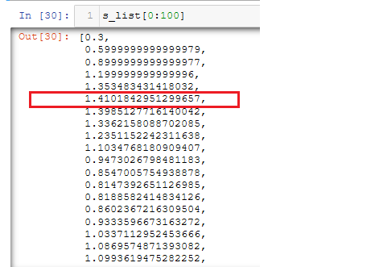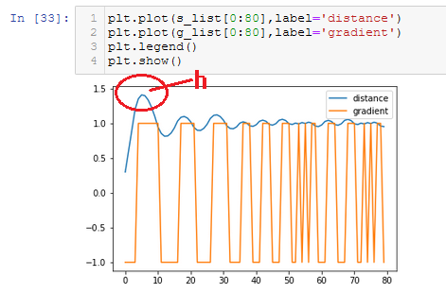Therefore, the intuition is the all the past gradients will add-up together and prop / push the current movement passing by the sloop of “x-h”, and that can be precisely calculated by a program – “q1.ipynb”

It shows the distance vs. gradient, and turning point located at:

h = 1.410184

what happen next when the peak distance-point of h is reached? – it’s oscillating at h, just like the behaviour in the previous question, but at diminishing attenuation, and eventually converges.

Only if there is another turning point sitting above x but below h – therefore it answers the question of maximum height, that is indicate by h.

# Q 2: (take note – It looks like I misread the instruction, thus I misunderstood the definition of laten-space of 2, 16, 256, I though they refer to individual models, i.e., the very last layer of encoder – when I found this, it’s already too late for me to change back, I will redress the problem during my presentation for this assignment.)

# Data Partitioning:

Training Dataset = 48000

Validation Dataset =12000

Test Dataset = 10000

# Try the simplest possible autoencoder (source code at “./q2_mlp.ipynb”)

It starts simple, with a single fully-connected nerual layer as encoder and as decoder:

It evaluates the reconstruction-loss with latent space dimension of 2:

Clearly, it’s the sign of under-fitting, since it’s too simple model, which justifies more layers required.

# Try sophisticated CNN mode (source code at “./q2.ipynb”)

### **Reconstruction only**

### Laten-space dimension set to 2:

* Total Classification-loss (test) = 0.07422441244125366
* Randomly regenerate samples from latent space.

* Plot of the 2-D location of the original images mapping out to the latent space.

* T-SNE visualization of the latent space.

1. Applying K-Means to the encoded layer for test-data, with Confusion matrix generated, followed by accuracy of prediction.

### **With either random noises or gaussian-noises added to individual input image, accordingly the loss function is defined as sum of reconstruction loss and denoising loss.**

### With Laten-space dimension set to 2:

* Classification-loss (test) = 0.07392493635416031

From left-to-right

1. Original image -> corrupted image -> reconstructed image
2. Dot-scatter plot of the 2-D latent space
3. T-SNE of the 2-D latent space (in place of K-Mean)

### With Laten-space dimension set to 16

* Total Classification (test) = 0.03253877907991409

### With Laten-space dimension set to 256

* Visualize coding of images in the latent-space:

* Total Classification -lost (test) = 0.02503991685807705

