The dynamic report

##Overview of the Data In this report, we are analyzing a dataset of food delivery orders. The dataset contains information on different platforms used for ordering, the types of restaurants, total order amounts, and customer ratings.

We aim to explore key factors like delivery times, ratings, and the correlation between platform choices and customer satisfaction.

##Delivery Time Analysis We begin by analyzing the average delivery time across different food delivery platforms.

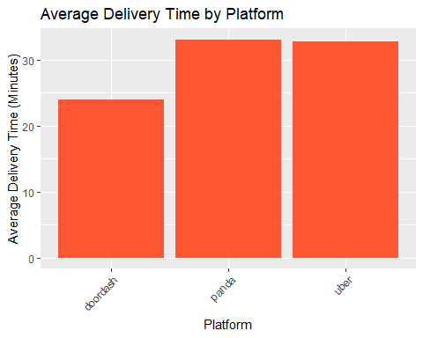

Customer Rating Analysis Next, we analyze the average ratings across different platforms.

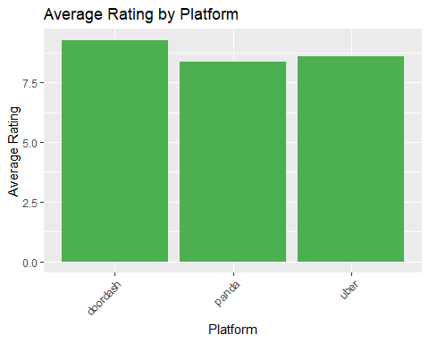

## FOOD DELIVERY PERFORMANCE REPORT  
##   
## Fastest Delivery Platform:  
## Platform:doordash  
## Average Delivery Time:24minutes  
##   
## Top-Rated Platform:  
## Platform:doordash  
## Average Rating:9.3stars  
##   
## Report generated on:2025-03-31

## Dynamic Commentary Based on Data

