Task 1: deployment:
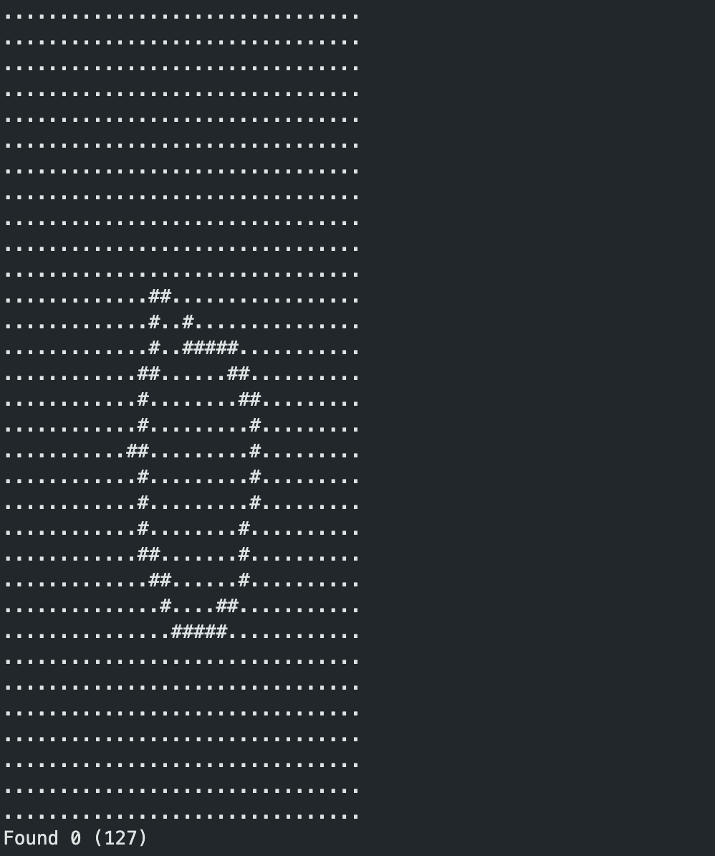
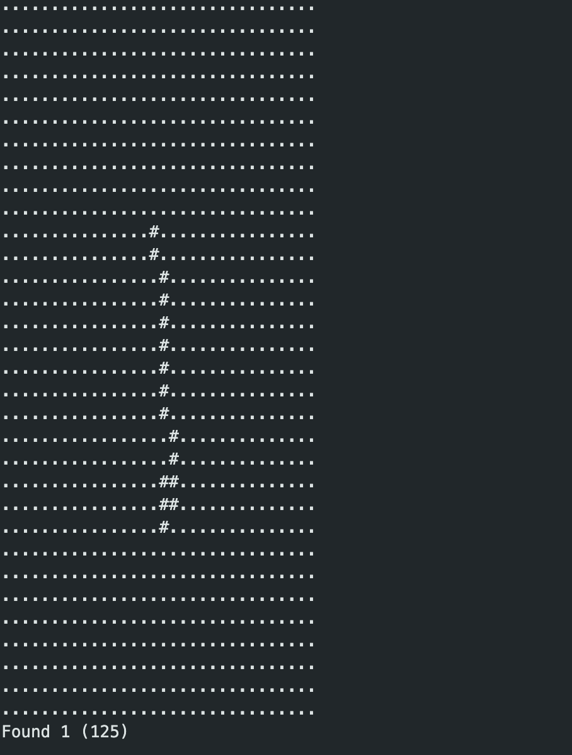
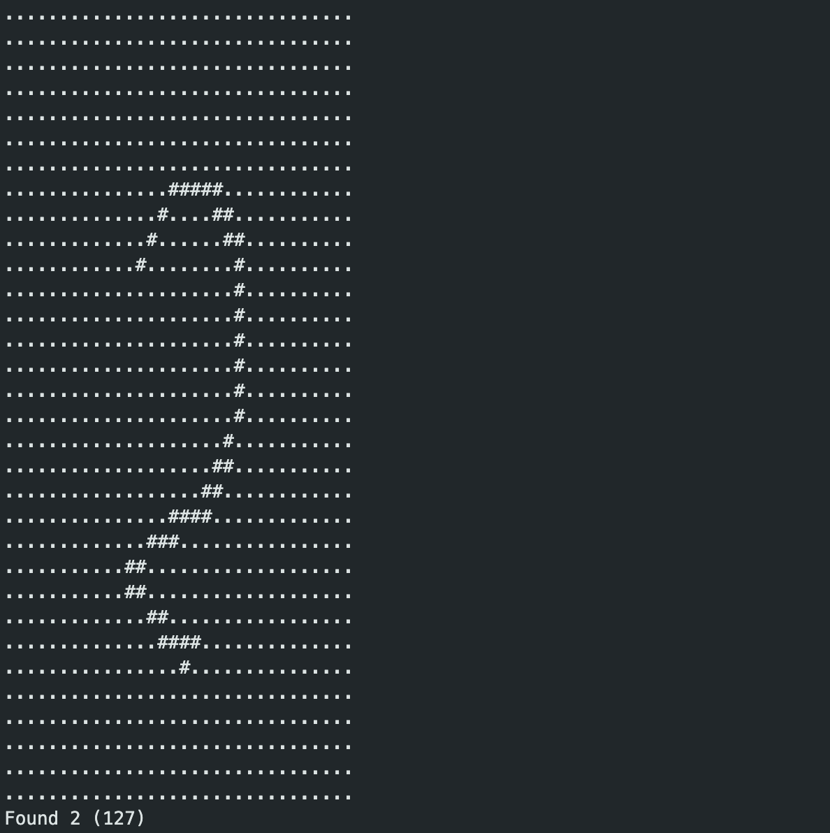
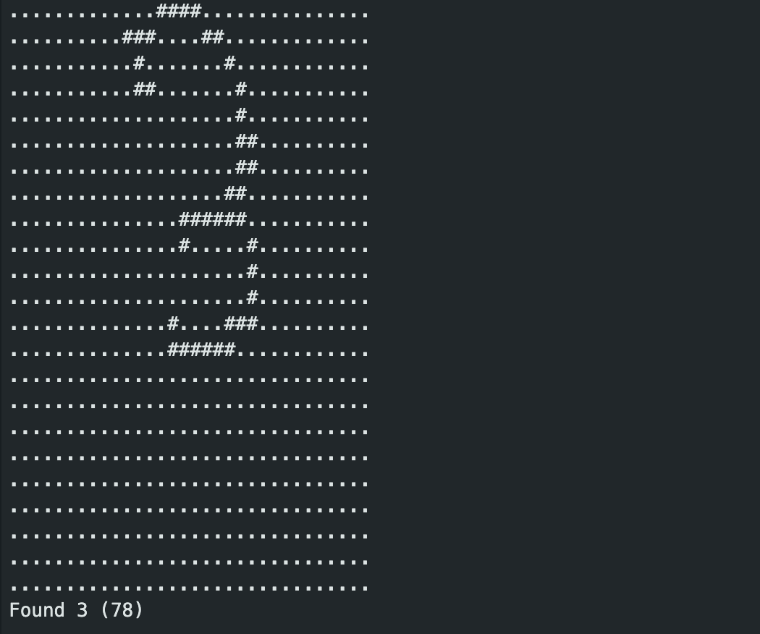

Task 4 Deployment:
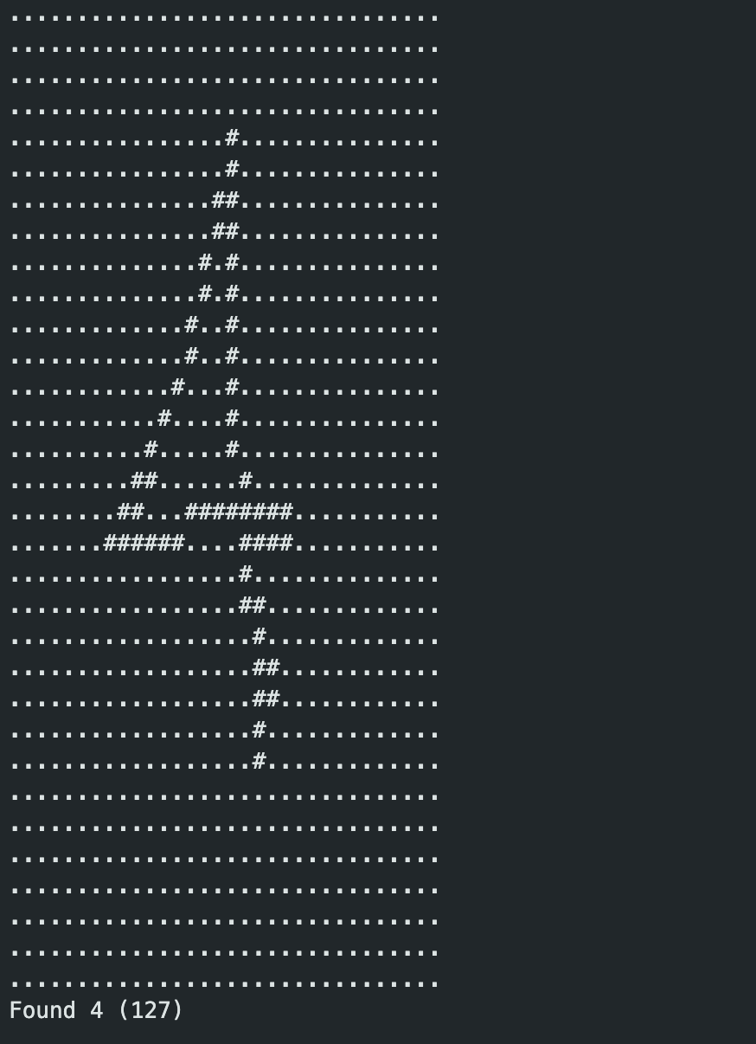
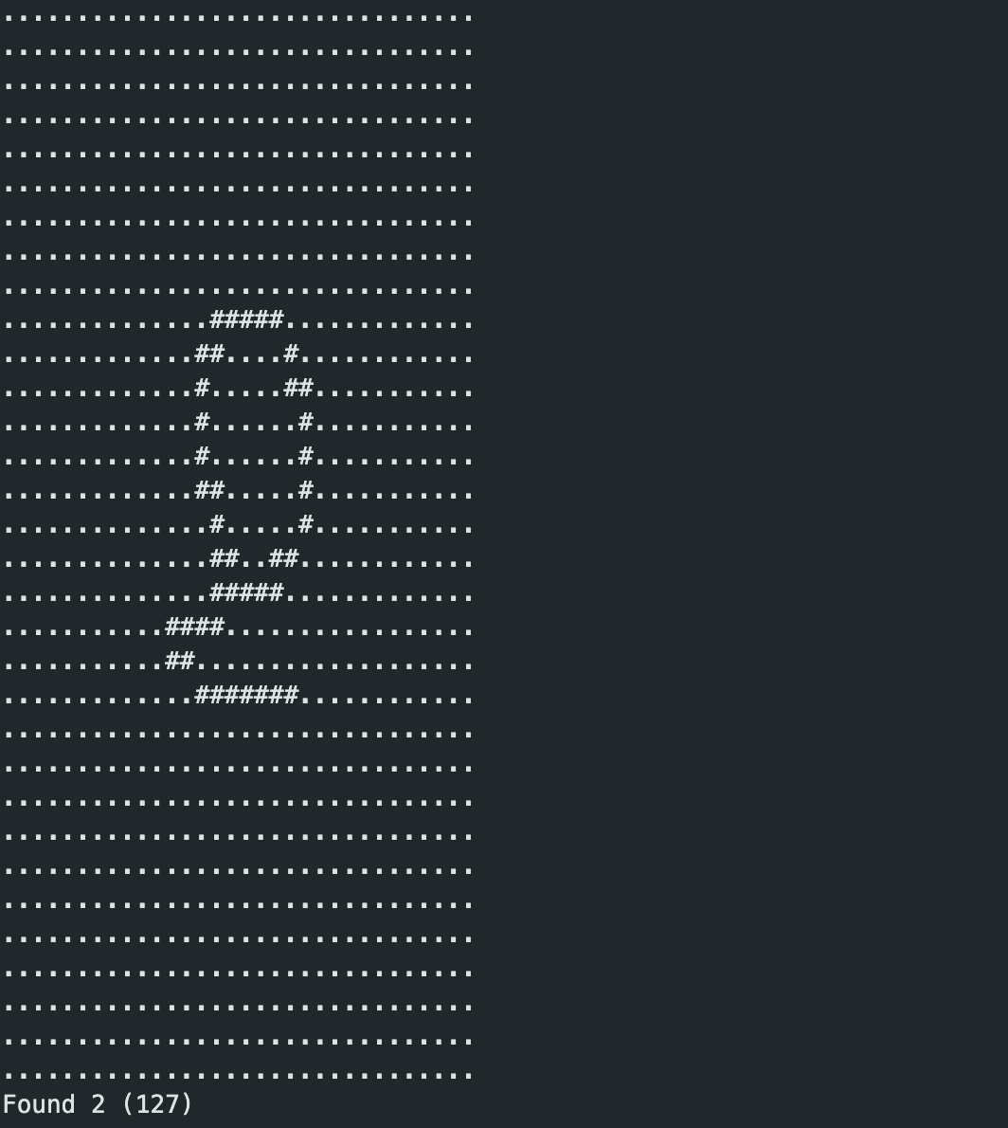
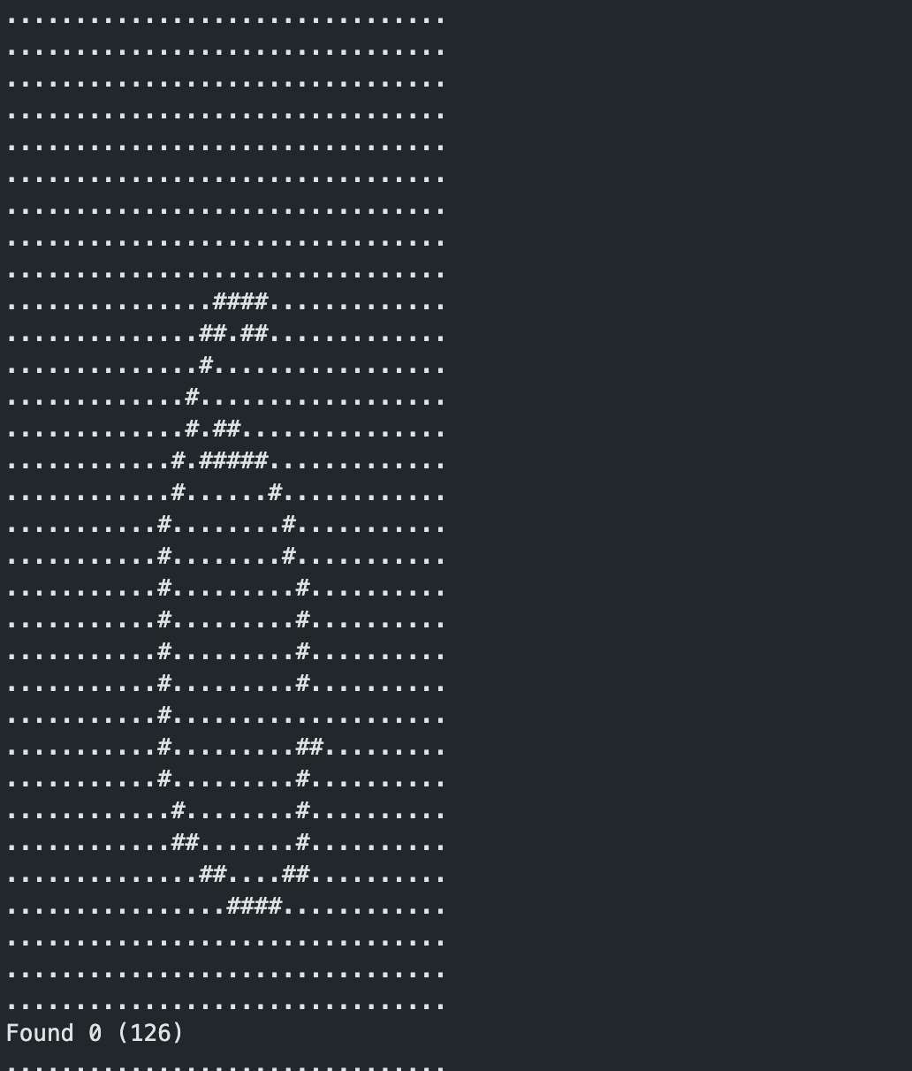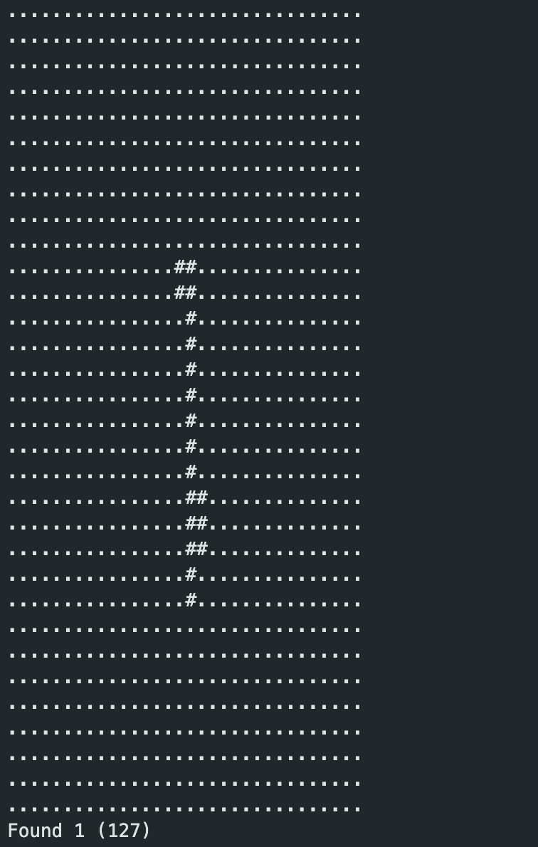

The fine-tuned model overall predicted the digits with more accuracy compared to the initial baseline model. One of the biggest differences was the fine-tuned model would predict with less errors and less misclassifications compared to the baseline model.
Fine tuning also did help for my specific gesture style since that was the style I trained my model on.

