**Project0502-01**

Changnan Jing, Jiading Chen, Kaho Ip, Wanyun Yang, Wenzhe Wu

**Name**

Silver Oaks Cooperative School(SOCS) Information System

**Description**

The information system is designed for the administrators of SOCS to manage the information including students, staffs, tasks and so on. The system can help administrators to abandon using paper-based work of managing work and improve the efficiency of data modification, insertion and deletion.

**Installation**

Users don’t need to install any other software to use the system. Users just need to use the website below to process the data managing work.

<http://128.8.127.120/Front-end/Member.php#>

**Usage**

1. **Home page**

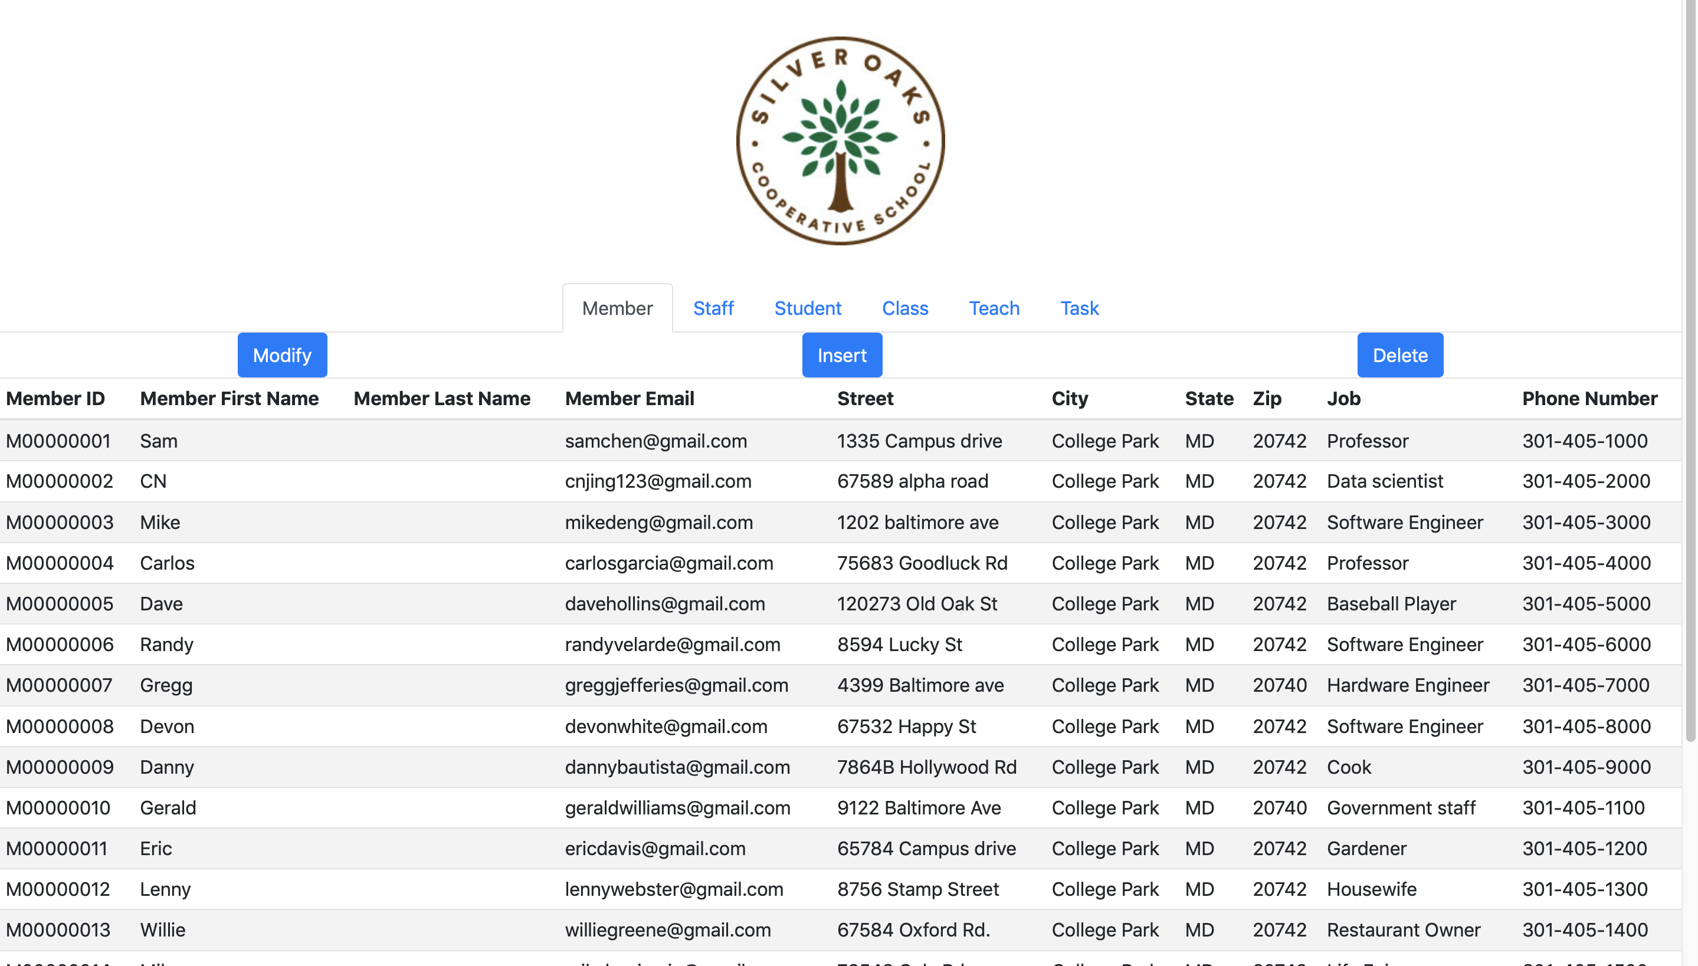

Exhibit a

As *Exhibit a* shows, this is the home page of our system. The cells under the school icon represents tables that we design in the database. User can click them to check them. User can also click *Modify, Insert, Delete* to modify data in the database to update information of the school.

1. **Modify Data**

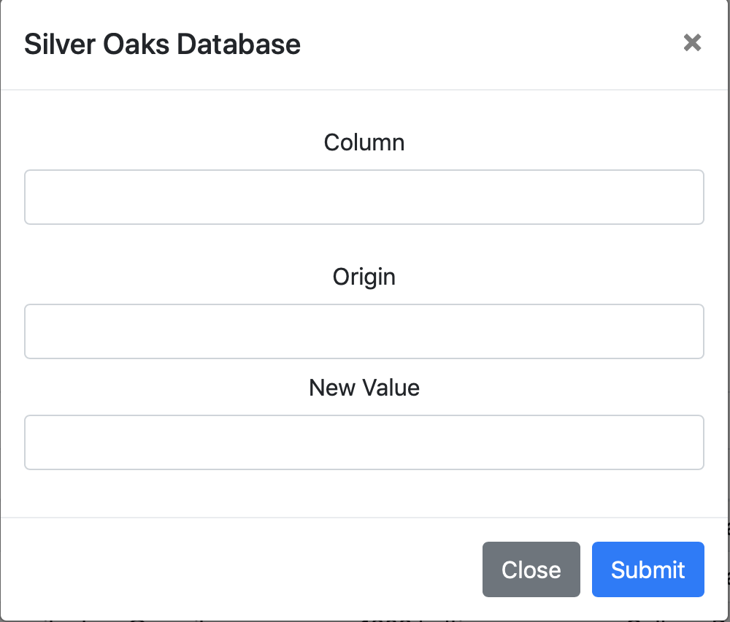

Exhibit b

As *Exhibit b* shows, after click *Modify*, user can modify the data in the system by assigning the value of *Column, Origin*, and *New Value*. *Column* represents the column’s name of the table which is being used. *Origin* represents the original data in the columns assigned, and *New Value* represents the new value that user is going to input. After assignment all of blanks, click *Submit* to finish modification.

1. **Insert Data**

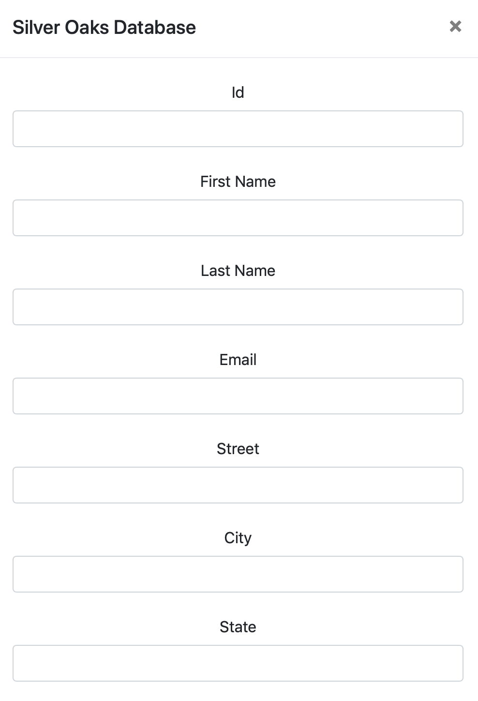

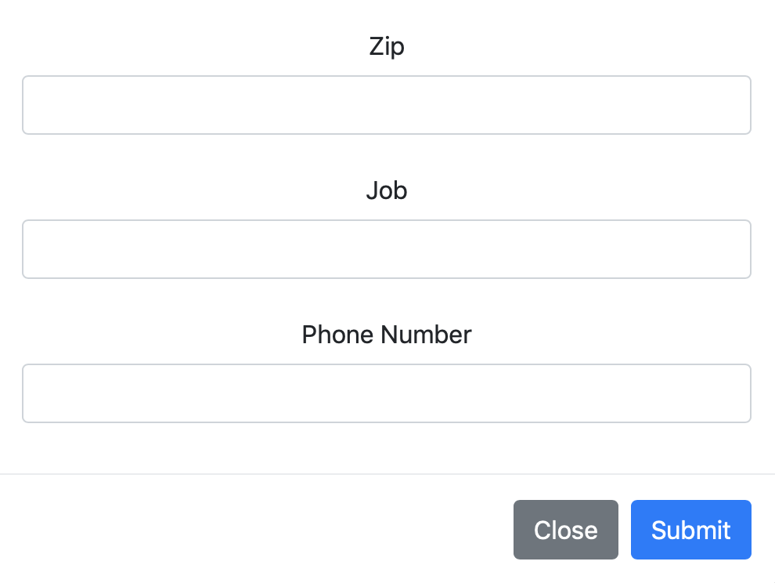

Exhibit c

As Exhibit c shows, user needs to assign value which is corresponded to the columns of the table which is being used to insert a new column of data. For example, in the table of Member, user needs to specify Id, First Name, Last Name, Email, Street, City, State, Zip, Job and Phone Number to finish the insertion of a new row. After assignment all of blanks, click *Submit* to finish Insertion.

1. **Delete Data**

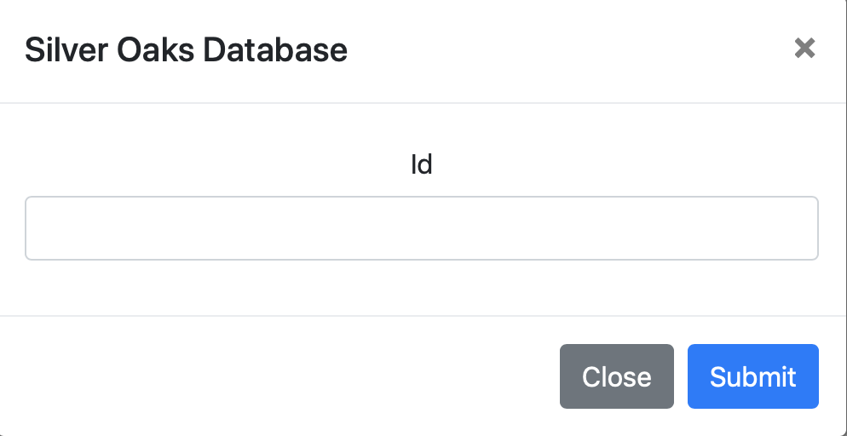

Exhibit d

As Exhibit d shows, user can delete a single row by assign the value of primary of the table. For example, in the Member table, we can assign Member Id to delete a specific row because Member Id is unique for every single member. After assignment the value of Id, click *Submit* to finish Deletion.