Q1:

The tutorial installed Django under the virtualenv project,

but I initially installed Django in my other directory. Do I need to download Django

under this specific directory again or I can choose my former Django?

A1:

Django needs to be installed in whatever virtualenv folder your project is using

the purpose of your virtualenv is to create a self-contained run time environment

Q2:

I installed my Django in

"c:\users\bingrchen\appdata\local\continuum\anaconda3\lib\site-packages" ($ pip show Django).

But there is a folder in "c:\users\bingrchen\django". Are these two directories equal?

Can I uninstall Django using $ pip uninstall Django?

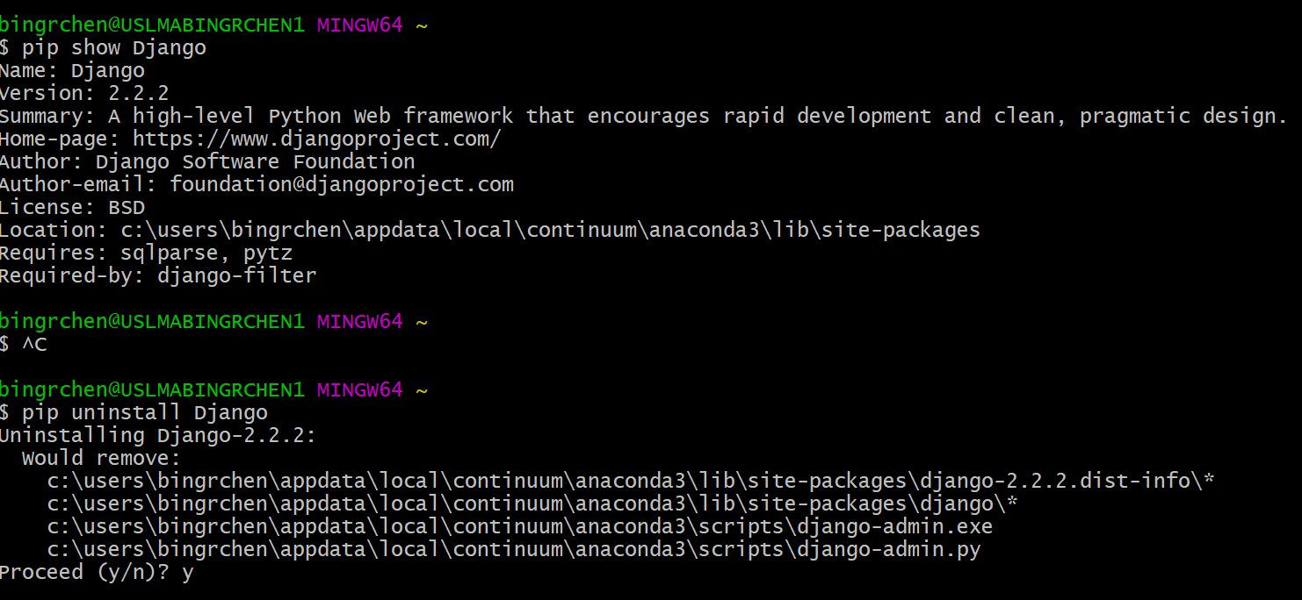

After I uninstall Django, the “Django” folder still exists in "c:\users\bingrchen\django". Why does it happen?

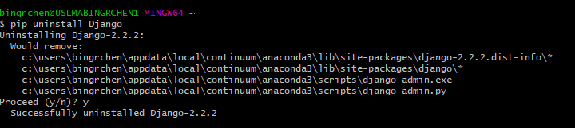

A2:

1) pip is a program. it is a program which installs things to a directory. It will, by default, install python packages to a directory where pip.exe is located.   
2) your anaconda version of python is located in ../appdata/local. **Anaconda, by default, comes with pip**.   
3) when you do pip show django it is showing django which installed in the **same location as pip.exe** that was **used to run that command**. Which means it is showing you django in .../appdata/local/site-packages **because the pip program you ran is in that same location**  
4) c:/users/bingrenchen/django doesnt really mean anything. is there a python project you have there?  
5) i can use pip to install any python package anywhere. but again, thats why we have virtual environments.   
6) If i have a virtual env folder in c:/users/kpahawa/MyAwesomeProject/venv/... then **there will be a separate, independent pip program in that folder**  
7) If I do  c:/users/kpahawa/MyAwesomeProject/venv/pip install Django it will install Django **ONLY in that folder location**. Not in ..../appdata/local/ or whatever**. It will isolate Django to THAT project which is the goal of the virtual environment** .  
8) when you talk about two folders being "equal" you mean having the same django version? if so, maybe? it depends on what version of django you installed in those two folders.

Q3: When I try to activate the virtualenv which is call “py1”, it always says “no such directory”. I have tried different commands according to the documentation.

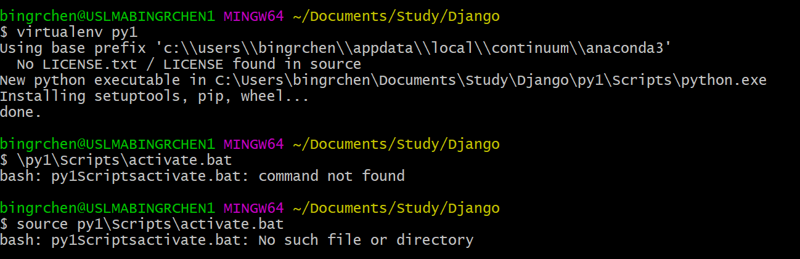

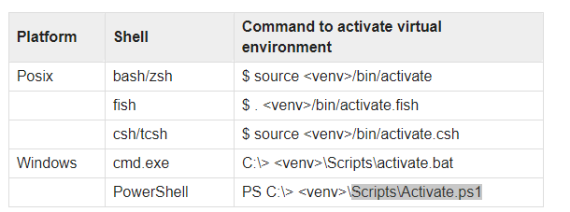

A3:

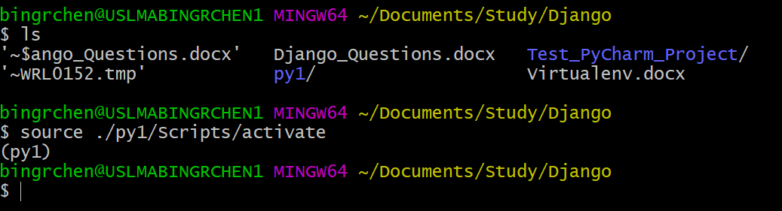

Q4:

The tutorial does not use PyCharm and directly use shell “python manage.py migrate”, there is no need to “make migration” first. What the difference between these two ways?

Q5: phpMyAdmin is loading forever. After I run $ python manage.py migrate. The bash looks good.

