**Project by Wei, Jordan, and Tony**

**Introduction:**

Helicopter project by using OSG library

**Milestone 2: (**commit 401a45f8323fe2c1711af74528d48be9d6294374**)**

Class Diagram

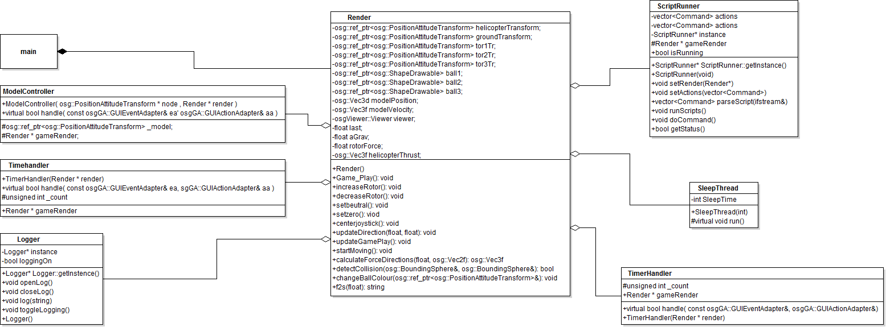

Sequence Diagram

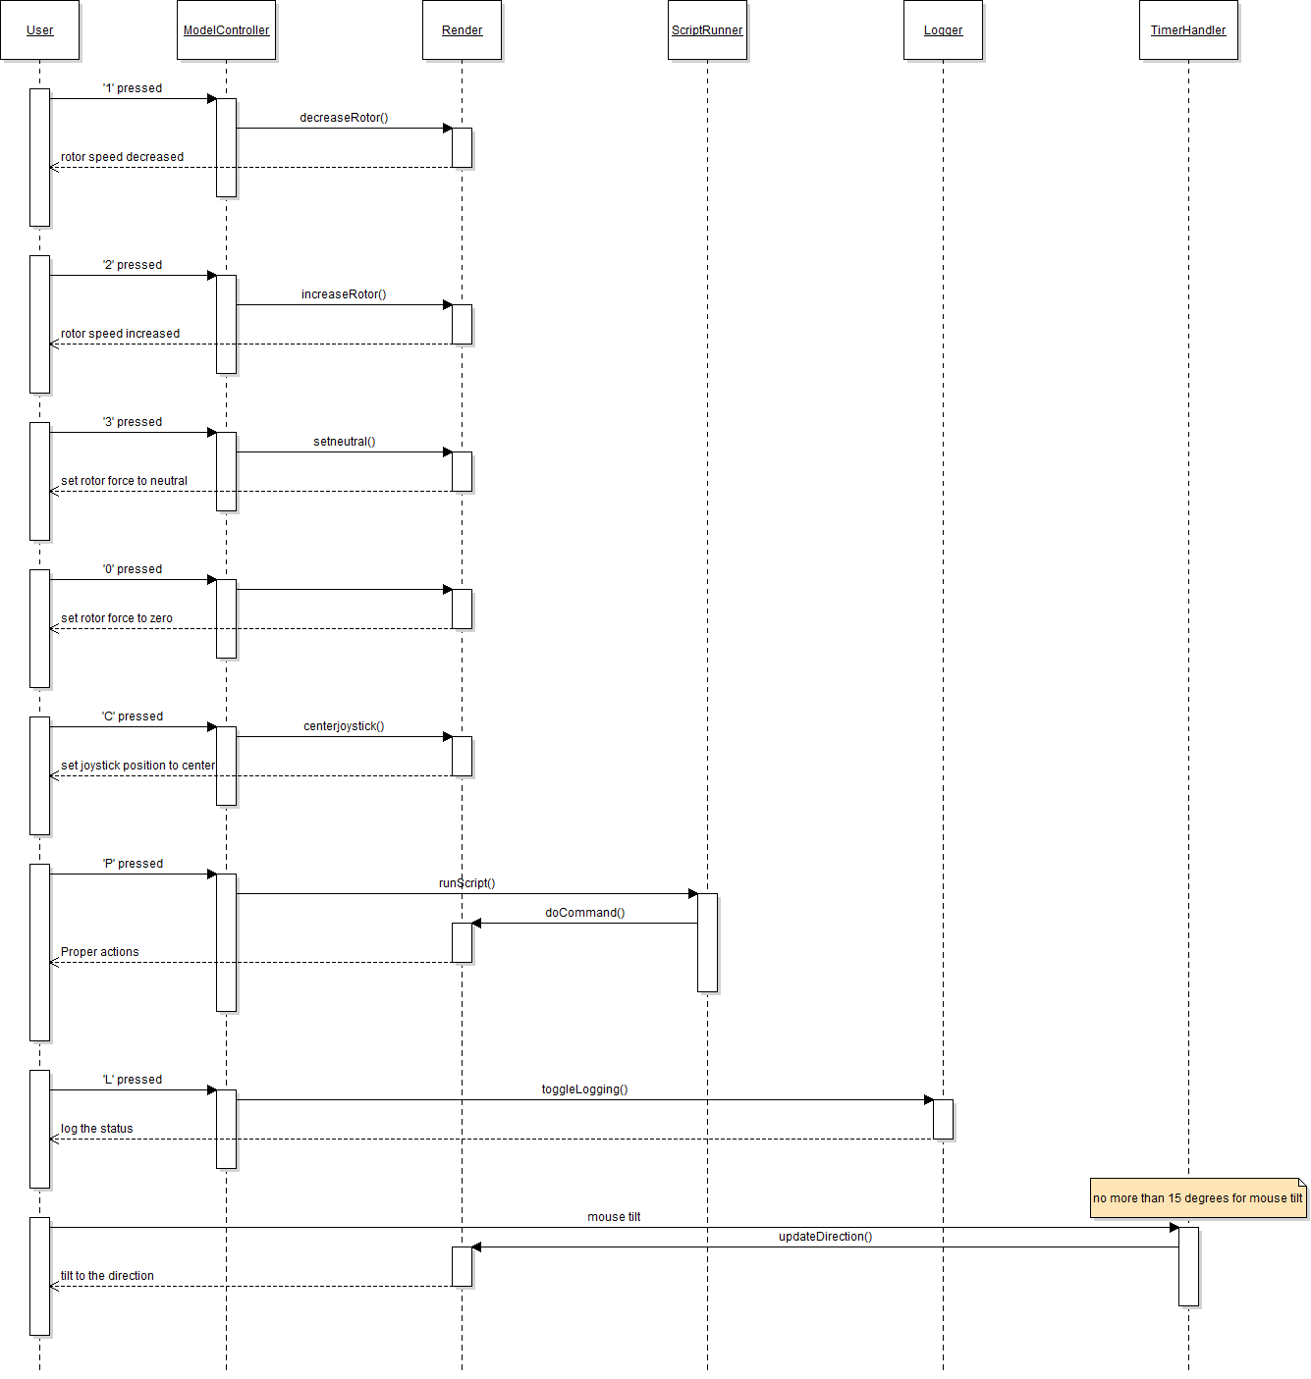

**Mislestone3:**

Class Diagram

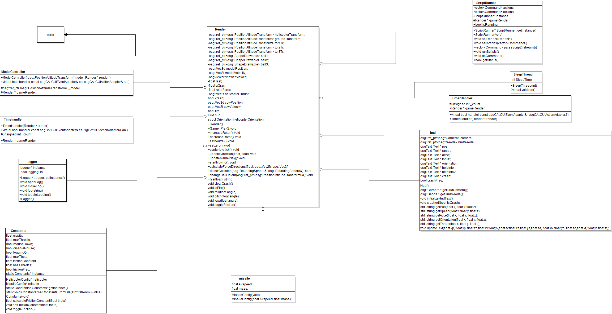

Sequence Diagram

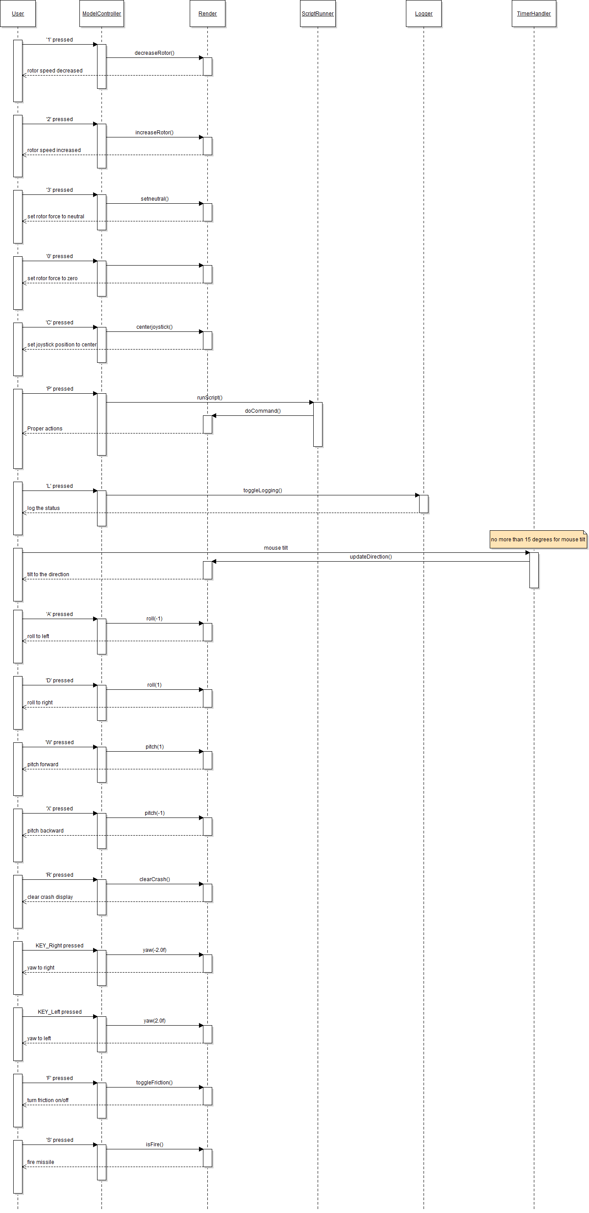

**Current Status:**

Currently, only Jordan and Wei are working on the project, and we have different availabilities, which makes it difficult to work together. Also, it is difficult to get into the lab because we have some trouble with OSG on our own computers. The lab is not always available when we have our free time.

Finally, we have three members in the lab to finish the project.

Right now, we finished:

1. Milestone 1 requirements
2. Milestone 2 requirements:

* Logging
* Scripting

1. Milestone 3 requirements:

* HUD
* Turn firction ON/OFF
* Crash Ditection
* Addition actions (roll, yaw, etc,.)
* Missile and inclination of -5 degrees, v = 40m/s

**Summary:**

The changes we made beyond the requirements:

1. The new equztions for helicopter physics

* Force in x, y, z aixes has been changed by taking the orientation of helicopter into account when calculating the force
* Friction toggle to turn on/off friction by using ‘F’ key, the acceleration will move towards zero
* The acceleration equation is new: they now take helicopter’s position into account

1. Scripting works by using P key to load the script file and disable the mouse and keyboard
2. Logger is working by pressing ‘L’ and directly writing to a file called “helicopterlog.txt”
3. When we press C key, the joystick is centered
4. Hover is working by pressing ‘3’ key to set the force to neutral
5. HUD

* Display x, y, z position, velocity, and acceleration
* Display the help infomation on the top of the screen
* Display missile related information: velocity and inclination
* Crash indication for helicopter and collision detection for missile

1. We add the function to detect the helicopter crash in Render.cpp (when the helicopter has a speed of 3m/s towards ground )
2. We added controls:

* Pitch: using key ‘W’and ‘X’
* Roll: using key ‘A’ and ‘D’
* Yaw: using arror key Left and Right
* Press ‘R’ to reset the crash infomation

1. Missile:

* Use cow.osg as our missile model
* Cow flys along with helicopter until it is been launched
* After about 2s, the cow will be reloaded into the helicopter
* The inclination of cow is -5 degree from the direction helicopter is facing
* V is 40m/s with the same direction of helicopter is facing

1. Collision detection for cow and ball: the ball will change color and logger will write this information to the file
2. Added missile related info to Constants.cpp
3. Made cpp and header files for missile
4. Cleaned and removed unnecessary code from the entire project

**Scene Graph:**

