Inside Page admin
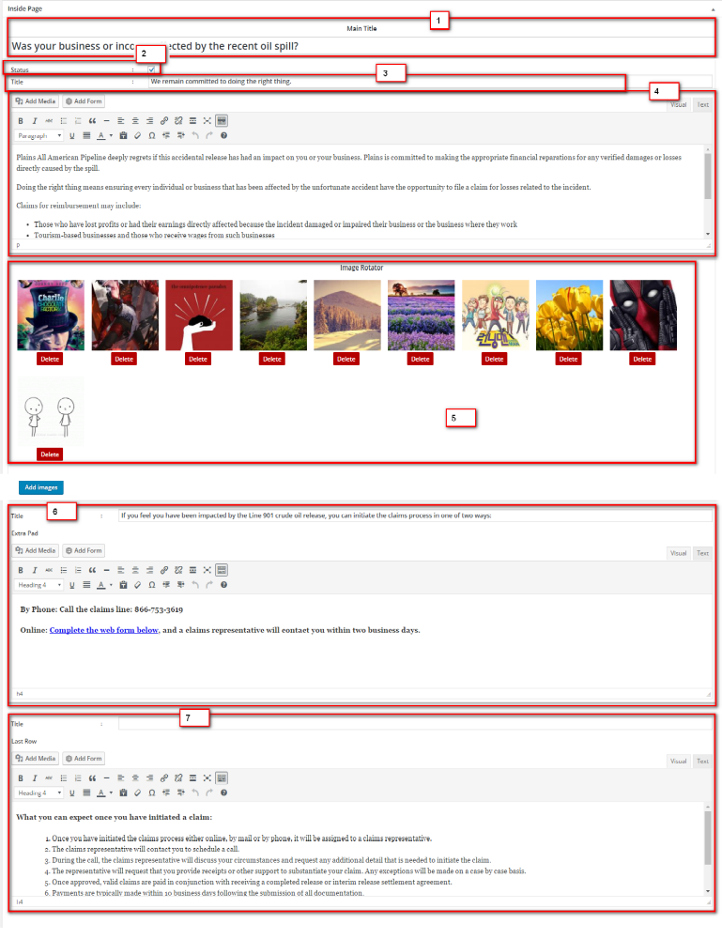

Note: Inside Page will show if “admin image” no 2(status),
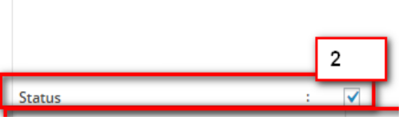

Inside Page Front End
