**Data Model**

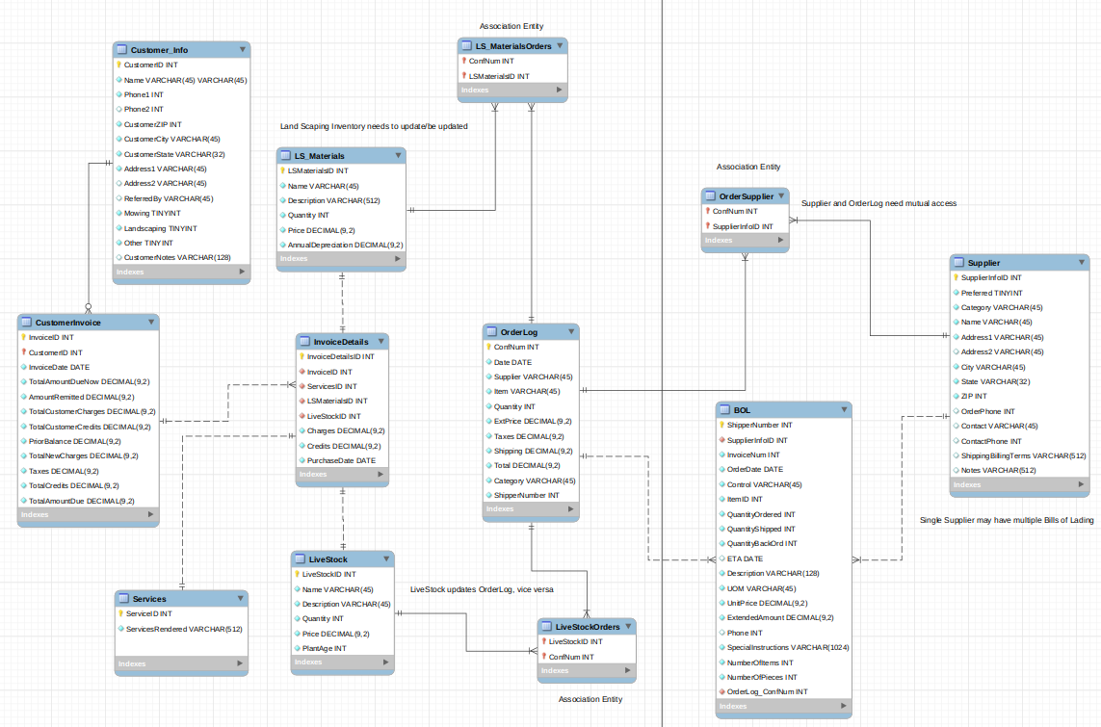

**DDL**

-- MySQL Script generated by MySQL Workbench

-- Wed 30 Oct 2019 09:55:06 PM MDT

-- Model: New Model Version: 1.0

-- MySQL Workbench Forward Engineering

SET @OLD_UNIQUE_CHECKS=@@UNIQUE_CHECKS, UNIQUE_CHECKS=0;

SET @OLD_FOREIGN_KEY_CHECKS=@@FOREIGN_KEY_CHECKS, FOREIGN_KEY_CHECKS=0;

SET @OLD_SQL_MODE=@@SQL_MODE, SQL_MODE='ONLY_FULL_GROUP_BY,STRICT_TRANS_TABLES,NO_ZERO_IN_DATE,NO_ZERO_DATE,ERROR_FOR_DIVISION_BY_ZERO,NO_ENGINE_SUBSTITUTION';

-- -----------------------------------------------------

-- Schema mydb

-- -----------------------------------------------------

-- -----------------------------------------------------

-- Schema mydb

-- -----------------------------------------------------

CREATE SCHEMA IF NOT EXISTS `mydb` DEFAULT CHARACTER SET utf8 ;

USE `mydb` ;

-- -----------------------------------------------------

-- Table `mydb`.`table1`

-- -----------------------------------------------------

CREATE TABLE IF NOT EXISTS `mydb`.`table1` (

)

ENGINE = InnoDB;

-- -----------------------------------------------------

-- Table `mydb`.`Customer_Info`

-- -----------------------------------------------------

CREATE TABLE IF NOT EXISTS `mydb`.`Customer_Info` (

`CustomerID` INT NOT NULL,

`Name VARCHAR(45)` VARCHAR(45) NOT NULL,

`Phone1` INT NOT NULL,

`Phone2` INT NULL,

`CustomerZIP` INT NOT NULL,

`CustomerCity` VARCHAR(45) NOT NULL,

`CustomerState` VARCHAR(32) NOT NULL,

`Address1` VARCHAR(45) NOT NULL,

`Address2` VARCHAR(45) NULL,

`ReferredBy` VARCHAR(45) NULL,

`Mowing` TINYINT NOT NULL,

`Landscaping` TINYINT NOT NULL,

`Other` TINYINT NOT NULL,

`CustomerNotes` VARCHAR(128) NULL,

PRIMARY KEY (`CustomerID`))

ENGINE = InnoDB;

-- -----------------------------------------------------

-- Table `mydb`.`CustomerInvoice`

-- -----------------------------------------------------

CREATE TABLE IF NOT EXISTS `mydb`.`CustomerInvoice` (

`InvoiceID` INT NOT NULL,

`CustomerID` INT NOT NULL,

`InvoiceDate` DATE NOT NULL,

`TotalAmountDueNow` DECIMAL(9,2) NOT NULL,

`AmountRemitted` DECIMAL(9,2) NOT NULL,

`TotalCustomerCharges` DECIMAL(9,2) NOT NULL,

`TotalCustomerCredits` DECIMAL(9,2) NOT NULL,

`PriorBalance` DECIMAL(9,2) NOT NULL,

`TotalNewCharges` DECIMAL(9,2) NOT NULL,

`Taxes` DECIMAL(9,2) NOT NULL,

`TotalCredits` DECIMAL(9,2) NOT NULL,

`TotalAmountDue` DECIMAL(9,2) NOT NULL,

PRIMARY KEY (`InvoiceID`, `CustomerID`),

INDEX `fk_CustomerInvoice_Customers_idx` (`CustomerID` ASC) VISIBLE,

CONSTRAINT `fk_CustomerInvoice_Customers`

FOREIGN KEY (`CustomerID`)

REFERENCES `mydb`.`Customer_Info` (`CustomerID`)

ON DELETE NO ACTION

ON UPDATE NO ACTION)

ENGINE = InnoDB;

-- -----------------------------------------------------

-- Table `mydb`.`Services`

-- -----------------------------------------------------

CREATE TABLE IF NOT EXISTS `mydb`.`Services` (

`ServiceID` INT NOT NULL,

`ServicesRendered` VARCHAR(512) NOT NULL,

PRIMARY KEY (`ServiceID`))

ENGINE = InnoDB;

-- -----------------------------------------------------

-- Table `mydb`.`LS_Materials`

-- -----------------------------------------------------

CREATE TABLE IF NOT EXISTS `mydb`.`LS_Materials` (

`LSMaterialsID` INT NOT NULL,

`Name` VARCHAR(45) NOT NULL,

`Description` VARCHAR(512) NOT NULL,

`Quantity` INT NOT NULL,

`Price` DECIMAL(9,2) NOT NULL,

`AnnualDepreciation` DECIMAL(9,2) NOT NULL,

PRIMARY KEY (`LSMaterialsID`))

ENGINE = InnoDB;

-- -----------------------------------------------------

-- Table `mydb`.`LiveStock`

-- -----------------------------------------------------

CREATE TABLE IF NOT EXISTS `mydb`.`LiveStock` (

`LiveStockID` INT NOT NULL,

`Name` VARCHAR(45) NOT NULL,

`Description` VARCHAR(45) NOT NULL,

`Quantity` INT NOT NULL,

`Price` DECIMAL(9,2) NOT NULL,

`PlantAge` INT NOT NULL,

PRIMARY KEY (`LiveStockID`))

ENGINE = InnoDB;

-- -----------------------------------------------------

-- Table `mydb`.`InvoiceDetails`

-- -----------------------------------------------------

CREATE TABLE IF NOT EXISTS `mydb`.`InvoiceDetails` (

`InvoiceDetailsID` INT NOT NULL,

`InvoiceID` INT NOT NULL,

`ServicesID` INT NOT NULL,

`LSMaterialsID` INT NOT NULL,

`LiveStockID` INT NOT NULL,

`Charges` DECIMAL(9,2) NOT NULL,

`Credits` DECIMAL(9,2) NOT NULL,

`PurchaseDate` DATE NOT NULL,

PRIMARY KEY (`InvoiceDetailsID`),

INDEX `fk_InvoiceDetails_CustomerInvoice1_idx` (`InvoiceID` ASC) VISIBLE,

INDEX `fk_InvoiceDetails_Services1_idx` (`ServicesID` ASC) VISIBLE,

INDEX `fk_InvoiceDetails_LS_Materials1_idx` (`LSMaterialsID` ASC) VISIBLE,

INDEX `fk_InvoiceDetails_LiveStock1_idx` (`LiveStockID` ASC) VISIBLE,

CONSTRAINT `fk_InvoiceDetails_CustomerInvoice1`

FOREIGN KEY (`InvoiceID`)

REFERENCES `mydb`.`CustomerInvoice` (`InvoiceID`)

ON DELETE NO ACTION

ON UPDATE NO ACTION,

CONSTRAINT `fk_InvoiceDetails_Services1`

FOREIGN KEY (`ServicesID`)

REFERENCES `mydb`.`Services` (`ServiceID`)

ON DELETE NO ACTION

ON UPDATE NO ACTION,

CONSTRAINT `fk_InvoiceDetails_LS_Materials1`

FOREIGN KEY (`LSMaterialsID`)

REFERENCES `mydb`.`LS_Materials` (`LSMaterialsID`)

ON DELETE NO ACTION

ON UPDATE NO ACTION,

CONSTRAINT `fk_InvoiceDetails_LiveStock1`

FOREIGN KEY (`LiveStockID`)

REFERENCES `mydb`.`LiveStock` (`LiveStockID`)

ON DELETE NO ACTION

ON UPDATE NO ACTION)

ENGINE = InnoDB;

-- -----------------------------------------------------

-- Table `mydb`.`OrderLog`

-- -----------------------------------------------------

CREATE TABLE IF NOT EXISTS `mydb`.`OrderLog` (

`ConfNum` INT NOT NULL,

`Date` DATE NOT NULL,

`Supplier` VARCHAR(45) NOT NULL,

`Item` VARCHAR(45) NOT NULL,

`Quantity` INT NOT NULL,

`ExtPrice` DECIMAL(9,2) NOT NULL,

`Taxes` DECIMAL(9,2) NOT NULL,

`Shipping` DECIMAL(9,2) NOT NULL,

`Total` DECIMAL(9,2) NOT NULL,

`Category` VARCHAR(45) NOT NULL,

`ShipperNumber` INT NOT NULL,

PRIMARY KEY (`ConfNum`))

ENGINE = InnoDB;

-- -----------------------------------------------------

-- Table `mydb`.`LS_MaterialsOrders`

-- -----------------------------------------------------

CREATE TABLE IF NOT EXISTS `mydb`.`LS_MaterialsOrders` (

`ConfNum` INT NOT NULL,

`LSMaterialsID` INT NOT NULL,

INDEX `fk_LS_MaterialsOrders_OrderLog1_idx` (`ConfNum` ASC) VISIBLE,

PRIMARY KEY (`LSMaterialsID`, `ConfNum`),

CONSTRAINT `fk_LS_MaterialsOrders_OrderLog1`

FOREIGN KEY (`ConfNum`)

REFERENCES `mydb`.`OrderLog` (`ConfNum`)

ON DELETE NO ACTION

ON UPDATE NO ACTION,

CONSTRAINT `fk_LS_MaterialsOrders_LS_Materials1`

FOREIGN KEY (`LSMaterialsID`)

REFERENCES `mydb`.`LS_Materials` (`LSMaterialsID`)

ON DELETE NO ACTION

ON UPDATE NO ACTION)

ENGINE = InnoDB;

-- -----------------------------------------------------

-- Table `mydb`.`LiveStockOrders`

-- -----------------------------------------------------

CREATE TABLE IF NOT EXISTS `mydb`.`LiveStockOrders` (

`LiveStockID` INT NOT NULL,

`ConfNum` INT NOT NULL,

INDEX `fk_LiveStockOrders_LiveStock1_idx` (`LiveStockID` ASC) VISIBLE,

PRIMARY KEY (`ConfNum`, `LiveStockID`),

CONSTRAINT `fk_LiveStockOrders_LiveStock1`

FOREIGN KEY (`LiveStockID`)

REFERENCES `mydb`.`LiveStock` (`LiveStockID`)

ON DELETE NO ACTION

ON UPDATE NO ACTION,

CONSTRAINT `fk_LiveStockOrders_OrderLog1`

FOREIGN KEY (`ConfNum`)

REFERENCES `mydb`.`OrderLog` (`ConfNum`)

ON DELETE NO ACTION

ON UPDATE NO ACTION)

ENGINE = InnoDB;

-- -----------------------------------------------------

-- Table `mydb`.`Supplier`

-- -----------------------------------------------------

CREATE TABLE IF NOT EXISTS `mydb`.`Supplier` (

`SupplierInfoID` INT NOT NULL,

`Preferred` TINYINT NOT NULL,

`Category` VARCHAR(45) NOT NULL,

`Name` VARCHAR(45) NOT NULL,

`Address1` VARCHAR(45) NOT NULL,

`Address2` VARCHAR(45) NULL,

`City` VARCHAR(45) NOT NULL,

`State` VARCHAR(32) NOT NULL,

`ZIP` INT NOT NULL,

`OrderPhone` INT NULL,

`Contact` VARCHAR(45) NULL,

`ContactPhone` INT NULL,

`ShippingBillingTerms` VARCHAR(512) NULL,

`Notes` VARCHAR(512) NULL,

PRIMARY KEY (`SupplierInfoID`))

ENGINE = InnoDB;

-- -----------------------------------------------------

-- Table `mydb`.`BOL`

-- -----------------------------------------------------

CREATE TABLE IF NOT EXISTS `mydb`.`BOL` (

`ShipperNumber` INT NOT NULL,

`SupplierInfoID` INT NOT NULL,

`InvoiceNum` INT NOT NULL,

`OrderDate` DATE NOT NULL,

`Control` VARCHAR(45) NOT NULL,

`ItemID` INT NOT NULL,

`QuantityOrdered` INT NOT NULL,

`QuantityShipped` INT NOT NULL,

`QuantityBackOrd` INT NOT NULL,

`ETA` DATE NULL,

`Description` VARCHAR(128) NOT NULL,

`UOM` VARCHAR(45) NOT NULL,

`UnitPrice` DECIMAL(9,2) NOT NULL,

`ExtendedAmount` DECIMAL(9,2) NOT NULL,

`Phone` INT NULL,

`SpecialInstructions` VARCHAR(1024) NOT NULL,

`NumberOfItems` INT NOT NULL,

`NumberOfPieces` INT NOT NULL,

`OrderLog_ConfNum` INT NOT NULL,

PRIMARY KEY (`ShipperNumber`),

INDEX `fk_Shipment_SupplierInfo1_idx` (`SupplierInfoID` ASC) VISIBLE,

INDEX `fk_BOL_OrderLog1_idx` (`OrderLog_ConfNum` ASC) VISIBLE,

CONSTRAINT `fk_Shipment_SupplierInfo1`

FOREIGN KEY (`SupplierInfoID`)

REFERENCES `mydb`.`Supplier` (`SupplierInfoID`)

ON DELETE NO ACTION

ON UPDATE NO ACTION,

CONSTRAINT `fk_BOL_OrderLog1`

FOREIGN KEY (`OrderLog_ConfNum`)

REFERENCES `mydb`.`OrderLog` (`ConfNum`)

ON DELETE NO ACTION

ON UPDATE NO ACTION)

ENGINE = InnoDB;

-- -----------------------------------------------------

-- Table `mydb`.`OrderSupplier`

-- -----------------------------------------------------

CREATE TABLE IF NOT EXISTS `mydb`.`OrderSupplier` (

`ConfNum` INT NOT NULL,

`SupplierInfoID` INT NOT NULL,

INDEX `fk_OrderSupplier_SupplierInfo1_idx` (`SupplierInfoID` ASC) VISIBLE,

PRIMARY KEY (`ConfNum`, `SupplierInfoID`),

CONSTRAINT `fk_OrderSupplier_OrderLog1`

FOREIGN KEY (`ConfNum`)

REFERENCES `mydb`.`OrderLog` (`ConfNum`)

ON DELETE NO ACTION

ON UPDATE NO ACTION,

CONSTRAINT `fk_OrderSupplier_SupplierInfo1`

FOREIGN KEY (`SupplierInfoID`)

REFERENCES `mydb`.`Supplier` (`SupplierInfoID`)

ON DELETE NO ACTION

ON UPDATE NO ACTION)

ENGINE = InnoDB;

SET SQL_MODE=@OLD_SQL_MODE;

SET FOREIGN_KEY_CHECKS=@OLD_FOREIGN_KEY_CHECKS;

SET UNIQUE_CHECKS=@OLD_UNIQUE_CHECKS;

**Assumptions**

* A customer doesn’t necessarily need to have any orders
* Bill of Lading is provided from each Supplier upon delivery
* when an order is placed (filed on the OrderLog), the Supplier will provide some shipment (doesn’t necessarily need to be the correct shipment, incorrect shipping can be seen when comparing Bill of Lading with Order Log)

**Surrogate Keys:**

* All surrogate keys are created when no good Candidate Keys exist in the respective table
* CustomerID (from Customer_Info)
* CustomerInvoiceID (from CustomerInvoice)
* ServiceID (from Services)
* InvoiceDetailsID (from InvoiceDetails)
* SupplierInfoID (from Supplier)
* Non-surrogates:
  + ShipperNumber (from BOL)
  + ConfNum (from OrderLog)