**自封袋**

厚度12丝，尺寸为30×40cm，购买300个

网址：<https://detail.tmall.com/item.htm?id=571430487678&ali_refid=a3_430673_1006:1103268181:N:aVvtC/90l6nBUGZTABS2lw==:41060dc4a4ac06f614a66276535c57dc&ali_trackid=1_41060dc4a4ac06f614a66276535c57dc&spm=a2e0b.20350158.31919782.1&skuId=3701704973963>

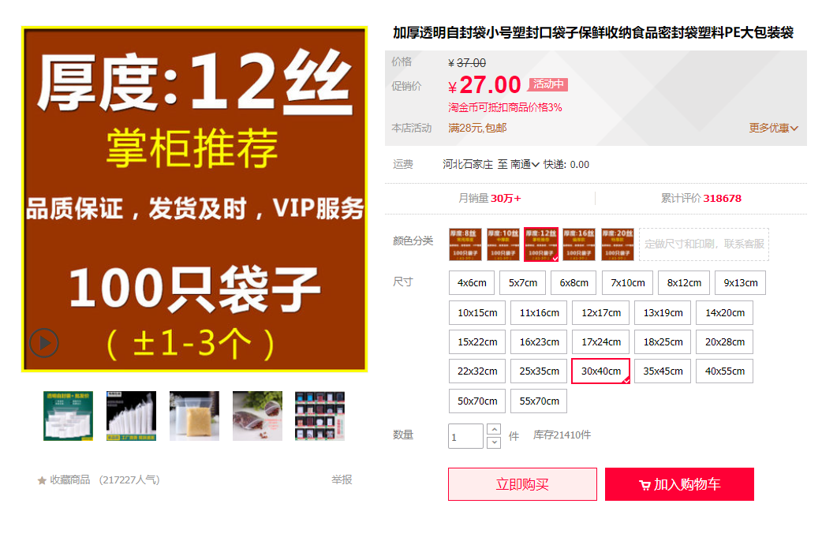

高压绝缘手套+绝缘靴

手掌12kv手套，20kv绝缘靴，鞋子购买43码，各购买1个

网址：<https://detail.tmall.com/item.htm?id=631401515230&ali_refid=a3_430673_1006:1105072077:N:5SYBP5ixL0tz8p0eQ1pByJtVBRw5CajR:8f6b03ff00b6c563618fd997546f391b&ali_trackid=1_8f6b03ff00b6c563618fd997546f391b&spm=a2e0b.20350158.31919782.2&skuId=4490560072864>

