Xbox 360 Game Previews

Ridge Racer 6

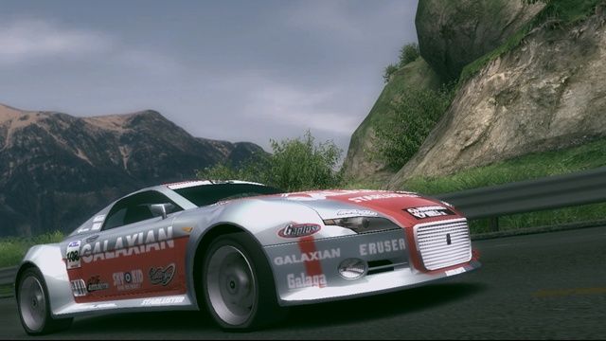

As a game that has normally launched with Sony platforms, this new Ridge Racer is a big addition for Microsoft. While it's nothing new or unique, Ridge Racer fans are going to love playing their favorite racer in hi-definition on the Xbox 360.

The Xbox 360 Ridge Racer 6 will have a total of about thirty tracks and no less than 130 cars (this is including eight “special machines”), these you’ll need to unlock in the game’s single player “World Xplorer” mode. Every race in this mode will be shown as a hexagon on a large, irregularly shaped map; from there you’ll be able to pick your own route thru the game as you progress.

This means you will be able to skip a large number of events if you want to, but you are discouraged from that by the presence of the unlockable items that you can access once you win all the races around the bonus icons on the map.

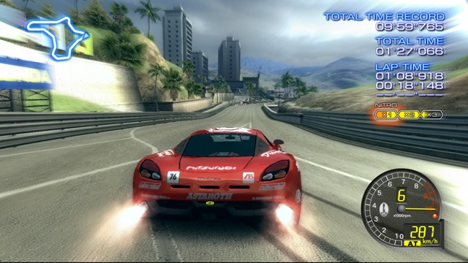

The game will feature new cars and tracks, the controls are based off of the recent PSP game, this is a good thing. For example, you have the same three-level boost meter, and it's possible to reverse steer into curves to spin your car around in a 360 and show off on your way through them. The game plays very well with the Xbox 360 controller with the right trigger being used to fuel your super boosts.

Standard races in Ridge Racer 6 will boast of a total of fourteen cars, but as in previous games, you will be going up against some very challenging opposition head to head on some occasions. Class 1 will be the slowest of four classes in Ridge Racer 6. The pace will be slowed considerably but there still is a good sense of speed thanks to the games 60 frames per second. It is especially noticeable if you use the car’s nitrous system. Just like in the PSP version is highlighted by sensational slides around corners. Then at the end of the race you are treated to great replays that showed off all your great skids and slides from many different camera angles.

Other game play modes in Ridge Racer 6 will focus mainly on online competition and will include heat to head online races, as well as a global time attack mode that will let you match your best race times against players from around the world using a leader board system.

As with any other next generation game, there is a question of how the graphics will look. In the case of Ridge Racer 6 there were some minor issues. The backgrounds were not as detailed as in some racers, but this has never been a big focus point. There are enough of the usual planes and helicopters along with some great There were some jagged edges arcross the top of the car, but with several weeks to go before launch it is fairly sure that the issue will be resolved by the time it hits the store shelves.

The Xbox 360 launch day is full of racing games. Such as Need for Speed: Most Wanted, Test Drive: Unlimited, Project Gotham Racing 3, Full Auto, and Ridge Racer 6 and they all are trying for your racing dollars. After seeing Ridge Racer we felt that it is a clear winner in the racing genre.

It has been told the game will support at least 10 players simultaneously and new content will be available via the Xbox Live Marketplace system. At this time there is no word as to if you will have to pay for the extra goods or if it will be a special bonus included with the purchase of the game. Scheduled for release in November many of the Ridge Racer 6’s features have not been finalized as of yet.

